Experiment no: 6

Aim: Use string functions and regex for email validation, data extraction, and text analysis.
Software / Tools Required:
· Visual Studio Code (VS Code)
· Google Chrome / Microsoft Edge
· HTML5, CSS3
Theory
Strings in JavaScript are sequences of characters used to store and manipulate text. JavaScript provides various built-in string functions and properties for performing operations on text. In this practical, trim(), length, and split() are used to process the entered text. The trim() function removes unnecessary spaces from the beginning and end of a string, length returns the number of characters, and split() divides a string into smaller parts such as words.
Regular Expressions, also called Regex, are patterns used to search, match, validate, and extract specific information from text. They are useful when the required data follows a particular format. In this practical, Regular Expressions are used to validate email addresses and extract email addresses and numbers from the entered text. The test() method checks whether the entered email matches the specified pattern, while the match() method finds matching data from a string.
String Functions Used
trim() – Removes extra spaces from the beginning and end of a string.
length – Returns the total number of characters in a string.
split() – Divides a string into smaller parts and returns them as an array.
match() – Searches a string for values that match a specified Regular Expression.
test() – Checks whether a string matches a specified Regular Expression.
Aim of the Case Study
To develop an Email and Text Analyzer using JavaScript that validates email addresses using Regular Expressions, analyzes user-entered text, counts characters and words, and extracts email addresses and numbers from the given text.

Path - Email and Text Analyzer
Name – Hiya Kriplani , PRN - 24070521277
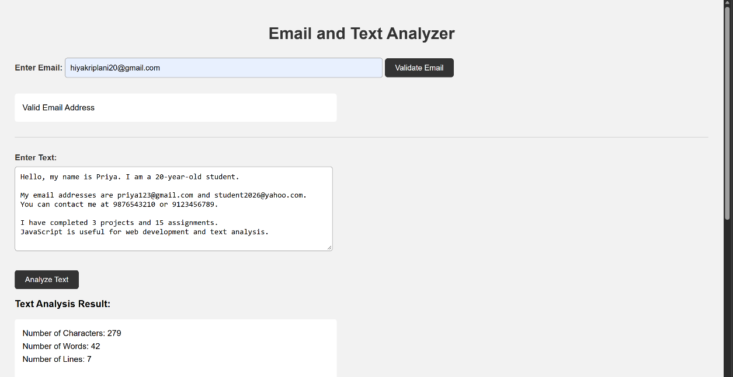
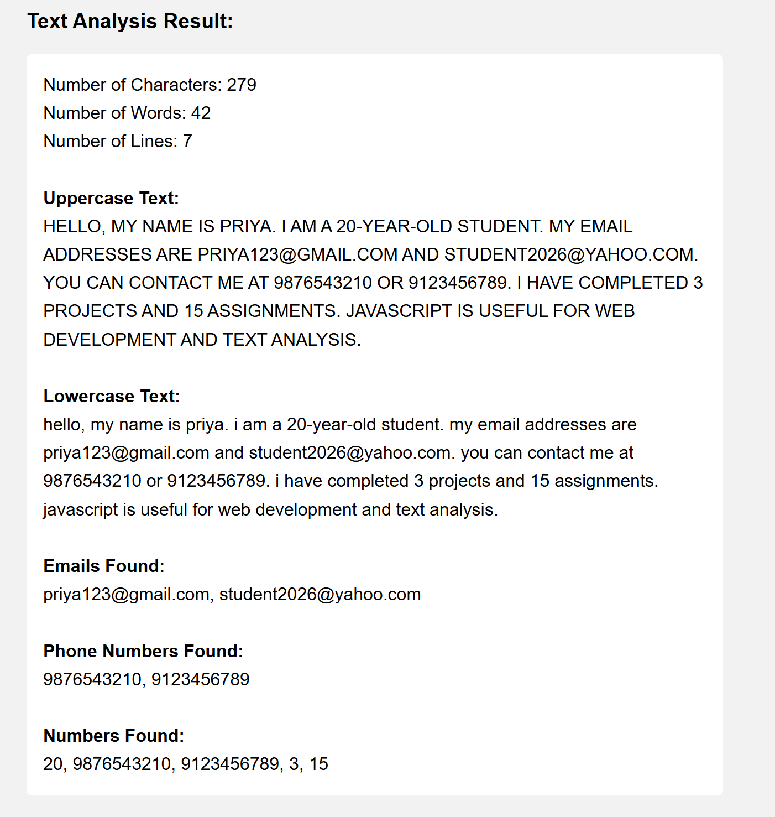
CONCLUSION
The Email and Text Analyzer was successfully developed using HTML, CSS, and JavaScript. String functions were used for text manipulation and analysis, while Regular Expressions were used for email validation and data extraction. The experiment helped in understanding the practical use of JavaScript string methods and Regex in processing text data.

