**Normalization**

**Definition :**

Normalization is a systematic approach of decomposing tables to eliminate data redundancy (repetition) and undesirable characteristics like insertion, update and delete anomalies (errors). It is a multi-Step process that puts data into tabular form by removing duplicated data from the relation tables.

* Normalization is the process of organizing the data in the database.
* Normalization is used to minimize the redundancy from a relation or set of relations. It is also used to eliminate undesirable characteristics like Insertion, Update, and Deletion Anomalies.
* Normalization divides the larger table into smaller and links them using relationships.
* The normal form is used to reduce redundancy from the database table.

There are three main types of normal forms (NF) : First Normal Form(1NF), Second Normal From(2NF), Third Normal Form(3NF) .

**First Normal Form(1NF) :** A relation will be 1NF if it contains an atomic value and distinct (unique) values.

**Second Normal Form(2NF) :**In the second normal form, all non-key attributes are fully functional dependent on the primary key.

**Third Normal Form(3NF) :** In 3NF there is no transitive dependency for non-prime attributes.

**Examples :**

1. **First Normal Form(1NF):** In the below example the columns of the **emp_info** table contains the atomic values(invisible) without any repeating values.

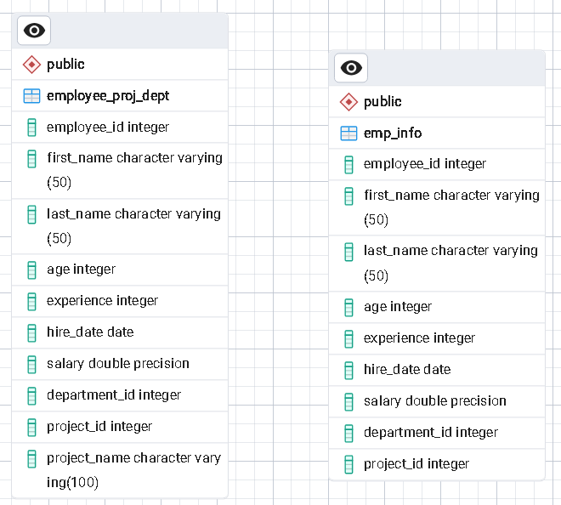

1. **Second Normal Form (2NF) :** In the second normal form (2NF), all non-key attributes are fully functional dependent on the primary key. So there is one Column should be primary key attribute and remaining other columns are dependent on the primary key column.

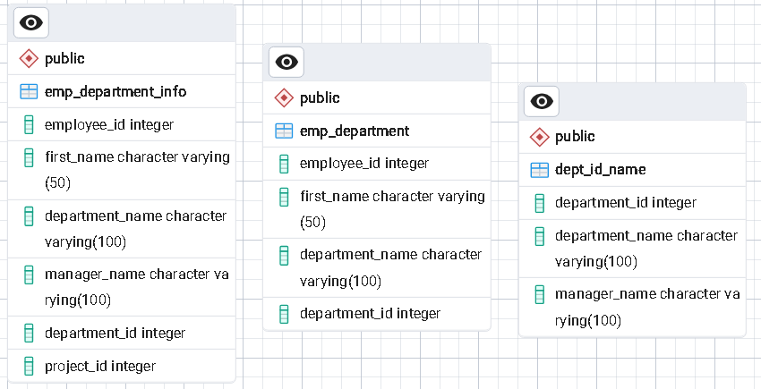

In this example we apply 2NF on **emp_department_info** table and create two table **emp_department** and **dept_id_name** where in each table the non-key attribute are fully dependent on the primary key column.

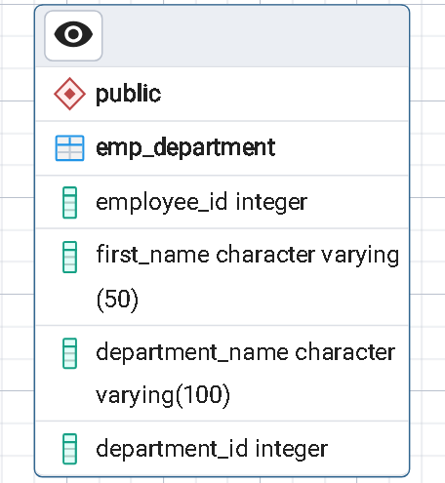

This **emp_department** table the employee_id is unique (primary key) and the other columns are fully dependent on the employee_id .

1. **Third Normal Form(3NF) :** A relation will be in 3NF if it is in 2NF and not contain any transitive partial dependency for non-prime attribute.

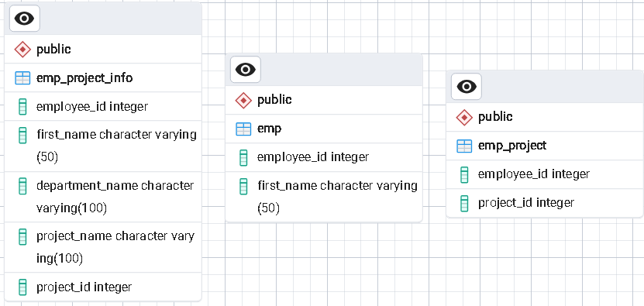

In the above example we apply 3NF on **emp_project_info** table and create **emp** and **emp_project** table that reduce the data duplication this is 3NF.