ETL Vs ELT:

<https://cloud.google.com/learn/what-is-etl>

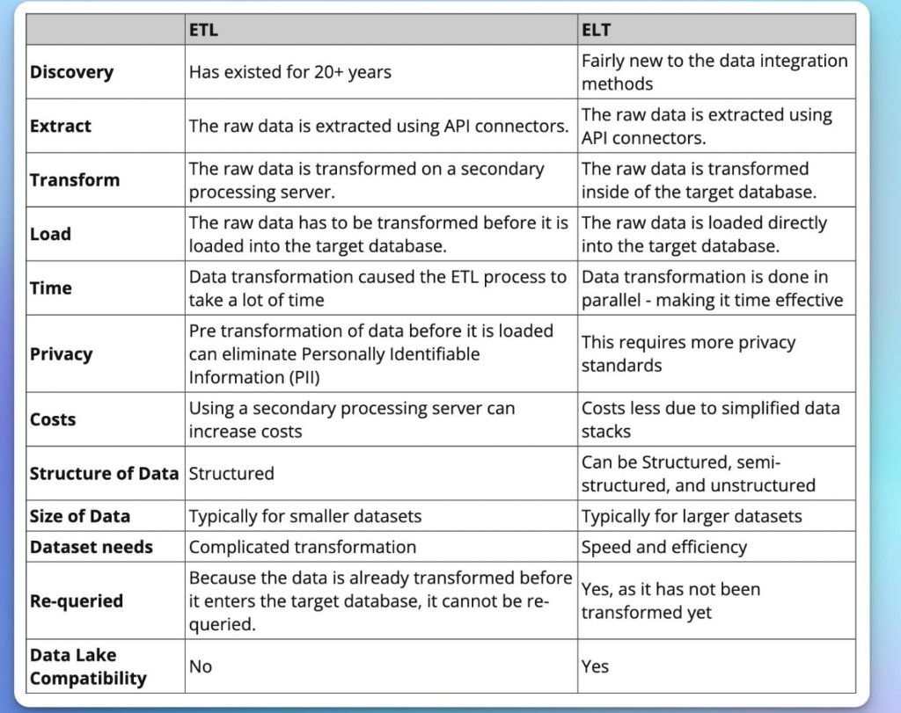

<https://www.geeksforgeeks.org/difference-between-elt-and-etl/>

<https://www.qlik.com/us/etl/etl-vs-elt>

<https://www.integrate.io/blog/etl-vs-elt/>

<https://www.ibm.com/cloud/blog/elt-vs-etl-whats-the-difference>

<https://www.guru99.com/etl-vs-elt.html>

<https://www.talend.com/resources/elt-vs-etl/>

<https://blog.panoply.io/etl-vs-elt-the-difference-is-in-the-how>

<https://www.snowflake.com/guides/etl-vs-elt>

<https://www.javatpoint.com/data-warehouse-etl-vs-elt>

<https://www.ibm.com/cloud/learn/elt>

<https://blog.hubspot.com/website/etl-tools>

<https://hevodata.com/learn/best-elt-tools/>

Data Hour:

1. What is Data Engineer and types of services in Data Engineering? (~5 -7 mints)
2. What is ETL and ELT?
3. Difference between ETL and ELT?
4. Google Cloud Services for ETL and ELT
   1. Dataproc
   2. Dataflow
   3. Data fusion
5. Practical demo on Dataflow using python sdk.