Name: Hyungu Kim (Steven)

Date: May 31, 2023

Course: IT FDN 110 A: Foundations of Programming: Python

[Hkim0120/IntroToProg-Python-Mod07 (github.com)](https://github.com/Hkim0120/IntroToProg-Python-Mod07)

Assignment 07 - Pickles & Errors

Introduction

Pickling in Python is used in serializing and deserializing a Python object structure. It’s a process of converting a Python object into a byte stream to store it in a file/database. What makes the pickling different from just storing data is that when you or other users try to open the file in a different format other than python program, it will show in a different and broken language which allows for the users to create more secured data in a smaller byte size.

Topic

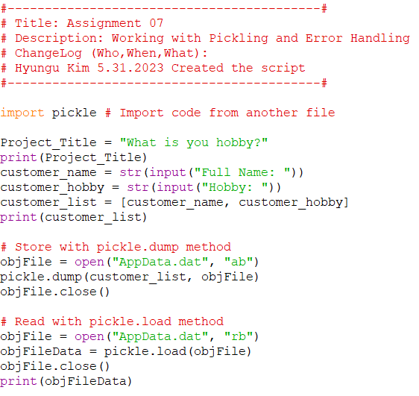

***Figure 1. Pickle Code***

The above figure 1 is the main part of the pickling code. As it is mentioned in red, it stores and reads the data the users have entered. I changed the assignment a little bit and created a program for the users to enter their hobby and store it into data.

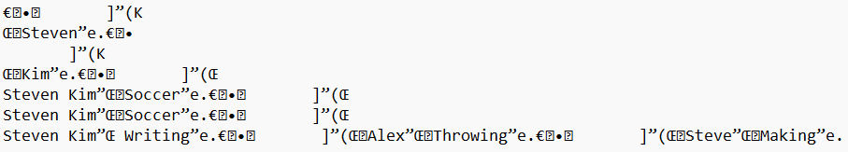

***Figure 2. Data in Note***

The above example shows when I opened the data with the notepad. Clearly you can see the data is not clear but it is hard to understand what data is entered. However, when you put that stored file into a python program, you will be able to see what the stored data is.

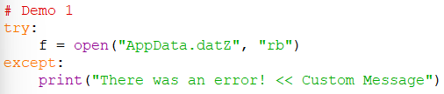

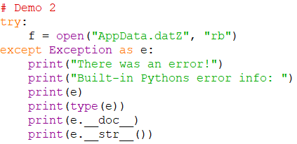

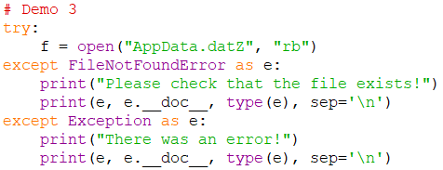

***Figure 3. Error Demos***

The above figure 3 shows three different error types I have tried. The errors occur when unpicklable objects are encountered. In my assignment I only left Demo 3, but all three error tests have worked properly.

Summary

Pickling is used in serializing and deserializing a Python object structure. It’converts a Python object into a byte stream to store it in a file/database. Therefore, the stored data in the text file is rather broken and unclear. However, when the stored data is played in Python programs the users and programmer can see what the byte size file was actually about. There are different types of errors in pickling. When the pickler encounters unpicklable objects, the error occurs. Throughout the assignment we learned how to visibly present when the errors occur and learned how to pickle and store files in byte size data.