wedding ~~JRP~~ vocalist

About ME



[Grab your reader’s attention with a great quote from the document or use this space to emphasize a key point. To place this text box anywhere on the page, just drag it.]

*🡨 Links in middle are fb, twitter, Instagram and YouTube (videos).*

Contact Me

*These pop up … not static on the page.*

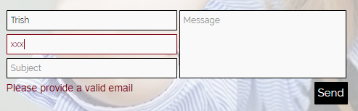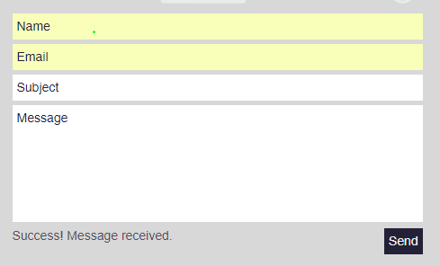

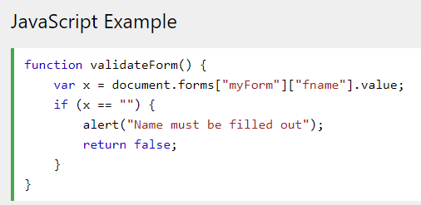*Validate email address.*

*Add date of function; validate date format.*

*Add time of function; validate time format.*

*Add location of function.*