**1. STUDENT NAME**

**2. URL to STUDENT WEB SITE**

**3. user_role TABLE DESIGN**

**4. web_user TABLE DESIGN and FOREIGN KEY**

**5. “OTHER” TABLE DESIGN and FOREIGN KEY**

**6. DATA ENTRY ERRORS**

**a) Error: Duplicate user_role PK**

**b) Error: Invalid user_role FK in web_user record**

**c) Error: Cannot delete a user_role record that’s referenced by a web _user record**

**d) Invalid web_user FK in “other” record**

**e) Error trying to delete a web_user record that’s referenced by an “other” record**

**7. SELECT STATEMENTS**

**a) USER_ROLE: all rows, all columns, sorted by user_role_id.**

**b) WEB_USER: all rows, all columns, sorted by web_user_id.**

**c) WEB_USER JOINED WITH USER_ROLE: all rows, certain columns, sorted.**

**f) “OTHER”: all rows, all columns, sorted by the id of your “other” table.**

**g) “OTHER” JOINED WITH WEB_USER all rows, certain columns, sorted.**

**h) “OTHER” JOINED WITH WEB_USER some rows, certain columns, sorted.**

1. Name: Himanshi Sheth
2. Web Link:[fa24_3308_tur08798/index.html](https://cis-linux2.temple.edu/tomcat10/fa24_3308_tur08798/index.html)
3. user_role TABLE DESIGN:

1. web_user TABLE DESIGN and FOREIGN KEY:



1. “OTHER” TABLE DESIGN and FOREIGN KEY



1. DATA ENTRY ERRORS:
2. Error: Duplicate user_role PK

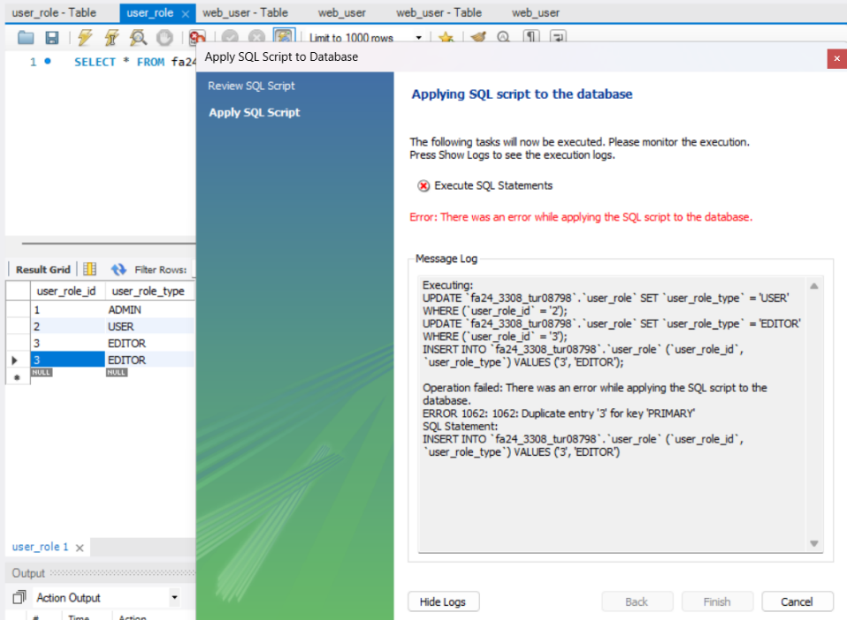

1. Error: Invalid user_role FK in web_user record

1. Error: Cannot delete a user_role record that’s referenced by a web _user record

1. Invalid web_user FK in “other” record

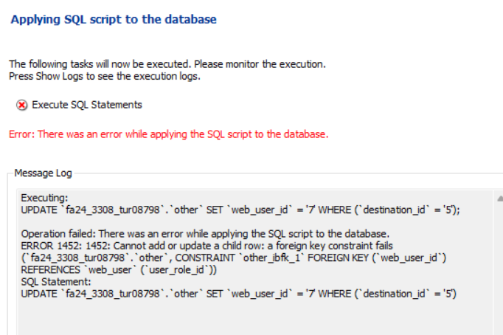

1. Error trying to delete a web_user record that’s referenced by an “other” record

1. SELECT STATEMENTS
2. USER_ROLE: all rows, all columns, sorted by user_role_id.

1. WEB_USER: all rows, all columns, sorted by web_user_id.

1. WEB_USER JOINED WITH USER_ROLE: all rows, certain columns, sorted.

1. “OTHER”: all rows, all columns, sorted by the id of your “other” table.

1. “OTHER” JOINED WITH WEB_USER all rows, certain columns, sorted.

1. “OTHER” JOINED WITH WEB_USER some rows, certain columns, sorted.

