STATISTICS — MEMO
Measures of Central Tendency, Spread & Position

QUESTION 1
4 ; 5 ; 8 ; 9 ; 9 ; 12 ; 14 ; 17 ; 40 (n = 9)
1.1 Mean (2)
x̄ = Σx ÷ n = (4+5+8+9+9+12+14+17+40) ÷ 9 = 118 ÷ 9
x̄ ≈ 13,11

1.2 Mode (1)
9 (the only value that repeats)

1.3 Median (1)
Position = (n+1) ÷ 2 = 10 ÷ 2 = 5th value
Median = 9

1.4 Lower quartile (2)
Position: Q1 = (n+1) ÷ 4 = 10 ÷ 4 = 2,5
Lower half: 4 ; 5 ; 8 ; 9 → average the 2nd and 3rd values
Q1 = (5 + 8) ÷ 2 = 6,5

1.5 Upper quartile (2)
Position: Q3 = 3(n+1) ÷ 4 = 30 ÷ 4 = 7,5
Upper half: 12 ; 14 ; 17 ; 40 → average the 2nd and 3rd values
Q3 = (14 + 17) ÷ 2 = 15,5

1.6 The 5 number summary of the data (2)
Minimum = 4 Q1 = 6,5 Median = 9 Q3 = 15,5 Maximum = 40

1.7 Range (1)
Range = max − min = 40 − 4 = 36

1.8 Interquartile range (IQR) (1)
IQR = Q3 − Q1 = 15,5 − 6,5 = 9

1.9 Standard deviation (2)
σ = √( Σ(x−x̄)² ÷ n ) (using a calculator)
σ ≈ 10,27

1.10 How many numbers lie within 1 standard deviation of the mean? (3)
[x̄ − σ ; x̄ + σ] = [13,11 − 10,27 ; 13,11 + 10,27] = [2,84 ; 23,38]
Values inside this interval: 4, 5, 8, 9, 9, 12, 14, 17 → 8 numbers
(40 falls outside this interval.)

1.11 Determine if there are any outliers. (4)
[Q1 − 1,5×IQR ; Q3 + 1,5×IQR] = [6,5 − 1,5(9) ; 15,5 + 1,5(9)] = [−7 ; 29]
40 > 29, so 40 IS an outlier. No value falls below −7.

1.12 Draw a box and whisker diagram for the data. (3)

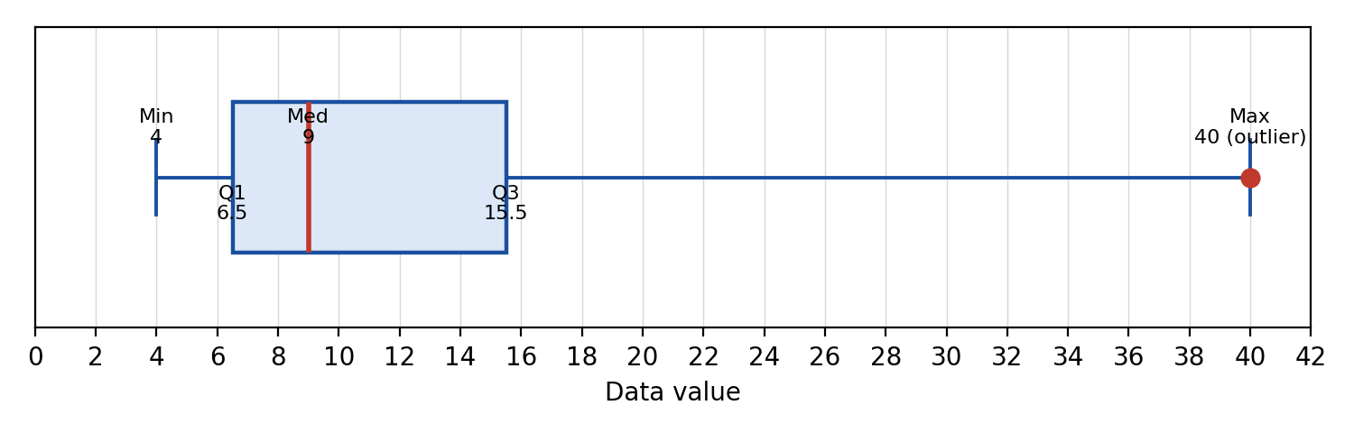
Note: the whisker is drawn to the actual maximum (40); 40 is separately identified as an outlier in 1.11, rather than the whisker being cut short.
QUESTION 2
Interval | 0 ≤ x < 10 | 10 ≤ x < 20 | 20 ≤ x < 30 | 30 ≤ x < 40 | 40 ≤ x < 50
Frequency | 3 | 7 | 12 | 5 | 2

2.1 Write down the modal class of the data. (2)
The modal class is the interval with the highest frequency.
Modal class = 20 ≤ x < 30 (frequency = 12)

END OF MEMO

