FUNCTIONS TEST: ADVANCED
Nature of roots, values of x, axes of symmetry and transformations
Name: ______________________________ | Date: ______________________________
Time: 30 minutes | Total: ______ / 30
Instructions
• Answer all the questions and show all your working.
• Leave answers as exact values (fractions or surds), not decimals.
• Write intervals using inequalities, for example x < 2 or x > 5.
Question 1 Parabola and nature of roots [11 marks]
 | Given: f(x) = −x² + 4x + 5
1.1 | Determine the nature of the roots of f(x) = 0 without solving the equation. Show all your working. | (3)
1.2 | Determine the value of k for which f(x) = k will have equal roots. | (3)
1.3 | Hence, or otherwise, determine the values of k for which f(x) = k will have non-real roots. | (2)
1.4 | The graph of f is shifted 3 units to the left and 2 units down to form the graph of h. Determine the equation of h in the form y = a(x + p)² + q. | (3)

Question 2 Hyperbola and axes of symmetry [5 marks]
 | Given: g(x) = (2x − 1)/(x − 3)
2.1 | Write g(x) in the form g(x) = a/(x + p) + q. | (2)
2.2 | Determine the equations of the two axes of symmetry of g in the form y = x + c and y = −x + c. | (3)
Question 3 Values of x [6 marks]
The graphs of f(x) = x² − 2x − 3 and g(x) = x − 3 are drawn below. The graphs intersect at (0 ; −3) and (3 ; 0).
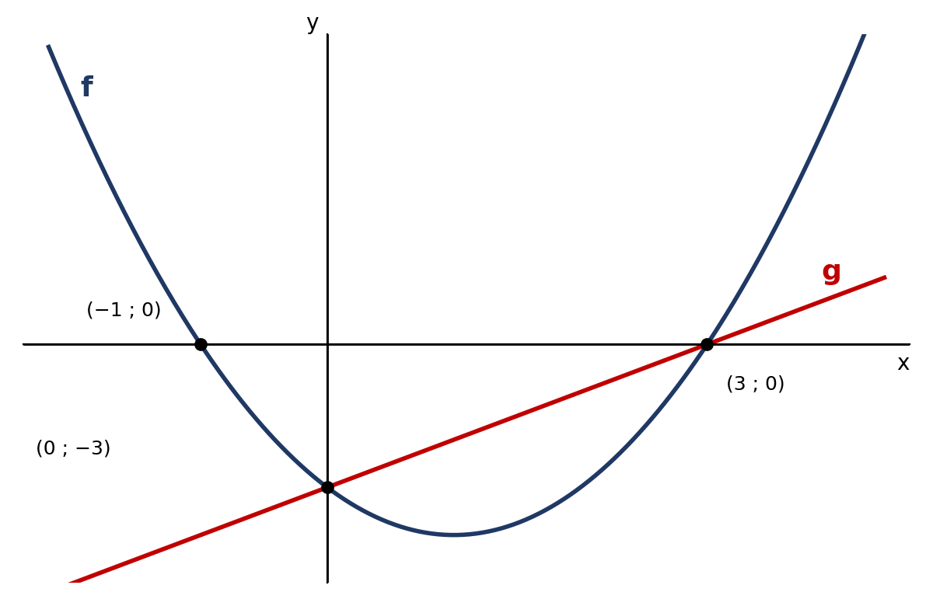
Diagram: graphs of f and g
3.1 | Calculate the x-coordinates of the points of intersection of f and g. | (2)
3.2 | Use the graphs to determine the values of x for which:
 | (a) f(x) > g(x) | (2)
 | (b) f(x) · g(x) < 0 | (2)

Question 4 Exponential function and transformations [8 marks]
 | Given: h(x) = 2 · 3ˣ + 4
4.1 | Explain why h does not have an x-intercept. | (2)
4.2 | Sketch the graph of h. Show the asymptote, the intercept with the y-axis and at least one other point on h. | (3)
Sketch:
4.3 | Describe the transformation from h to k if k(x) = 2(3⁻ˣ − 1). | (3)
TOTAL: 30 marks

