Visual Design for Greenfield Local Hub

Site map:
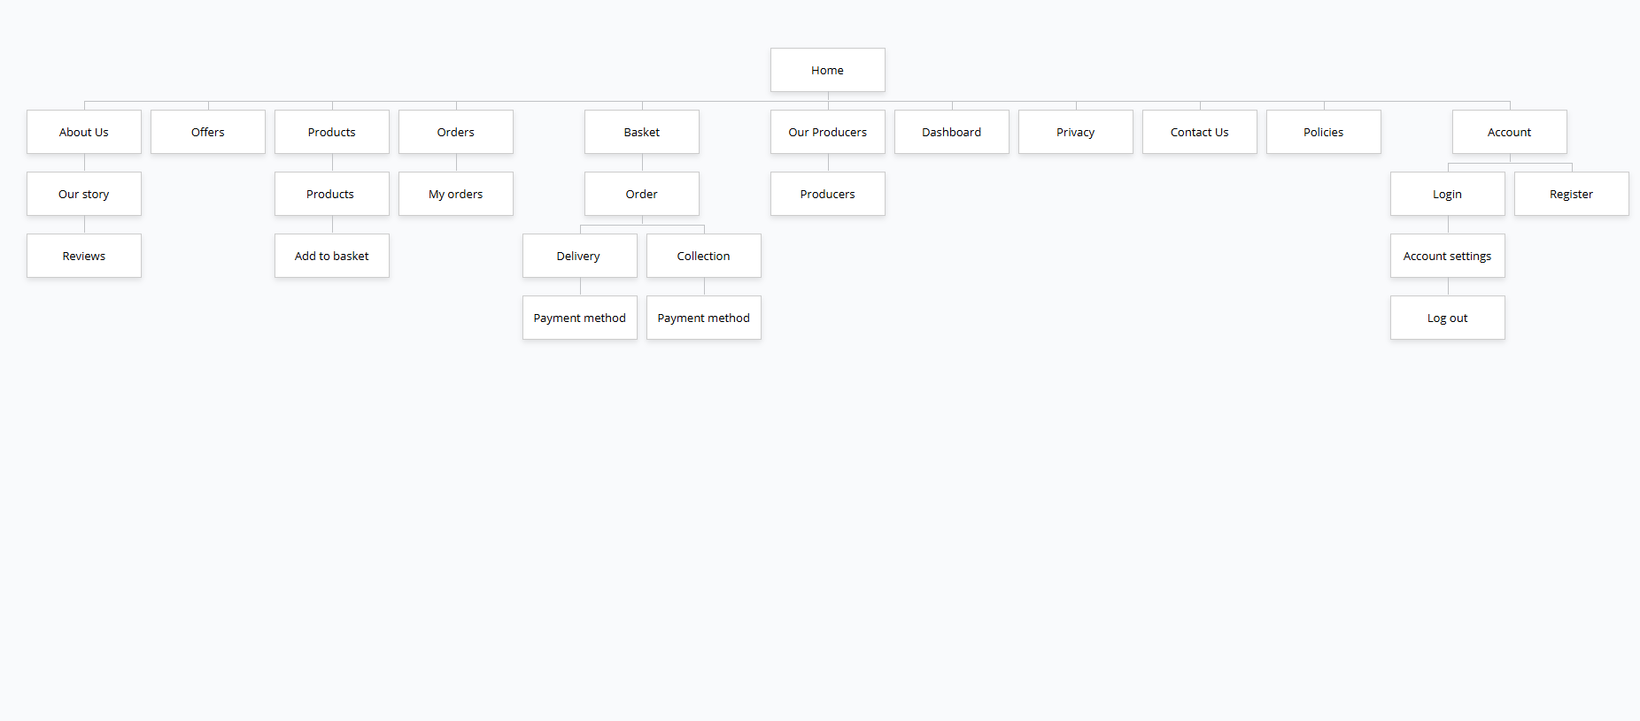
Home – The landing page for potential customers. It contains specified sections that tells the users what the website is about and where to go.
About us – It shows information for anyone who wants to learn more about the company.
Offers – It contains potential special offers and discounts for loyal customers.
Products – It contains products that are can be ordered through the website which are sold by multiple producers. Products can be filtered by the user’s preference. Through that, users are able to add products to their “basket”.
Orders – A transaction that is stored once a customer has ordered a product. So, the customer can see their past orders.
Basket – It allows potential customers to store selected products before ordering. It tracks the quantity of the products and calculates the total costs.
Delivery – It is an efficient way of delivering the product to the customer directly to their homes by using the post code provided.
Collection – It helps customers find what they are looking for quickly and easily. Allows the customer to collect the product themselves.
Payment method – It allows customers to pay for a product using their digital wallets, credit cards and debit cards.
Our Producers – It shows all producers that are selling the products on Greenfield Local Hub.
Dashboard – A page that strictly allows users with the role “Producer”. It displays all producers, pending orders with the products.
Privacy – Outlines how personal data is protected, how data is collected and how data is used.
Contact Us – Allows visitors or potential customers to contact the business.
Policies – Provides information about legality on the website to keep the business safe and the customers safe.
Account- Contains the user’s account on the website.
Login – Allows a user to login.
Register – Allows a user to register.
Account settings – Allows the user to manage their own personal account.
Log out – Allows a user to out.

Wire Frame:

Log in:
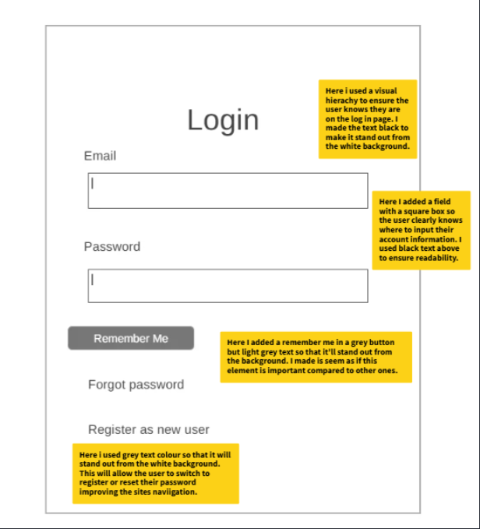

Register:
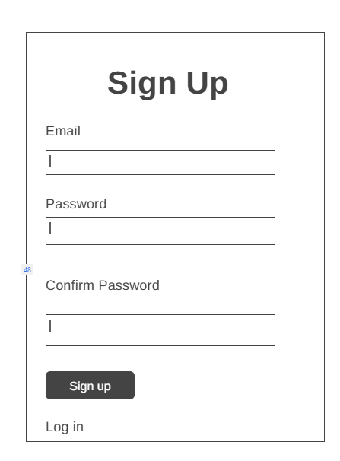

Home page: Navigation bar
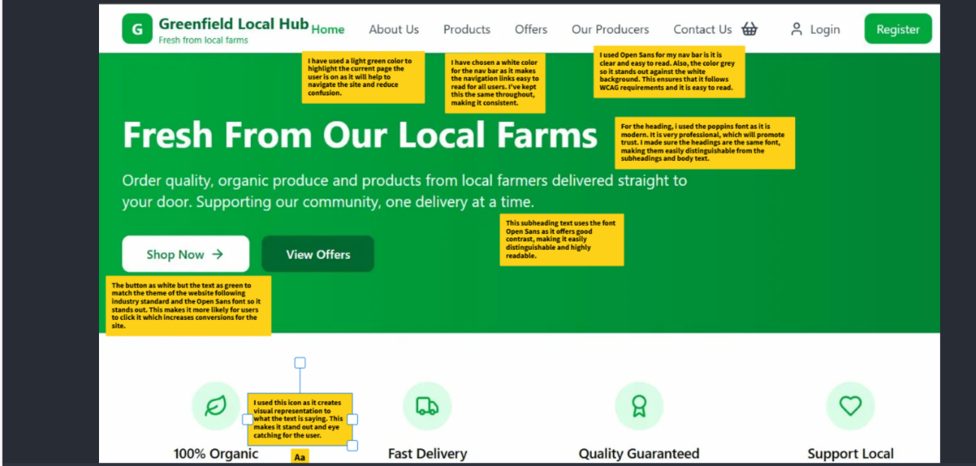

Home page:


Footer:
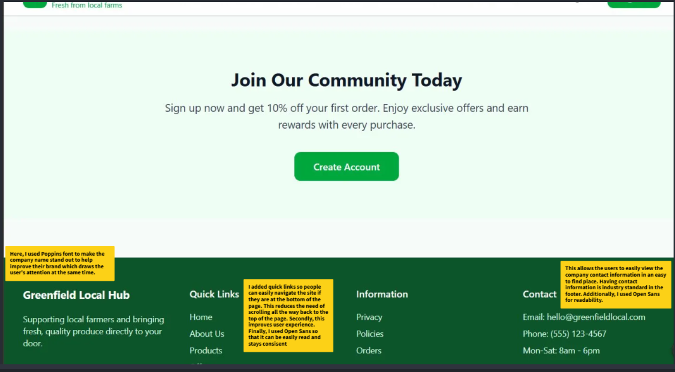

About Us:
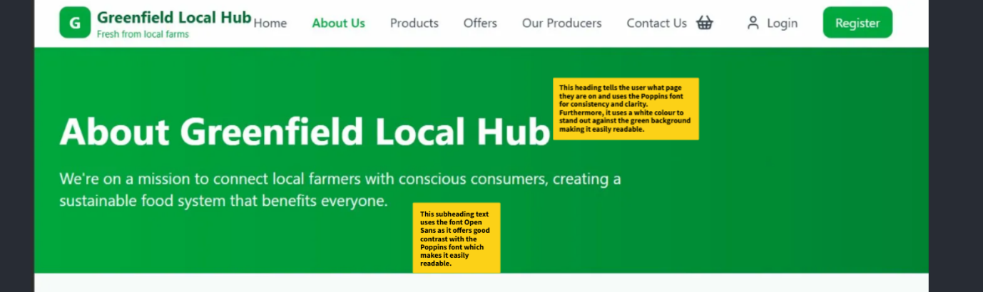

About us: Scrolled down
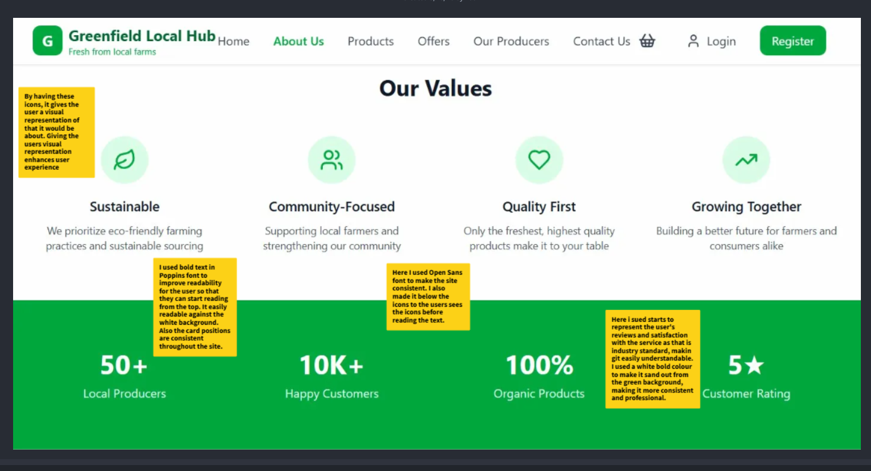

About Us: Footer:
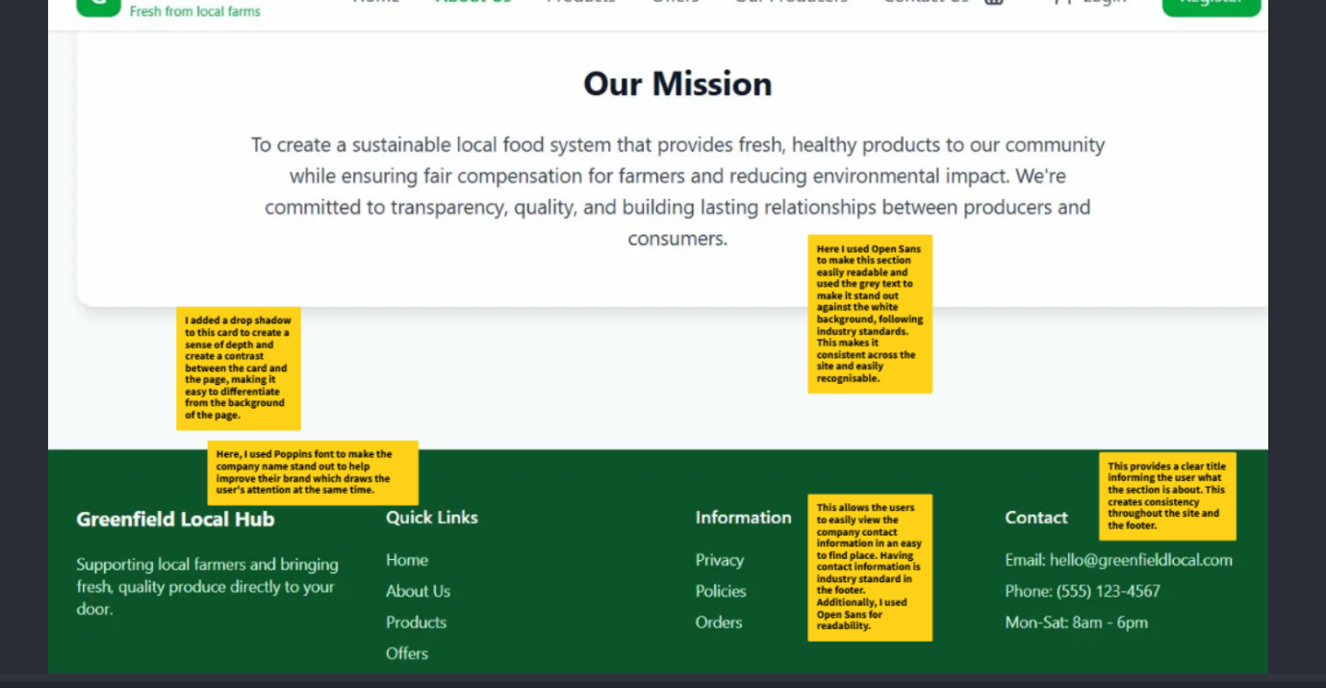

Products:
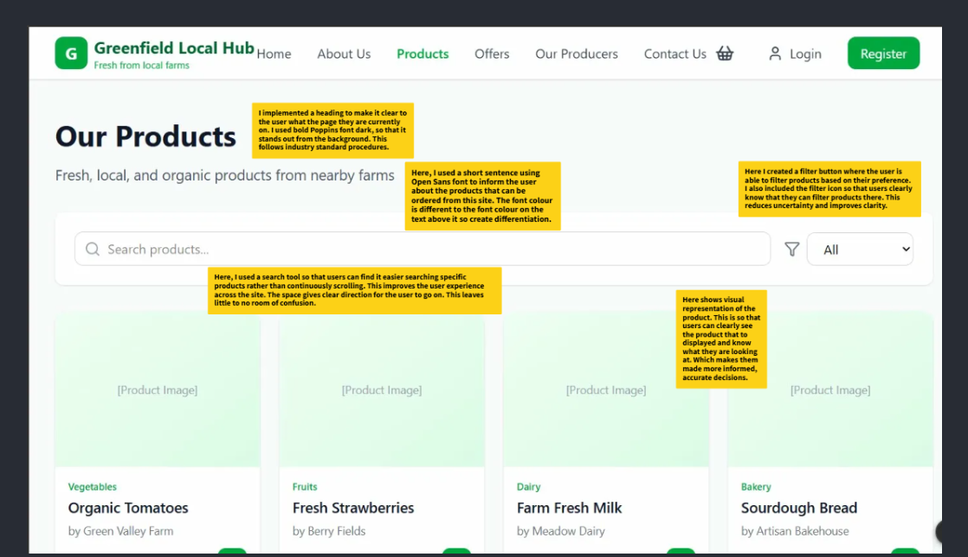

Product: Scrolled down product page:
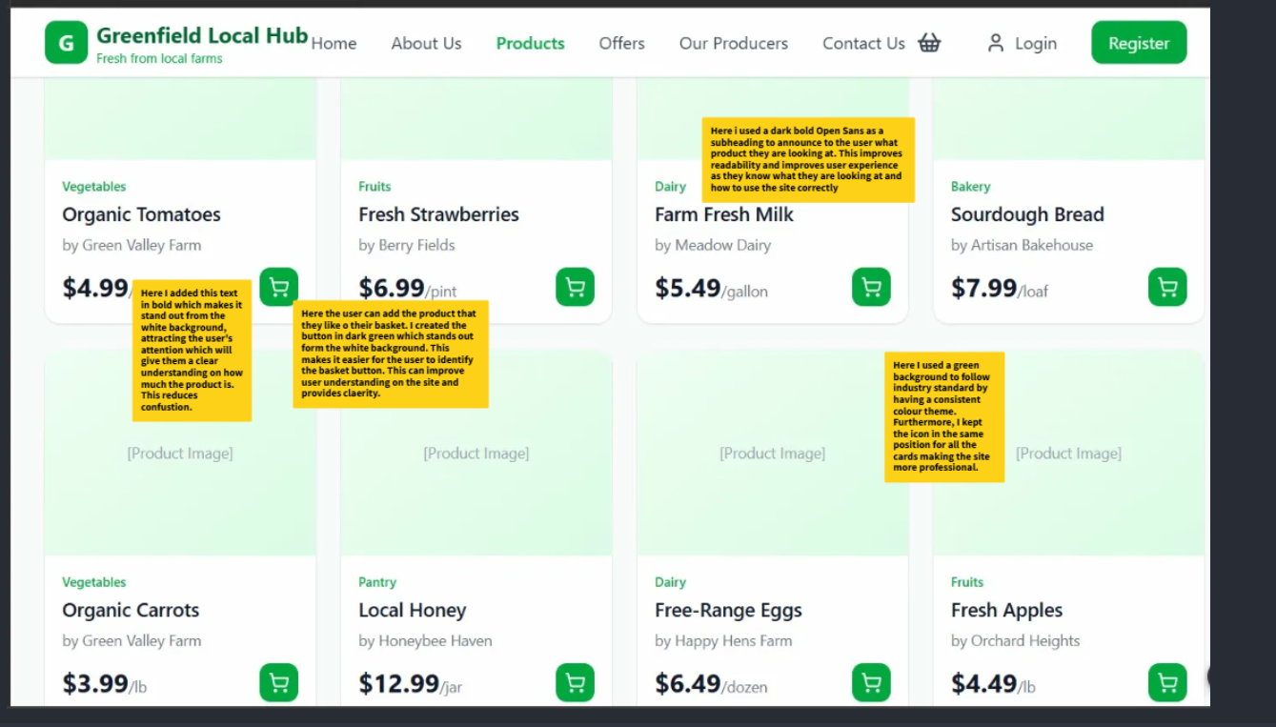

Product page footer:
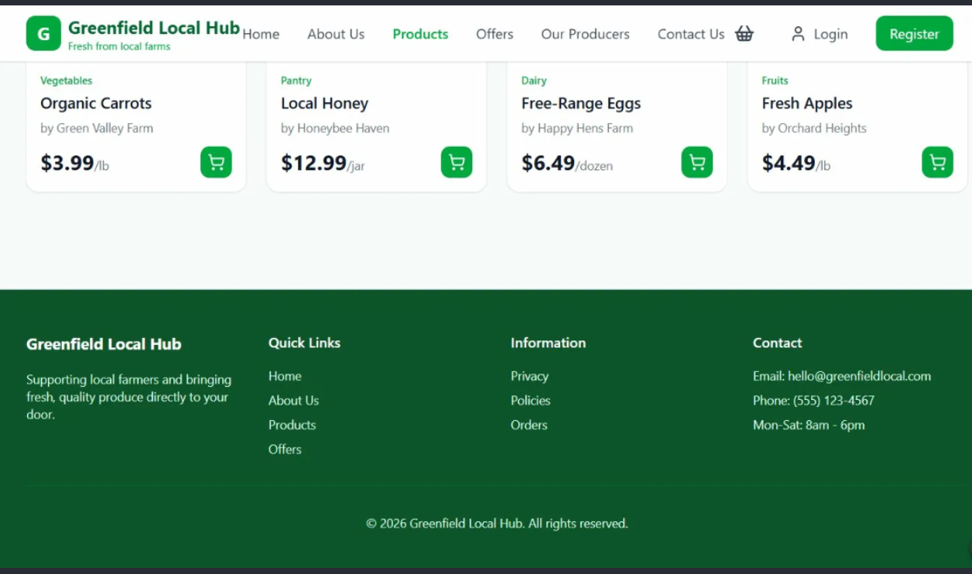

Rewards / Offers:
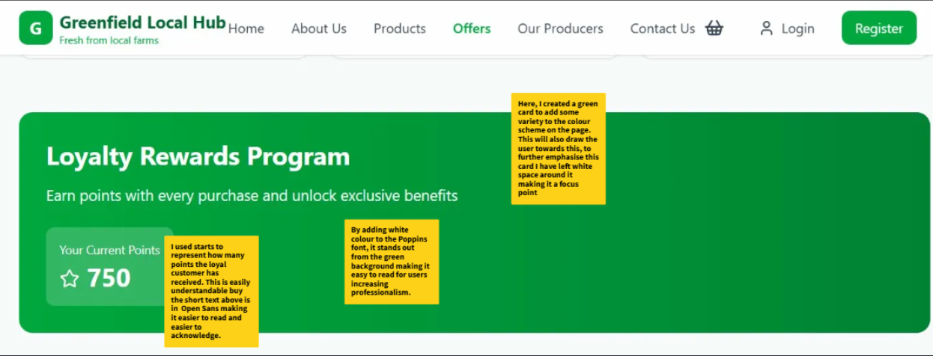

Our producers:
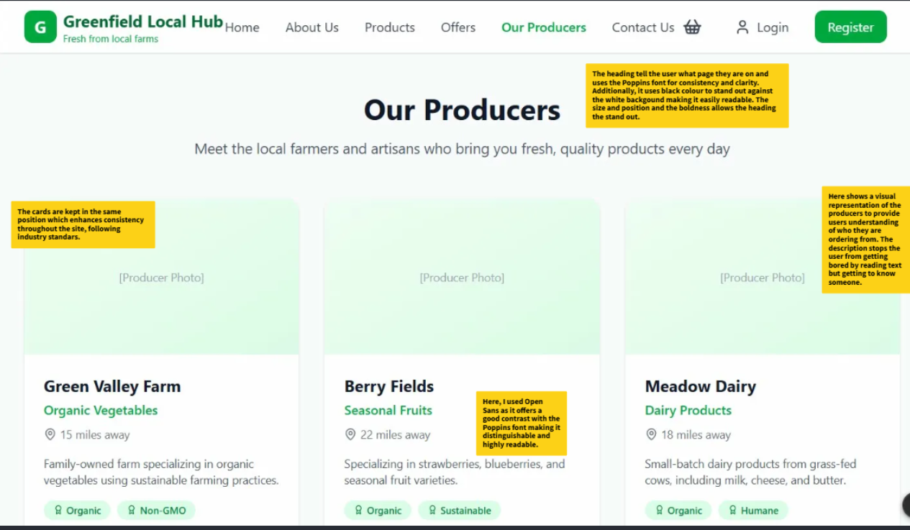

Flowcharts:

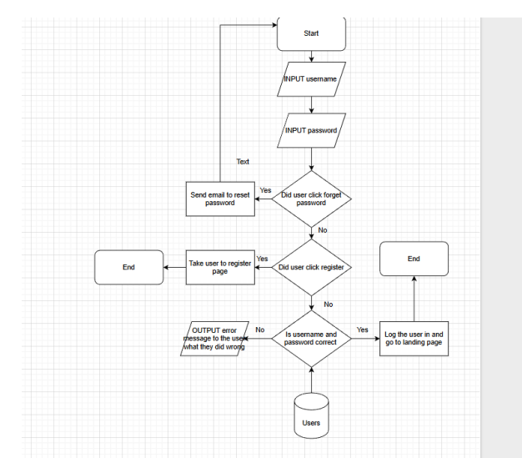
Log in:
The user will be prompted to enter their username and password. The system will then check if the user clicked other options like forgot password or register. If they did, it will take the appropriate actions like sending a reset email link or taking the user to the register page. If not, the system will check if the username and password match the ones in the database of not. It will send an error message telling the user what they did wrong. If its correct, the system will log the user in and redirects them to the landing page.

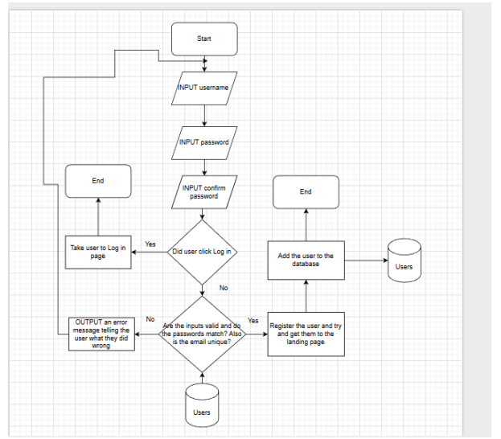
Register:
The user will be prompted to enter their username and password. The system will check if the user clicked their options like log in. If it did, it will send the user to the log in page, otherwise it checks if the user details are valid, if the passwords match and if the email isn’t already registered, if all this is correct and isn’t an existing email the system will register the user and send them to the landing page and add their details to the database.

Edit products:
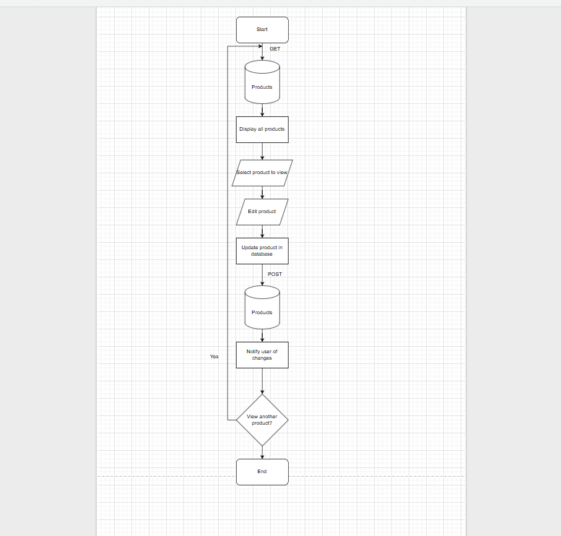

The producer will be able to go product database to be able to view all products. Then the producer can select a product then edit it or add new products. By doing so, new products will be displayed to the user and reduce any incorrect information prompted to the user.

Add products to basket:
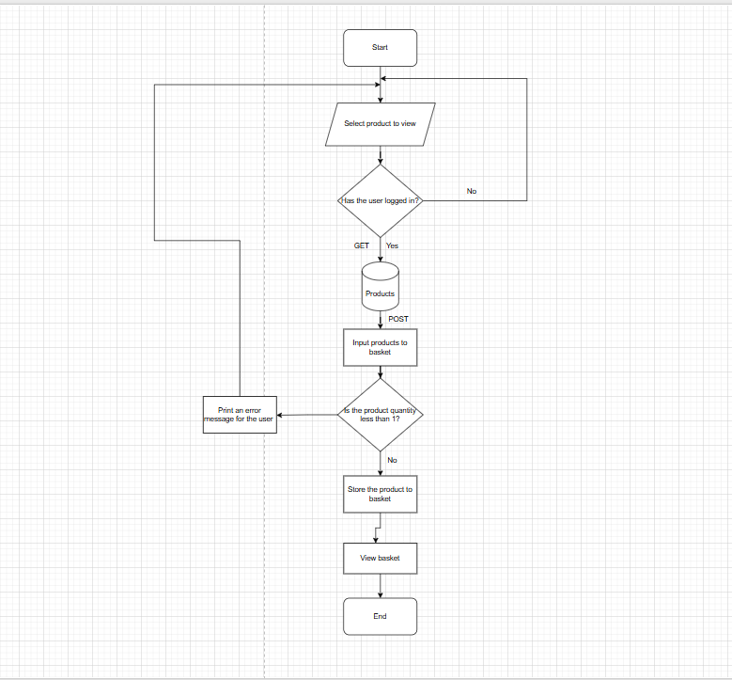
The user will be able to add product to their basket. The user will go to the products section then select a product that they would like. Through selecting that product, the user is able to add that product to their basket but the product cannot be less than 1. If so, then the system will the provide the user with an error message. This makes it easier for the user to know how to user the website. Also this clears any unclear information on how to add a product to basket.

Edit product availability:
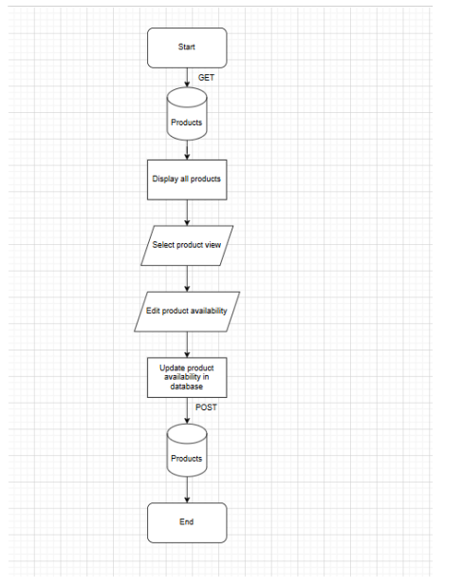

The producer will be able to go into the order database to be able to view all products. Then the producer can select the products then edit them. They can edit the product availability to ensure if the product is available or unavailable. Finally, the producer can update the changes to the products database to notify the user if the product is available or not.

Entity Relationship Diagram
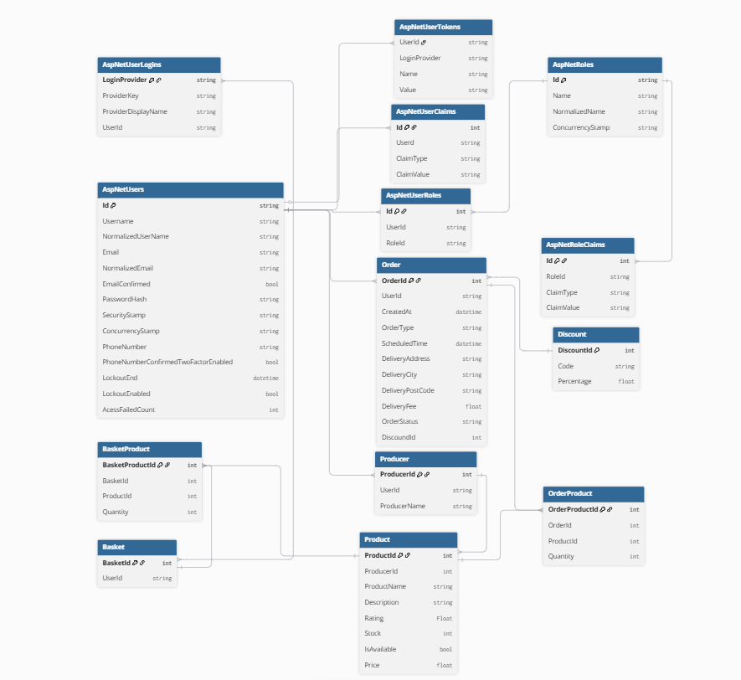

Data Dictionaries

AspNetUsers
Column | Data Type | Required | Default | Validation | Primary/  Foreign
Id | String | Yes |  |  | Primary
UserName | String | Yes
NormalisedUserName | String | Yes
Email | String | Yes |  | Must include a valid structure, must have a “@” symbol, must have a domain name, must be in the correct format.
NormalisedEmail | String | Yes
EmailConfirmed | Bool | Yes |  | User must confirm their email.
PasswordHash | String | Yes
SecurityStamp | String
ConcurrencyStamp | String
PhoneNumber | String
PhoneNumberConfirmed | Bool
TwoFactorEnabled | Bool
LookoutEnd | DateTime
LookoutEnabled | Bool
AccessFailedCount | Int

AspNetUserRoles
Column | Data Type | Required | Default | Validation | Primary/  Foreign
Id | Int | Yes |  |  | Primary
UserId | String | Yes | Users Id |  | Foreign
RoleId | String | Yes |  |  | Foreign

AspNetRoles
Column | Data Type | Required | Default | Validation | Primary/  Foreign
Id | String | Yes |  |  | Primary
Name | String | Yes
NormalisedName | String | Yes
ConcurrencyStamp | String | Yes

AspNetUserTokens
Column | Data Type | Required | Default | Validation | Primary/  Foreign
UserId | String | Yes |  |  | foreign
LoginProvider | String | Yes
Name | String | Yes
Value | String | No

AspNetUserRoleClaims
Column | Data Type | Required | Default | Validation | Primary/  Foreign
Id | Int | Yes |  |  | Primary
UserId | String | Yes |  |  | Foreign
ClaimType | String | No
ClaimName | String | No

AspNetUserClaims
Column | Data Type | Required | Default | Validation | Primary/  Foreign
Id | Int | Yes |  |  | Primary
RoleId | String | Yes |  |  | Foreign
ClaimType | String | No
ClaimValue | String | No

AspNetUserLogins
Column | Data Type | Required | Default | Validation | Primary/  Foreign
LoginProvider | String | Yes |  |  | Primary
ProviderKey | String | Yes
ProviderDisplayName | String | No
UserId | String | Yes |  |  | Foreign

Producer
Column | Data Type | Required | Default | Validation | Primary/  Foreign
ProducerId | Int | Yes |  |  | Primary
UserId | String | Yes |  |  | Foreign
ProducerName | string | Yes

Product
Column | Data Type | Required | Default | Validation | Primary/  Foreign
ProductId | Int | Yes |  |  | Primary
ProducerId | Int | Yes
ProductName | String | Yes
Description | String | Yes
Rating | Float | Yes
Stock | Int | Yes |  | No less than 0
IsAvailable | Bool | Yes
Price | Float | Yes |  | No less that 0 or equal to 0

Order
Column | Data Type | Required | Default | Validation | Primary/  Foreign
OrderId | Int | Yes |  |  | Primary
UserId | String | Yes
CreatedAt | DateTime | Yes
OrderType | String | Yes |  | User can only select “Delivery” or “Collection”
ScheduledTime | DateTime | Yes |  | Cannot be a date before the current date
DeliveryAddress | String | No |  | Only available if the OrderType == Delivery. A valid address is required.
DeliveryCity | String | No |  | Only available if the OrderType == Delivery.  A valid city is required.
DeliveryPostCode | String | No |  | Only available if the OrderType == Delivery.  A valid postcode is required.
DeliveryFee | Float | No |  | Only available if the OrderType == Delivery.
OrderStatus | String | No
DiscountId | Int | No |  |  | Foreign

OrderProduct
Column | Data Type | Required | Default | Validation | Primary/  Foreign
OrderProductId | Int | Yes |  |  | Primary
OderId | Int | Yes |  |  | Foreign
ProductId | Int | Yes |  |  | Foreign
Quantity | Int | Yes |  | No less than 1 and cannot be more than what it in stock

Discount
Column | Data Type | Required | Default | Validation | Primary/  Foreign
DiscountId | Int | Yes |  |  | Primary
Code | String | Yes
Percentage | Float | Yes

Basket
Column | Data Type | Required | Default | Validation | Primary/  Foreign
BasketId | Int | Yes |  |  | Primary
UserId | String | Yes |  |  | Foreign

BasketProduct
Column | Data Type | Required | Default | Validation | Primary/  Foreign
BasketProductId | Int | Yes |  |  | Primary
BasketId | Int | Yes |  |  | Foreign
ProductId | Int | Yes |  |  | Foreign
Quantity | Int | Yes |  | No less than 1

