Privacy-Preserving Analytics on Sensitive Government Data
Team Cyberleek
Hassan Mousa | 24000292
Sana Mathbut | 24000985
Leen Albadda | 24001293
Khalid Albadda | 24000542

Project Objective:
UAE health authorities need cross-hospital data to analyse diabetes, hypertension, and 30-day readmission rates. However, the UAE Personal Data Protection Law (PDPL, Federal Decree-Law No. 45 of 2021) and the Health ICT Law (Federal Law No. 2 of 2019) restrict the sharing of raw patient records. This shows how “Differential Privacy” (DP) and “Federated Learning” (FL) can both provide useful analytics without having to share raw patient data. The intended users are MOHAP and the emirate health authorities, who could use this instead of pooling patient records centrally or relying on data-sharing agreements for every analysis. This combination is practical now in a way it was not a few years ago, since standard privacy-accounting methods (such as zCDP composition) and production federated-learning tooling have matured enough to deploy rather than remain research prototypes.
This was tested using 15,000 synthetic EHR records from three different hospitals in Abu Dhabi (8,000), Dubai (5,000), and Ras Al Khaimah (2,000). The dataset passed 42/42 validation checks.

Proposed Solution:
Approach 1: Differential Privacy (DP): DP is used to protect patient information when calculating population statistics. Noise is added to the results while keeping the data useful. Also, a privacy budget is used to govern the amount of access to information.
Approach 2: Federated Learning (FL): FL is employed to train a 30-day readmission risk model across the hospitals. The hospitals only share model updates, not their raw patient records. DP-FedAvg also adds noise to these updates to provide additional privacy.
What is new here is not either technique alone but running both against the same three-hospital population with two separately-tuned privacy budgets, and backing the epsilon choice with a live membership-inference and differencing attack rather than trusting the theoretical guarantee alone.
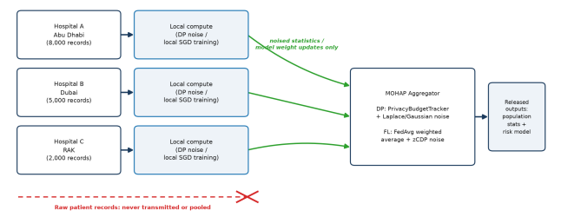
Figure 1: Each hospital processes its data locally. Only noised statistics or model updates reach the MOHAP aggregator. Raw patient records never cross hospital boundaries.

Solution Validation:

Dataset and System Validation
The synthetic dataset passed 42/42 validation checks, covering ranges, correlations, missingness, and internal consistency.
The privacy system passed 11/11 tests, including Laplace/Gaussian correctness, privacy budget composition, exhaustion protection, and zCDP composition.

Results:

Differential Privacy Results
At ε = 1.0
Query | True Value | DP Estimate | Absolute Error | True Value in 95% CI
National Diabetes Prevalence | 26.63% | 26.66% | 0.026% | Yes
National Hypertension Prevalence | 31.82% | 31.75% | 0.074% | Yes
National 30-Day Readmission Rate | 19.11% | 19.25% | 0.134% | No
Mean HbA1c, Diabetic | 7.80 | 7.80 | 0.003 | Yes
The total privacy budget of ε = 1.0 was shared between 14 different queries using two different methods.

Readmission Model
The 30-day readmission model produced the following results:
Metric | Centralized | Federated (FedAvg) | DP-FedAvg (ε = 2.0)
Accuracy | 0.6120 | 0.5887 | 0.4213
ROC-AUC | 0.6256 | 0.6393 | 0.4809
Precision | 0.2634 | 0.2700 | 0.1901
Recall | 0.5742 | 0.6303 | 0.5882
F1 | 0.3611 | 0.3780 | 0.2874
FedAvg achieved ROC-AUC 0.6393 compared with 0.6256 for the centralized model, while moving zero raw patient records. Adding DP reduced ROC-AUC to 0.4809 at ε = 2.0. The gap between FedAvg and the centralized model is small and should not be read as FedAvg being better than centralized training. At ε = 2.0, DP-FedAvg performs at roughly random-guessing level, so at this dataset size it does not produce a useful model; this is why its utility target in the Recommendations is much higher.

Privacy Attack Demonstration
Two real attacks were tested: Membership Inference (MIA) and Differencing/Reconstruction.
Attack | Target | AUC | Advantage | Result
Membership Inference | Naive unregularized decision tree | 0.6493 | 0.2987 | Vulnerable
Membership Inference | Naive centralized regularized LR | 0.5082 | 0.0164 | Strongly Protected
Membership Inference | Standard FedAvg | 0.5009 | 0.0018 | Strongly Protected
Membership Inference | DP-FedAvg | 0.4942 | 0.0000 | Strongly Protected
Differencing Attack | Naive aggregate counts | 1.0000 | 1.0000 | Leaked
Differencing Attack | DP analytics | 0.5243 | 0.0486 | Strongly Protected
The naive unregularized decision tree was the most vulnerable model, with a membership inference advantage of 0.2987. The logistic regression models were already hard to attack (0.0164 for the naive centralized version), and DP-FedAvg brought the advantage down to 0.0000, which is equivalent to chance. Because the decision tree and the logistic regression models are different, this is not a strict before-and-after comparison of the same model.
The differencing attack achieved an advantage of 1.00 against naive aggregate counts. Under DP with ε = 0.2 per query, the advantage fell to 0.049, a 95% reduction.

Privacy-Utility Trade-Off
The privacy attack advantage decreased as ε decreased:
ε | Attack Advantage
1.0 | 0.323
0.5 | 0.155
0.2 | 0.058
0.1 | 0.036
0.05 | 0.020
0.02 | 0.013
Each point was calculated using 10 trials for the attack sweep and 20 independent noise trials per ε for the privacy-utility analysis.
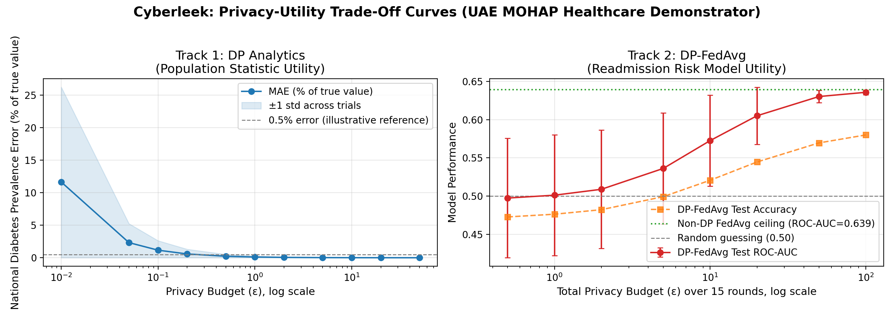
Figure 2: The privacy-utility curves show that the two tracks have different optimal privacy budgets and should therefore be budgeted separately.

Recommendations:
Deployment | Utility Target ε | Reason
DP Analytics — Population Statistics | 5.0 | Mean national diabetes-prevalence error falls below 0.03% of the true value
DP-FedAvg — Readmission Model | 20.0 | Mean test ROC-AUC comes within 0.05 of the non-DP ceiling
The values in this table are the budgets at which each track reaches its utility target, not the recommended defaults. The report recommends ε = 1.0 for routine DP population health reporting because it provides strong formal privacy with good utility, and the errors at ε = 1.0 are already below 0.14%. DP-FedAvg should be treated separately and should use additional defenses such as secure aggregation and rate limiting.

Meaning of ε
ε | Worst-Case Odds Bound e^{ε} | Use
1 | 2.7× | DP analytics
2 | 7.4× | DP-FedAvg validation
5 | 148.4× | DP analytics utility target
20 | ~485 million× | DP-FedAvg utility target
At ε = 20, the formal privacy bound is weak despite the tested attacks failing. Therefore, additional security measures are required.

Conclusion:
Overall, this project shows that hospital data can be used while still keeping patient information private. Differential Privacy gave us population statistics with very small errors. Federated Learning also performed well, with a ROC-AUC of 0.6393 compared to 0.6256 for the model trained using all the data, without sharing raw patient data. The security tests also showed that these methods can reduce the risks of attacks. For example, the difference in the attack successfully extracted accurate information from normal data, but the performance dropped drastically when Differential Privacy was implemented. These findings suggest that DP analytics at ε = 1.0 is suitable for continues population health reporting. DP-FedAvg should be taken with more caution since the additional privacy can decrease model performance and may necessitate further safety precautions.

Limitations:
The project has a number of limitations. First, the data used was synthetic, so it was not based on real patient records. Second, the membership inference attack was done with a simple method, thus an advanced attack could produce different results. Also, the Federated Learning model used logistic regression, so the results might be different for more complex models. Finally, DP-FedAvg performed well against the two attacks tested for ε = 20, but it does not have the same level of formal privacy as ε = 1. In addition, the attacks failing against DP-FedAvg at ε = 2.0 is partly because that model learned very little.

