**Supplementary Data**

All the Accuracy curves have their x-axis corresponding to the Training Dataset

size and the y-axis corresponding to the accuracy.

An epoch is the number of times the machine learning mode is passed on the trainning dataset during the learning process.

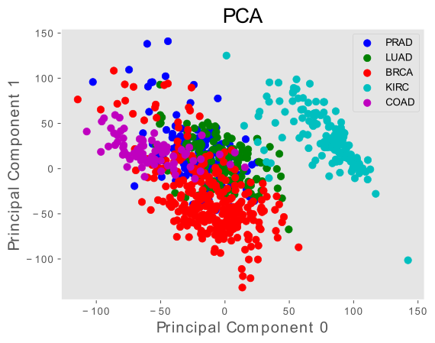

*Figure 1: PCA Dimension Reduction Technique applied on the Dataset with the First and Second Components*

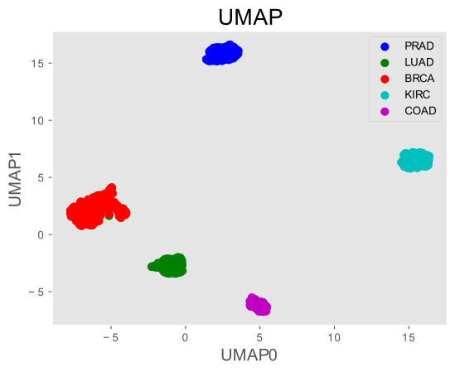

*Figure 2: UMAP Dimension Reduction Technique applied on the Dataset*

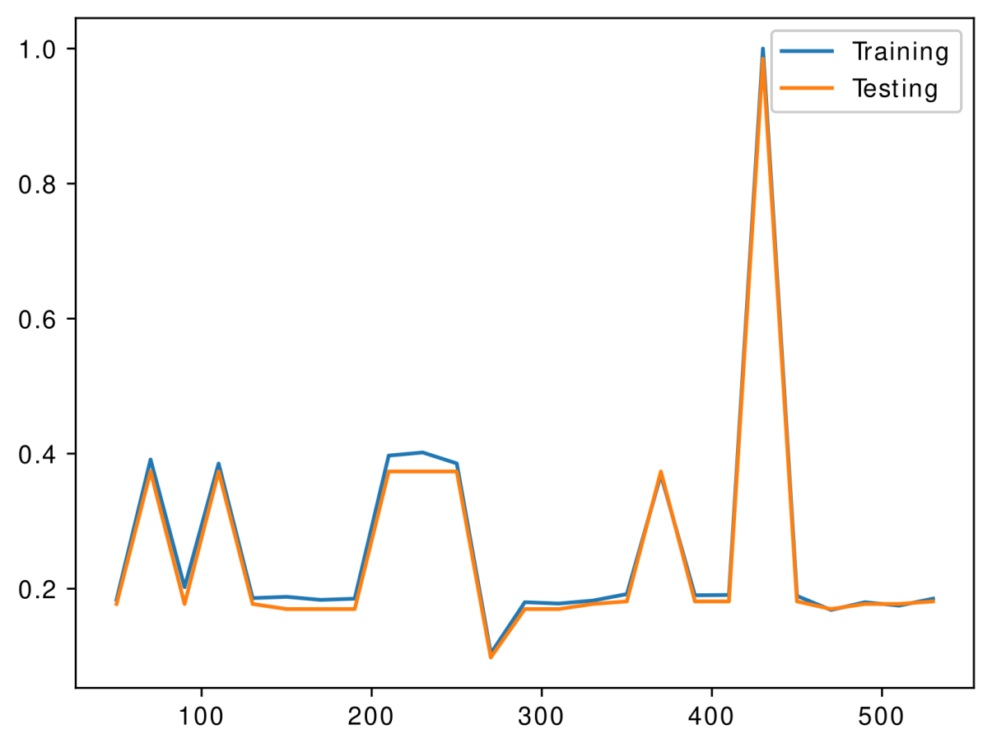

*Figure 3: Accuracy Curve for the 4th Neural Network Configuration at the 20th epoch*

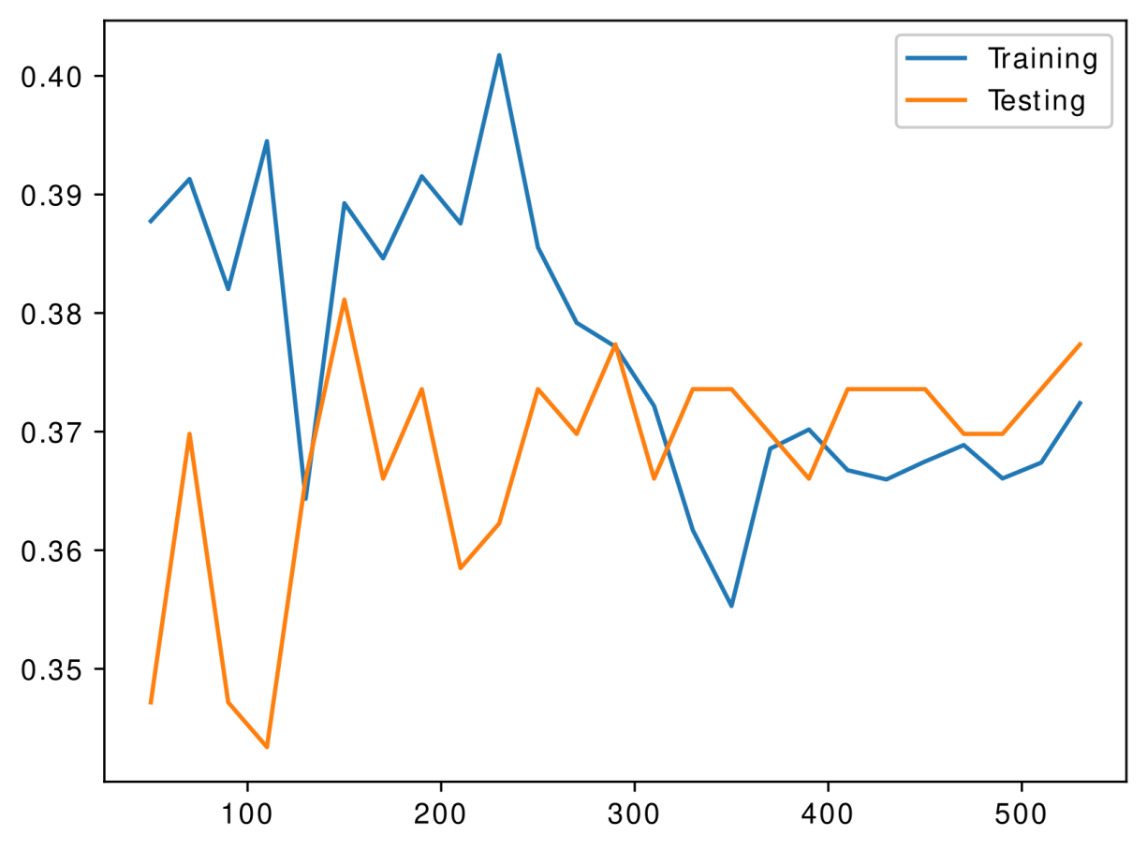

*Figure 4: Accuracy Curve for the 6th Neural Network Configuration at the 20th epoch*

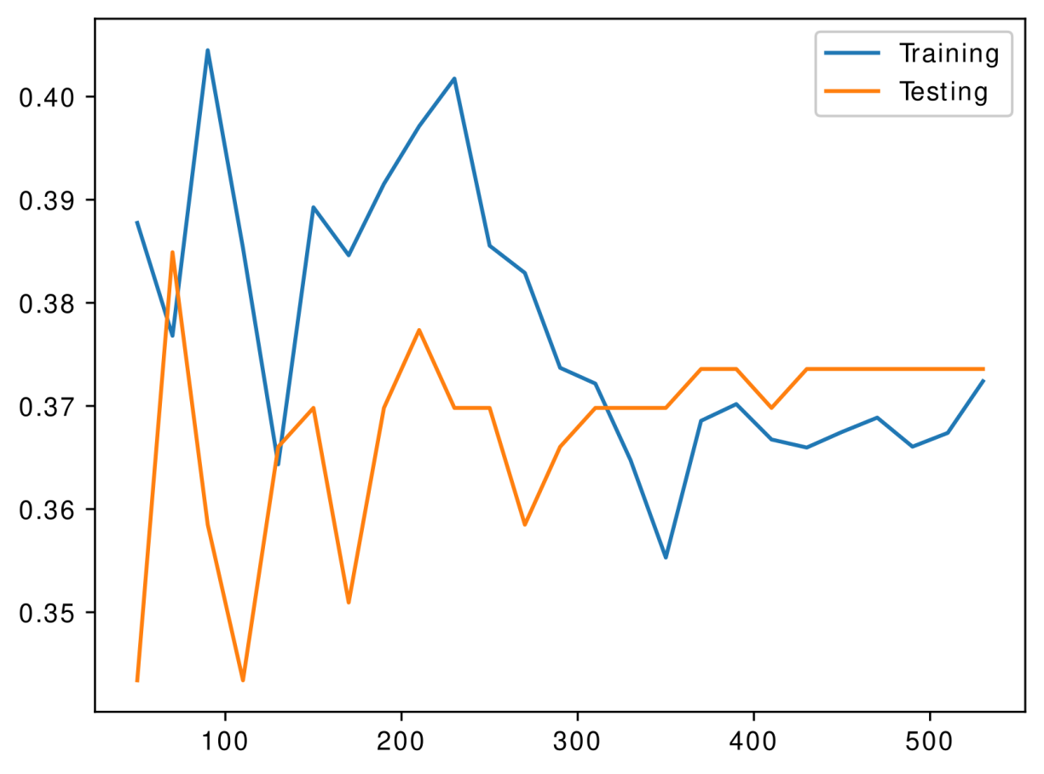

*Figure 5: Accuracy Curve for the 5th Neural Network Configuration at the 20th epoch*

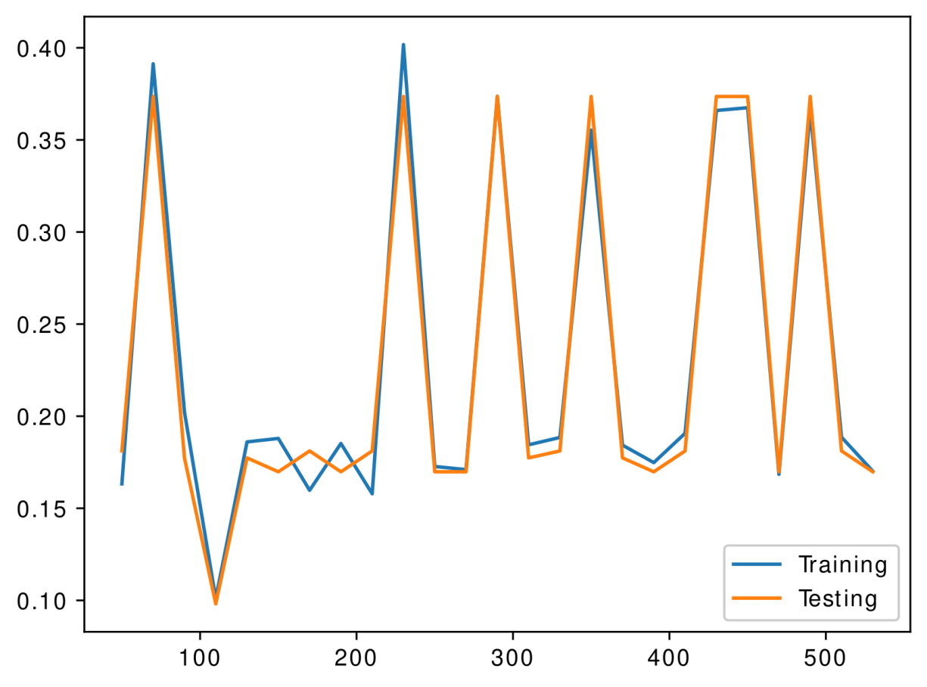

*Figure 6: Accuracy Curve for the 4th Neural Network Configuration at the 50th epoch*

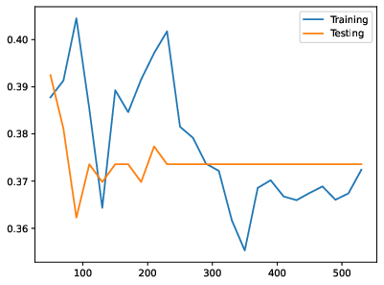

*Figure 7: Accuracy Curve for the 6th Neural Network Configuration at the 50th epoch*

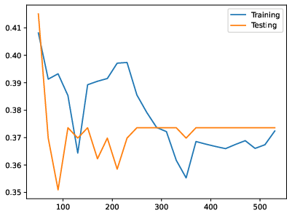

*Figure 8: Accuracy Curve for the 5th Neural Network Configuration at the 50th epoch*

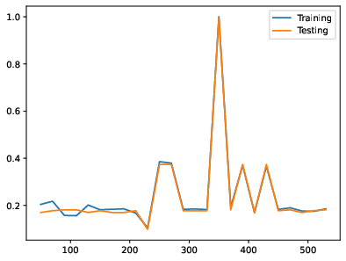

*Figure 9: Accuracy Curve for the 4th Neural Network Configuration at the 100th epoch*

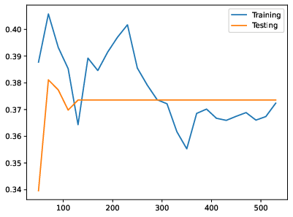

*Figure 10: Accuracy Curve for the 6th Neural Network Configuration at the 100th epoch*

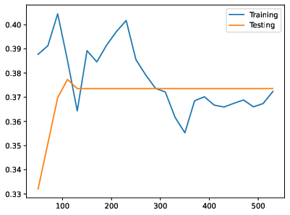

*Figure 11: Accuracy Curve for the 5th Neural Network Configuration at the 100th epoch*

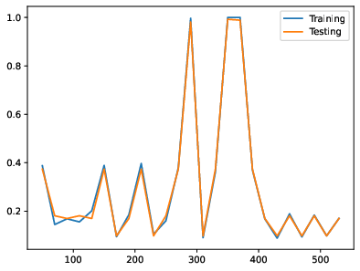

*Figure 12: Accuracy Curve for the 1st Neural Network Configuration at the 20th epoch*

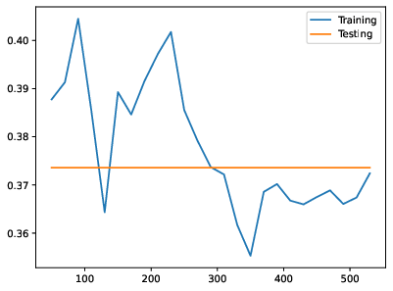

*Figure 13: Accuracy Curve for the 3rd Neural Network Configuration at the 20th epoch*

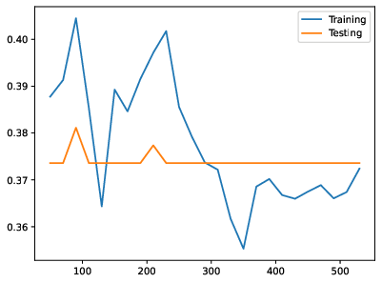

*Figure 14: Accuracy Curve for the 2nd Neural Network Configuration at the 20th epoch*

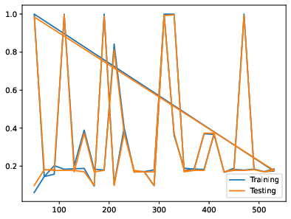

*Figure 15: Accuracy Curve for the 1st Neural Network Configuration at the 50th epoch*

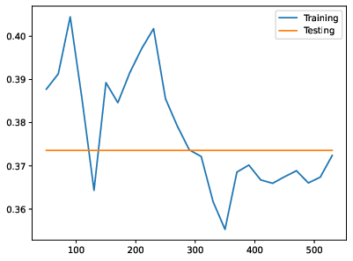

*Figure 16: Accuracy Curve for the 3rd Neural Network Configuration at the 50th epoch*

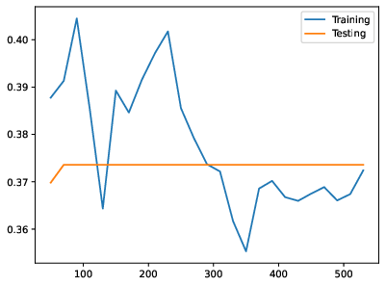

*Figure 17: Accuracy Curve for the 2nd Neural Network Configuration at the 50th epoch*

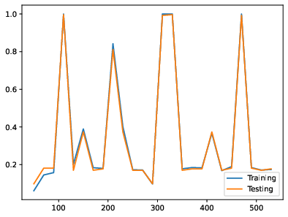

*Figure 18: Accuracy Curve for the 1st Neural Network Configuration at the 100th epoch*

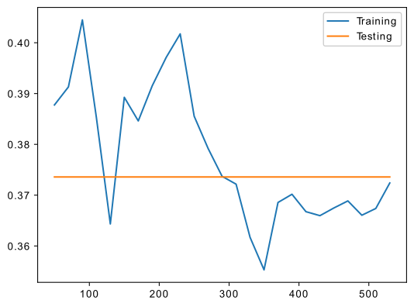

*Figure 19: Accuracy Curve for the 3rd Neural Network Configuration at the 100th epoch*



*Figure 20: Accuracy Curve for the 2nd Neural Network Configuration at the 100th epoch*

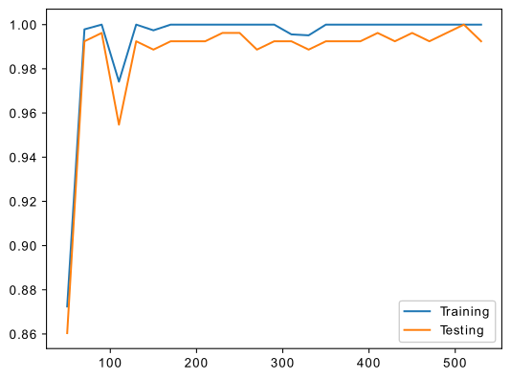

*Figure 21: Accuracy Curve for the 7th Neural Network Configuration at the 100th epoch*

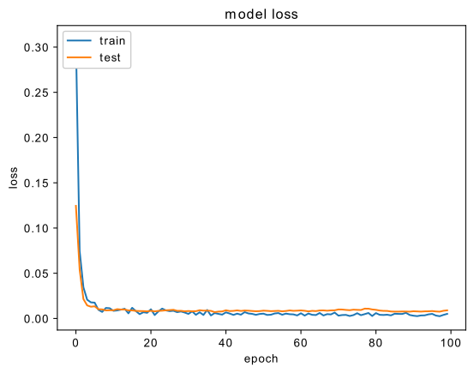

*Figure 22: Loss Curve for the 7th Neural Network Configuration*

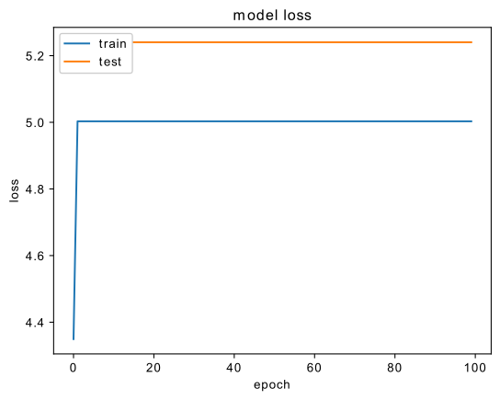

*Figure 23: Loss Curve for the 1st Neural Network Configuration*

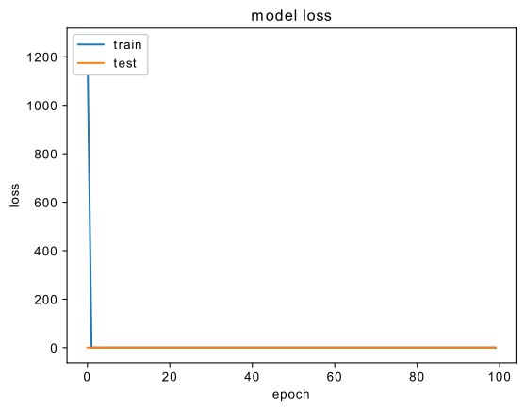

*Figure 24: Loss Curve for the 3rd Neural Network Configuration*

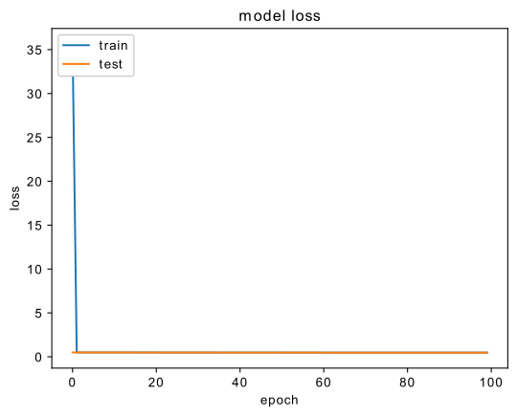

*Figure 25: Loss Curve for the 2nd Neural Network Configuration*

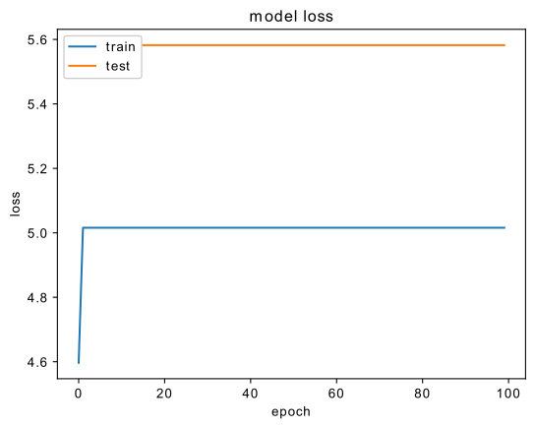

*Figure 26: Loss Curve for the 4th Neural Network Configuration*

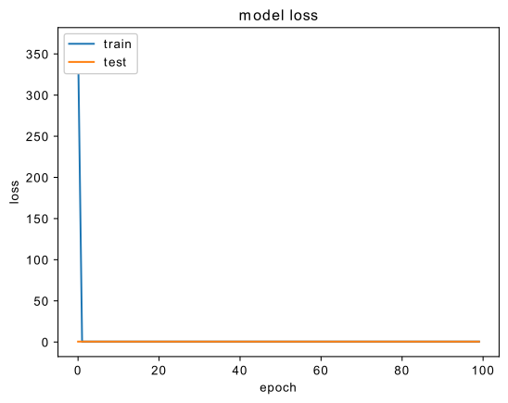

*Figure 27: Loss Curve for the 3rd Neural Network Configuration*

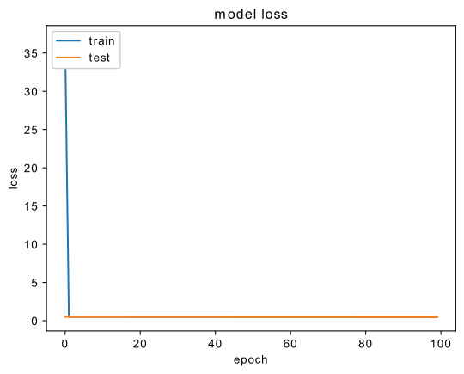

*Figure 28: Loss Curve for the 5th Neural Network Configuration*