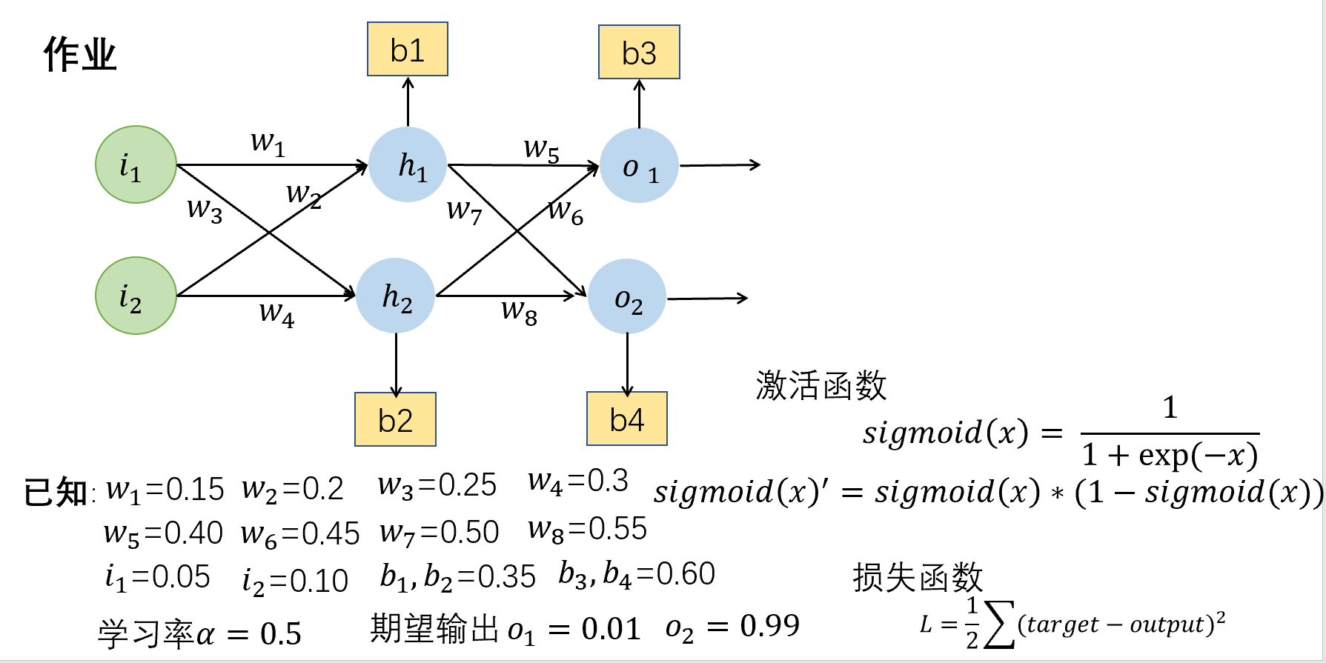

**求：**



**解：**

1. **正向传播**

**输入层🡪隐藏层**

1）神经元 $h_{1}$ 的输入加权和

${net}_{h_{1}}=w_{1}∗i_{1}+w_{2}∗i_{2}+b1$ =0.15*0.05+0.2*0.10+0.35=0.3775

2）神经元 $h_{1}$ 的输出

${out}_{h_{1}}=\frac{1}{1+\exp^{(−{net}_{h_{1}})}}$ =0.59326999

同理神经元 $h_{2}$ 的输出

${net}_{h_{2}}=w_{3}∗i_{1}+w_{4}∗i_{2}+b2$ =0.25*0.05+0.3*0.10+0.35=0.3925

${out}_{h_{2}}=\frac{1}{1+\exp^{(−{net}_{h_{2}})}}$ =0.59688438

**隐藏层->输出层**

计算神经元 $o_{1}$ 的输出

$${net}_{o_{1}}=w_{5}∗{out}_{h_{1}}+w_{6}∗{out}_{h_{2}}+b3$$

=0.40*0.59326999+0.45*0.59688438+0.60

=1.105905967 ${out}_{o_{1}}=\frac{1}{1+\exp^{(−{net}_{o_{1}})}}$*=*0.75136507

计算神经元 $o_{2}$ 的输出

${net}_{o_{2}}=w_{7}∗{out}_{h_{1}}+w_{8}∗{out}_{h_{2}}+b$ 4

=0.50*0.59326999+0.55*0.59688438+0.60

=1.2249214039999998 ${ out}_{o_{2}}=\frac{1}{1+\exp^{(−{net}_{o_{2}})}}$*=*0.77292847

输出值[0.75136507，0.77292847] 真实值[0.01,0.99]

**二 计算总误差**

$Loss= \frac{1}{2}\sum{{\left(target−output\right)}^{2}= }$ 0.2983711080763229

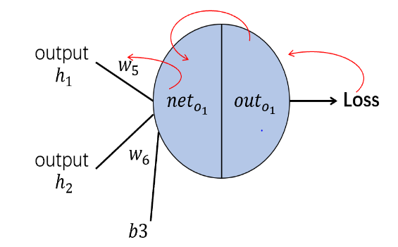**三 反向传播**

1) $\frac{∂Loss}{∂w_{5}}=\frac{∂Loss}{∂{out}_{o_{1}}} \frac{∂{out}_{o_{1}}}{∂{net}_{o_{1}}} \frac{∂{net}_{o_{1}}}{∂w_{5}}$

$\frac{∂Loss}{∂{out}_{o_{1}}}= −\left(target−output\right)$ =0.74136507

$\frac{∂{out}_{o_{1}}}{∂{net}_{o_{1}}}=$*Sigmod（${net}_{o_{1}}$）*（1-Sigmod（${net}_{o_{1}}$））=*0.186815602

$\frac{∂{net}_{o_{1}}}{∂w_{5}}= {out}_{h_{1}}$ =0.59326999

$\frac{∂Loss}{∂w_{5}}=\frac{∂Loss}{∂{out}_{o_{1}}} \frac{∂{out}_{o_{1}}}{∂{net}_{o_{1}}} \frac{∂{net}_{o_{1}}}{∂w_{5}}$ =0.74136507*0.186815602*0.59326999

=0.08216704040603146

更新后 $w_{5}$ 等于

$w_{5}^{'}$**= $w_{5}−α∗\frac{∂Loss}{∂w_{5}}$** =0.4-0.5*0.08216704040603146=0.35891647979698427

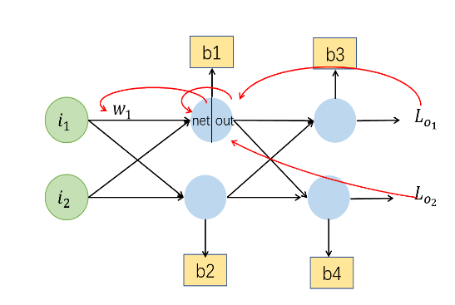**2) $\frac{∂Loss}{∂w_{1}}=\frac{∂Loss}{∂{out}_{h_{1}}}∗ \frac{∂{out}_{h_{1}}}{∂{net}_{h_{1}}}∗\frac{∂{net}_{h_{1}}}{∂w_{1}}$**

$\frac{∂Loss}{∂{out}_{h_{1}}}= \frac{∂L_{o_{1}}}{∂{out}_{h_{1}}}+\frac{∂L_{o_{2}}}{∂{out}_{h_{1}}}$

$$\frac{∂L_{o_{1}}}{∂{out}_{h_{1}}}= \frac{∂L_{o_{1}}}{∂{net}_{o_{1}}} \frac{∂{net}_{o_{1}}}{∂{out}_{h_{1}}}$$

$$=\frac{∂L_{o_{1}}}{∂{out}_{o_{1}}}\frac{∂{out}_{o_{1}}}{∂{net}_{o_{1}}} \frac{∂{net}_{o_{1}}}{∂{out}_{h_{1}}}$$

= $−\left(target−output\right)$ ${ Sigmod（{net}_{o_{1}}）∗（1−Sigmod（{net}_{o_{1}}））∗w}_{5}$*\**

=-(0.01-0.75136507)*0.1868156*0.40

=0.05539942414843679

$$\frac{∂L_{o_{2}}}{∂{out}_{h_{1}}}= \frac{∂L_{o_{2}}}{∂{net}_{o_{2}}} \frac{∂{net}_{o_{2}}}{∂{out}_{h_{1}}}$$

$=\frac{∂L_{o_{2}}}{∂{out}_{o_{2}}}\frac{∂{out}_{o_{2}}}{∂{net}_{o_{2}}} \frac{∂{net}_{o_{2}}}{∂{out}_{h_{1}}}$

= $−\left(target−output\right)$ ${ Sigmod（{net}_{o_{2}}）∗（1−Sigmod（{net}_{o_{2}}））∗w}_{7}$*\**

=-(0.99-0.77292847)*0.17551005*0.50

=-0.019049117541938252

$\frac{∂Loss}{∂{out}_{h_{1}}}= \frac{∂L_{o_{1}}}{∂{out}_{h_{1}}}+\frac{∂L_{o_{2}}}{∂{out}_{h_{1}}}$ = 0.05539942414843679-0.019049117541938252

= 0.036350306606498545

$\frac{∂{out}_{h_{1}}}{∂{net}_{h_{1}}}$ = *Sigmod（${net}_{h_{1}}$）*（1-Sigmod（${net}_{h_{1}}$））=*0.24130071

$\frac{∂{net}_{h_{1}}}{∂w_{1}}=$ 0.05

$\frac{∂Loss}{∂w_{1}} =\frac{∂Loss}{∂{out}_{h_{1}}}∗ \frac{∂{out}_{h_{1}}}{∂{net}_{h_{1}}}∗\frac{∂{net}_{h_{1}}}{∂w_{1}}$

=0.036350306606498545*0.241300709*0.05

=0.00043856773782577417

更新后 $w_{1}$ 等于

$w_{1}^{'}$**= $w_{1}−α∗\frac{∂Loss}{∂w_{1}}$ =** 0.15-0.5*0.00043856773782577417

=0.1497807161310871