Class.txt

A class is a template for an object, and an object is an instance of a class.

A class creates a new data type that can be used to create objects.

When you declare an object of a class, you are creating an instance of that class.

Thus, a class is a logical construct. An object has physical reality. (That is, an object occupies space in memory.)

Objects are characterized by three essential properties: state, identity, and behavior.

The state of an object is a value from its data type. The identity of an object distinguishes one object from another.

It is useful to think of an object’s identity as the place where its value is stored in memory.

The behavior of an object is the effect of data-type operations.

The dot operator links the name of the object with the name of an instance variable.

Although commonly referred to as the dot operator, the formal specification for Java categorizes the . as a separator.

The 'new' keyword dynamically allocates(that is, allocates at run time)memory for an object & returns a reference to it.

This reference is, more or less, the address in memory of the object allocated by new.

This reference is then stored in the variable.

Thus, in Java, all class objects must be dynamically allocated.

Box mybox; // declare reference to object

mybox = new Box(); // allocate a Box object

The first line declares mybox as a reference to an object of type Box. At this point, mybox does not yet refer to an actual object. The next line allocates an object and assigns a reference to it to mybox. After the second line executes, you can use mybox as if it were a Box object. But in reality, mybox simply holds, in essence, the memory address of the actual Box object. The key to Java’s safety is that you cannot manipulate references as you can actual pointers.

Thus, you cannot cause an object reference to point to an arbitrary memory location or manipulate it like an integer.

A Closer Look at new:

classname class-var = new classname ( );

Here, class-var is a variable of the class type being created. The classname is the name of the class that is being instantiated. The class name followed by parentheses specifies the constructor for the class. A constructor defines what occurs when an object of a class is created.

You might be wondering why you do not need to use new for such things as integers or characters.

The answer is that Java’s primitive types are not implemented as objects.

Rather, they are implemented as “normal” variables.

This is done in the interest of efficiency.

It is important to understand that new allocates memory for an object during run time.

Box b1 = new Box();

Box b2 = b1;

b1 and b2 will both refer to the same object. The assignment of b1 to b2 did not allocate any memory or copy any part of the original object. It simply makes b2 refer to the same object as does b1. Thus, any changes made to the object through b2 will affect the object to which b1 is referring, since they are the same object.

When you assign one object reference variable to another object reference variable, you are not creating a copy of the object, you are only making a copy of the reference.

int square(int i){

return i * i;

}

A parameter is a variable defined by a method that receives a value when the method is called. For example, in square( int i), i is a parameter. An argument is a value that is passed to a method when it is invoked.

For example, square(100) passes 100 as an argument. Inside square( ), the parameter i receives that value.

NOTE:

Bus bus = new Bus();

lhs(reference i.e. bus) is looked by compiler & rhs (object i.e. new Bus()) is looked by jvm

This.txt

The this Keyword:

Sometimes a method will need to refer to the object that invoked it. To allow this, Java defines the this keyword.

this can be used inside any method to refer to the current object. That is, this is always a reference to the object on

which the method was invoked.

final Keyword:

A field can be declared as final. Doing so prevents its contents from being modified, making it, essentially, a constant.

This means that you must initialize a final field when it is declared.

It is a common coding convention to choose all uppercase identifiers for final fields:

final int FILE_OPEN = 2;

Unfortunately, final guarantees immutability only when instance variables are primitive types, not reference types.

If an instance variable of a reference type has the final modifier, the value of that instance variable (the reference

to an object) will never change—it will always refer to the same object—but the value of the object itself can change.

The finalize( ) Method:

Sometimes an object will need to perform some action when it is destroyed.

To handle such situations, Java provides a mechanism called finalization. By using finalization,

you can define specific actions that will occur when an object is just about to be reclaimed by the garbage collector.

To add a finalizer to a class, you simply define the finalize( ) method. The Java run time calls that method whenever

it is about to recycle an object of that class. Right before an asset is freed, the Java run time calls the finalize( )

method on the object.

protected void finalize( ) {

// finalization code here

}

Constructors:

Once defined, the constructor is automatically called when the object is created, before the new operator completes.

Constructors look a little strange because they have no return type, not even void.

This is because the implicit return type of a class’ constructor is the class type itself.

In the line

Box mybox1 = new Box();

new Box( ) is calling the Box( ) constructor.

Inheritance and constructors in Java:

In Java, constructor of base class with no argument gets automatically called in derived class constructor.

For example, output of following program given below is:

Base Class Constructor Called

Derived Class Constructor Called

// filename: Main.java

class Base {

Base() {

System.out.println("Base Class Constructor Called ");

}

}

class Derived extends Base {

Derived() {

System.out.println("Derived Class Constructor Called ");

}

}

public class Main {

public static void main(String[] args) {

Derived d = new Derived();

}

}

Any class will have a default constructor, does not matter if we declare it in the class or not. If we inherit a class, then the derived class must call its super class constructor. It is done by default in derived class. If it does not have a default constructor in the derived class, the JVM will invoke its default constructor and call the super class constructor by default. If we have a parameterised constructor in the derived class still it calls the

default super class constructor by default. In this case, if the super class does not have a default constructor, instead it has a parameterised constructor, then the derived class constructor should call explicitly call the parameterised super class constructor.

Package.txt

Packages are containers for classes. They are used to keep the class name space compartmentalized.

For example, a package allows you to create a class named List, which you can store in your own package without concern that it will collide with some other class named List stored elsewhere. Packages are stored in a hierarchical manner and are explicitly imported into new class definitions.

The package is both a naming and a visibility control mechanism.

The following statement creates a package called MyPackage: package MyPackage;

Java uses file system directories to store packages. For example, the .class files for any classes you declare to be part of MyPackage must be stored in a directory called MyPackage. Remember that case is significant, and the directory

name must match the package name exactly.

A package hierarchy must be reflected in the file system of your Java development system.

For example, a package declared as

package java.awt.image;

needs to be stored in java\awt\image in a Windows environment. Be sure to choose your package names carefully. You cannot rename a package without renaming the directory in which the classes are stored.

How does the Java run-time system know where to look for packages that you create? The answer has three parts.

- First, by default, the Java run-time system uses the current working directory as its starting point.

Thus, if your package is in a subdirectory of the current directory, it will be found.

- Second, you can specify a directory path or paths by setting the CLASSPATH environmental variable.

- Third, you can use the -classpath option with java and javac to specify the path to your classes.

When a package is imported, only those items within the package declared as public will be available to non-subclasses

in the importing code.

Understanding static:

When a member is declared static, it can be accessed before any objects of its class are created, and without reference to any object. You can declare both methods and variables to be static.

The most common example of a static member is main( ).

main( ) is declared as static because it must be called before any objects exist.

Static method in Java is a method which belongs to the class and not to the object.

A static method can access only static data. It cannot access non-static data (instance variables) A non-static member belongs to an instance. It's meaningless without somehow resolving which instance of a class you are talking about. In a static context, you don't have an instance, that's why you can't access a non-static member without explicitly entioning an object reference. In fact, you can access a non-static member in a static context by pecifying the object reference explicitly :

public class Human {

String message = "Hello World";

public static void display(Human human){

System.out.println(human.message);

}

public static void main(String[] args) {

Human kunal = new Human();

kunal.message = "Kunal's message";

Human.display(kunal);

}

}

A static method can call only other static methods and cannot call a non-static method from it.

A static method can be accessed directly by the class name and doesn’t need any object

A static method cannot refer to "this" or "super" keywords in anyway

If you need to do computation in order to initialize your static variables,

you can declare a static block that gets executed exactly once, when the class is first loaded.

// Demonstrate static variables, methods, and blocks.

class UseStatic {

static int a = 3;

static int b;

static void meth(int x) {

System.out.println("x = " + x);

System.out.println("a = " + a);

System.out.println("b = " + b);

}

static {

System.out.println("Static block initialized.");

b = a * 4;

}

public static void main(String args[]) {

meth(42);

}

}

As soon as the UseStatic class is loaded, all of the static statements are run. First, a is set to 3, then the static block executes, which prints a message and then initializes b to a*4 or 12. Then main( ) is called, which calls meth( ), passing 42 to x. The three println( ) statements refer to the two static variables a and b, as well as to the local variable x.

Here is the output of the program:

Static block initialized. x = 42

a = 3

b = 12

Note: main method is static, since it must be accessible for an application to run, before any instantiation takes place.

NOTE: Only nested classes can be static.

NOTE: Static inner classes can have static variables

You cant override the inherited static methods, as in java overriding takes place by resolving the type of object at

run-time and not compile time, and then calling the respective method.

Static methods are class level methods, so it is always resolved during compile time.

Static INTERFACE METHODS are not inherited by either an implementing class or a sub-interface.

NOTE:

public class Static {

// class Test // ERROR

static class Test{

String name;

public Test(String name) {

this.name = name;

}

}

public static void main(String[] args) {

Test a = new Test("Kunal");

Test b = new Test("Rahul");

System.out.println(a.name); // Kunal

System.out.println(b.name); // Rahul

}

}

Because :

The static keyword may modify the declaration of a member type C within the body of a non-inner class or interface T.

Its effect is to declare that C is not an inner class. Just as a static method of T has no current instance of T in its body, C also has no current instance of T, nor does it have any lexically enclosing instances.

Here, test does not have any instance of it's outer class Static. Neither does main.

But main & Test can have instances of each other.

Singleton Class:

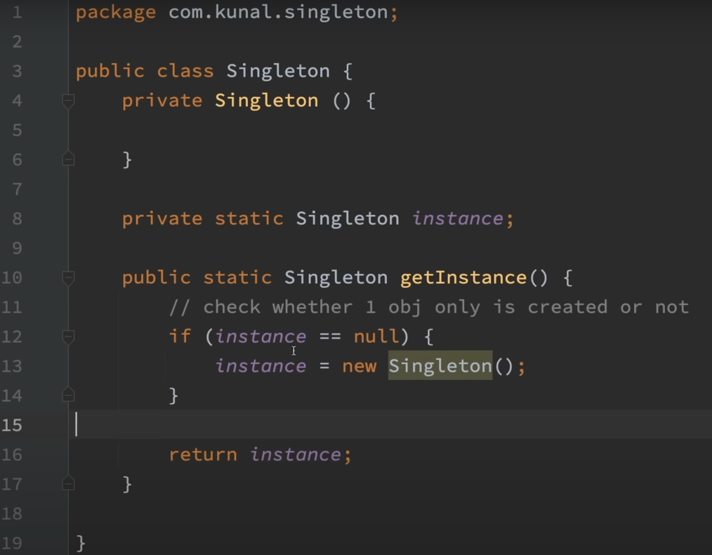

Inheritance.txt

To inherit a class, you simply incorporate the definition of one class into another by using the extends keyword. class subclass-name extends superclass-name {

// body of class

}

You can only specify one superclass for any subclass that you create. Java does not support the inheritance of multiple superclasses into a single subclass. You can, as stated, create a hierarchy of inheritance in which a subclass becomes a superclass of another subclass. However, no class can be a superclass of itself.

Although a subclass includes all of the members of its superclass, it cannot access those members of the superclass that have been declared as private.

A Superclass Variable Can Reference a Subclass Object:

It is important to understand that it is the type of the reference variable—not the type of the object that it refers to—that determines what members can be accessed.

When a reference to a subclass object is assigned to a superclass reference variable, you will have access only to those parts of the object defined by the superclass.

plainbox = weightbox;

(superclass) (subclass)

SUPERCLASS ref = new SUBCLASS(); // HERE ref can only access methods which are available in SUPERCLASS

Using super:

Whenever a subclass needs to refer to its immediate superclass, it can do so by use of the keyword super. super has two general forms. The first calls the superclass’ constructor.

The second is used to access a member of the superclass that has been hidden by a member of a subclass.

BoxWeight(double w, double h, double d, double m) {

super(w, h, d); // call superclass constructor

weight = m;

}

Here, BoxWeight( ) calls super( ) with the arguments w, h, and d. This causes the Box constructor to be called, which initializes width, height, and depth using these values. BoxWeight no longer initializes these values itself.

It only needs to initialize the value unique to it: weight. This leaves Box free to make these values private if desired. Thus, super( ) always refers to the superclass immediately above the calling class. This is true even in a multileveled hierarchy.

class Box {

private double width;

private double height;

private double depth;

// construct clone of an object

Box(Box ob) { // pass object to constructor

width = ob.width;

height = ob.height;

depth = ob.depth;

}

}

class BoxWeight extends Box {

double weight; // weight of box

// construct clone of an object

BoxWeight(BoxWeight ob) { // pass object to constructor

super(ob);

weight = ob.weight;

}

}

Notice that super() is passed an object of type BoxWeight—not of type Box.This still invokes the constructor Box(Box ob).

NOTE: A superclass variable can be used to reference any object derived from that class.

Thus, we are able to pass a BoxWeight object to the Box constructor.Of course,Box only has knowledge of its own members.

A Second Use for super The second form of super acts somewhat like this, except that it always refers to the superclass of the subclass in fwhich it is used.

super.member Here, member can be either a method or an instance variable. This second form of super is most applicable to situations in which member names of a subclass hide members by the same name in the superclass.

super( ) always refers to the constructor in the closest superclass. The super( ) in BoxPrice calls the constructor in BoxWeight. The super( ) in BoxWeight calls the constructor in Box. In a class hierarchy, if a superclass constructor

requires parameters, then all subclasses must pass those parameters “up the line.” This is true whether or not a subclass needs parameters of its own.

If you think about it, it makes sense that constructors complete their execution in order of derivation. Because a superclass has no knowledge of any subclass, any initialization it needs to perform is separate from and possibly prerequisite to any initialization performed by the subclass. Therefore, it must complete its execution first.

NOTE: If super( ) is not used in subclass' constructor, then the default or parameterless constructor of each superclass

will be executed.

Using final with Inheritance:

The keyword final has three uses:

# First, it can be used to create the equivalent of a named constant.

# Using final to Prevent Overriding:

To disallow a method from being overridden, specify final as a modifier at the start of its declaration.

Methods declared as final cannot be overridden.

Methods declared as final can sometimes provide a performance enhancement: The compiler is free to inline calls to them because it “knows” they will not be overridden by a subclass. When a small final method is called, often the Java compiler can copy the bytecode for the subroutine directly inline with the compiled code of the calling method, thus eliminating the costly overhead associated with a method call. Inlining is an option only with final methods.

Normally, Java resolves calls to methods dynamically, at run time. This is called late binding. However, since final methods cannot be overridden, a call to one can be resolved at compile time. This is called early binding.

# Using final to Prevent Inheritance:

Sometimes you will want to prevent a class from being inherited. To do this, precede the class declaration with final.

NOTE: Declaring a class as final implicitly declares all of its methods as final, too.

As you might expect, it is illegal to declare a class as both abstract and final since an abstract class is incomplete by itself & relies upon its subclasses to provide complete implementations.

# NOTE: Although static methods can be inherited, there is no point in overriding them in child classes because the method in parent class will run always no matter from which object you call it. That is why static interface methods cannot be inherited because these method will run from the parent interface and no matter if we were allowed to override them, they will always run the method in parent interface. That is why static interface method must have a body.

NOTE : Polymorphism does not apply to instance variables.

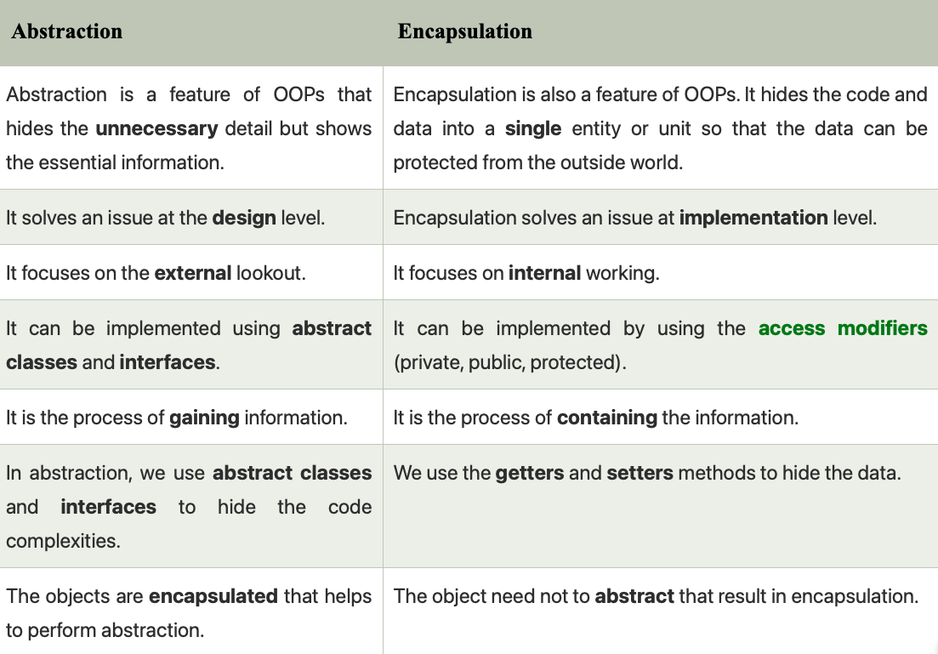

Package.txt

Packages are containers for classes. They are used to keep the class name space compartmentalized. For example, a package allows you to create a class named List, which you can store in your own package without concern that it will collide with some other class named List stored elsewhere. Packages are stored in a hierarchical manner and are explicitly imported into new class definitions.

The package is both a naming and a visibility control mechanism.

The following statement creates a package called MyPackage: package MyPackage;

Java uses file system directories to store packages. For example, the .class files for any classes you declare to be part of MyPackage must be stored in a directory called MyPackage. Remember that case is significant, and the directory name must match the package name exactly. A package hierarchy must be reflected in the file system of your Java development system. For example, a package declared as

package java.awt.image;

needs to be stored in java\awt\image in a Windows environment. Be sure to choose your package names carefully. You cannot rename a package without renaming the directory in which the classes are stored.

How does the Java run-time system know where to look for packages that you create? The answer has three parts. - First, by default, the Java run-time system uses the current working directory as its starting point. Thus, if your package is in a subdirectory of the current directory, it will be found. - Second, you can specify a directory path or paths by setting the CLASSPATH environmental variable.

- Third, you can use the -classpath option with java and javac to specify the path to your classes.

When a package is imported, only those items within the package declared as public will be available to non-subclasses in the importing code.

Access Control.txt

How a member can be accessed is determined by the access modifier attached to its declaration. Usually, you will want to restrict access to the data members of a class—allowing access only through methods. Also, there will be times when you will want to define methods that are private to a class.

Java’s access modifiers are public, private, and protected. Java also defines a default access level. protected applies only when inheritance is involved.

When no access modifier is used, then by default the member of a class is public within its own package, but cannot be accessed outside of its package.

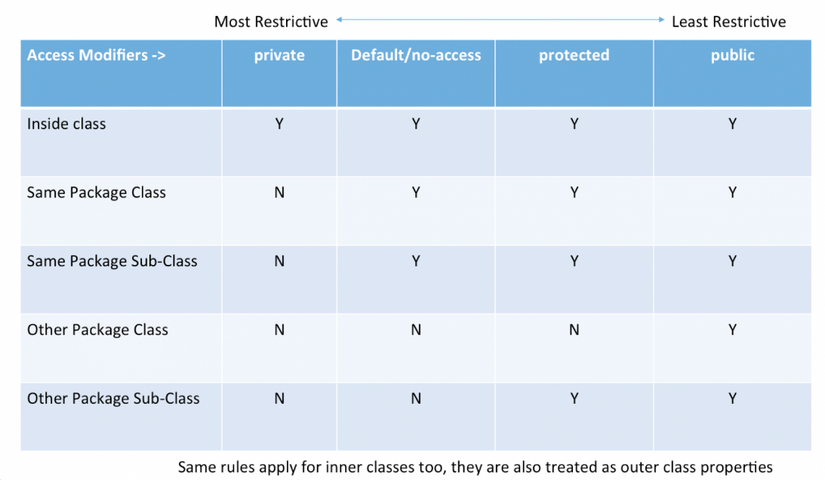

package packageOne;

public class Base

{

protected void display(){

System.out.println("in Base");

}

}

package packageTwo;

public class Derived extends packageOne.Base{

public void show(){

new Base().display(); // this is not working

new Derived().display(); // is working

display();//is working

}

}

protected allows access from subclasses and from other classes in the same package.

We can use child class to use protected member outside the package but only child class object can access it. That's why any Derived class instance can access the protected method in Base. The other line creates a Base instance (not a Derived instance!!).

And access to protected methods of that instance is only allowed from objects of the same package.

display();

-> allowed, because the caller, an instance of Derived has access to protected members and fields of its subclasses,

even if they're in different packages

new Derived().display();

-> allowed, because you call the method on an instance of Derived and that instance has access to the protected methods

of its subclasses

new Base().display();

-> not allowed because the caller's (the this instance) class is not defined in the same package like the Base class, so this can't access the protected method. And it doesn't matter - as we see - that the current subclasses a class from that package. That backdoor is closed ;)

Remember that any time talks about a subclass having an access to a superclass member, we could be talking about the

subclass inheriting the member, not simple accessing the member through a reference to an instance of the superclass.

class C

protected member;

// in a different package

class S extends C

obj.member; // only allowed if type of obj is S or subclass of S

The motivation is probably as following. If obj is an S, class S has sufficient knowledge of its internals, it has the right to manipulate its members, and it can do this safely. If obj is not an S, it's probably another subclass S2 of C, which S has no idea of. S2 may have not even been born when S is written. For S to manipulate S2's protected internals is quite dangerous. If this is allowed, from S2's point of view, it doesn't know who will tamper with its protected internals and how, this makes S2 job very hard to reason about its own state.

Now if obj is D, and D extends S, is it dangerous for S to access obj.member? Not really.

How S uses member is a shared knowledge of S and all its subclasses, including D. S as the superclass has the right to define behaviours, and D as the subclass has the obligation to accept and conform.

For easier understanding, the rule should really be simplified to require obj's (static) type to be exactly S. After all, it's very unusual and inappropriate for subclass D to appear in S. And even if it happens, that the static type of obj is D, our simplified rule can deal with it easily by upcasting: ((S)obj).member

Interface.txt

Multiple inheritance is not available in java.

(Same functions in 2 classes it will skip that hence no multiple inheritance)

Instead we have java interfaces. they have abstract functions (no body of functions)

Interface is like class but not completely. it is like an abstract class.

By default functions are public and abstract in interface.

variables are final and static by default in interface.

Interfaces specify only what the class is doing, not how it is doing it.

The problem with MULTIPLE INHERITANCE is that two classes may define different ways of doing the same thing,

and the subclass can't choose which one to pick.

Key difference between a class and an interface: a class can maintain state information

(especially through the use of instance variables), but an interface cannot.

Using interface, you can specify a set of methods that can be implemented by one or more classes.

Although they are similar to abstract classes, interfaces have an additional capability:

A class can implement more than one interface. By contrast, a class can only inherit a single superclass

(abstract or otherwise).

Using the keyword interface, you can fully abstract a class’ interface from its implementation.

That is, using interface, you can specify what a class must do, but not how it does it.

Interfaces are syntactically similar to classes, but they lack instance variables, and, as a general rule,

their methods are declared without any body.

By providing the interface keyword, Java allows you to fully utilize the “one interface, multiple methods”

aspect of polymorphism.

NOTE: Interfaces are designed to support dynamic method resolution at run time.

Normally, in order for a method to be called from one class to another, both classes need to be present at compile time

so the Java compiler can check to ensure that the method signatures are compatible. This requirement by itself makes for

a static and nonextensible classing environment. Inevitably in a system like this, functionality gets pushed up higher

and higher in the class hierarchy so that the mechanisms will be available to more and more subclasses. Interfaces are

designed to avoid this problem. They disconnect the definition of a method or set of methods from the inheritance

hierarchy. Since interfaces are in a different hierarchy from classes, it is possible for classes that are unrelated

in terms of the class hierarchy to implement the same interface. This is where the real power of interfaces is realized.

Beginning with JDK 8, it is possible to add a default implementation to an interface method.

Thus, it is now possible for interface to specify some behavior.However, default methods constitute what is, in essence,

a special-use feature, and the original intent behind interface still remains.

Variables can be declared inside of interface declarations.

NOTE: They are implicitly final and static, meaning they cannot be changed by the implementing class.

They must also be initialized. All methods and variables are implicitly public.

NOTE: The methods that implement an interface must be declared public. Also, the type signature of the implementing

method must match exactly the type signature specified in the interface definition.

It is both permissible and common for classes that implement interfaces to define additional members of their own.

NOTE:

You can declare variables as object references that use an interface rather than a class type.

This process is similar to using a superclass reference to access a subclass object.

Any instance of any class that implements the declared interface can be referred to by such a variable.

When you call a method through one of these references, the correct version will be called based on the actual instance

of the interface being referred to. Called at run time by the type of object it refers to.

The method to be executed is looked up dynamically at run time, allowing classes to be created later than the code which

calls methods on them.

The calling code can dispatch through an interface without having to know anything about the “callee.”

CAUTION: Because dynamic lookup of a method at run time incurs a significant overhead when compared with the normal

method invocation in Java, you should be careful not to use interfaces casually in performance-critical code.

Nested Interfaces:

An interface can be declared a member of a class or another interface. Such an interface

is called a member interface or a nested interface. A nested interface can be declared as public, private, or protected.

This differs from a top-level interface, which must either be declared as public or use the default access level.

// This class contains a member interface.

class A {

// this is a nested interface

public interface NestedIF {

boolean isNotNegative(int x);

}

}

// B implements the nested interface.

class B implements A.NestedIF {

public boolean isNotNegative(int x) {

return x < 0 ? false: true;

}

}

class NestedIFDemo {

public static void main(String args[]) {

// use a nested interface reference

A.NestedIF nif = new B();

if(nif.isNotNegative(10))

System.out.println("10 is not negative");

if(nif.isNotNegative(-12))

System.out.println("this won't be displayed");

}

}

Interfaces Can Be Extended:

One interface can inherit another by use of the keyword extends. The syntax is the same as for inheriting classes.

Any class that implements an interface must implement all methods required by that interface, including any that are

inherited from other interfaces.

Default Interface Methods (aka extension method) :

A primary motivation for the default method was to provide a means by which interfaces could be expanded without breaking existing code.

i.e. suppose you add another method without body in an interface. Then you will have to provide the body of that method

in all the classes that implement that interface.

Ex:

default String getString() {

return "Default String";

}

For example, you might have a class that implements two interfaces.

If each of these interfaces provides default methods, then some behavior is inherited from both.

# In all cases, a class implementation takes priority over an interface default implementation.

# In cases in which a class implements two interfaces that both have the same default method, but the class does not

override that method, then an error will result.

# In cases in which one interface inherits another, with both defining a common default method, the inheriting

interface’s version of the method takes precedence.

NOTE: static interface methods are not inherited by either an implementing class or a subinterface.

i.e. static interface methods should have a body! They cannot be abstract.

NOTE : when overriding methods, the access modifier should be same or better i.e. if in Parent Class it was protected, then then overridden should be either protected or public.

Maybe imp??????

Sure! Let's compare **Python** and **Java** with respect to their **memory management** systems, focusing on the concepts of **reference counting** and **cyclic garbage collection**.

**Memory Management in Python vs Java**

Both Python and Java manage memory automatically through garbage collection, but they differ in how this process works under the hood, especially regarding **reference counting** and **cyclic garbage collection**.

**1. Reference Counting**

* **Python**:
  + Python uses **reference counting** as the primary mechanism for memory management.
  + Every object in Python has a reference count that tracks how many references point to it.
  + When you create a variable that points to an object, Python increases the reference count of that object.
  + When a variable goes out of scope or is reassigned, Python decreases the reference count.
  + If the reference count drops to **zero**, the object is automatically deallocated (freed) by the garbage collector.

**Example**:

import sys

obj1 = [1, 2, 3] # Reference count of obj1 is 1

obj2 = obj1 # Reference count of obj1 becomes 2

del obj1 # Reference count of obj1 becomes 1

del obj2 # Reference count of obj1 becomes 0, memory is freed

**Note**: **Reference counting** is efficient for most situations. However, it can't handle **cyclic references** (when two or more objects reference each other). This is where **cyclic garbage collection** comes into play.

* **Java**:
  + Java **does not use reference counting**. Instead, it uses a **reachability analysis** algorithm, where objects are considered reachable if they can be accessed from the **root set** (e.g., active threads, static fields, etc.).
  + Java's garbage collector works by **tracing** the object graph to see which objects are reachable. If an object is not reachable from any root, it becomes eligible for garbage collection.
  + Reference counting isn’t used because it can be inefficient and tricky, especially with cyclic references.

**Java Example**:

MyClass obj1 = new MyClass();

MyClass obj2 = obj1; // obj2 and obj1 point to the same object

obj1 = null; // obj1 no longer points to the object

// obj2 still points to the object, so it is not garbage collected

Java does not track reference counts for individual objects; instead, it determines which objects are "reachable" through its garbage collection process.

**2. Cyclic Garbage Collection**

* **Python**:
  + While **reference counting** handles most cases, it **fails to handle cyclic references**. A **cyclic reference** occurs when two or more objects reference each other, creating a cycle (e.g., obj1 -> obj2 -> obj1).
  + To address this issue, Python includes a **cyclic garbage collector**, which runs periodically to detect **cyclic references** and free those objects.
  + Python’s garbage collector is part of the **gc** module. It works in addition to reference counting and helps clean up unreachable objects that are involved in cycles.
  + The cyclic garbage collector works using the **generational** model, where objects are divided into generations, and older objects are collected less frequently than younger ones.

**Python Garbage Collection**:

* + When a cyclic reference is detected (e.g., an object referring to itself or another object in a cycle), the garbage collector will **break the cycle** and reclaim the memory.
  + You can manually interact with the garbage collector using the gc module (e.g., force garbage collection with gc.collect()).

**Example of a Cyclic Reference in Python**:

import gc

class A:

def __init__(self):

self.ref = None

obj1 = A()

obj2 = A()

obj1.ref = obj2

obj2.ref = obj1

del obj1

del obj2

# At this point, there is a cyclic reference, but Python's gc will clean it up

gc.collect() # Force garbage collection

* **Java**:
  + Java’s **garbage collector** handles cyclic references natively.
  + Java does **not** use reference counting, and because of this, it is inherently immune to issues arising from cyclic references.
  + Java relies on a **reachability analysis** mechanism (based on **mark-and-sweep** or **tracing** algorithms), which ensures that even objects in cyclic references are properly identified as unreachable and cleaned up.

**Example of a Cyclic Reference in Java**:

class A {

A ref;

}

public class Main {

public static void main(String[] args) {

A obj1 = new A();

A obj2 = new A();

obj1.ref = obj2;

obj2.ref = obj1;

// At this point, there is a cyclic reference between obj1 and obj2

obj1 = null; // No references to obj1

obj2 = null; // No references to obj2

// Java's garbage collector will handle this cycle and clean up both objects

}

}

Java's garbage collector will handle this cyclic reference by detecting that obj1 and obj2 are no longer reachable and cleaning them up.

**3. Garbage Collection Algorithm**

* **Python**:
  + Python uses a **generational garbage collection** strategy. It organizes objects into **three generations**:
    - **Generation 0**: New objects that have just been created.
    - **Generation 1**: Objects that survived one garbage collection.
    - **Generation 2**: Long-lived objects that survived multiple collections.
  + The garbage collector runs more frequently on younger objects (Generation 0) than on older objects, which improves performance.

**Generational Approach** helps optimize memory management because it’s statistically likely that younger objects will die (become unreachable) quickly, and thus don't need to be checked as frequently as older objects.

* **Java**:
  + Java also uses a **generational garbage collection** approach, which divides objects into different generations (young, old, and permanent generations in some JVMs).
  + The garbage collection process in Java is managed by the **JVM** using algorithms like **Mark-and-Sweep**, **Mark-and-Compact**, and **Copying**.
  + The **young generation** (objects that are recently created) is collected more often, while the **old generation** (objects that have survived multiple garbage collections) is collected less frequently.
  + **Garbage collection in Java** is often handled by different **collectors**, like the **Serial Garbage Collector**, **Parallel Garbage Collector**, and **G1 Garbage Collector** (used for large applications).

**Key Differences:**

| **Feature** | **Python** | **Java** |
| --- | --- | --- |
| **Reference Counting** | Yes, used as the main mechanism. | No, uses reachability analysis. |
| **Cyclic Garbage Collection** | Yes, handled by gc module. | Yes, handled by JVM’s garbage collector. |
| **Object Reachability** | Reference counting and cyclic GC. | Tracing of reachable objects. |
| **GC Algorithms** | Generational GC (young, old, etc.). | Generational GC (young, old, etc.), mark-and-sweep, etc. |
| **Garbage Collection Process** | Reference counting + cyclic GC. | Mark-and-Sweep, Mark-and-Compact, G1 GC, etc. |
| **Performance** | May be slower due to reference counting overhead and cyclic GC. | Can be optimized with JVM collectors, but might still have pauses due to GC. |

**Conclusion:**

* **Python** uses a **reference counting** mechanism for memory management but supplements it with a **cyclic garbage collector** to handle cyclic references.
* **Java** does not use reference counting; instead, it uses **reachability analysis** to determine which objects should be garbage collected and includes built-in mechanisms to handle cyclic references.

Both languages handle garbage collection efficiently, but Python's **reference counting** and **cyclic garbage collection** is an additional step that can introduce overhead, especially in programs with many cyclic references. On the other hand, Java's **mark-and-sweep** approach naturally handles cyclic references without the need for reference counting.