**DEPARTMENT OF COMPUTER & SOFTWARE ENGINEERING**

**COLLEGE OF E&ME, NUST, RAWALPINDI**

Digital Image Processing

Project Report

**Student Name: Muhammad Hamza Tariq – 371070**

**Saad Hassan - 398416**

**Degree/ Syndicate: 43 CE B**

### Digital Image Processing (DIP) Project Report

#### Introduction

Detecting prohibited items in luggage is crucial for ensuring the safety of travelers and minimizing the likelihood of terrorist actions. Manual luggage detection is currently common practice at airports, retail malls, and cargo terminals, but it is inefficient, time-consuming, and prone to human errors. To address these challenges, the objective of this project is to develop an autonomous system capable of classifying and segmenting specific types of threat items in luggage images. The dataset provided is categorized into three classes: guns and knives along with images considered safe.

#### Problem Understanding and Literature Review

The problem involves two main tasks: classification and segmentation. Classification identifies whether an image contains a threat item (gun, knife, shuriken) or is safe. Segmentation identifies all pixels in the image that belong to a specific object/class.

**Classification**: This is treated as a binary classification problem where an image is either classified as safe or containing a threat item.

**Segmentation**: This process involves identifying all pixels that belong to a particular object within the image.

The performance of the system is evaluated using overall accuracy, confusion matrix, and Dice coefficient (or F1 score).

#### **Data Preparation**

The dataset was divided into training and testing sets, each containing subfolders for guns, knives, and safe images. Annotations were provided in the form of masks for images containing threat items.

#### **Methodology**

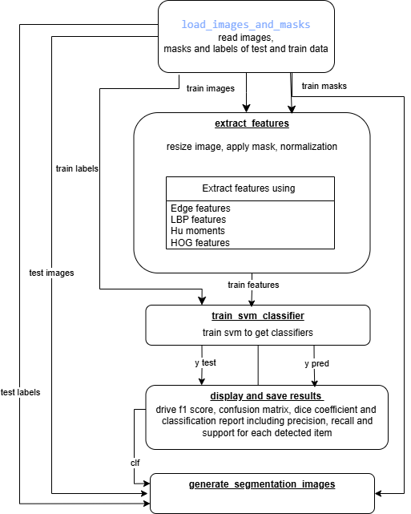

**1. Image and Mask Loading:**

This step involves loading images and their corresponding masks (annotations) from the dataset. The function load_images_and_masks reads images from different categories (safe, gun, knife) and their respective masks. Masks are used to highlight the regions of interest (threat items) within the images. For the 'safe' category, a mask of ones (indicating no threat) is created. This step is crucial as it prepares the data for further processing by ensuring that both images and their annotations are available and correctly matched.

**2. Feature Extraction:**

Feature extraction is a critical step in machine learning where important characteristics of images are identified and extracted. In this project, the function extract_features is used to extract several types of features from the images, including:

* **Edge Features**: Using the Canny edge detector to capture the outlines of objects.
* **Local Binary Pattern (LBP)**: To describe the texture.
* **Hu Moments**: To capture the shape characteristics.
* **Histogram of Oriented Gradients (HOG)**: To capture the gradient and edge orientations.

These features collectively help in distinguishing between different classes (safe, gun, knife) and are combined into a single feature vector for each image.

**3. SVM Classifier Training:**

The Support Vector Machine (SVM) is a powerful classifier used in this project to distinguish between safe and threat images. The function train_svm_classifier trains the SVM model using the extracted features and their corresponding labels. The dataset is split into training and testing sets to evaluate the performance of the model. The classifier's performance is measured using accuracy, confusion matrix, and classification report (which includes precision, recall, and F1-score).

**4. Image Segmentation:**

Segmentation involves identifying the exact location of threat items within an image. The function segment_image uses the trained SVM classifier to predict the presence of a threat item in a given image. If a threat is detected, the image is segmented to highlight the regions corresponding to the threat item. This step includes converting the image to grayscale, resizing, applying a mask, and extracting features similar to the classification step. The predicted threat item is then highlighted on the image for visual inspection.

#### **Results and Analysis**

**Classification Report:** The classification report provides detailed metrics on precision, recall, F1-score, and support for each class.

* **Accuracy:** The model achieved an accuracy of 86.0%, as shown in the classification report plot.

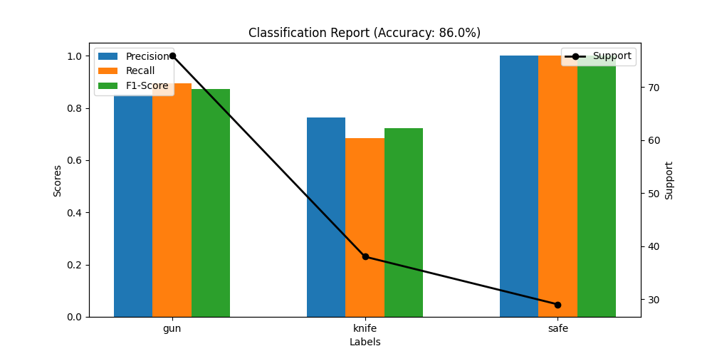

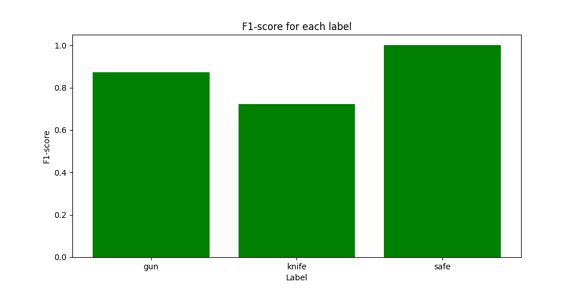

**Confusion Matrix:** The confusion matrix visualizes the performance of the classifier in terms of true positive, false positive, true negative, and false negative predictions.

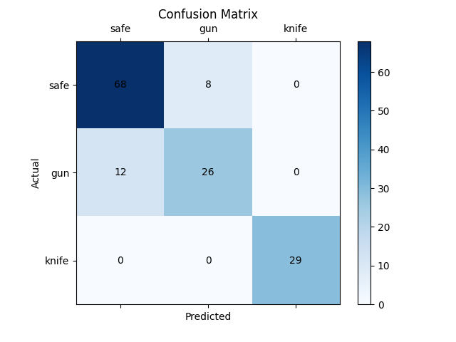

**Dice Coefficient:** The Dice coefficient plot provides a measure of the segmentation accuracy for each class, reflecting the overlap between the predicted and actual segmented regions.

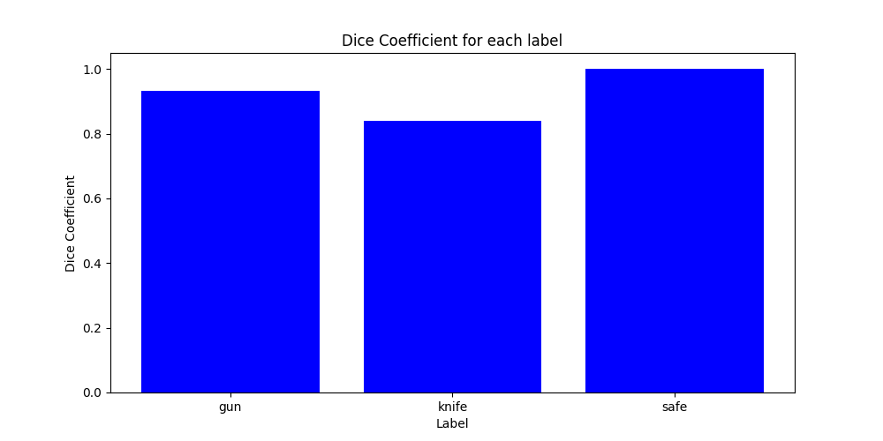

**Sample Outputs:** Sample output images show the segmented results for various test images, highlighting the predicted threat items and their actual labels.

#### **Conclusion**

The developed system demonstrates significant potential in automating the detection and segmentation of threat items in luggage images. With an overall accuracy of 86% and high Dice coefficients for segmentation, the system can effectively reduce human error and workload in security operations.

**Future Work:** Future improvements could include:

* Incorporating additional features and models to enhance classification and segmentation accuracy.
* Exploring deep learning techniques for end-to-end threat detection and segmentation.
* Expanding the dataset to include more diverse threat items and real-world scenarios.

#### **References**

* [Mean Average Precision](https://www.v7labs.com/blog/mean-average-precision)
* [Semantic Segmentation Topics on GitHub](https://github.com/topics/semantic-segmentation)

#### **Appendices**

**Code Files:** The complete code for this project is available on GitHub.

[DIP - Project · Hmmza-tariq](https://github.com/Hmmza-tariq/DIP/tree/main/Project)

**Figures:** The figures include the classification report, confusion matrix, Dice coefficient plot, and sample segmented images.

**Data Division:** The dataset is divided into training and testing sets, with corresponding annotations provided for images containing threat items.