1. Analyze the Problem

This a program that is a weight converter, that converts pounds(lb) into grams, kilograms, and ounces.

1. Determine Specifications

Input- Enter the number of pounds (lb.)

Process- Converts units by assigning values

Output- pounds is converted into grams, kilograms, ounces

1. Create a Design

-We ask the user to input the mass unit value in pounds which will convert but is stored

-The user enters the amount of lbs. and by using the while loop, if true it converts to grams,kilograms,ounces but if false then it tells the user that it’s an invalid entry and please enter a valid number to continue.

- then its prints out the results of the conversation on the graphics

1. Implement the Design –

def weightConvert():

'''

Input : enter pounds(lb) to convert into grams,kilograms, ounces

Process: Converts the lb into grams, kilograms , ounces

Output: The Grams, kilograms and ounces are converted

'''

while True:

lb = float(entry1.getText())

if lb >= 0:

gram = lb \* 453.59237

entry2.setText(round(gram,2))

win.getMouse()

kilograms = lb \* .45359237

entry3.setText(round(kilograms,2))

win.getMouse()

ounces = lb \* 16

entry4.setText(round(ounces,2))

win.getMouse()

win.close()

print("Gram:",(round(gram,2)))

print("Kilograms:",(round(kilograms,2)))

print("Ounces:",(round(ounces,2)))

else:

entry1.setText("INVAILD INPUT,PLEASE enter a NUMBER under the entry.")

print("INVAILD INPUT,PLEASE enter a NUMBER under the entry.")

weightConvert()

1. Test/Debug the Program-

This is how the program looks once you open it, asking user to enter the lb to convert

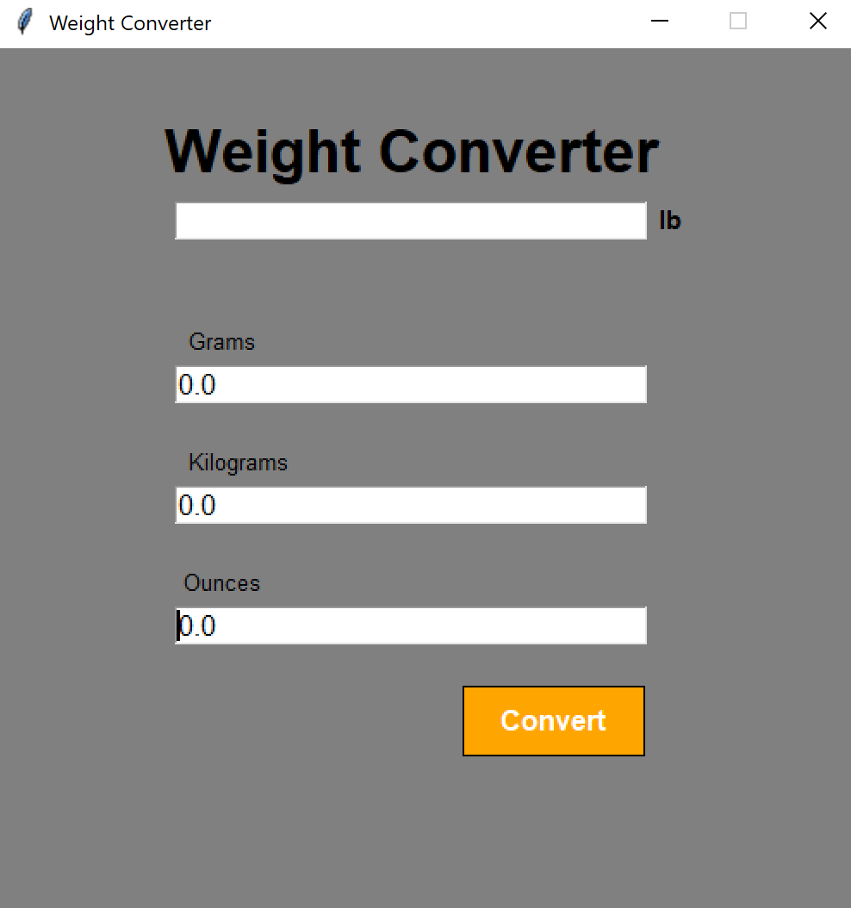

I enter 20lb and it convert each unit in grams, kilograms,ounces

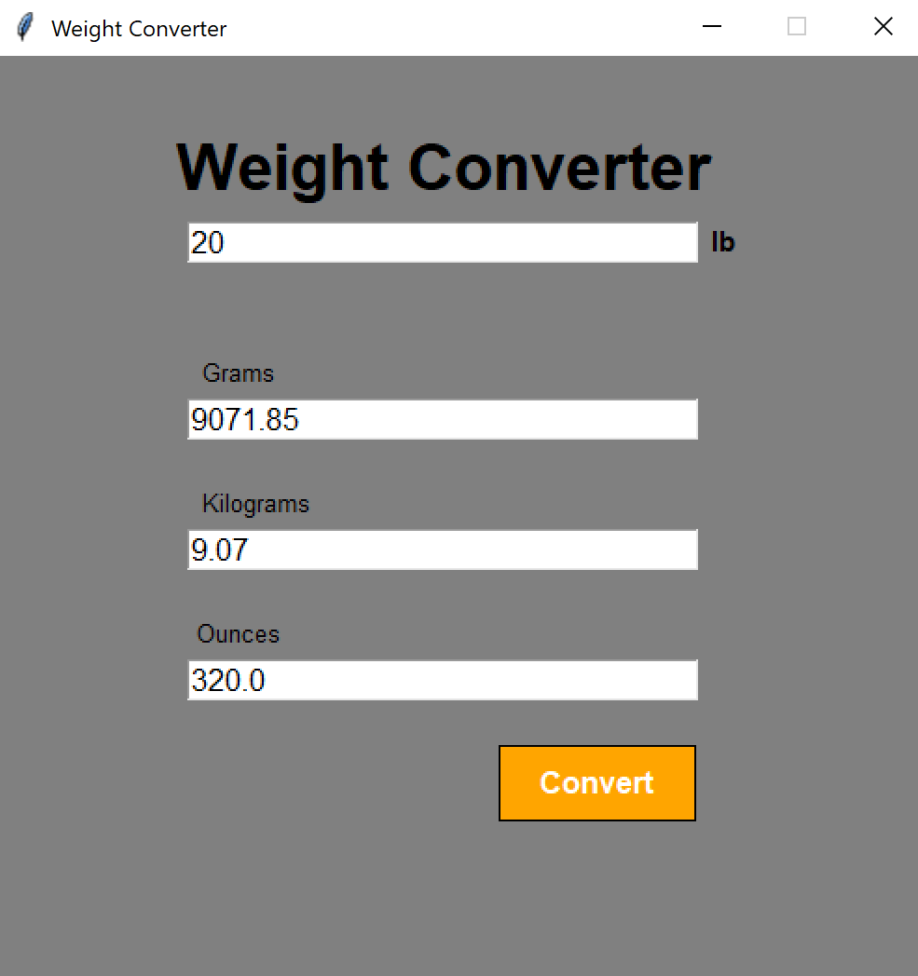

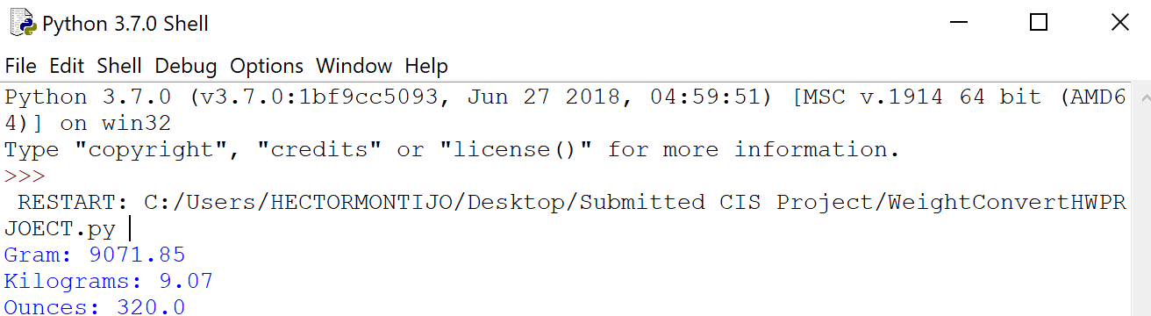

-when it’s an Invalid input , this pops up and must try again which makes this FALSE

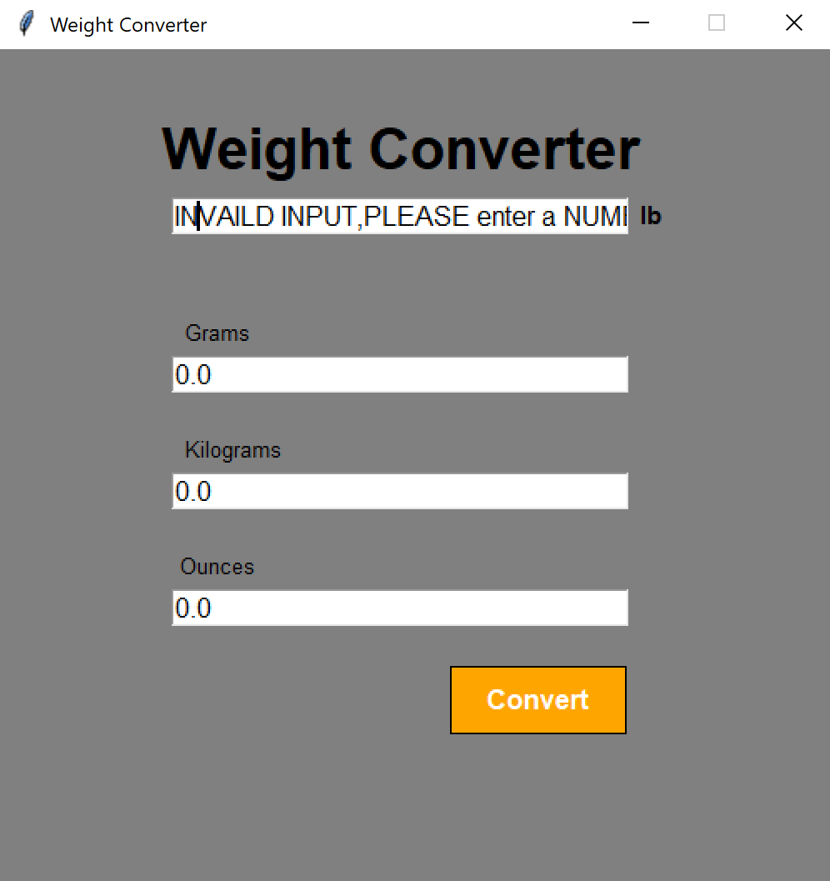

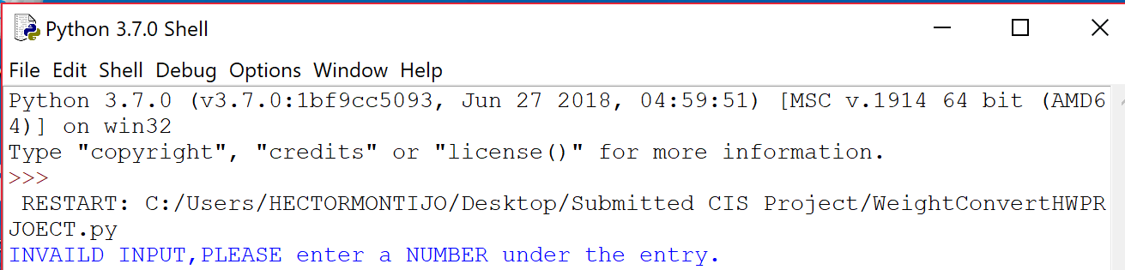

1. Maintain the Program- keep the program up to date and fix the errors.