
Function Specification Title

FS Number | FS_016
Client | All
DU BA | Suchada Buranasinlapakit / Dylan Quek
Date | Mar 19, 2014
Internal Enhancement Reference(s)
Revision history

Version | Date | Description | By
1.0 | Nov 25, 2013 | Initial Draft | Suchada B.
2.0 | Feb 14, 2014 | Add section 1.1.3 Equity Retail Reports | Dylan Quek
3.0 | Mar 19, 2014 | Updated regarding signoff session  - Remove Trade Report Deal from 1.1 Report List for Derivatives and section 1.1.2 Derivatives Reports  - Other changes highlight as Yellow | Suchada B.

Contents
1 Customer requirements 4
1.1 Customer needs 4
1.1.1 Report List 4
1.1.2 Derivatives Reports 5
1.1.3 Equity Retail Reports 29
1.2 Customer deadlines /milestones 42
1.3 Required kinematics 42
2 Proposed functional solution 43
2.1 Products delivery 43
3 Work order development 44
3.1 Scope 44
3.2 Implementation Services 44
3.3 Invoicing Terms 44
3.4 Implementation schedule 44
4 Authorization 45

Customer requirements

Customer needs

Report List

Report List for Derivatives

Report Name | Phase | GUI/ SFTP | Report Path
- EOD Report
1 Order Report | P3 | SFTP | SFTP Folder
2 Trade Report Order | P3 | SFTP | SFTP Folder
3 Deal Report | P3 | SFTP | SFTP Folder
4 Cancel Order Report | P3 | SFTP | SFTP Folder
5 Change Order Report | P3 | SFTP | SFTP Folder
6 Orders & Confirmation Report | P3 | SFTP | SFTP Folder
7 Credit Approved Order Report | P3 | SFTP | SFTP Folder
8 Customer Information | P3 | SFTP | SFTP Folder
9 Rectified Report | P3 | SFTP | SFTP Folder
10 Take up Report | P3 | SFTP | SFTP Folder
11 Give up Report | P3 | SFTP | SFTP Folder
12 Split Report | P3 | SFTP | SFTP Folder
13 Cancelled Expired Order Report | P3 | SFTP | SFTP Folder
14 Call Report | P3 | SFTP | SFTP Folder
15 Force Report | P3 | SFTP | SFTP Folder
16 Open Orders Report | P3 | SFTP | SFTP Folder
17 Mark to Market Report | P3 | SFTP | SFTP Folder
18 Deny/Exercise Request | P3 | SFTP | SFTP Folder

Report List for Equity Retail

Report Name | Phase | GUI/ SFTP | Report Path
- EOD Report
1 Credit Approved Order Report | Retail | SFTP | SFTP Folder
2 Trader Information Report | Retail | SFTP | SFTP Folder
3 Trader Audit Report | Retail | SFTP | SFTP Folder
4 Credit Balance Call Margin Customer Report Margin Portfolio Summary By Account No. | Retail | SFTP | SFTP Folder
5 Credit Balance Force Sell Report Margin Portfolio Summary By Account No. | Retail | SFTP | SFTP Folder
6 Credit Balance Report Margin Portfolio Summary By Account No. | Retail | SFTP | SFTP Folder
7 Audit Market Control Term Report | Retail | STFP | SFTP Folder
8 Audit User Report (Trader) | Retail | SFTP | SFTP Folder
9 Customer Activity Over Credit | Retail | SFTP | SFTP Folder
10 Customer Activity | Retail | SFTP | SFTP Folder
11 Order Margin Value Report | Retail | SFTP | SFTP Folder
12 Report For Short Sell Order Use Foreign | Retail | SFTP | SFTP Folder
13 Price Approved Orders by Order Entry, Customer, Order# | Retail | SFTP | SFTP Folder
14 Approve Report | Retail | SFTP | SFTP Folder
15 Trader Information | Retail | SFTP | SFTP Folder

Derivatives Reports
For derivative reports, system will generate only derivative instrument.

Order Report
This report will provide the order information in different grouping. We provide brokers for 7 reports of Order Report
- Order Report By Order No.
- Order Report By Series, Order No.
- Order Report By Order Entry, Order No.
- Order Report By Order Entry, Series, Order No.
- Order Report By Deposit, Order No.
- Order Report By Deposit, Series, Order No.
- Order Report By Order Entry, Deposit, Series, Side, Order No.
Filename, report title, report header, report group by and report order vary in different reports as below:-

- Order Report By Order No.
File Name: order_by_order_no-<YYYYMMDD>_dev
Report Title: <hardcode as “Order Report By Order No.”> at center
Group By: N/A
Order By: Level 0: Order Number (Ascending Order)

- Order Report By Series, Order No.
File Name: order_by_sec_order_no-<YYYYMMDD>_dev
Report Title: <hardcode as “Order Report By Series, Order No.”> at center
Group By: Level 0: Underlying Asset
Level 1: Series
Order By: Level 0: Underlying Asset (Ascending Order)
Level 1: Series (Ascending Order)
Level 2: Order Number (Ascending Order)

- Order Report By Order Entry, Order No.
File Name: order_by_entry_order_no-<YYYYMMDD>_dev
Report Title: <hardcode as “Order Report By Order Entry, Order No.”> at center
Group By: Level 0: Entry Trader ID
Order By: Level 0: Entry Trader ID (Ascending Order)
Level 1: Order Number (Ascending Order)

- Order Report By Order Entry, Series, Order No.
File Name: order_by_entry_sec_ord-<YYYYMMDD>_dev
Report Title: <hardcode as “Order Report By Order Entry, Series, Order No.”> at center
Group By: Level 0: Entry Trader ID
Order By: Level 0: Series (Ascending Order)
Level 1: Order Number (Ascending Order)

- Order Report By Deposit, Order No.
File Name: order_by_dep_order_no-<YYYYMMDD>_dev
Report Title: <hardcode as “Order Report By Deposit, Order No.”> at center
Group By: Level 0: Account Number
Order By: Level 0: Account Number (Ascending Order)
Level 1: Order Number (Ascending Order)

- Order Report By Deposit, Series, Order No.
File Name: order_by_dep_sec_order_no-<YYYYMMDD>_dev
Report Title: <hardcode as “Order Report By Deposit, Series, Order No.”> at center
Group By: Level 0: Account Number
Order By: Level 0: Series (Ascending Order)
Level 1: Order Number (Ascending Order)

- Order Report By Entry Trader ID, Deposit, Series, Side, Order No.
File Name: order_by_dep_sec_s_order_no-<YYYYMMDD>_dev
Report Title: <hardcode as “Order Report By Order Entry, Deposit, Series, Side, Order No.”> at center
Group By: Level 0: Entry Trader ID
Level 1: Account Number
Order By: Level 0: Entry Trader ID (Ascending Order)
Level 1: Account Number (Ascending Order)
Level 2: Series (Ascending Order),
Level 3: Side (Ascending Order)
Level 4: Order Number (Ascending Order)

However, all order reports are common in following dimensions:-

Report Header:
Broker No. <Broker Number>
Broker <Broker Name>
Report Date <Report generated Date in DD/MM/YYYY format>
Trade Date < Date in DD/MM/YYYY format>
Criteria:
- Order Entry Date and Report Generation Date
- All Orders except Block Trade Order
- All Order Status
Output Format: text format
Frequency: EOD
Format Delimited: Delimited by 1 space character
No. | Field Name | Description
1. | Order Number | Internal Order Number
2. | Side | Side of order.  Possible Value are as follows:  - B (Buy)  - S (Sell)
3. | Position | Position  Possible Value are as follows:  - O (Open)  - C (Close)
4. | Series | SeriesID
5. | Qty | Order Quantity
6. | Matched | Matched Quantity
7. | Price | Price of Series. Support both Limit Price and Market Price  Possible Value are as follows:  - 700.10 (Limit Price)  - MP (Market Price)  - ML (Market to Limit)  - MO (Special Market)
8. | Trader ID | Trader ID who entry order
9. | Deposit | Customer Account Number
10. | Ord Status | Order Status. Refer to FS_001_GUI and Order Validations for order status detail.
11. | Ord Date | Order Entry Date
12. | Ord Time | Order Entry Time
13. | Valid | Order is valid till.  Possible Values are as follows:  - Day = Good Till Day (Default Value)  - Date = Good Till Date  - Cancel = Good Till Cancel  - FAK = Fill And Kill  - FOK = Fill Or Kill  - GTT = Good Till Time  - GTS = Good Till Session  - GTA = Good Till Next Auction
14. | VDate | Valid Date
15. | StSeries | Stop Series
16. | StPrice | Stop Price
17. | StCond | Stop Condition for this series

Order Report Example
- Order Report By Order No.
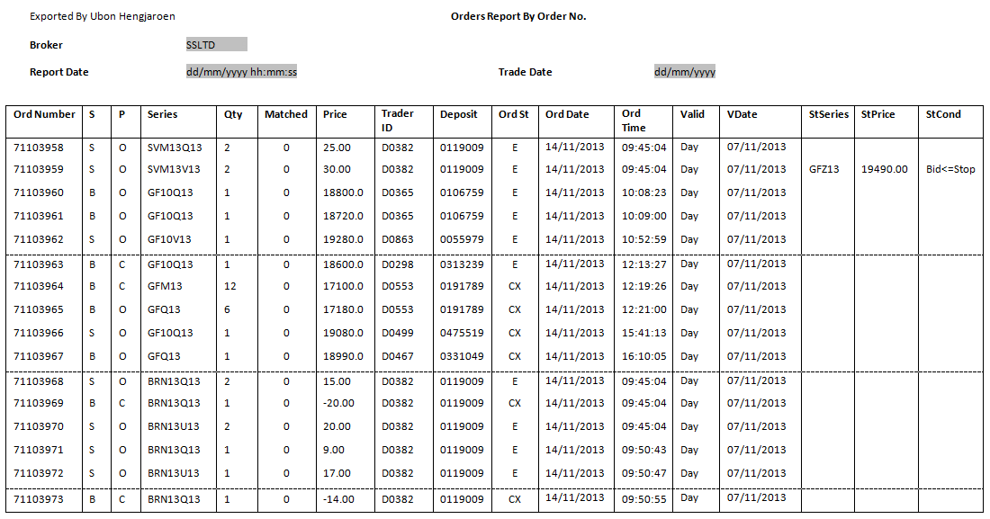
- Order Report By Series, Order No.
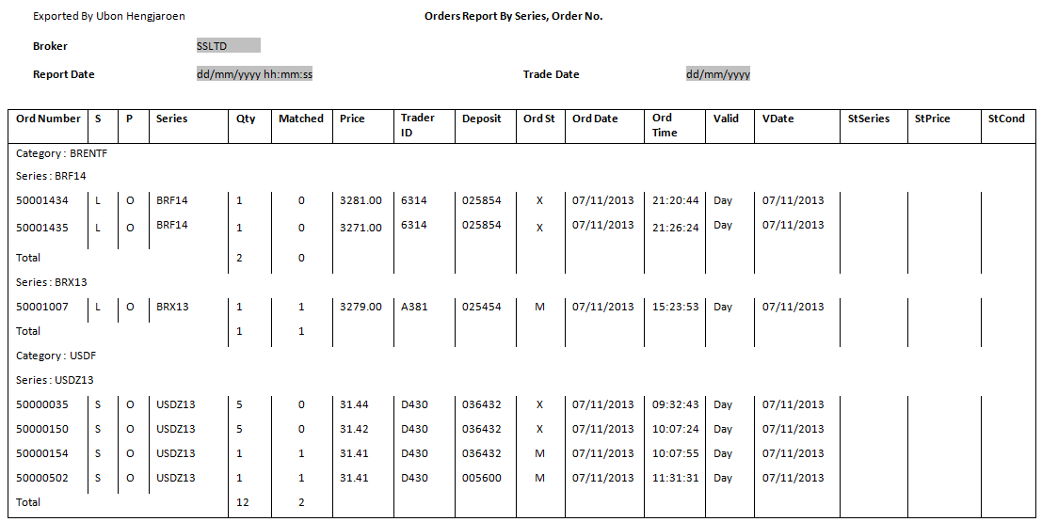
- Order Report By Entry Trader ID, Order No.
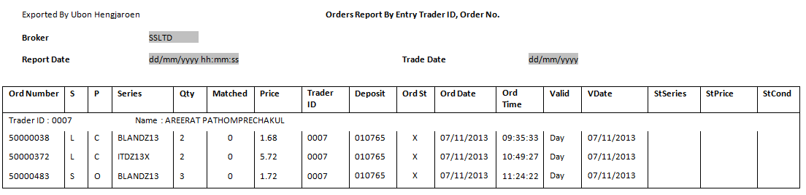
- Order Report By Entry Trader ID, Series, Order No.
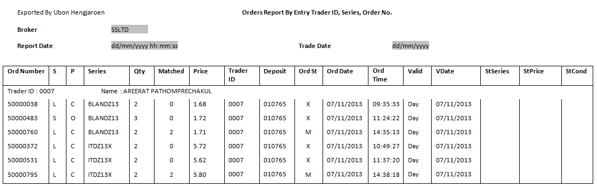
- Order Report By Deposit, Order No.
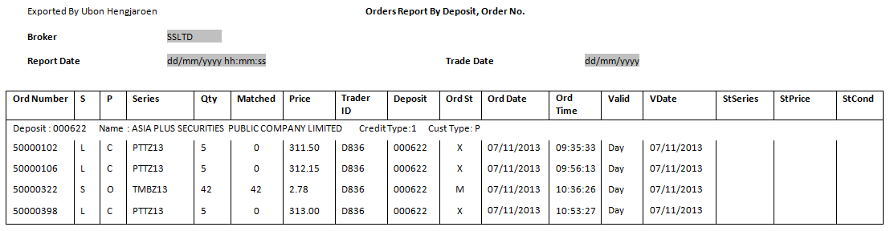
- Order Report By Deposit, Series, Order No.
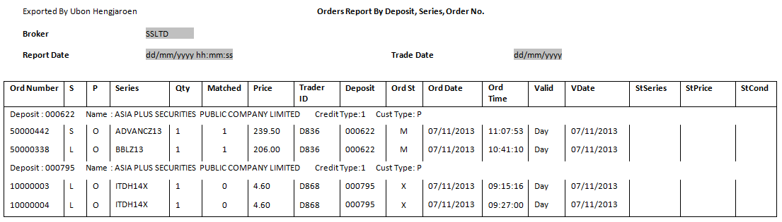
- Order Report By Entry Trader ID, Deposit, Series, Side, Order No.
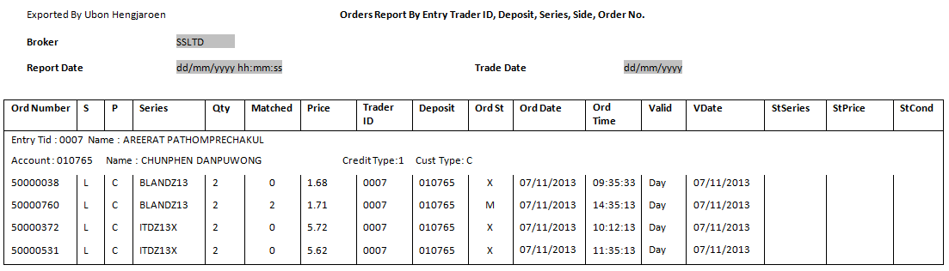

Trade Report Order
File Name: trade_report_order-<YYYYMMDD>_dev
Report Title: <hardcode as “Trade Report Order By Order No.”> at center
Group By: N/A
Order By: Order Number (Ascending Order)
Report Header:
Broker No. <Broker Number>
Broker <Broker Name>
Report Date <Report generated Date in DD/MM/YYYY format>
Trade Date < Date in DD/MM/YYYY format>
Criteria:
- Order Entry Date and Report Generation Date
- Block Trade Order (Trade Report Order)
- All Order Status
Output Format: text format
Frequency: EOD
Format Delimited: Delimited by 1 space character
No. | Field Name | Description
1. | Ord No. | Order Number
2. | S | Side
3. | P | Position
4. | Series | Series
5. | Qty | Order Quantity
6. | Matched | Matched Quantity
7. | Price | Price
8. | Trader ID | Trader ID
9. | Deposit | Deposit
10. | Ord St | Order Status
11. | Date | Order Entry Date
12. | Time | Order Entry Time
13. | CPM | Counter Party Member

Trade Report Order Example
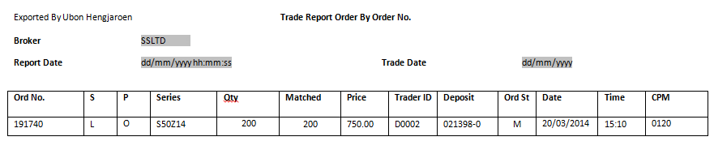

Deal Report
This report will provide the deal information in different grouping. We provide brokers for 6 reports of Deal Report
- Deal Report By Trade No.
- Deal Report By Series, Trade No.
- Deal Report By Order Entry, Trade No.
- Deal Report By Order Entry, Series, Trade No.
- Deal Report By Deposit, Trade No.
- Deal Report By Deposit, Series, Trade No.
Filename, report title, report header, report group by and report order vary in different reports as below:-
- Deal Report By Trade No.
File Name: deal_by_trade_no-<YYYYMMDD>_dev
Report Title: <hardcode as “Deal Report By Trade No.”> at center
Group By: N/A
Order By: Trade Number (Ascending Order)

- Deal Report By Series, Trade No.
File Name: deal_by_sec_trade_no-<YYYYMMDD>_dev
Report Title: <hardcode as “Deal Report By Series, Trade No.”> at center
Group By: Underlying Asset and Series
Order By: Trade Number (Ascending Order)

- Deal Report By Order Entry, Trade No.
File Name: deal_by_entry_trade_no-<YYYYMMDD>_dev
Report Title: <hardcode as “Deal Report By Order Entry, Trade No.”> at center
Group By: Entry Trader ID
Order By: Trade Number (Ascending Order)

- Deal Report By Order Entry, Series, Trade No.
File Name: deal_by_entry_sec_trade-<YYYYMMDD>_dev
Report Title: <hardcode as “Deal Report By Order Entry, Series, Trade No.”> at center
Group By: Entry Trader ID
Order By: Series (Ascending Order) and then Trade Number (Ascending Order)

- Deal Report By Deposit, Trade No.
File Name: deal_by_dep_trade_no-<YYYYMMDD>_dev
Report Title: <hardcode as “Deal Report By Deposit, Trade No.”> at center
Group By: Account Number
Order By: Trade Number (Ascending Order)

- Deal Report By Deposit, Series, Trade No.
File Name: deal_by_dep_sec_trade_no-<YYYYMMDD>_dev
Report Title: <hardcode as “Deal Report By Deposit, Series, Trade No.”> at center
Group By: Account Number
Order By: Series (Ascending Order) and then Trade Number (Ascending Order)

However, all deal reports are common in following dimensions:-

Report Header:
Broker No. <Broker Number>
Broker <Broker Name>
Report Date <Report generated Date in DD/MM/YYYY format>
Trade Date < Date in DD/MM/YYYY format>
Criteria:
- Match Date and Report Generation Date
- Trading Board is Main
- All Match Status
Output Format: text format
Frequency: EOD
Format Delimited: Delimited by 1 space character
No. | Field Name | Description
1. | Ord Number | Order Number
2. | Series | SeriesID
3. | Trade No. | Trade Number
4. | Ord Price | Order Price
5. | Qty | Order Quantity
6. | Exc Price | Execution Price
7. | Exc Qty | Execution Series
8. | S | Side
9. | P | Position
10. | Trader ID | Trader ID
11. | Deposit | Customer Account Number
12. | Ord Date | Order Date
13. | Ord Time | Time
14. | Exc Date | Execution Date
15. | Exc Time | Execution Time
16. | StSeries | Stop Series
17. | StPrice | Stop Price
18. | StCond | Stop Condition

Deal Report Example
- Deal Report By Trade No.
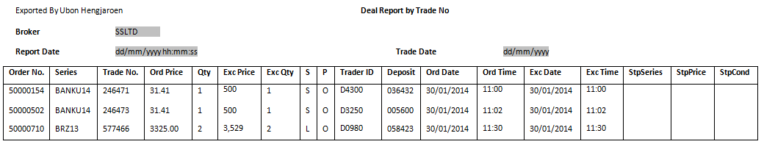
- Deal Report By Series, Trade No.
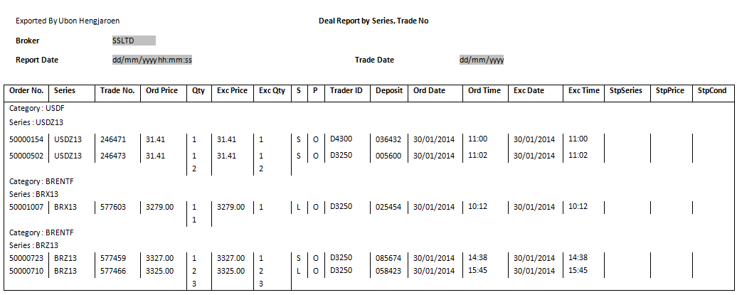

- Deal Report By Order Entry, Trade No.
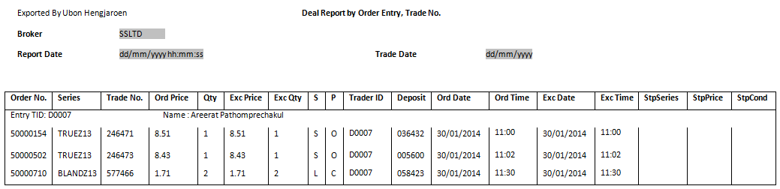
- Deal Report By Order Entry, Series, Trade No.
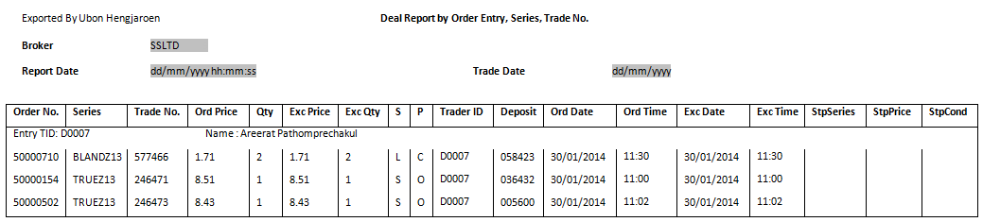
- Deal Report By Deposit, Trade No.
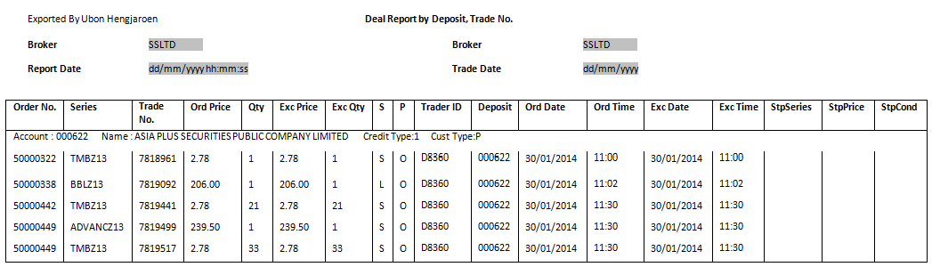
- Deal Report By Deposit, Series, Trade No.
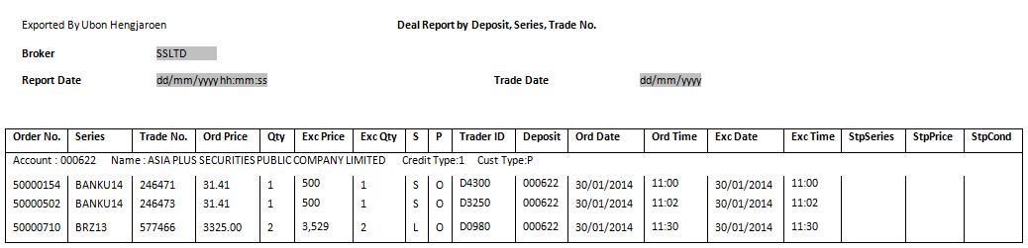

Cancel Order Report

Filename: cancel_by_order_no-<YYYYMMDD>_dev
Report Title: <hardcode as “Cancel Order Report order by Order No.”> at center
Group By: N/A
Order By: Order Number (Ascending Order)
Report Header:
Broker No. <Broker Number>
Broker <Broker Name>
Report Date <Report generated Date in DD/MM/YYYY format>
Trade Date < Date in DD/MM/YYYY format>
Criteria:
- Cancel Date and Report Generation Date
- Cancel Status:
  - Order is cancelled by user
  - Cancelled Order that has been approved by trader
  - Cancel Approve Change by Trader
  - Cancelled Order by Exchange
  - Cancelled Order and Approved
Output Format: text format
Frequency: EOD
Format Delimited: Delimited by 1 space character
No. | Field Name | Description
1. | Order Number | Internal Order Number
2. | TFEX Order No. | TFEX Order Number
3. | S | Side of order  Possible Value are as follows:  - B (Buy)  - S (Sell)
4. | P | Position  Possible Value are as follows:  - O (Open)  - C (Close)
5. | Series | SeriesID
6. | Qty | Quantity
7. | Pub | Publish
8. | Matched | Matched Quantity
9. | Price | Price of Series.
10. | Order Trader ID | Trader ID
11. | Ord Date | Order Entry Date
12. | Ord Time | Order Entry Time
13. | Cancel Trader ID | Cancel Trader ID
14. | Deposit | Customer Account
15. | Ord St | Order Status
16. | Cancel Date | Cancel Date
17. | Cancel Time | Cancel Time
18. | Valid | Order is valid till.  Possible Values are as follows:  - Day = Good Till Day (Default Value)  - Date = Good Till Date  - Cancel = Good Till Cancel  - FAK = Fill And Kill  - FOK = Fill Or Kill  - GTT = Good Till Time  - GTS = Good Till Session  GTA = Good Till Next Auction
19. | VDate | Valid Date
20. | StSec | Stop SeriesID
21. | StPrice | Stop Price
22. | StCond | Stop Condition for this series

Cancel Order Report Example

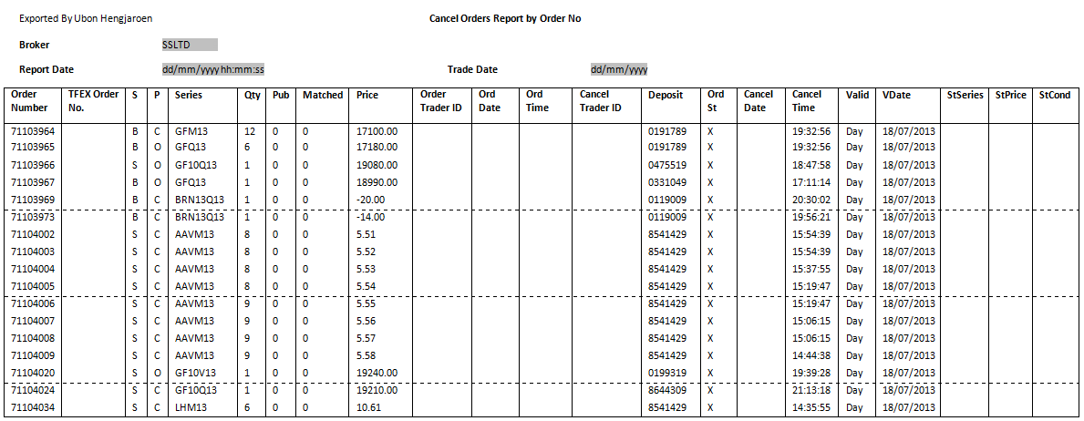

Change Order Report
Change Order report is report to provide order information that was changed

Filename: change_by_order_no-<YYYYMMDD>_dev
Report Title: <hardcode as “Change Order Report order by Order No.”> at center
Group By: N/A
Order By: Order Number
Report Header:
Broker No. <Broker Number>
Broker <Broker Name>
Report Date <Report generated Date in DD/MM/YYYY format>
Trade Date <Date” in DD/MM/YYYY format>
Criteria: Modified Status
  - Change
  - Change (Approve)
Output Format: text format
Frequency: EOD
Format Delimited: Delimited by 1 space character

No. | Field Name | Description
1. | Chg Time | Change Order Time
2. | Order Trader ID | Order Trader ID
3. | Change Trader ID | Change Trader ID
4. | S | Side of Order
5. | Series | SeriesID
6. | O-Order No. | Old Order Number
7. | O-Deposit | Old Customer Account
8. | O-Pos | Old Position
9. | O-Price | Old Price
10. | O-Qty | Old Quantity
11. | O-Pub | Old Publish
12. | O-Status | Old Status
13. | N-Order No. | New Order Number
14. | N-Deposit | New Customer Account
15. | N-Pos | New Position
16. | N-Price | New Price
17. | N-Qty | New Quantity
18. | N-Pub | New Publish
19. | N-Status | New Status

Change Orders Report Example
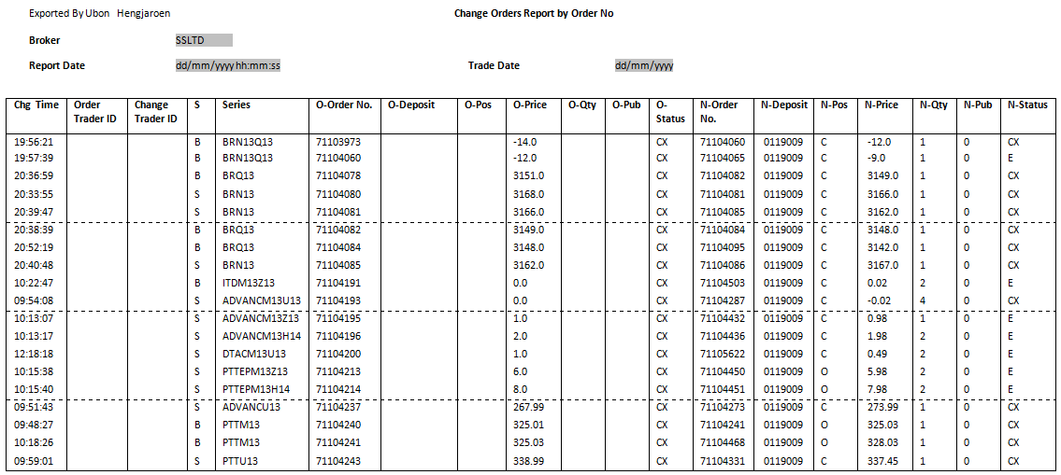

Orders & Confirmation Report
This report will provide the order and confirmation information in different grouping. We provide brokers for 4 reports of Order & Confirmation Report
- Order & Confirmation Report order by Order No.
- Order & Confirmation Report by Order Trader ID, Deposit, Side and Order No.
- Order & Confirmation Report by Trader ID, Deposit, Side and Order No.
- Order & Confirmation Report by Deposit and Order No.

Filename, report title, report header, report group by and report order vary in different reports as below:-
- Order & Confirmation Report by Order No.
Filename: order_confirm_by_order_no-<YYYYMMDD>_dev
Report Title: <hardcode as “Order & Confirmation Report order by Order Entry”> at center
Group By: N/A
Order By: Order Number (Ascending Order)
- Order & Confirmation Report by Order Trader ID, Deposit, Side and Order No.
Filename: order_confirm_by_orderid_dep_ord-<YYYYMMDD>_dev
Report Title: <hardcode as “Order & Confirmation Report by Order Trader ID, Deposit and Order No.”> at center
Group By:
Order By:
- Order & Confirmation Report by Trader ID, Deposit, Side and Order No.
Filename: order_confirm_by_trader_dep_s_ord-<YYYYMMDD>_dev
Report Title: <hardcode as “Order & Confirmation Report by Trader ID, Deposit, Side and Order No.”> at center
Group By: Trader ID, Deposit
Order By: Side (Ascending Order) and then Order Number (Ascending Order)
- Order & Confirmation Report by Deposit and Order No.
Filename: order_confirm_by_dep_ord_no-<YYYYMMDD>_dev
Report Title: <hardcode as “Order & Confirmation Report by Deposit and Order No.”> at center
Group By: Account Number
Order By: Order Number (Ascending Order)

However, all order & confirmation reports are common in following dimensions:-
Criteria:
- Order Entry Date and Report Generation Date
- Trading Board is Main
- All Order Status
Report Header:
Broker No. <Broker Number>
Broker <Broker Name>
Report Date <Report generated Date in DD/MM/YYYY format>
Trade Date <“Date” in DD/MM/YYYY format>
Output Format: text format
Frequency: EOD
Format Delimited: Delimited by 1 space character
No. | Field Name | Description
1. | Order No. | Order Number
2. | S | Side of order  Possible Value are as follows:  - B (Buy)  - S (Sell)
3. | P | Position  Possible Value are as follows:  - O (Open)  - C (Close)
4. | Series | SeriesID
5. | Qty | Quantity
6. | Matched | Matched Quantity
7. | Price | Price of Series(average matched)
8. | Ord Time | Order Entry Time
9. | Trader ID | Trader ID
10. | Deposit | Customer Account Number
11. | Ord St | Order Status
12. | Trade No. | System Trade Number(Market TA eg TN-xx)
13. | D No. | Deal Number( Market No. eg DN-xx)
14. | D Qty | Deal Quantity
15. | D Price | Deal Price
16. | D Time | Deal Time
17. | Valid | Order is valid till.  Possible Values are as follows:  - Day = Good Till Day (Default Value)  - Date = Good Till Date  - Cancel = Good Till Cancel  - FAK = Fill And Kill  - FOK = Fill Or Kill  - GTT = Good Till Time  - GTS = Good Till Session  GTA = Good Till Next Auction
18. | VDate | Valid Date
19. | StSec | Stop SeriesID
20. | StPrice | Stop Price
21. | StCond | Stop Condition for this series
22. | Credit Type | Credit Type
23. | Customer Type | Client Account Type  Possible Value are as follows:  C = Customer  P = Principle (broker deposit)  F = Foreign  I = Institution

Orders & Confirmation Report Example
- Order & Confirmation Report by Order No
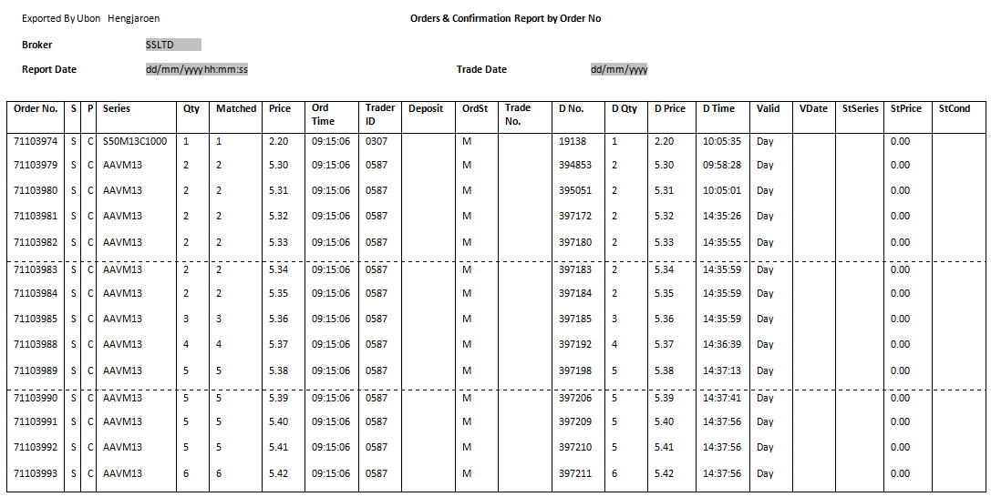
- Order & Confirmation Report by Order Trader ID, Deposit, Side and Order No.
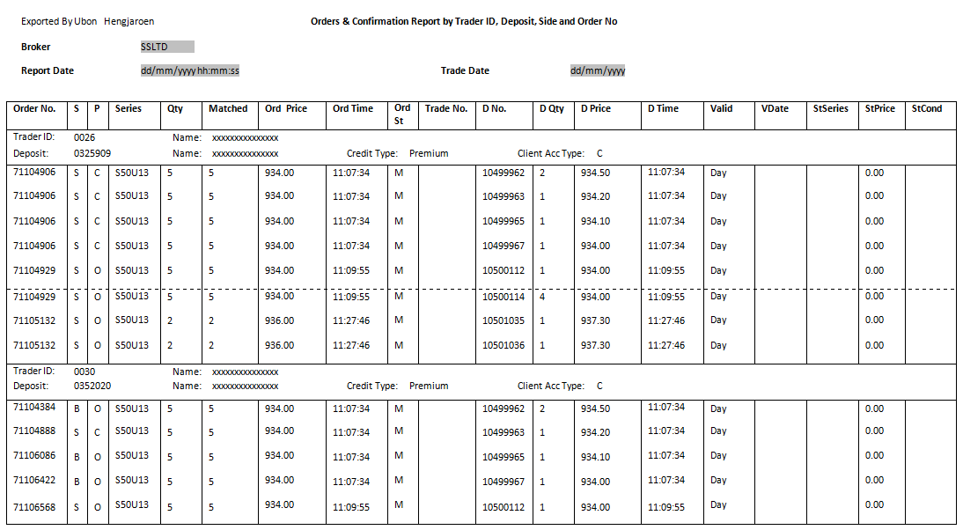
- Order & Confirmation Report by Trader ID, Deposit, Side and Order No.
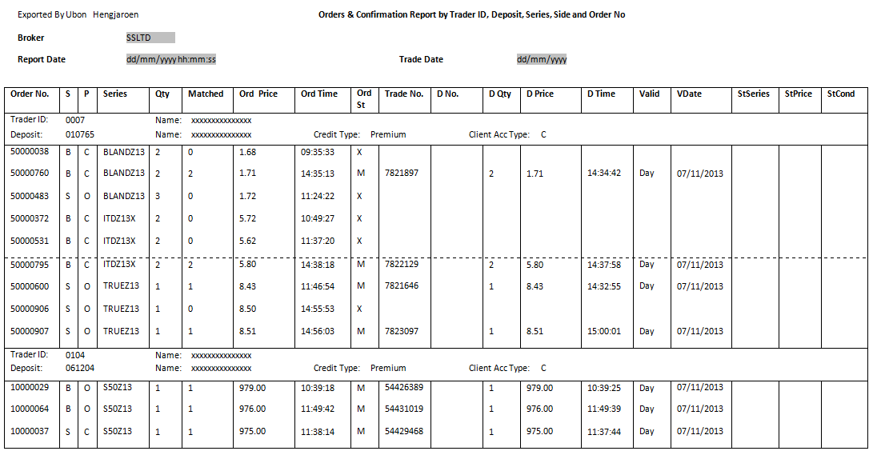
- Order & Confirmation Report by Deposit and Order No.
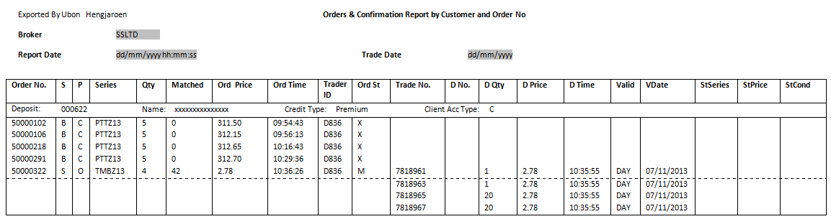

Credit Approved Order Report

Filename: credit_appr_order-<YYYYMMDD>_dev
Report Title: <hardcode as “Credit Approved Orders Report by Order Entry, Appr Trader, Customer, Order No.”> at center
Group By: N/A
Order By: Trader ID (Ascending Order), Approval Trader (Ascending Order), Deposit Number (Ascending Order) and then Order Number (Ascending Order)
Report Header:
Broker No. <Broker Number>
Broker <Broker Name>
Report Date <Report generated Date in DD/MM/YYYY format>
Trade Date <“Date” in DD/MM/YYYY format>
Criteria:
- Order Approved Date and Report Generation Date
- Order Status is Approve for "Max Order Volume and Value Limit"
Output Format: text format
Frequency: EOD
Format Delimited: Delimited by 1 space character
No. | Field Name | Description
1. | Order No. | Order Number
2. | S | Side
3. | P | Position
4. | Series | SeriesID
5. | Qty | Quantity
6. | Matched | Matched Quantity
7. | Price | Price
8. | Trader ID | Trader ID
9. | Deposit | Deposit
10. | St | Status
11. | Date | Date
12. | Time | Time
13. | Valid | Valid
14. | VDate | Valid Date
15. | StSeries | Stop Sec
16. | StPrice | Stop Price
17. | StCond | Stop Condition
Credit Approved Order Report Example
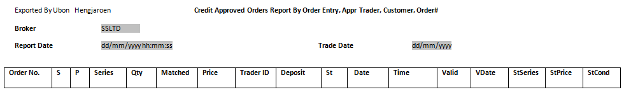

Customer Information Report
Filename: customer_info_report-<YYYYMMDD>_dev
Report Title: <hardcode as “Customer Information Report”> at center
Group By: Customer Account Number
Order By: Order Number
Report Header:
Broker No. <Broker Number>
Broker <Broker Name>
Report Date <Report generated Date in DD/MM/YYYY format>
Trade Date <“Date” in DD/MM/YYYY format>
Deposit <Customer Account Number>
Customer Name <Customer Name>
Long Limit <Customer Long Limit>
Short Limit <Customer Short Limit>
Deposit Type <Deposit Type>
Client Acc Type <Customer Account Type>
Credit Type <Credit Type>
Criteria: Trade date and Report Generation Date
Output Format: text format
Frequency: EOD
Format Delimited: Delimited by 1 space character
No. | Field Name | Description
1. | Order No. | Order Number
2. | S | Side
3. | Series | SeriesID
4. | Quantity | Quantity
5. | Price | Price
6. | Matched | Matched Quantity
7. | Status | Status
8. | D Quantity | Deal Quantity
9. | D Price | Deal Price
10. | P | Position
11. | Total Bought Quantity | Total Bought Quantity
12. | Average Bought Price | Average Bought Price
13. | Total Sold Quantity | Total Sold Quantity
14. | Average Sold Price | Average Sold Price
15. | Total Bought Amount | Total Bought Amount
16. | Total Sold Amount | Total Sold Amount

Customer Information Report Example
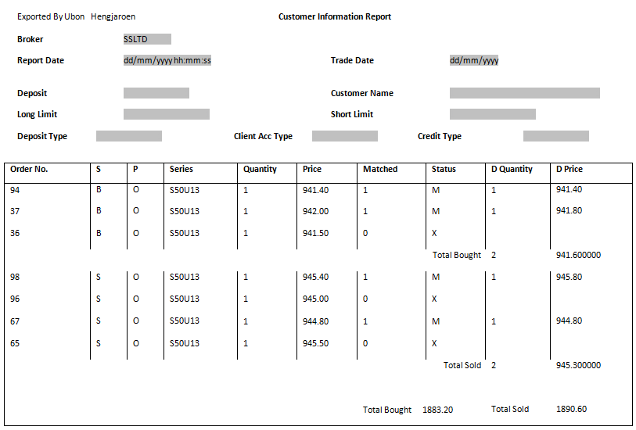

Rectified Report

Filename: rectified-<YYYYMMDD>_dev
Report Title: <hardcode as “Rectified Report”> at center
Group By: N/A
Order By: Order Number (Ascending Order)
Report Header:
Broker No. <Broker Number>
Broker <Broker Name>
Report Date <Report generated Date in DD/MM/YYYY format>
Trade Date <“Date” in DD/MM/YYYY format>
Criteria: Rectified Date and Report Generation Date
Output Format: text format
Frequency: EOD
Format Delimited: Delimited by 1 space character
No. | Field Name | Description
1. | Series | SeriesID
2. | Order Number | Internal Order Number
3. | Ledger Seq No | Clearing Number (Key fields of Clearing)
4. | Position | Position  Possible Value are as follows:  - O (Open)  - C (Close)
5. | Side | Side of order.  Possible Value are as follows:  - B (Buy)  - S (Sell)
6. | Qty | Quantity
7. | Price | Price of Series. Support both Limit Price and Market Price  Possible Value are as follows:  - 700.10 (Limit Price)  - MP (Market Price)
8. | Deposit | Customer Account
9. | Rectify-Series | Rectified SeriesID
10. | Rectify-P | Rectified Position  Possible Value are as follows:  - O (Open)  - C (Close)
11. | Rectify-Qty | Rectified Quantity
12. | Rectify-Account | Rectified Customer Account

Rectified Report Example
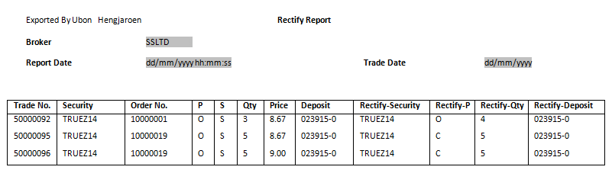

Take up Report
Filename: take_up-<YYYYMMDD>_dev
Report Title: <hardcode as “Take Up Report”> at center
Group By: N/A
Order By: Order Number (Ascending Order)
Report Header:
Broker No. <Broker Number>
Broker <Broker Name>
Report Date <Report generated Date in DD/MM/YYYY format>
Trade Date <“Date” in DD/MM/YYYY format>
Criteria: Take Up Date and Report Generation date
Output Format: text format
Frequency: EOD
Format Delimited: Delimited by 1 space character
No. | Field Name | Description
1. | Order No. | Internal Order Number
2. | Confirm No. | Confirm Number
3. | Trade No. | Trade Number
4. | Order Type | Order Type
5. | S | Side of order.  Possible Value are as follows:  - B (Buy)  - S (Sell)
6. | P | Position
7. | Series | Series ID
8. | D Qty | Deal Quantity
9. | D Price | Deal Price
10. | D Time | Deal Time
11. | Deposit | Customer Account
12. | Client Acc Type | Client Account Type  Possible Value are as follows:  C = Customer  P = Principle (broker deposit)  F = Foreign  I = Institution
13. | Take Up Time | Take Up Time

Take up Report Example
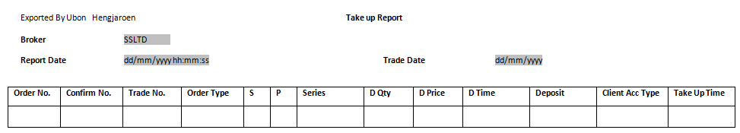

Give up Report
Filename: give_up-<YYYYMMDD>_dev
Report Title: <hardcode as “Give Up Report”> at center
Group By: N/A
Order By: Order Number (Ascending Order)
Report Header:
Broker No. <Broker Number>
Broker <Broker Name>
Report Date <Report generated Date in DD/MM/YYYY format>
Trade Date <“Date” in DD/MM/YYYY format>
Criteria: Give Up Date and Report Generation date
Output Format: text format
Frequency: EOD
Format Delimited: Delimited by 1 space character
No. | Field Name | Description
1. | Order No. | Internal Order Number
2. | TFEX Ord No. | TFEX Order Number
3. | Confirm Number | Confirm Number
4. | Trade No. | Trade Number
5. | Order Type | Order Type
6. | S | Side of order.  Possible Value are as follows:  - B (Buy)  - S (Sell)
7. | P | Position
8. | Series | SeriesID
9. | D Qty | Quantity
10. | D Price | Price of confirm
11. | D Time | Deal Time
12. | Deposit | Customer Account
13. | Client Acc Type | Client Account Type
14. | Give Up Time | Give Up Time
15. | New TCH Account | New Clearing House Account

Give up Report Example
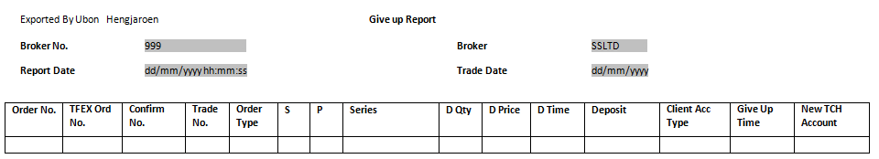

Split Report
Filename: split_report-<YYYYMMDD>_dev
Report Title: <hardcode as “Split Report”> at center
Group By: N/A
Order By: Order Number (Ascending Order)
Report Header:
Broker No. <Broker Number>
Broker <Broker Name>
Report Date <Report generated Date in DD/MM/YYYY format>
Trade Date <“Date” in DD/MM/YYYY format>
Criteria: Rectified Date and Report Generation Date
Output Format: text format
Frequency: EOD
Format Delimited: Delimited by 1 space character
No. | Field Name | Description
1. | Order No. | Order Number
2. | Old Ord No. | Old Order Number
3. | TFEX Ord No. | TFEX Order Number
4. | Confirm No. | Confirm Number
5. | Trade No. | Trade Number
6. | Old Trade No. | Old Trade Number
7. | Order Type | Order Type
8. | S | Side
9. | P | Position
10. | Series | Series
11. | D Qty | Deal Quantity
12. | D Price | Deal Price
13. | D Time | Deal Time
14. | Deposit | Deposit
15. | Client Acc Type | Client Account Type
16. | Split Time | Split Time
17. | Split Qty | Split Quantity

Split Report Example
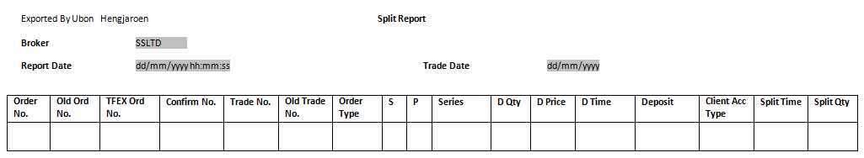

Cancelled Expired Order Report
Filename: cancelled_order_report-<YYYYMMDD>_dev
Report Title: <hardcode as “Cancelled Expired Order Report”> at center
Group By: N/A
Order By: Order No.
Report Header:
Broker No. <Broker Number>
Broker <Broker Name>
Report Date <Report generated Date in DD/MM/YYYY format>
Trade Date <“Date” in DD/MM/YYYY format>
Criteria:
- Order Cancel Date and Report Generation Date
- Orders that are cancelled because of date expires
Output Format: text format
Frequency EOD
Format Delimited: Delimited by 1 space character
No. | Field Name | Description
1. | Order No. | Order Number
2. | Ord Date | Order Date
3. | TFEX Order No. | TFEX Order No.
4. | S | Side
5. | Series | SeriesID
6. | P | Position
7. | Qty | Quantity
8. | Match | Match Quantity
9. | Price | Price
10. | Deposit | Customer Account Number
11. | Trader ID | Trader ID
12. | St | Status
13. | Cancel Time | Cancelled Time
14. | Valid | Valid
15. | VDate | Valid Date

Cancelled Expired Order Report Example
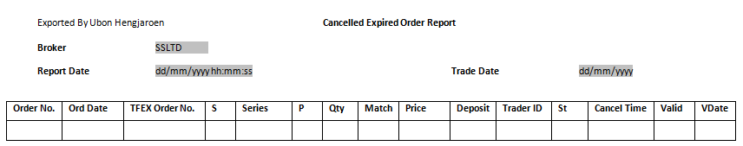

Call Report
Filename: call_report-<YYYYMMDD>_dev
Report Title: <hardcode as “Call Report By Trader ID”> at center
Group By: Trader ID
Order By: Account Number
Report Header:
Broker No. <Broker Number>
Broker <Broker Name>
Report Date <Report generated Date in DD/MM/YYYY format>
Trade Date <“Date” in DD/MM/YYYY format>
Criteria: Call Margin Account and Report Generation Date
Output Format: text format
Frequency: EOD
Format Delimited: Delimited by 1 space character

No. | Field Name | Description
1. | Deposit | Customer Account Number
2. | Cash Balance | Cash Balance
3. | Floating | Floating
4. | Equity Balance | Equity Balance
5. | Margin Balance | Margin Balance
6. | Unreal P&L | Unrealized Profit & Loss
7. | Unreal MB | Unrealized MB (Margin Balance minus Unrealized Profit & Loss)
8. | Total MM | Total Maintenance Margin
9. | Call Amount | Call Amount

Call Report Example
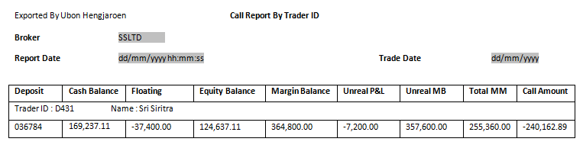

Force Report
Filename: force_report-<YYYYMMDD>_dev
Report Title: <hardcode as “Force Report By Trader ID”> at center
Group By: Trader ID
Order By: Account Number
Report Header:
Broker No. <Broker Number>
Broker <Broker Name>
Report Date <Report generated Date in DD/MM/YYYY format>
Trade Date <“Date” in DD/MM/YYYY format>
Criteria: Force Margin Account and Report Generation Date
Output Format: text format
Frequency: EOD
Format Delimited: Delimited by 1 space character

No. | Field Name | Description
1. | Deposit | Customer Account Number
2. | Cash Balance | Cash Balance
3. | Floating | Floating
4. | Equity Balance | Equity Balance
5. | Margin Balance | Margin Balance
6. | Unreal P&L | Unrealized Profit & Loss
7. | Unreal MB | Unrealized MB (Margin Balance minus Unrealized Profit & Loss)
8. | Force Level | Force Level
9. | Force Amount | Force Amount

Force Report Example
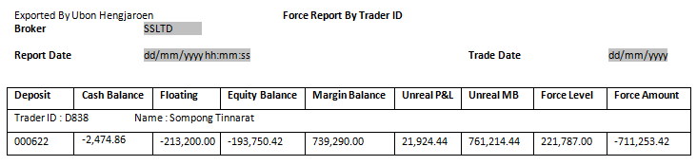

Open Orders Report
Filename: open_orders_eport-<YYYYMMDD>_dev
Report Title: <hardcode as “Open Orders Report By Customer, Order Entry, Series and Order No.”> at center
Group By: Deposit and Trader ID
Order By: Series (Ascending Order) and then Order Number (Ascending Order)
Report Header:
Broker No. <Broker Number>
Broker <Broker Name>
Report Date <Report generated Date in DD/MM/YYYY format>
Trade Date <“Date” in DD/MM/YYYY format>
Criteria: Order Status is open
Order Date and Report Generation Date
Output Format: text format
Frequency: EOD
Format Delimited: Delimited by 1 space character

No. | Field Name | Description
1. | Order No. | Order Number
2. | S | Side
3. | P | Position
4. | Series | SeriesID
5. | Qty | Quantity
6. | Pub | Publish Quntity
7. | Match | Match Quantity
8. | Price | Price
9. | Trader ID | Trader ID
10. | St | Status
11. | Date | Order Date
12. | Time | Order Time
13. | Valid | Valid
14. | VDate | Valid Date
15. | StSec | Stop Series
16. | StPrice | Stop Price
17. | StCond | Stop Condition

Open Orders Report Example
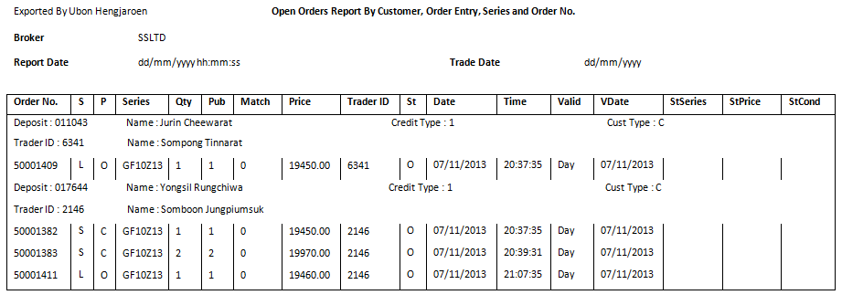

Mark to Market Report
Filename: mark_to_market_report-<YYYYMMDD>_dev
Report Title: <hardcode as “Mark to market Report By Trader ID, Customer, Series, Side”> at center
Group By: Trader ID and Account Number
Order By: Series (Ascending Order) and then Side (Ascending Order)
Report Header:
Broker No. <Broker Number>
Broker <Broker Name>
Report Date <Report generated Date in DD/MM/YYYY format>
Trade Date <“Date” in DD/MM/YYYY format>
Criteria: Mark to Market Account and Report Generation Date
Output Format: text format
Frequency: EOD
Format Delimited: Delimited by 1 space character

No. | Field Name | Description
1. | S | Side
2. | Series | SeriesID
3. | Sellable Qty | Sellable Quantity
4. | Mark Avg | Market Average Price
5. | Last Sale | Last Sale
6. | Unreal PL | Unrealized Profit & Loss
7. | Floating | Floating
8. | Total Unreal PL | Total Unrealized Profit & Loss
9. | Margin Balance | Margin Balance
10. | Cash Balance | Cash Balance
11. | Unrealized Margin Balance | Unrealized Margin Balance
12. | EE Balance | EE Balance
13. | Equity Balance | Equity Balance
14. | Before Cash/Excess or Insuff cash or Call/Force Flag, Margin | Before Cash/Excess or Insufficient cash or Call/Force Flag, Margin
15. | After Cash Call/Force Flag Margin | After Cash Call/Force Flag Margin

Mark to market Report Example
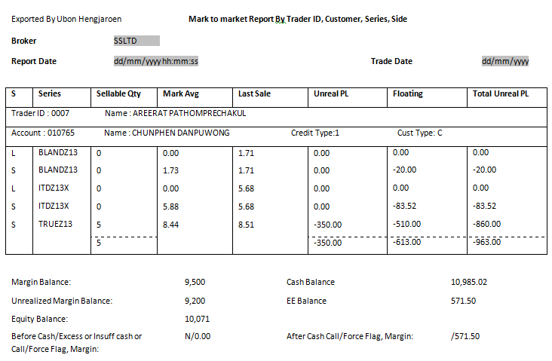

Deny/Exercise Request
Filename: deny_exercise_request_report-<YYYYMMDD>_dev
Report Title: <hardcode as “Deny/Exercise Request By Order No.”> at center
Group By: N/A
Order By: Order Number
Report Header:
Broker No. <Broker Number>
Broker <Broker Name>
Report Date <Report generated Date in DD/MM/YYYY format>
Trade Date <“Date” in DD/MM/YYYY format>
Criteria: Deny Request Date and Report Generation Date
Exercise Request Date and Report Generation Date
Output Format: text format
Frequency: EOD
Format Delimited: Delimited by 1 space character

No. | Field Name | Description
1. | Order No. | Order Number
2. | Time | Time
3. | Series | SeriesID
4. | S | Side
5. | P | Position
6. | Qty | Quantity
7. | St | Status
8. | Deposit | Customer Account Number
9. | Trader ID | Trader ID
10. | Total Exercise Request | Total Exercise Request (Quantity)
11. | Total Deny Request | Total Deny Request (Quantity)

Deny/Exercise Request Report Example
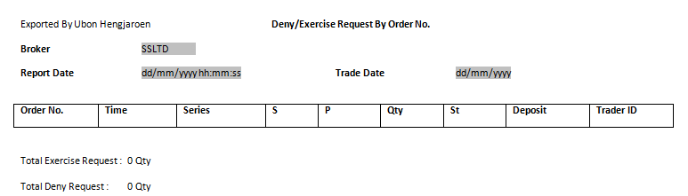

Equity Retail Reports
For Equity Retail reports, system will generate only equity instrument.

Credit Approved Order Report
Filename: credit_appr_order_<YYYYMMDD>_Retail
Report Title: <hardcode as “Credit Approved Orders Report by Order Entry, Appr Trader, Customer, Order No.”> at center
Group By: N/A
Order By: Trader ID (Ascending Order), Approval Trader (Ascending Order), Deposit Number (Ascending Order) and then Order Number (Ascending Order)
Report Header: Broker No. <Broker Number>
Broker <Broker Name>
Report Date <Report generated Date in DD/MM/YYYY hh:mm:ss 24hrs format>
Trade Date <“Date” in DD/MM/YYYY format>
Criteria: Order Approved Date and Report Generation Date
Order Status is Approve for "Max Order Volume and Value Limit"
Output Format: text format
Frequency: EOD
Format Delimited: Delimited by 1 space character
No. | Field Name | Description
1. | Order No. | Order Number
2. | S | Side
3. | P | Position
4. | Series | SeriesID
5. | Qty | Quantity
6. | Matched | Matched Quantity
7. | Price | Price
8. | Trader ID | Trader ID
9. | Deposit | Deposit
10. | St | Status
11. | Date | Date
12. | Time | Time
13. | Valid | Valid
14. | VDate | Valid Date
15. | StSeries | Stop Sec
16. | StPrice | Stop Price
17. | StCond | Stop Condition

Credit Approved Order Report Example

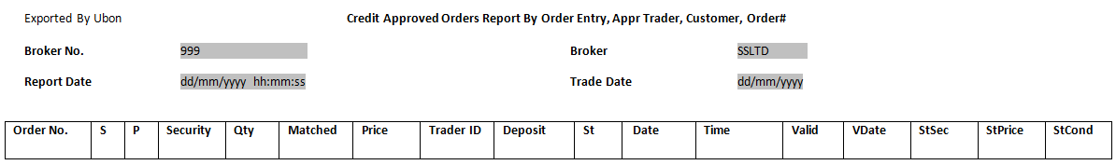

Trader Information Report
Filename: pr_trad_<YYYYMMDD>_Retail
Report Title: <hardcode as “Trader Information”> at center
Group By: N/A
Order By: Trader ID (Ascending Order)
Report Header: Report Date <Report generated Date in DD/MM/YYYY HH:MM PM/AM format>
Trade Date <“Date” in DD/MM/YYYY format>
Page <Page Number>
Criteria: Trader ID and Report Generation Date
Output Format: text format
Frequency: EOD
Format Delimited: Delimited by 1 space character
Footer: Sum of total Trader ID

No. | Field Name | Description
1. | T_ID | Trader ID
2. | Type | Trader Type  S = Super Manager (trader can see all transaction)  M = Marketing (trader group manager but permissions depend on fields setting)  T = Trader (mostly is Entry Trader)
3. | Level | Level on trader hierarchy
4. | Name | Name of the Trader
5. | SET_ID | SET unique ID
6. | SUP_ID | Supervisor-Trader ID
7. | GRP ID | Trader Group ID
8. | BR_ID | Branch ID
9. | PC_APP | Percent approval
10. | BUY_CREDIT | Credit used for Buy Order
11. | SELL_CREDIT | Credit used for Sell Order
12. | AUTH_CREDIT | Authorised Credit for the Trader
13. | CHG_FLAG | Flag identified if trader is allowed to change order’s account

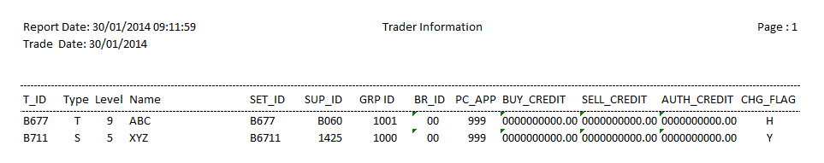

Trader Audit Report

Filename: taudit_<YYYYMMDD>_Retail
Report Title: <hardcode as “Trader Audit Report”> at center
Group By: N/A
Order By: Trader ID (Ascending Order)
Report Header: Report Date <Report generated Date in DD/MM/YYYY HH:MM PM/AM format>
Trade Date <“Date” in DD/MM/YYYY format>
Page <Page Number>
Criteria: Trader ID and Report Generation Date
Output Format: text format
Frequency: EOD
Format Delimited: Delimited by 1 space character
Footer: Sum of total Trader ID

No. | Field Name | Description
1. | User-ID | Trader ID
2. | Name | Name of the Trader
3. | TYPE | Trader Type  S = Super Manager (trader can see all transaction)  M = Marketing (trader group manager but permissions depend on fields setting)  T = Trader (mostly is Entry Trader)
4. | GR-ID | Trader Group ID
5. | BR-ID | Branch ID
6. | SUP-ID | Supervisor-Trader ID
7. | SET-ID | SET unique ID
8. | CHG-ORD | Allow to Change Order?
9. | KEY-ORD | Allow to Key Order?
10. | VIEW-ORD | Allow to View Order?
11. | EXPIRE-DATE | User expiry date
12. | BUY-AUTH | Credit used for Buy Order
13. | SELL-AUT | Credit used for Sell Order
14. | ST-DAY-AUTH | ST day approval authority
11. | DAY-AUTH | Trader’s day approval authority
12. | PC-APP | Percentage of customer’s over credit that trader can approve

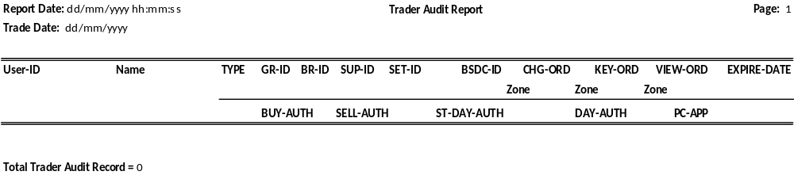

Credit Balance Call Margin Customer Report Margin Portfolio Summary By Account No.

Filename: BOS_CRDTBALCALL_REPORT_<YYYYMMDD>_Retail
Report Title: <hardcode as “CREDIT BALANCE CALL MARGIN CUSTOMER REPORT MARGIN PORTFOLIO SUMMARY BY ACCOUNT NO.”> at center
Group By: N/A
Order By: Account Number (Ascending Order)
Report Header: Report Date: <Generation Date in DD/MM/YYYY HH:MM:SS 24hrs format>
PAGE: <Page Number >
Trade Date: <Date in DD/MM/YYYY format>
Report Name: <hardcode as “BOS_CRDTBALCALL_REPORT.LIS”>
Report Footer: Total <count of Account no.> Record Printed
Criteria: Account No. with Call Margin > 0 and Report Generation Date
Output Format: text format
Frequency: Ad-hoc
Format Delimited: Delimited by 1 space character
No. | Field Name | Description
1. | Account No. | Customer Account Number
2. | T.ID | Trader ID
3. | Asset Cash Balance | Cash Balance
4. | Asset LMV | Long Market Value (No. of Shares x Closing Price)
5. | Asset Collateral | Collateral
6. | Liabilities Loan | Loan
7. | Liabilities SMV | Short Market Value
8. | Equity | Equity
9. | Margin Req. | Margin Require
10. | Excess Equity | Excess Equity (Mark to Market)
10. | Call | Margin Call

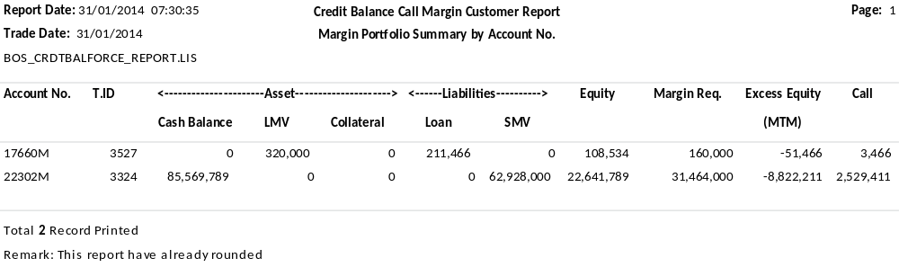

Credit Balance Force Sell Report Margin Portfolio Summary By Account No.

Filename: BOS_CRDTBALFORCE_REPORT.LIS_<YYYYMMDD>_Retail
Report Title: <hardcode as “Credit Balance Call Margin Customer Report Margin Portfolio Summary by Account No.”> at center
Group By: N/A
Order By: Account Number (Ascending Order)
Report Header: Report Date: <Generation Date in DD/MM/YYYY HH:MM:SS 24hrs format>
PAGE: <Page Number >
Trade Date: <Date in DD/MM/YYYY format>
Report Name: <hardcode as “BOS_CRDTBALFORCE_REPORT.LIS”>
Report Footer: Total <count of Account no.> Record Printed
Criteria: Force Sell Value > 0 and Report Generation Date
Output Format: text format
Frequency: Ad-hoc
Format Delimited: Delimited by 1 space character
No. | Field Name | Description
1. | Account No. | Customer Account Number
2. | T.ID | Trader ID
3. | Asset Cash Balance | Cash Balance
4. | Asset LMV | Long Market Value (No. of Shares x Closing Price)
5. | Asset Collateral | Collateral
6. | Liabilities Loan | Loan
7. | Liabilities SMV | Short Market Value
8. | Equity | Equity
9. | Margin Req. | Margin Require
10. | Excess Equity | Excess Equity (Mark to Market)
10. | Force | Force Sell value

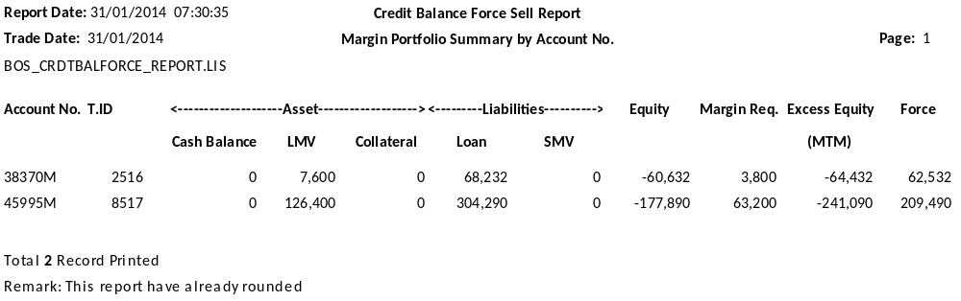

Credit Balance Report Margin Portfolio Summary By Account No.

Filename: BOS_CRDTBAL_REPORT.LIS_<YYYYMMDD>_Retail
Report Title: <hardcode as “Credit Balance Report Margin Portfolio Summary by Account No.”> at center
Group By: N/A
Order By: Account Number (Ascending Order)
Report Header: Report Date: <Generation Date in DD/MM/YYYY HH:MM:SS 24hrs format>
PAGE: <Page Number >
Trade Date: <Date in DD/MM/YYYY format>
Report Name: <hardcode as “BOS_CRDTBAL_REPORT.LIS”>
Report Footer: Total <count of Account no.> Record Printed
Criteria: Account Number and Report Generation Date
Output Format: text format
Frequency: Ad-hoc
Format Delimited: Delimited by 1 space character
No. | Field Name | Description
1. | Account No. | Customer Account Number
2. | T.ID | Trader ID
3. | Asset Cash Balance | Cash Balance
4. | Asset LMV | Long Market Value (No. of Shares x Closing Price)
5. | Asset Collateral | Collateral
6. | Liabilities Loan | Loan
7. | Liabilities SMV | Short Market Value
8. | Equity | Equity
9. | Margin Req. | Margin Require
10. | Excess Equity | Excess Equity (Mark to Market)
10. | Call/Force | Margin Call/Force Sell value

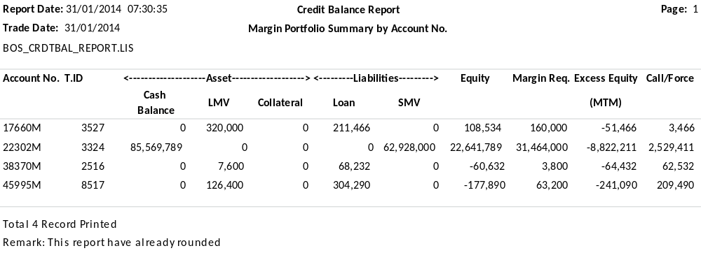

Audit Market Control Term Report

Filename: BOS_CHGMKT_CRTLTERM_RPT_<YYYYMMDD>_Retail
Report Title: <hardcode as “Audit Market Control Term Report”> at center
Group By: N/A
Order By: Time and Account Number (Ascending Order)
Report Header: Report Date: <Generation Date in DD/MM/YYYY HH:MM:SS 24hrs format>
PAGE: <Page Number >
Trade Date: <Date in DD/MM/YYYY format>
Report Name: <hardcode as “BOS_CHGMKT_CRTLTERM_RPT”>
Report Footer: N/A
Criteria: Report Generation Date
Output Format: text format
Frequency: Ad-hoc
Format Delimited: Delimited by 1 space character
No. | Field Name | Description
1. | TIME | Time
2. | FRMNAME | Firm name
3. | CC | Customer credit disable
4. | SM | Stock margin rate default
5. | C | Customer database require
6. | MTID | Approval manager trader id
7. | V | View group only
8. | PC | Price spread check parameter
9. | CT | Check trader login limit
10. | CH | Trader can change order account
11. | MS | Margin account can short sell
12. | PD | Port account can buy ds stock
13. | BUYLMT(KB) | Value for check buy order sel
14. | SELLMT(KB) | Value for check sell order
15. | CD | Check credit when change account
16. | CL | Check upper limit credit
17. | CM | Calculate commission
18. | DL | Enter group root level
19. | DC | Default confirm
20. | PO | Check percent over approve
21. | VP | Check view real posi
22. | NB | Margin can't over buy limit
23. | PN | Set process name
24. | BP | Investor best price save screen
25. | VF | View broker value
26. | MM | Maintenance margin enable
27. | TR | Trustee id rank
28. | SPR | View stock position by line only
29. | LOGNAME | Login name
30. | OF | Order entry flag
31. | MA | All manager can approve order
32. | PK | Percent price check
33. | A | Accumulate credit
34. | MB | Margin account type
35. | D | Display deal by group
36. | H | View history news at main
37. | B | Percent price check board
38. | R | Give back short sell volume
39. | PCC | Percent call
40. | PCF | Percent force sell
41. | M | Market close can change order
42. | PVAT | Percent vat
43. | SPC | Short percent call
44. | SPF | Short percent force
45. | PAV | Percent price prior advantage
46. | PAD | Percent price prior disadvantage
47. | EAV | Percent price execute advantage
48. | EAD | Percent price execute disadvantage
49. | LAV | Percent price local advantage
50. | LAD | Percent price local disadvantage
51. | X | Order cancel display message
52. | G | Order entry by group
53. | Brk. Portfolio | Broker portfolio value
54. | Ac.Pct | Percent limit credit balance acc.
55. | BrkPct | Percent limit for all margin.
56. | SecPct | Percent limit of stock for margin.
57. | LA | Level for force sell alert sound.
58. | PE | Percent margin for calculate est. pp.
59. | CS | CS
60. | CO | CO
61. | CR | CR
62. | ES | ES
63. | TRO | TRO
64. | PD | Port account can buy ds stock

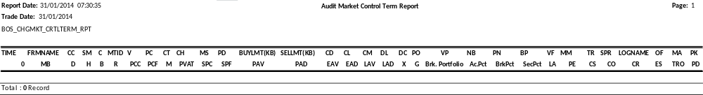

Audit User Report (Trader)

Filename: BOS_CHGUSER_RPT_<YYYYMMDD>_Retail
Report Title: <hardcode as “Audit User Report (Trader)”> at center
Group By: N/A
Order By: Time and Trader ID (Ascending Order)
Report Header: Report Date: <Generation Date in DD/MM/YYYY HH:MM:SS 24hrs format>
PAGE: <Page Number >
Trade Date: <Date in DD/MM/YYYY format>
Report Name: <hardcode as “BOS_CHGUSER_RPT”>
Report Footer: N/A
Criteria: Amendment on Trader information and Report Generation Date
Output Format: text format
Frequency: Ad-hoc
Format Delimited: Delimited by 1 space character
No. | Field Name | Description
1. | TIME | Time
2. | USRNO | Trader ID
3. | USERNAME | Username
4. | SUNO | Supervisor ID
5. | OVER/LIMIT | Override approval limit
6. | PCOVER | Percent override approval
7. | PRN | Confirm printer
8. | OPRN | Order printer
9. | LLM | Login limit
10. | T | User type
11. | PASSW | Password
12. | BRN | Branch license
13. | FS | Sub-broker flag
14. | SS | Short sell flag
15. | OE | Order entry
16. | OPA | Order entry port only
17. | SVO | Special view order
18. | DEFCUSTID | Default customer id
19. | LOINNAME | Login name
20. | F | Status flag
21. | ODS | Order entry default stock
22. | TITLE | Title name
23. | TS | Trading short flag
24. | TC | Trader can change account
25. | ACCOVER | Accumulate credit
26. | TM | Timer update screen
27. | OS | Order entry style
28. | Q | Order entry seq.
29. | V | Criteria view order
30. | S | Adjust short
31. | L | Level view brk-val
32. | G | Display in group
33. | SBST | Stabilize stock
34. | TP | Check percent price
35. | E | Disable message
36. | H | View head group
37. | P | Trader can change port
38. | A | Approve level
39. | GRP_H | Group head
40. | B | Special bbo
41. | R | Set right as user
42. | V_GRP | View head group

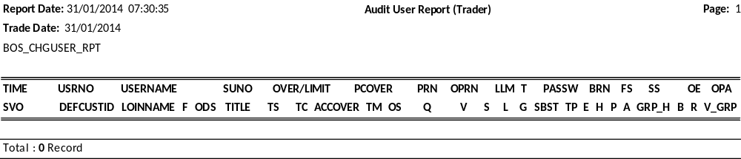

Customer Activity Over Credit

Filename: BOS_CUSTACTIVITY_OVERCRDT_RPT.LIS_<YYYYMMDD>_Retail
Report Title: <hardcode as “Customer Activity Over Credit”> at center
Group By: N/A
Order By: Time and Order Number (Ascending Order)
Report Header: Report Date: <Generation Date in DD/MM/YYYY HH:MM:SS 24hrs format>
PAGE: <Page Number >
Trade Date: <Date in DD/MM/YYYY format>
Report Name: <hardcode as “BOS_CUSTACTIVITY_OVERCRDT_RPT.LIS”>
Cust Id: <Customer ID>
Name: <Customer Name>
Credit Line: <Credit Line>
Owner Tid: <Owner Trade ID>
Begin BuyLmt: <Initial Buy Limit given>
Avl. BuyLmt: <Available Buy Limit>
Begin HighLmt: <Initial High Limit>
HighLmt: <High Limit>
Comm. Type: <Commission Type>
Report Footer: N/A
Criteria: Customer ID and Report Generation Date
Output Format: text format
Frequency: Ad-hoc
Format Delimited: Delimited by 1 space character
No. | Field Name | Description
1. | Time | Time
2. | Code | O = Open Order  A = Approval Order  X = Cancel Order  R = Reject Order  M = Deal Confirm  C = Change Account  Z = Credit Adjust  P = Put-through deal
3. | Side | Buy/Sell
4. | Order# | Order Number
5. | St | Order Status
6. | Series | Series Name
7. | Volume | Number of Series
8. | Price | Price Traded
9. | Value | Volume x Price
10. | Comm&VAT | Commission + VAT
11. | Avl. BuyLmt | Available Buy Limit
12. | Cnfrm Entry | Confirmation Entry code
13. | A-Tid | Trader ID
14. | OldCust | Old Customer ID
15. | Short | Short Limit
16. | High Limit | High Limit

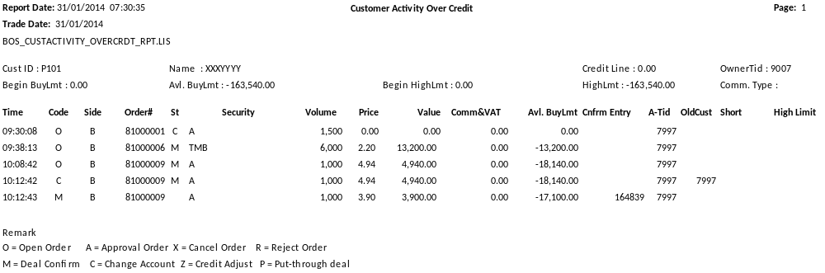

Customer Activity

Filename: BOS_CUSTACTIVITY_RPT.LIS_<YYYYMMDD>_Retail
Report Title: <hardcode as “CUSTOMER ACTIVITY”> at center
Group By: Customer ID
Order By: Time and Order Number (Ascending Order)
Report Header: Report Date: <Generation Date in DD/MM/YYYY HH:MM:SS 24hrs format>
PAGE: <Page Number >
Trade Date: <Date in DD/MM/YYYY format>
Report Name: <hardcode as “BOS_CUSTACTIVITY_RPT.LIS”>
Cust Id: <Customer ID>
Name: <Customer Name>
Credit Line: <Credit Line>
Owner Tid: <Owner Trade ID>
Begin BuyLmt: <Initial Buy Limit given>
Avl. BuyLmt: <Available Buy Limit>
Begin HighLmt: <Initial High Limit>
HighLmt: <High Limit>
Comm. Type: <Commission Type>
Report Footer: N/A
Criteria: Customer ID and Report Generation Date
Output Format: text format
Frequency: Ad-hoc
Format Delimited: Delimited by 1 space character
No. | Field Name | Description
1. | Time | Time
2. | Code | O = Open Order; A = Approval Order; X = Cancel Order; R = Reject Order;  M = Deal Confirm; C = Change Account; Z = Credit Adjust; P = Put-through deal
3. | Side | Buy/Sell
4. | Order# | Order Number
5. | St | Order Status
6. | Series | Series Name
7. | Volume | Series Quantity
8. | Price | Price Traded
9. | Value | Volume x Price
10. | Comm&VAT | Commission + VAT
11. | Avl. BuyLmt | Available Buy Limit
12. | Cnfrm Entry | Confirmation Entry code
13. | A-Tid | Trader ID
14. | OldCust | Old Customer ID
15. | Short | Short Limit
16. | High Limit | High Limit

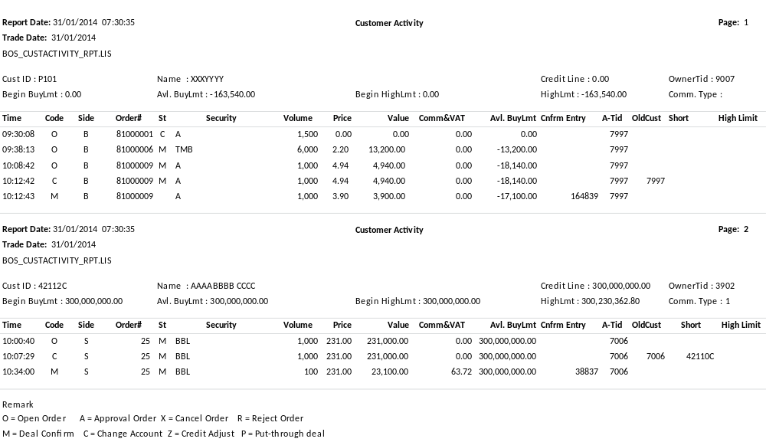

Order Margin Value Report

Filename: BOS_ORDMRGVALUE_RPT.LIS_<YYYYMMDD>_Retail
Report Title: <hardcode as “ORDER MARGIN VALUE REPORT”> at center
Group By: N/A
Order By: Order Number (Ascending Order)
Report Header: Report Date: <Generation Date in DD/MM/YYYY HH:MM:SS 24hrs format>
PAGE: <Page Number >
Trade Date: <Date in DD/MM/YYYY format>
Report Name: <hardcode as “BOS_ORDMRGVALUE_RPT.LIS”>
Report Footer: Total <count of Order no.> Orders was Printed.
Criteria: Order Number and Report Generation Date
Output Format: text format
Frequency: Ad-hoc
Format Delimited: Delimited by 1 space character
No. | Field Name | Description
1. | Ord No. | Order Number
2. | Time | Time
3. | Stock | Stock name
4. | Side | Buy/Sell
5. | Status | Order Status
6. | Volume | Volume
7. | Price | Price
8. | Value | Volume x Price
9. | Comm+VAT | Commission + VAT
10. | Net | Total sum of Buy and Sell Order
11. | B/S | Buy/Sell
12. | Value | Total Value Payable by customer
13. | Use-Dept | Use-Dept
14. | Mrg-Rate | Margin Rate
15. | Mrg-Value | Margin Value
16. | Conf No. | Confirmation Number
17. | Time | Time of the confirmation
18. | Match Volume | Matched Quantity
19. | Price | Matched Price
20. | Value | Matched Quantity x Matched Price

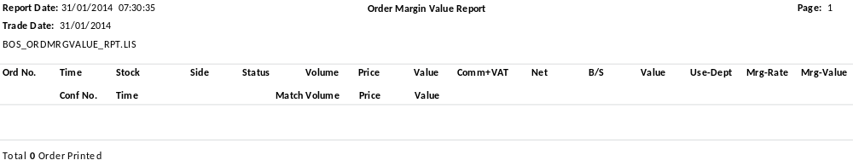

Report For Short Sell Order Use Foreign

Filename: BOS_USEFOREIGN_RPT.LIS_<YYYYMMDD>_Retail
Report Title: <hardcode as “Report For Short Sell Order Use Foreign”> at center
Group By: Trader ID
Order By: Order Number (Ascending Order)
Report Header: Report Date: <Generation Date in DD/MM/YYYY HH:MM:SS 24hrs format>
PAGE: <Page Number >
Trade Date: <Date in DD/MM/YYYY format>
Report Name: <hardcode as “BOS_USEFOREIGN_RPT.LIS”>
Report Footer: N/A
Criteria: Trader ID and Report Generation Date
Output Format: text format
Frequency: Ad-hoc
Format Delimited: Delimited by 1 space character
No. | Field Name | Description
1. | Entry | Trader ID
2. | Order No. | Order Number
3. | Time | Time
4. | Stock | Stock name
5. | B/S | Buy/Sell
6. | Stat | Order Status
7. | Volume | Order Volume
8. | Normal-Vol | Non Foreign Volume
9. | Foreign-Vol | Foreign Volume
10. | Short | Short
11. | Price | Price
12. | Matched | Volume Matched
13. | Normal-Used | Non Foreign order matched value (Matched x Normal Volume)
14. | Foreign-Used | Foreign order matched value (Matched x Foreign Volume)
15. | Short-Used | Short order matched value (Matched x Short)
16. | Owner Trader ID | Trader ID
17. | Name | Trader Name
18. | Customer | Customer ID
19. | Name | Customer Name
20. | Type | Customer Type
21. | Credit Type | Credit Type
22. | Credit Line | Credit Line

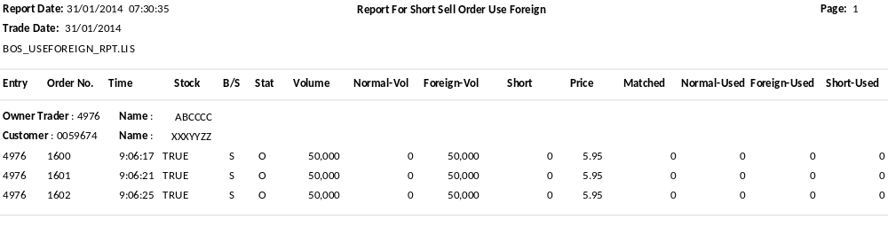

Price Approved Orders by Order Entry, Customer, Order#

Filename: BOS_APPRICE_RPT.LIS_<YYYYMMDD>_Retail
Report Title: <hardcode as “Price Approved Orders by Order Entry, Customer, Order#”> at center
Group By: N/A
Order By: Stock (Ascending Order)
Report Header: Report Date: <Generation Date in DD/MM/YYYY HH:MM:SS 24hrs format>
PAGE: <Page Number >
Trade Date: <Date in DD/MM/YYYY format>
Report Name: <hardcode as “BOS_APPRICE_RPT.LIS”>
Report Footer: Price Approved Orders By Order Entry, Customer, Order# <count of Order Number> records printed
Criteria: Trader ID and Report Generation Date
Output Format: text format
Frequency: Ad-hoc
Format Delimited: Delimited by 1 space character
No. | Field Name | Description
1. | TF | Thai Trust Fund
2. | Stock | Stock name
3. | Order # | Order Number
4. | Time | Time
5. | B/S | Buy/Sell
6. | Volume | Quantity
7. | Price | Price
8. | Buycrd | Buy Credit
9. | Stockcrd | Stock Credit
10. | Selcrd | Sell Credit
11. | Appr | Approval
12. | St | Order Status

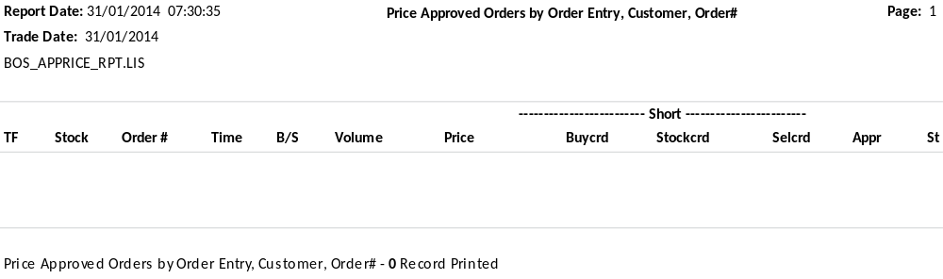

Approve Report

Filename: BOS_APPROVE_RPT.LIS_<YYYYMMDD>_Retail
Report Title: <hardcode as “Approve Report”> at center
Group By: Trader ID
Order By: Trader ID then Account (Ascending Order)
Report Header: Report Date: <Generation Date in DD/MM/YYYY HH:MM:SS 24hrs format>
PAGE: <Page Number >
Trade Date: <Date in DD/MM/YYYY format>
Report Name: <hardcode as “BOS_APPROVE_RPT.LIS”>
Report Footer: Total <count of Order Number> Record Printed
Criteria: Order with Approval code and Report Generation Date
Output Format: text format
Frequency: Ad-hoc
Format Delimited: Delimited by 1 space character
No. | Field Name | Description
1. | TF | Thai Trust Fund
2. | Stock | Stock name
3. | Order # | Order Number
4. | Time | Time
5. | B/S | Buy/Sell
6. | Volume | Quantity
7. | Price | Price
8. | Buycrd | Buy Credit
9. | Stockcrd | Stock Credit
10. | Selcrd | Sell Credit
11. | Appr | Approval
12. | St | Order Status
13. | SB | SB
14. | Tid | Trader ID
15. | Name | Trader Name
16. | Account | Client Account Code
17. | Name | Client Name
18. | Type | Account Type
19. | Crdt Type | Credit Type

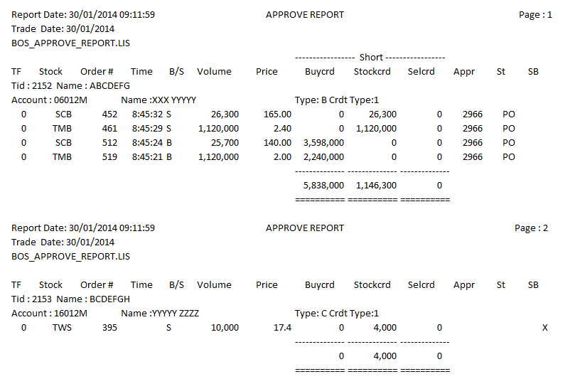

Trader Information

Filename: BOS_CKUSER.LIS_<YYYYMMDD>_Retail
Report Title: <hardcode as “User Check - BOS_DAT:BOS_USER.DAT”> at center
Group By: Route level
Order By: Route (Ascending Order)
Report Header: Report Date: <Generation Date in DD/MM/YYYY HH:MM:SS 24hrs format> at left
PAGE: <Page Number > at right
Trade Date: <Date in DD/MM/YYYY format> at left
Report Name: <hardcode as “BOS_CKUSER.LIS”> at left
Report Footer: Total <count of trader extracted> Record Printed
Criteria: Route, Trader ID and Report Generation Date
Output Format: text format
Frequency: Ad-hoc
Format Delimited: Delimited by 1 space character
No. | Field Name | Description
1. | Route | Trader route ID
2. | TID | Trader ID
3. | Type | Trader Type
4. | Lev | Trader Level
5. | Name | Trader Name
6. | Override Limit | Override limit amount
7. | Approval (%) | Percentage approval
8. | Short Sell Flag | Short Sell Flag
9. | Login Limit | Login Limit
10. | Super TID | Super Trader ID
11. | Confirm Port | Confirmation Port
12. | Order Port | Order Port
13. | Brh | Branch Code
14. | Set TID | Set Trader ID

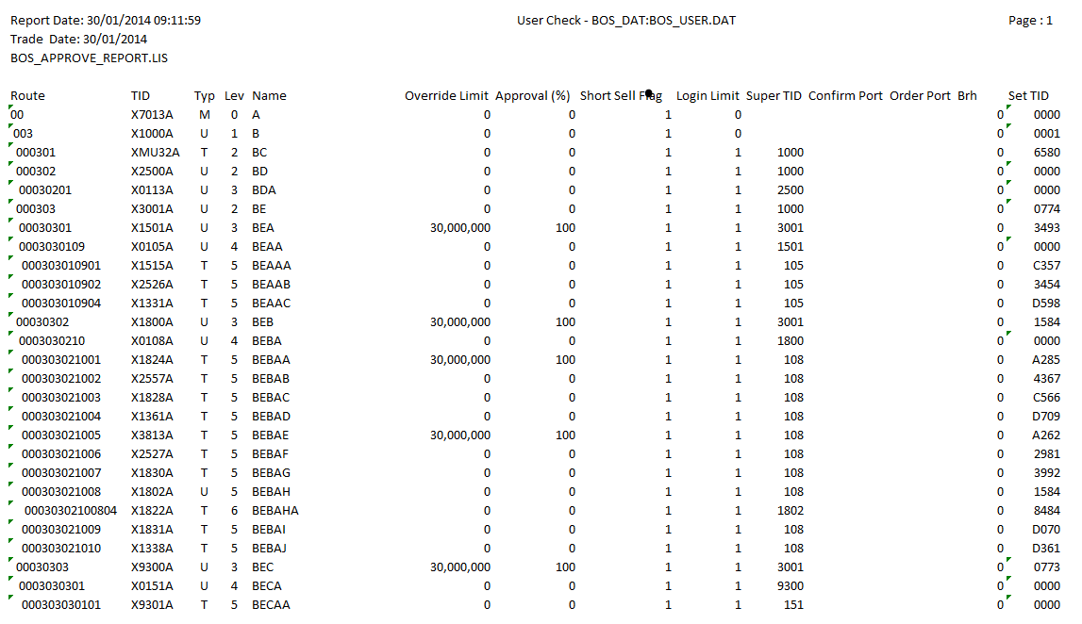

Customer deadlines /milestones
TBA

Required kinematics
If needed, explain here in details the actions sequence or message sequence required by the client to implement the functionality

Proposed functional solution

Products delivery
N/A

Work order development

Scope
TASKS | COST PER MAN DAY | MAN DAYS | TOTAL COSTS
Analysis/Specifications |  | x md
Specific Development |  | x md
QA Testing |  | X md
Project management |  | X md
TOTAL

Implementation Services

TASKS | COST PER MAN DAY | MAN DAYS | TOTAL COSTS
Implementation PM
Implementation
TOTAL

Invoicing Terms

% on work order signature, delivery & acceptance of the software.

Implementation schedule

The products described in § Products delivery coping with specifications described in § Proposed functional solution can be delivered to customer on DDMMYYYY if this work order is signed before DDMMYYYY. Without any signature prior to this date, the cost & implementation schedule may be reviewed by Serisys.

Authorization

By signing at the space below, the Client accepts the terms and conditions of this Work Order.

  For the Client:
  Name:
  Position:
  Date:
  Signature:
  For the Supplier:
  Name:
  Position:
  Date:
  Signature:

