
preconfirmation_reports_v0.1

Version | Date | Description
0.1 | 05/11/2014 | First draft by Hugo Lee

Contents
1 Abstract 3
2 Configurations in Pattern Tables 4
3 How to generate Pre-Confirmation reports? 5
4 Folder Structure in Linux server 6
5 Points to be aware when using SVN in Linux 9
6 Triggering Flow 9
7 How to make a release? 10
8 Documents to refer 10
9 Miscellaneous about LUA 11

Abstract

Pre-Confirmation Reports are the reports to show the trading records and detail information of the client. The reports can be generated by both Classic GUI and Blackscreen of DECIDE. PDV had tailor made a LUA engine for Serisys to get data from DECIDE then generate a SQLite database file. The SQLite database file will be applied to Jasper to generate the report in PDF format. The data flow can be simply understood as the below diagram shown:

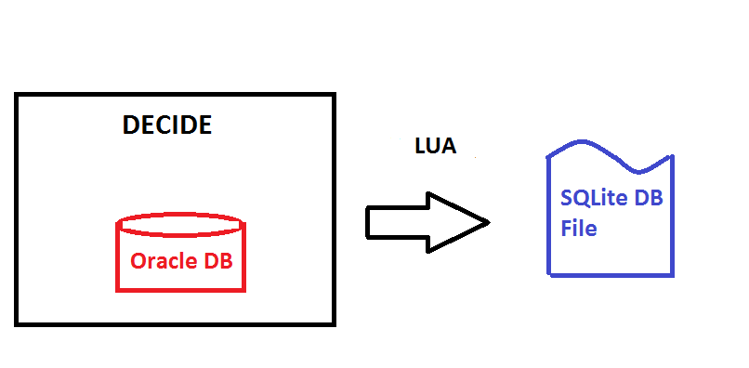

Configurations in Pattern Tables

First, please go to SYS -> Parameters -> Pattern Tables
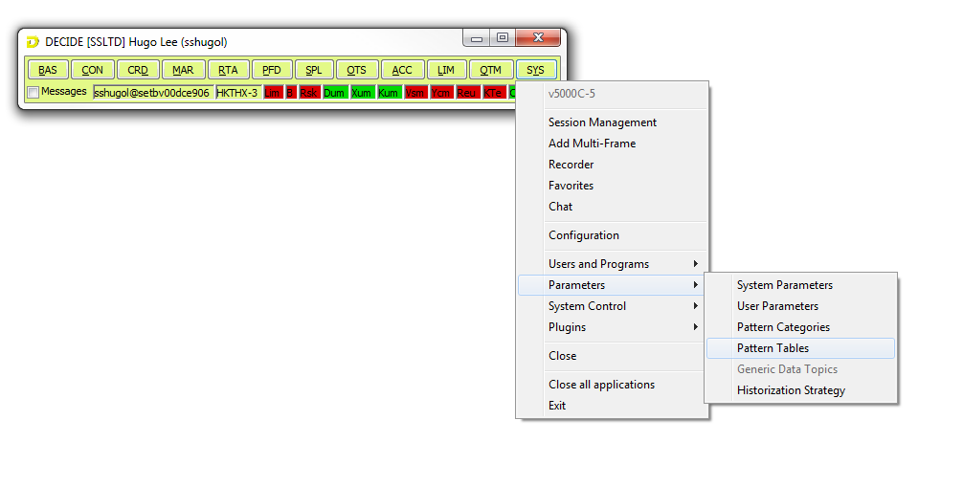
Then search the configurations of Pre-Confirmation reports:

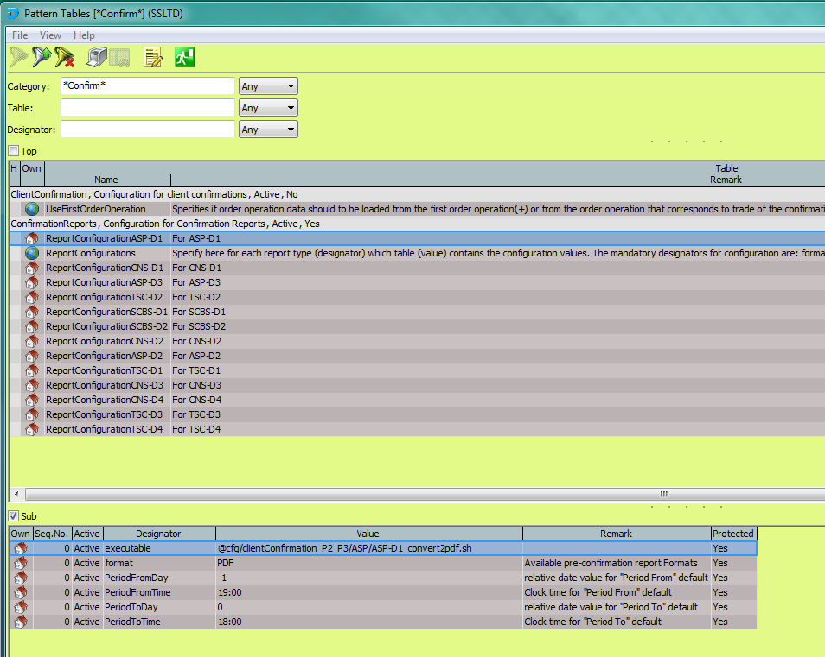

The highlighted path with “@cfg” in the lower part of the Pattern Tables is setting the script to trigger when the user pressing the report generating button in GUI. This part has normally configured by BA.

How to generate Pre-Confirmation reports?

After all paths are configured in Pattern Tables, user can try to generate Pre-Confirmation reports in GUI. Please go to ACC -> Special Reports -> Confirmation Report
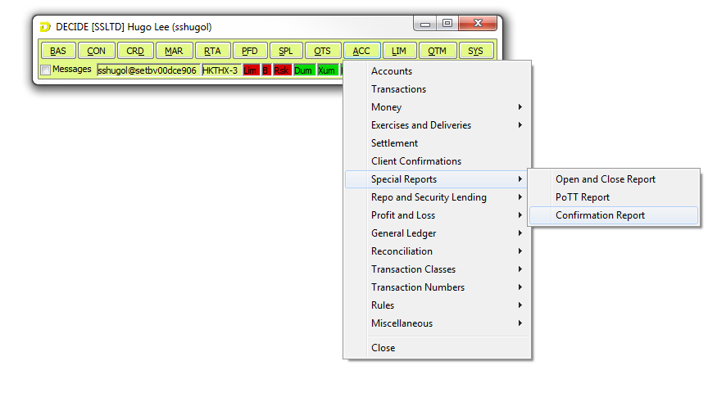
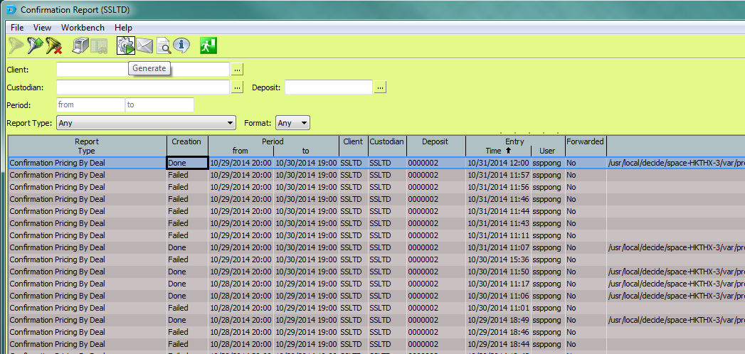

A pop-up window will be shown after the user pressed the button
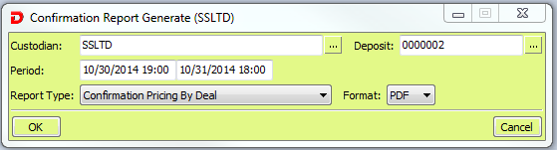

The field “Period” in this pop-up is not allowed to be empty. We currently set the generating period to be maximum 7 days as CNS requested. This 7 days range can be changed in the LUA function “CheckValidTimeRange” in the LUA code “common.lua”.
Please press the button “OK” to generate report. User can read the report by clicking the button There is a bug in DECIDE GUI that when a new generated report is done, the button will be disabled. This button will be reactive after user selected other row then selecting the toppest row back.
There may be some chances to generate report fail, user can check the error message by clicking the button

User can also generate this report in black screen:

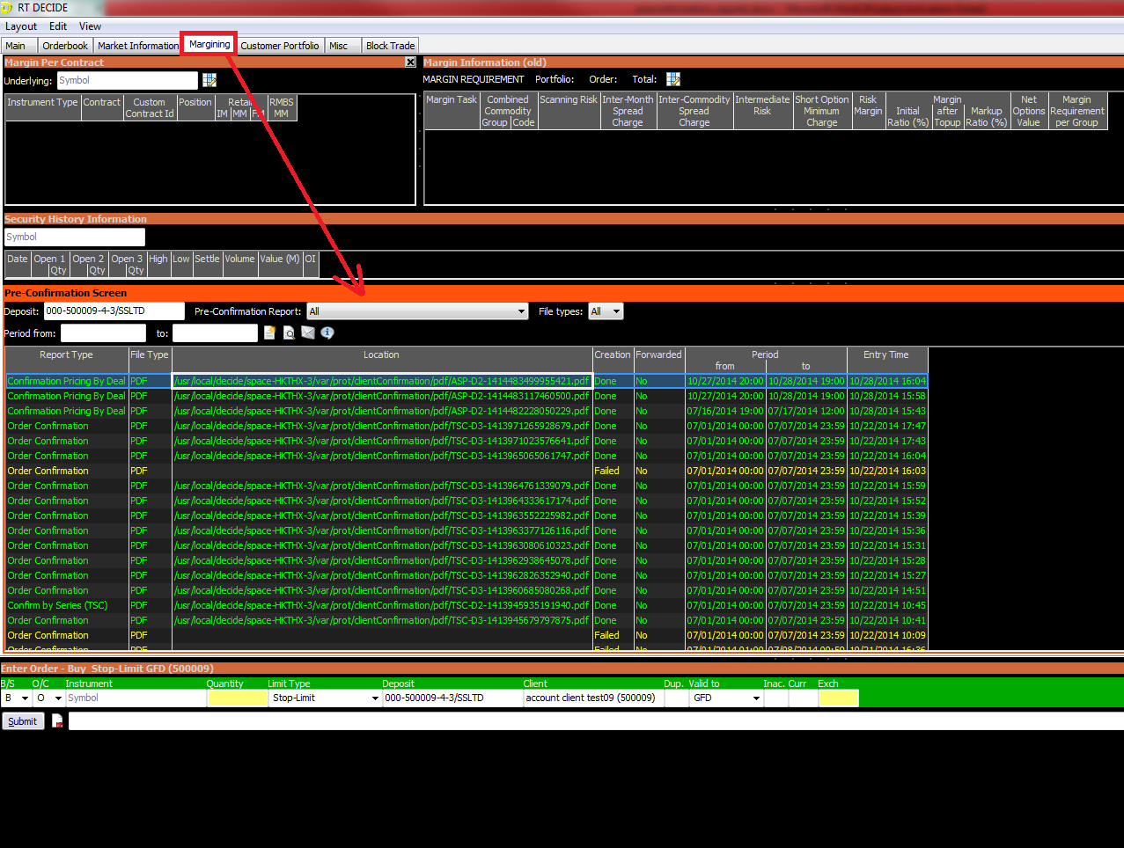

Folder Structure in Linux server

Dev team is currently using HKTHX-3 Linux server to do all development works, please login as “decide” user then go to this path:

/usr/local/decide/cust/clientConfirmation/v0001
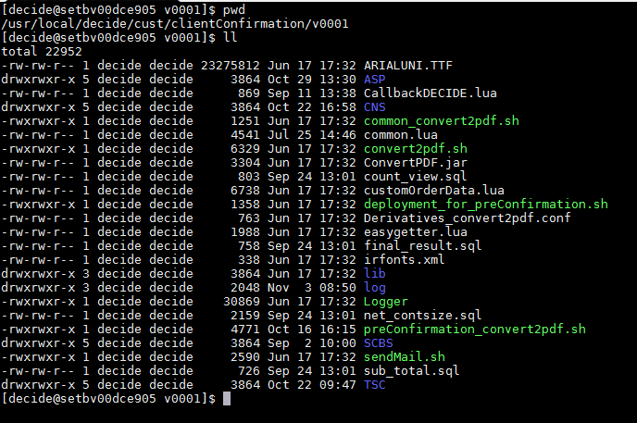

This folder is connecting to the SVN server, which can be found in this path:

http://10.31.42.62/svn/DECIDE_THAI/trunk/pre_confirmation_p2_p3

ARIALUNI.TTF: Fonts to be used in reports
CallbackDECIDE.lua: To return the report generating status back to DECIDE GUI by using the PDV provided LUA functions
common.lua: Centralized many common LUA functions which are required by all reports
Derivatives_convert2pdf.conf: Configuration file
customOrderData.lua: To map the order status as broker requested
easygetter.lua: To guarantee the return values from LUA functions are valid
*.sql: SQL logic for a sub-table of CNS-D1, D2, D4 and TSC-D2 only
sendMail.sh: To send mail out when report generating fail
preConfirmation_convert2pdf.sh: Main report generating flow
deployment_for_preConfirmation.sh: To deploy those Shell scripts which triggering the entire report generating flow to the target destination
Logger: This C++ program will write all log messages to the log files
log: This folder contains all log files. It is suggested to print the log messages out in real time for debug purpose by: tail –f <<log_file_name>>
lib: This folder contains all required library files
<<broker_prefix_folders>>: Those folders contain all LUA code, Jasper layout files and the Shell scripts which triggering the entire report generating flow to the target destination of the corresponding broker.
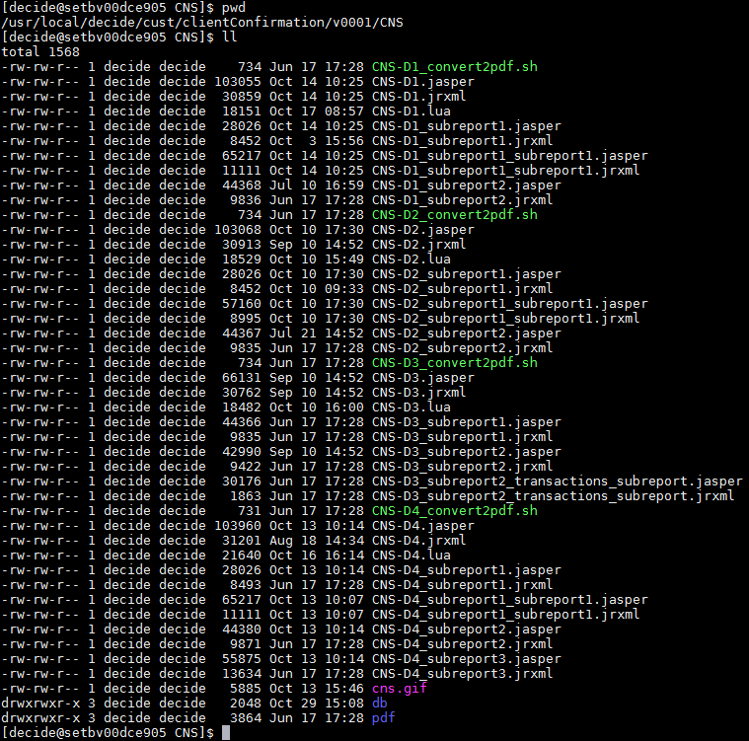
<<broker_prefix_folders>>/db: Contains all Sqlite database files that generated by LUA of the corresponding broker
ConvertPDF.jar: This Java program will apply the Sqlite database file to those Jasper layouts to generate reports in PDF format. The code of this program can be found in SVN:

http://10.31.42.62/svn/DECIDE_THAI/trunk/JasperReportGenerator

Points to be aware when using SVN in Linux

Please always get the latest version code from SVN before you do any changes by:

svn --username <<your_svn_user_name>> update
Dev team members will change the code in HKTHX-3 server then commit to SVN directly by:

svn --username <<your_svn_username>> commit –m “<<short descriptions about this change>>” <<path_of_the_file_to_be_committed>>
It is suggested to check the difference of the current version and the old version before commitment by:

svn diff

Triggering Flow

When the user click the report generating button, DECIDE will trigger a series of scripts and programs to generate the report in PDF format. Here is the triggering flow: (Using CNS-D4 as an example)

CNS-D4_convert2pdf.sh [Load the config file]
|-> common_convert2pdf.sh [Making log messages into a log file]
|-> preConfirmation_convert2pdf.sh [Main Flow]
|-> To get all parameters from DECIDE and config file
|-> To check the generating time range is empty or not
|-> Return the status “Fail” and error messages to DECIDE GUI if the time range is empty
|-> Triggering the target LUA file of the corresponding broker to generate SQLite database file
|-> Return the status “Fail” and error messages to DECIDE GUI if LUA got any errors
|-> Run the SQL logics if the report type matches with any one of the following:
CNS-D1, CNS-D2, CNS-D4 andTSC-D2
|-> Triggering the mentioned Java program to generate reports in PDF format
(With SQLite database and those Jasper layout files)
|-> Return the status “Fail” and error messages to DECIDE GUI if Jasper got any errors
|-> To check the PDF file is generated successfully or not
|-> Return the status “Fail” and error messages to DECIDE GUI if the PDF file is not generated.
Otherwise, return the status “Done” to DECIDE GUI without error.
|-> Process Finished!

DECIDE GUI will pass some parameters to the starting Shell script. Use “CNS-D4_convert2pdf.sh” as an example in this case

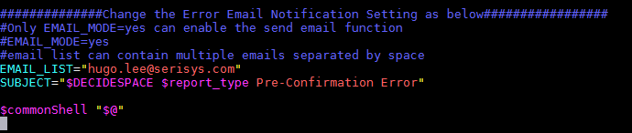

The variable “$@” contains the information of deposit ID, from time, to time. This variable will be passed to the next Shell scripts in the mentioned triggering flow as well.

How to make a release?

It is suggested to checkout the entire SVN folder to Window. Please find the SVN folder here:

http://10.31.42.62/svn/DECIDE_THAI

There will be 3 folders:
archive: To store the old version stuffs.
release: For release.
trunk: For development purpose, please find the code in this folder

It is suggested to keep this SVN folder to be latest version before you make any changes.

BA will request dev team to deliver a release when some Change Requests and Bugs are fixed. Please check the steps below:

- Commit all changes to SVN
- Update the folder of Pre-Confirmation in “trunk” to the latest version in Window
- Copy everything in the folder of Pre-Confirmation from “trunk” to the folder “release”
- Commit the changes in “release” from Window to SVN
- Notifying BA that the release is ready via email
- BA will ask CS team to preform deployment
- Done.

The deployment guide can be found in this path:
https://docs.pdv-fs.de/serisys/DECIDE Thai/Deployment Procedure/DECIDE_V500A/For CS

DECIDE_v5000A_Production_Deployment_Guide-v2.8.doc: Please ask CS team to follow session 6 to perform the deployment procedure.

Documents to refer

Please check the related documents in this path:

It is suggested to checkout the entire document folder from SVN to your local PC.

https://docs.pdv-fs.de/serisys/DECIDE Thai/Main ASP/Business docs/Derivatives/FunctionalSpec

FS_015_Pre Confirmation.doc: Functional specification of Pre-Confirmation Reports. Dev team members normally follow the stated details to implement the reports. However, some requirements in this document are no longer valid. Please check with the corresponding BA for the details.

https://docs.pdv-fs.de/serisys/DECIDE Thai/Main ASP/Business docs/Derivatives/PreConfirmationReport

PreConfirmStatusTracking.xlsx: Logged all details about the Change Requests and Bugs. Please follow this document to work.
DECIDE SDK Reference.pdf: Official document from PDV to explain the LUA functions. This document has not yet told everything about LUA, please follow with PDV if you find any functions missing.
decide_sdk.pdf: A very simple LUA code demonstration by PDV
dubi_lua.pdf: A very simple LUA code demonstration specifically for dubi by PDV
Pre-confirmation Account Settings data.docx: Stated how to get the account information by LUA
Pre-confirmation Limit And Risk data.docx: Stated the details about Order Volume Limit and Order Volume Risk. These information will be required when working on the deposit table of Pre-Confirmation Reports.
Pre-confirmation Order data.docx: Stated the order structure in DECIDE and the order related LUA functions.
Pre-confirmation Trade data.docx: A very simple LUA code demonstration of getting the order structure from DECIDE.
PreConfirmation_Position_data.xls: The suggested LUA code from PDV for the position related table

Miscellaneous about LUA

The LUA engine in DECIDE is tailor made by PDV. There may be some different behaviors from the native LUA. It is suggested to test your LUA code in HKTHX-3 Linux server even you are just writing some very simple logics.

LUA script can be simply triggered by:

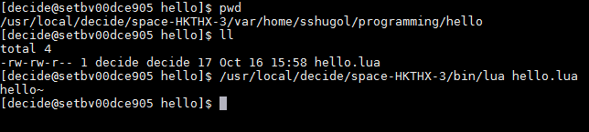

There are some self-defined LUA scripts in Pre-Confirmation folder. Those scripts may contain some common LUA functions for all reports. This is how we include those self-defined scripts:

Compatibility problem with different DECIDE versions

There was an issue that a dummy user, who has only got an user account in DECIDE but do not have an account in Linux server, would cause the report generating status stuck at “Requested”. This issue had already been fixed by PDV from v5000C-3. This fix requires some LUA code changes in Pre-Confirmation. Please check more details in CIM issue 36813 for the LUA code changes. LUA code changes had already been done. However, the changed LUA codes work only at v5000C-3 or later versions of DECIDE.

Please make sure the version of DECIDE is compactable with the code, otherwise, user may get errors when generating reports!

