

|  |  |
| --- | --- |
| **Audit Report** | |
| **FS Number** | FS_224 |
| **Client** | TISCO Broker |
| **DU BA** | Austin Wongham |
| **Date** | 22-Sep-14 |
| **Internal Enhancement Reference(s)** |  |

**Revision history**

|  |  |  |  |
| --- | --- | --- | --- |
| **Version** | **Date** | **Description** | **By** |
| 1.0 | 22-SEP-14 | Initial version | Austin Wongham |
| 1.1 | 01-Oct-14 | First review by TISCO | TISCO |
| 1.2 | 18-Dec-14 | Proposed solution for Req01 and Req02 | Axel Schwank |
| 1.2.1 | 19-Dec-14 | Updates to section 1.5.2 | Axel Schwank |
|  |  |  |  |

**Reference Documents**

|  |  |  |
| --- | --- | --- |
| **Document Name** | **Version** | **Description** |
| FS_016 Business Report | 3.0 | 1.1.1.2 Report List for Equity Retail |
| FS_224-Mapping.xlsx | - | Mapping of required report output fields to corresponding DAUDIT data fields or FO methods. Available in the project Subversion repository along with this specification. |



**Contents**

1.1 Document Objective 3

1.2 Scope 3

1.3 Current As-Is / Business Case 3

1.4 Business Requirement 3

**1.4.1.1** **UC01 – FC01 Audit Customer Report** 3

**1.4.1.2** **UC02 – FC02 Audit Position Report** 3

**1.4.1.3** **UC03 – FC03 User Login List** 4

1.4.2 Requirement Catalogue 5

1.4.3 Detailed Requirements 6

**1.4.3.1** **Req01 – FC01 Audit Customer Report** 6

**1.4.3.2** **Req02 – FC02 Audit Position Report** 8

**1.4.3.3** **Req03 – FC03 User Login List** 9

1.4.4 Data Scenarios 13

1.4.5 Activity Diagram 13

1.4.6 Limitations 13

1.5 Proposal/ Solution 13

1.6 Report Requirements 13

1.7 Glossary 13

1.8 Appendix 13

1.9 Authorization 14

## Document Objective

This document’s objective is to manifest those 3 reports that use for the audit purpose which cover the equity retail trading for the retail clients.

## Scope

|  |  |  |
| --- | --- | --- |
| **Area** | **In Scope** | **Out of Scope** |
| Instrument | All Equities | - |
| Exchange | SET, SETOL | TFEX |
| EOD Report Types | 1. FC01 Audit Customer Report 2. FC02 Audit Position Report 3. FC03 User Login List | - |

## Current as-is / Business Case

Currently, DECIDE supports the Login-Logout report, Audit Customer report, and Audit Position report for equity trading. However it’s not completed yet as user requires in the Retails phase, that’s why we have to create this document in order to implement those reports effectively.

## Business Requirement

**1.4.1.1 UC01** – Audit Customer Report

* This report displays the action of user that change the customer information as user required.
* This report is used for add/ edit the customer information in the Front system such as customer credit limit etc.
* As amended by the Back Office where is able to see the information before editing and after editing.

| **Title** | **Criteria** | **Description** | **Remarks** |
| --- | --- | --- | --- |
| **EOD REPORT : FC01 AUDIT CUSTOMER REPORT** | | | |
| Template | Template | Template that display information | *Refer to Req01* |
| Report path | Location | SFTP Folder |  |

**1.4.1.2 UC02** – Audit Position Report

* This report manifest the action of user that is able to add or change the position for individual stock and keep it as the action log for the audit purpose respectively.
* The Audit report for the Add/ Edit Portfolio of clients, such as increasing the number of shares, editing, and share price which able to see the information before and after the correction

| **Title** | **Criteria** | **Description** | **Remarks** |
| --- | --- | --- | --- |
| **EOD REPORT : FC02 AUDIT POSITION REPORT** | | | |
| Template | Template | Template that display information | *Refer to Req02* |
| Report path | Location | SFTP Folder |  |

**1.4.1.3 UC03** – User Login List

* This report manifests the user login/logout actions and keeps it as a record to use to tract the user‘s action for audit purpose.
* The system is used for monitoring access (Login and logout) for each day when a user is logged. The report displays the access time from the system including IP address and so on.

| **Title** | **Criteria** | **Description** | **Remarks** |
| --- | --- | --- | --- |
| **EOD REPORT : FC03 USER LOGIN LIST** | | | |
| Template | Template | Template that display information | *Refer to Req03* |
| Report path | Location | SFTP Folder |  |

### Requirement Catalogue

| Req ID | Use Case ID | Req Title | Req Description | Dependency | Ref ID | Priority |
| --- | --- | --- | --- | --- | --- | --- |
| Req01 | UC01 | FC01 Audit Customer Report | Create the Audit Customer Report |  |  | HIGH |
| Reg02 | UC02 | FC02 Audit Position Report | Create the Position Report |  |  | HIGH |
| Req03 | UC03 | FC03 User Login List | Create User Login List |  |  | HIGH |

### Detailed requirements

#### Req01 – FC01 AUDIT CUSTOMER REPORT

* This report displays the action of user that change the customer information as user required.
* This report is used for add/ edit the customer information in the Front system such as customer credit limit etc.
* As amended by the Back Office where is able to see the information before editing and after editing.

Report Formatting and Template;



|  |  |  |
| --- | --- | --- |
| Format Type | Alignment | Example |
| Alpha-numeric format | Left | “Commerzbank AG ” |
| Date/Time format | Left | “2014-08-25 T18:45:15:999 ” |
| Numeric format | Right | “ 1.95583000” |

| **Item** | **Criteria** | **Description** | **Remarks** |
| --- | --- | --- | --- |
| **EOD REPORT : FC01 AUDIT CUSTOMER REPORT** | | | |
| Template | Template | Display the report formatting |  |
| Report path | Location | SFTP Folder | Define SFTP Path |
| File name | Name | FC01_Audit Customer _<YYYYMMDD> |  |
| Report Title | Title | FC01 Audit Customer Report | Refer to Template file |
| Frequency | Time | EOD | End of Day |
| Output Format | Format | Text format |  |

FIELD IN THIS REPORT

| **Field** | **Criteria** | **Description** | **Remarks** |
| --- | --- | --- | --- |
| **Title that can perform updating by user** | | | |
| HEADER |  |  |  |
| Report date | Display | Date of report generation |  |
| Time | Display | Generation time |  |
| FC01 Audit Customer report | Display | Report name |  |
| TISCO Securities Company Limited | Display | Company name |  |
| Trade date | Display | Date of trading |  |
| Page | Display | Report Page |  |
| BODY |  |  |  |
| Old | Column | Column to display the Old action | The Information BEFORE updating |
| New | Column | Column to display the New action | The Information AFTER updating |
| Time | Column | Column to display the action Time (HH:MM:SS) |  |
| User | Display | User ID that update customer information |  |
| Cust ID | Display | Customer ID |  |
| Name | Display | Customer Name |  |
| Name | Display | [Old/New] Customer Name |  |
| CustType | Display | [Old/New] Customer type flag (C ,P,M,F) |  |
| CrType | Display | [Old/New] Credit Type |  |
| CrLimit | Display | [Old/New] Credit Limit |  |
| BuyTotalCr | Display | [Old/New] Buy total Credit |  |
| SellCr | Display | [Old/New] Sell Credit |  |
| LimitVal/Ord | Display | [Old/New] Limit Value/Order |  |
| CashBalance | Display | [Old/New] Cash Balance |  |
| Collateral | Display | [Old/New] Collateral |  |
| CommCustType | Display | [Old/New] Commission Type |  |
| BranchID | Display | [Old/New] Branch ID |  |
| CanBuy | Display | [Old/New] Can Buy |  |
| CanBuyDS | Display | [Old/New] Can Buy DS | Not included |
| CanSell | Display | [Old/New] Can Sell |  |
| CanShortVol | Display | [Old/New] Can short Volume |  |
| CanShortLending | Display | [Old/New] Can Short Lending | Not included |
| CanMTM | Display | [Old/New] Can Mark to Market | Not included |
| CanOverCr | Display | [Old/New] Can Over Credit | Not included |
| LimitPcApp | Display | [Old/New] Limit PC App | Not included |
| ScrollMsgZone | Display | [Old/New] Scroll Msg Zone | Not included |
| PackageType | Display | [Old/New] Commission Package Type |  |
| CanEntry | Display | [Old/New] Can Entry | Not included |
| canChange | Display | [Old/New] Can Change | Not included |
| RestID1 | Display | [Old/New] Restrict Trader Id 1 |  |
| RestID2 | Display | [Old/New] Restrict Trader Id 2 |  |
| RestID3 | Display | [Old/New] Restrict Trader Id 3 |  |
| Audit Customer Report - 46 records | Display | Number of all action records |  |

MOCK-UP SCREEN

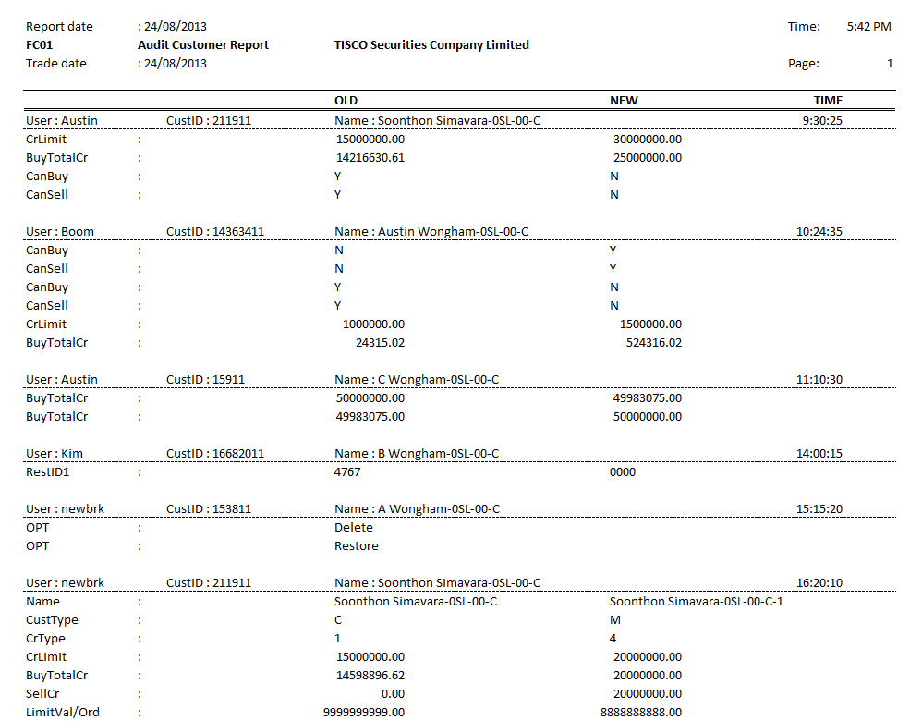

#### Req02 – FC02 AUDIT POSITION REPORT

* This report manifest the action of user that is able to add or change the position for individual stock and keep it as the action log for the audit purpose respectively.
* The Audit report for the Add/ Edit Portfolio of clients, such as increasing the number of shares, editing, and share price which able to see the information before and after the correction

Report Formatting and Template;



|  |  |  |
| --- | --- | --- |
| Format Type | Alignment | Example |
| Alpha-numeric format | Left | “Commerzbank AG ” |
| Date/Time format | Left | “2014-08-25 T18:45:15:999 ” |
| Numeric format | Right | “ 1.95583000” |

| **Item** | **Criteria** | **Description** | **Remarks** |
| --- | --- | --- | --- |
| **EOD REPORT : FC02 AUDIT POSITION REPORT** | | | |
| Template | Template | Display the report formatting |  |
| Report path | Location | SFTP Folder |  |
| File name | Name | FC02_Audit Position_<YYYYMMDD> |  |
| Report Title | Title | FC02 Audit Position Report | Refer to Template file |
| Frequency | Time | EOD |  |
| Output Format | Format | Text format |  |

FIELD IN THIS REPORT

| **Field** | **Criteria** | **Description** | **Remarks** |
| --- | --- | --- | --- |
| **Title that can perform updating by user** | | | |
| HEADER |  |  |  |
| Report date | Display | Date of report generation |  |
| Time | Display | Generation time |  |
| FC02 Audit Position Report | Display | Report name |  |
| TISCO Securities Company Limited | Display | Company name |  |
| Trade date | Display | Date of trading |  |
| Page | Display | Report page |  |
| BODY |  |  |  |
| OPT | Column | Operations Column that display action of user (Add/ Change) |  |
| Add | Display | Action: User can add |  |
| Change | Display | Action: User can change |  |
| Time | Column | Display time of action |  |
| Cus. NO | Column | Displat Customer ID |  |
| Stock | Column | Display Stock name |  |
| Volume(Old) | Column | Display previous volume before other action |  |
| Volume(New) | Column | Display new volume after did action |  |
| Avg/Pri | Column | average price |  |
| User_ID | Column | Display user ID |  |
| Stock_type | Column | Display stock type |  |
| TTF | Column | Thai Trust Fund; 1 , 2 , ‘ ‘ |  |
| Audit Position Report - 5 records printed | Display | Number of all action records |  |

MOCK-UP SCREEN

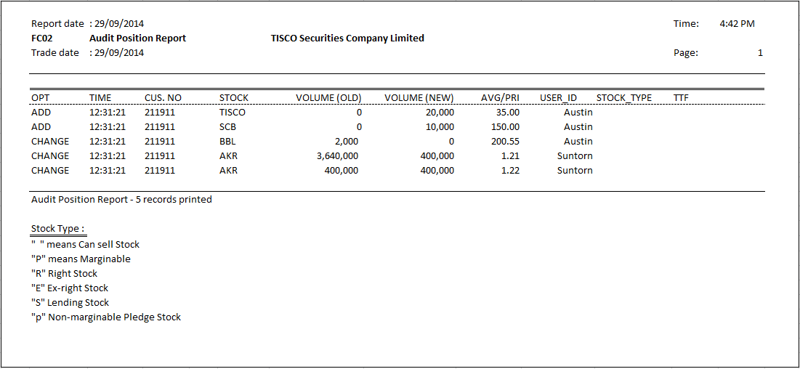

#### Req03 – FC03 USER LOGIN LIST

* This report manifests the user login/logout actions and keeps it as a record to use to tract the user‘s action for audit purpose.
* The system is used for monitoring access (Login and logout) for each day when a user is logged. The report displays the access time from the system including IP address and so on.

Report Formatting and Template;



|  |  |  |
| --- | --- | --- |
| Format Type | Alignment | Example |
| Alpha-numeric format | Left | “Commerzbank AG ” |
| Date/Time format | Left | “2014-08-25 T18:45:15:999 ” |
| Numeric format | Right | “ 1.95583000” |

| **Item** | **Criteria** | **Description** | **Remarks** |
| --- | --- | --- | --- |
| **EOD REPORT : FC03 USER LOGIN LIST REPORT** | | | |
| Template | Template | Display the report formatting |  |
| Report path | Location | SFTP Folder |  |
| File name | Name | FC03_User Login List_<YYYYMMDD> |  |
| Report Title | Title | FC03 User Login List | Refer to Template file |
| Frequency | Time | EOD |  |
| Output Format | Format | Text format |  |

| **Field** | **Criteria** | **Description** | **Remarks** |
| --- | --- | --- | --- |
| **Title that can perform updating by user** | | | |
| HEADER |  |  |  |
| Report date | Display | Date of report generation |  |
| Time | Display | Generation time |  |
| FC03 User Login List | Display | Report name |  |
| TISCO Securities Company Limited | Display | Company name |  |
| Trade date | Display | Date of trading |  |
| Page | Display | Report page |  |
| BODY |  |  |  |
| User-ID | Column | Login User ID |  |
| Channel | Column | User login from Black Screen/ Classic DECIDE |  |
| User-Name | Column | User name |  |
| SET-ID | Column | SET Trader ID |  |
| Time | Column | Login time, Logout time |  |
| Status | Column | Login, Logout |  |
| Server IP | Column | Server IP |  |
| Client IP | Column | Client IP |  |
| User Login List - 10 records | Display | Number of all action records |  |

MOCK-UP SCREEN

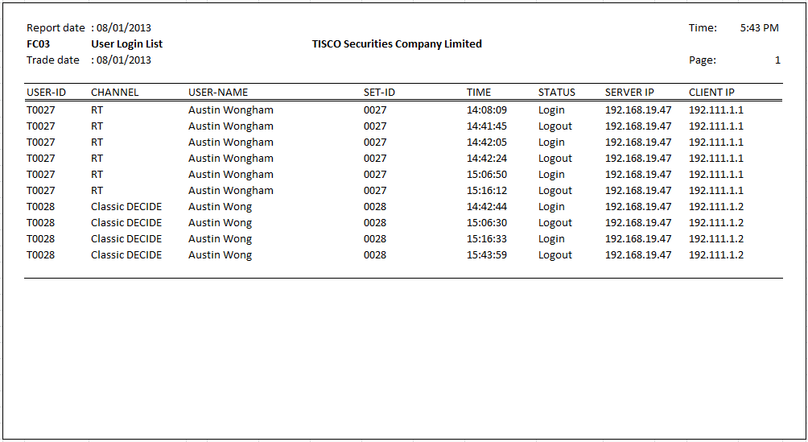

### Data Scenarios

N.A.

### Activity Diagram

N.A.

**1.4.5 Limitations**

N.A.

## Proposal/ Solution

### General technique

As for other reports (see for instance FS 016 from derivative phase), the scope of this proposal is to explain access to the data needed to build the required reports. Further processing and formatting issues are not scope of this chapter.

For audit purpose, access is generally provided by DECIDE’s Audit Server DAUDIT. It has a Lua binding which allows Lua scripts (as well as compiled Lua programs, of course) to subscribe for events covered by DAUDIT. These events contain changes made to DECIDE data by human users except for data categories explicitly excluded (e.g. database tables known to be changed by automated processes only or data categories which provide mechanism to comprehend changes by themselves like trade transactions).

Once an audit event is triggered due to a change of data, a Lua table object is returned by the DAUDIT function. There are three classes of events: insert, change and delete events. Insert and delete events return a single table containing the data inserted or deleted. It is comprised by data fields representing the DECIDE database table affected. Foreign keys appear in their native database format but can be resolved by DECIDE’s object model FO-Lua. Change events return a pair of tables reflecting the data before and after the change.

Plain data can be taken from the Lua tables directly. Human-readable identifiers of referenced foreign keys can be taken of appropriate methods from a FO object.

Mapping from required output fields to data fields from DAUDIT or FO method can be taken from the reference document “FS_224-Mapping.xlsx”.

### Requirement 01: Audit Customer Report

For this purpose, there will be two reports: One for customer static data which includes client, deposit and portfolio data and another for Order Volume Limits.

#### Audit Customer Report for customer static data

This report is generated if one of the DECIDE objects client, deposit or portfolio is changed manually, i.e. not by a back office import process. The output data corresponds to the DECIDE screen “Client and Deposit Administration”, but can be extended any time to cover the full set of data.

If a record is inserted, a header line will show that the record is inserted and the data will be output. Same applies if a record is deleted. In case a record is changed, a header line will state so and the data will be output in two columns, reflecting the state before and after the change.

The report consists of three blocks corresponding to the mentioned DECIDE objects. The following table shows which blocks will be output in the report if one of the objects is changed.

|  |  |
| --- | --- |
| Changed object | Blocks in output |
| Client | Client |
| Deposit | Deposit, Client |
| Portfolio | Portfolio, Client |

#### Audit Customer Report for Order Volume Limits

This report is generated if an Order Volume Limit is changed.

### Requirement 02: Audit Position Report

In DECIDE, there is no ability to edit a position randomly as stated in section 1.4.2.2, without entering a transaction the leads to the desired effect. In the current setup, this kind of operation is performed in the Back Office System, which the sends a decrease/increase transaction to DECIDE. These transactions are described in FS 215, BO Real Time Interface.

For this reason, the “Audit Position Report” is in fact a transactions business report which covers the transactions mentioned above.

This type of transactions might also be entered via DECIDE`s OTC Trade Capture Application “Buy/Sell” in case there are problems with the Back Office Interface. Figure 1 shows a screenshot. In case it is called from a position overview like “Portfolio Accounts” with position selection, what is the normal mode of operation, all position defining criteria are already filled in and do not need to be entered manually. It is suggested to use the same pseudo-counterparty for this transaction as the BO Interface. In case the OTC trade capture is operated only for this purpose by the user in charge, this pseudo-counterparty can also be configured to be automatically filled. Thus, despite the great variety of data that can be entered in this application, only Buy/Sell (reflecting Increase/Decrease), quantity and price need to be entered.  
Again, it should be pointed out that receiving the position adjustments from BO system is the regular use-case instead of entering them in DECIDE.

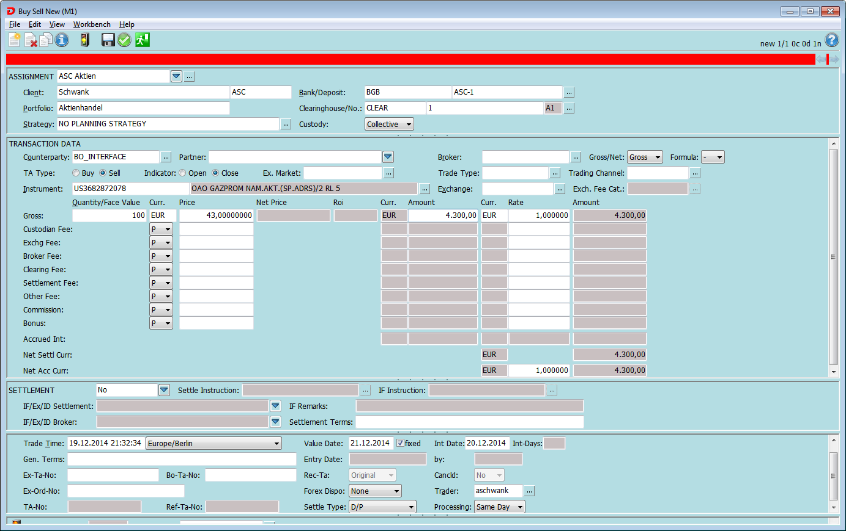

Figure 1: DECIDE's OTC Trade Capture

The raw data can best be retrieved with DECIDE’s Report Server RPS in CSV format which is suitable for further processing, e.g. formatting purpose. If the proposal from the mapping table belonging to FS 215 is followed, assigning an individual counterparty to the decrease/increase transactions, these transactions can be filtered by this counterparty from the Application ACC/Transactions.

The following columns are proposed to be included in the report:

* Client Id
* Portfolio
* Instrument Id
* BuySell
* Quantity (or Quantity Change which is signed – in this case BuySell is dispensable)
* Price Gross
* Volume Trade Curr
* TA No. System
* TA No. BackOffice
* Entry Time
* Trader
* Cancelled

The position quantity before and after the change is not part of the transaction received from the Back Office and will be calculated from the position’s transactions at the time of report generation end of day. This approach has some consequences which are important to acknowledge:

1. Depending on the posting method, it is expensive to calculate and might impact the runtime of the report. However, this might not turn out to be critical as long as there are only few position adjustments per day.
2. Unlike a change of static data like customer data above, a transaction is not a change log of the position, but transaction constitute a timeline of a position. This timeline might change if other transactions are entered backwards or cancelled.  
   So it might happen that the reported quantities before and after the transaction do no longer reflect the values at entry time of the transaction.
3. It is known that the values of the same position differ between Back Office System and DECIDE during the day. Thus, if DECIDE calculates the position quantities before and after the change, they do not reflect the values that the user changed upon entry in the Back Office System.

Figure 2 shows an example for items 2 and 3. The graphs represent the position values (applied on the axis of ordinates) for a given and fixed observation time *T* dependent on the trading time *t* applied on the abscissa. The trading times represent arbitrary points in time.

Both system start at begin of day (*t0*) with a position of 100 shares. At *t1*, DECIDE receives a buy transaction of 100 shares which is not visible in the BO system. At *t2*, a user edits and decreases the position by 100 shares from 100 to 0 in the Back Office system. DECIDE receives and books a decrease (sell) transaction of 100. At *t4*, DECIDE receives a sell transaction of 100 shares which is also not visible in the Back Office system. At *t6*, a user edits and increases the position by 100 shares from 0 to 100 in the Back Office system. DECIDE receives and books an increase (buy) transaction of 100.

So at a given observation time *T1 > t6*, the position timelines for the Back Office system and DECIDE look like the graphs in the upper and middle lane. What can be seen here is that the position values before and after the change might be different between the Back Office system and DECIDE (item 3).

If, at some time *T2 > T1*, a user cancels the sell transaction at trading time *t4*for some reason, the timeline changes and becomes that one shown in the lower lane. If nothing else happens, this will be the timeline at end of day *Teod > T2*. Thus, the position values before and after the change calculated by the report for the transactions at *t2* and *t6* will be 200/100 and 100/200. What can be seen here is that the position values before and after the increase/decrease transaction might be different at the time of report generation (which will be used for the report) than at entry time of the transaction (item 2).

 Figure 2: Position timelines

### Requirement 03: User Login list

A user Login/Logout report is already established. The only requested addition to the existing one is the inclusion of the server IP address.

For this reason, the Login/Logout report will be enhanced by an additional field, the Server-IP. This field will be fed as follows:

* For DECIDE Classic, the machine in the data centre which runs the DECIDE Classic session. This is one server of the application cluster.
* For DECIDE Retail, the machine in the data centre which runs the Black Screen Engine. This is one server of the application cluster.
* For the Internet API, the value needs to be defined.

**Mock-up reports have been added in the file below;**



## Report Requirements

N.A.

## Glossary

N.A.

## Appendix

N.A.

## Business Requirement Authorization

By signing at the space below, the client accepts the terms and condition of this Work Order of FS_224 Audit Report v1.1

|  |  |  |
| --- | --- | --- |
| FOR THE CLIENT: TSC |  | FOR THE SUPPLIER: |
| NAME: Vason Thangkavivit |  | NAME: |
| POSITION: Head Of Private Client Group |  | POSITION: |
| DATE: |  | DATE: |
| SIGNATURE: |  | SIGNATURE: |

|  |  |  |  |
| --- | --- | --- | --- |
| FOR THE CLIENT: TSC |  | FOR THE SUPPLIER: |  |
| NAME: Tharatporn Techakitkachorn |  | NAME: |  |
| POSITION: Head Of Securities Brokerage |  | POSITION: |  |
| DATE: |  | DATE: |  |
| SIGNATURE: |  | SIGNATURE: |  |