**UNIVERSITY OF COMPUTER STUDIES (MONYWA)**

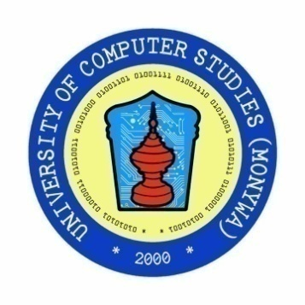

**BASIC WEB DEVELOPMENT**

**JAVASCRIPT PROJECT (CS-2254)**

**EXCHANGE RATE CALCULATOR**

**August, 2022**

**SUPERVISOR** Daw Myat San Nwe

**MEMBERS LIST** Group-I

**No Roll-No Name**

1. 2CS-43 Mg Hein Htet Aung

2 2CS-204 Mg Hmue Set San

3 2CS-205 Mg Aung Kyaw Thein

4 2CS-206 Mg Thet Aung Zin

5 2CS-8 Ma Phyo Thiri Kyaw

6 2CS-29 Ma Ingyin San

**CONTENTS**

**No Description Page**

1 Abstract i

2 List of Figures ii

3 Introduction 1

4 Objectives 2

5 Implementation of the project 3

6 Conclusion 7

7 Lesson Learned 8

8 References 9