**Introduction**

This project can exchange currency that uses throughout the world. For instance, the user can exchange from MMK (Myanmar Kyat) to JPY (Japanese Yen) vice versa can also exchange JPY to MMK. And then, this project include history list so that the user can view the list that exchange from one to another. This history list is made by using Date & Time to review the specific amount of time and currency fluctuations. Finally, the project makes responsive for all devices and creates dark & light mode as user interface.

**Objectives**

* To convert quickly between different foreign currencies
* To check the exchange rates
* To make easily the user calculate the exchange rates
* To review the history calculated

**Implementation of the project**

**Using HTML, CSS**

* Pages are created by using HTML.
* User interface designs are used with CSS like inserting images, background, font-style, table layout and responsive (media-query) etc.

**Using JavaScript**

* Buttons are created by using DOM Event Handlers.
* Table rows are created by using DOM (Document Object Model)
* Functions are created to calculate the operations of tasks.
* Object array is used to store the currency rates.
* Date object is used to get the current date of time.

**Home**

This is our home page.

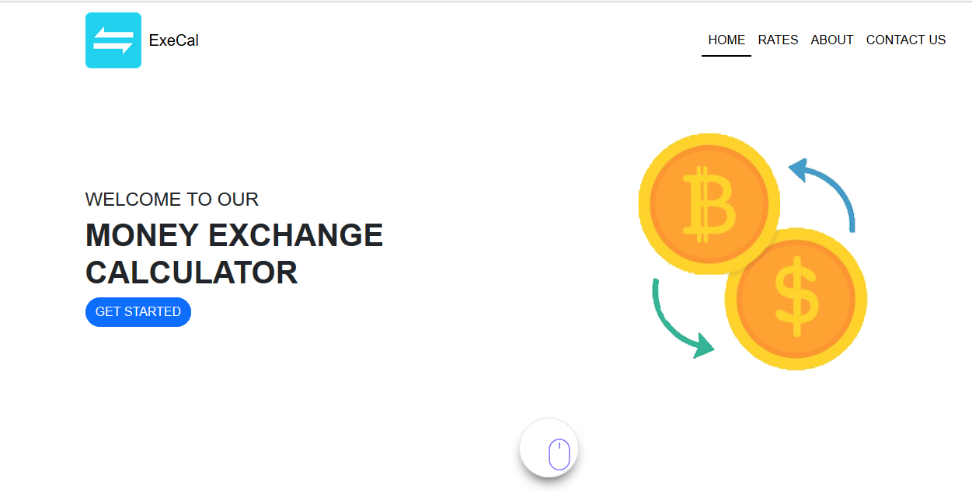

**Figure 1 Home Page**

If the users click on the **GET STARTED** button, the users will see this calculate page.

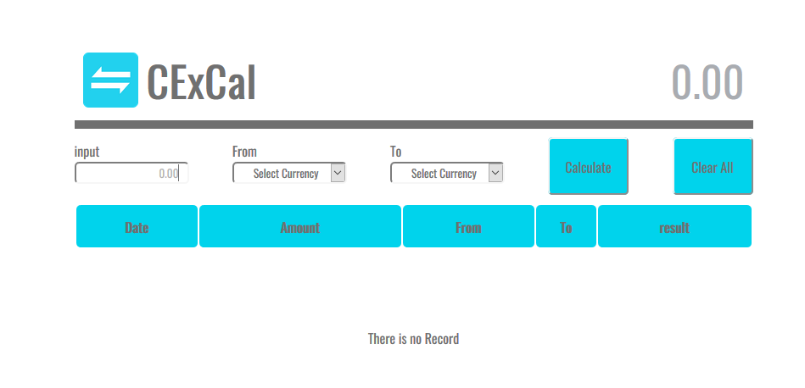

**Figure 2 Calculate Page**

If the users click the **dark/light** mode, the users will see like this.

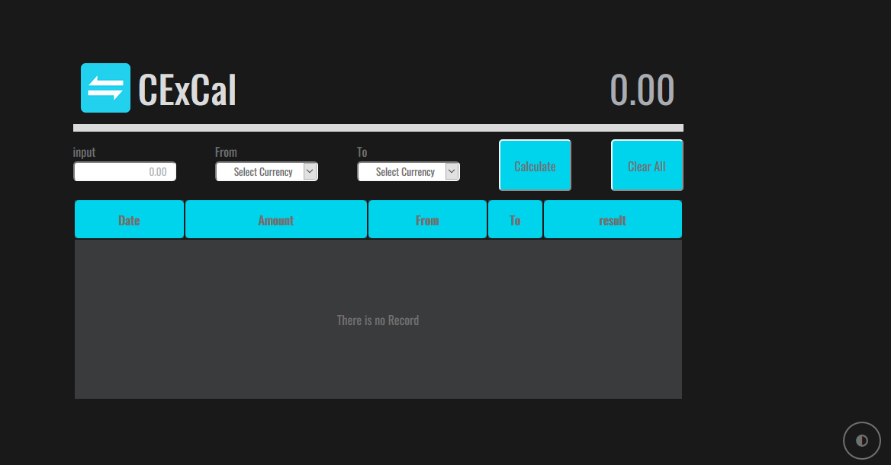

**Figure 3 Calculate Page with dark mode**

This is the results for the calculated rates.

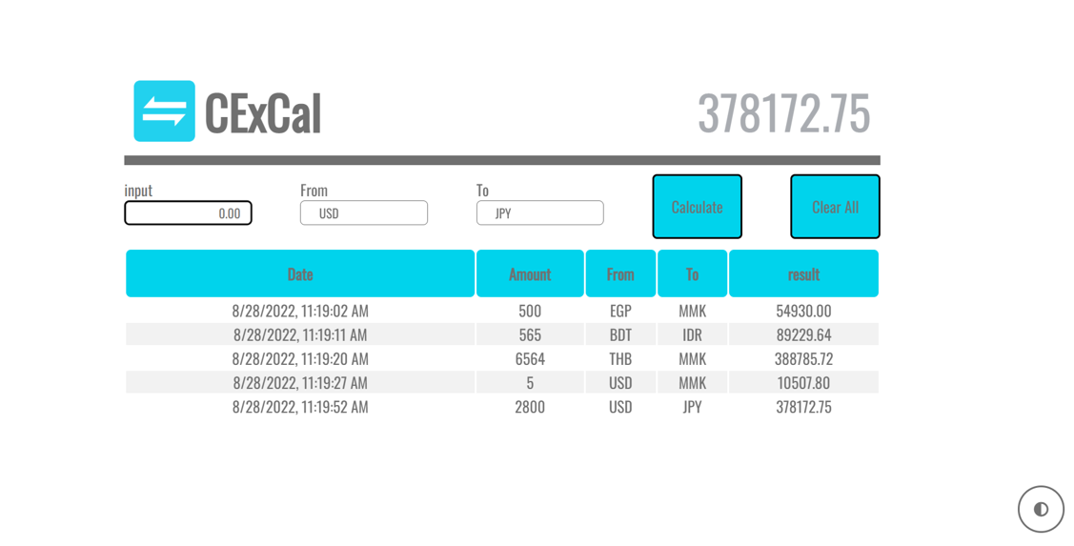

**Figure 4 Calculate Page with results**

**Rates**

In this page, the users can check the exchange rates.

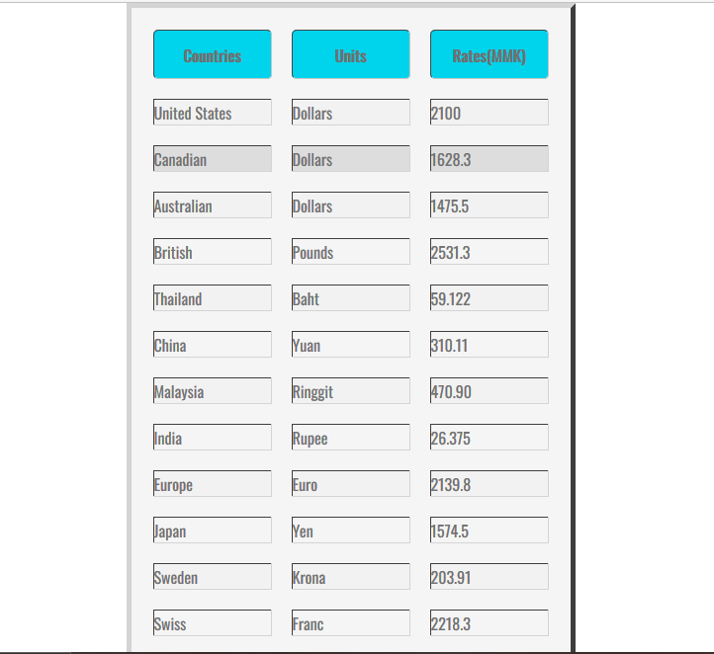

**Figure 5 Rates Page**

**About**

This page is about us. It describes about the members and launched time of this project.

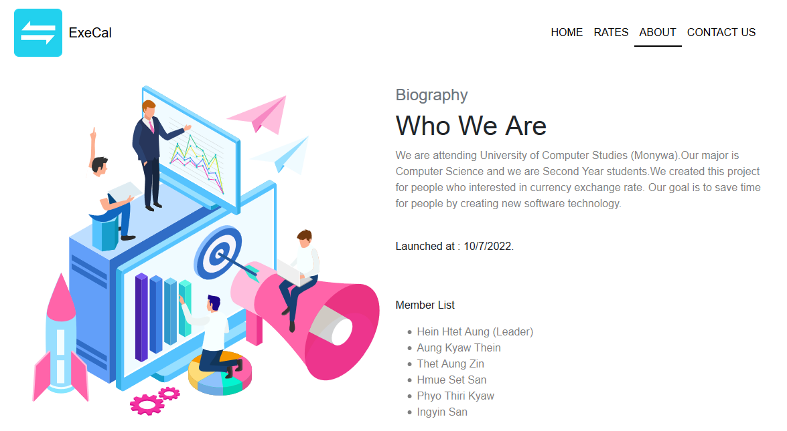

**Figure 6 About Page**

**Contact Us**

The users can contact us in this page if the users have something to say and ask for us.

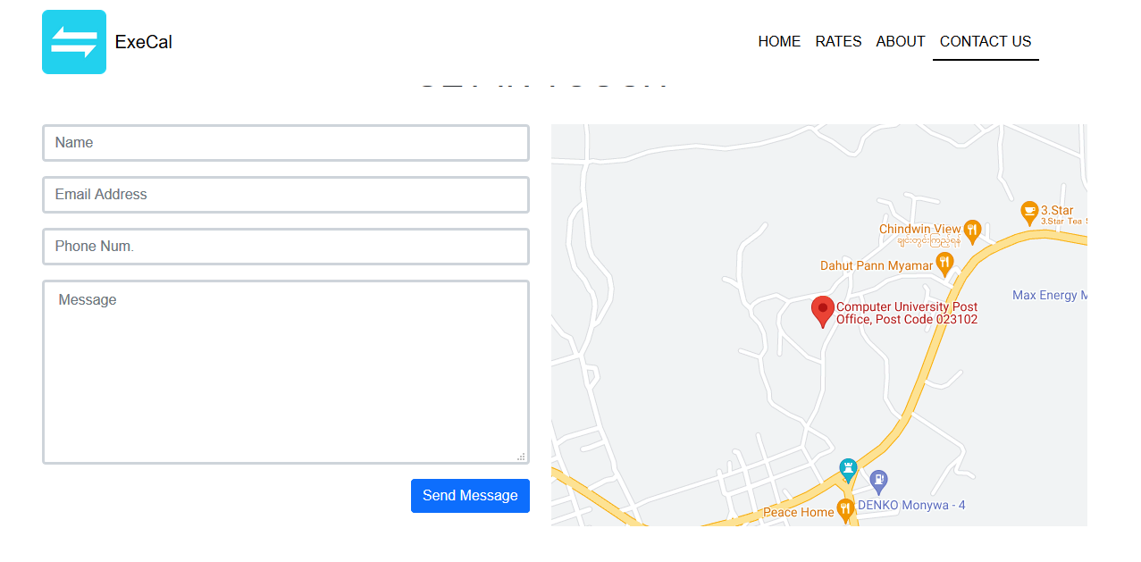

**Figure 7 Contact Us Page**

**Conclusion**

This project is exchange rate calculator. It helps to check the amount the users want to change and convert the desired currency directly. So, this project will be useful for everyone.

**Lesson Learned**

We have got many experiences and advantages by creating this project. They are:

* Understanding the overview of project planning and scheduling
* Knowing the principal tasks of project to complete rapidly
* Good skills for time management
* Improving teamwork skills
* Realizing and applying the use of HTML, CSS and JavaScript
* Getting problem solving skills
* Applying creative thinking skills for project design

**References**

[1] Nicholas C. Zakas, "Professional JavaScript for Web Developers"

[2] <https://www.google.com>

[3] https://www.developer.mozilla.org