**How Women are Presented in our Media**

*Role of Media:-*

Media has always played an important role in influencing certain groups. Its role can be positive and negative depending on the way it is used to spread information. Now a days it has become a trend to spread a lot of false rumors and information regarding a certain group by using the media in a negative way. Media has also played a very important role in portraying the women in our society. In many cases it has proven to be biased and having a hypocritical opinion. It has become a more of a negative impact to the society than the positive impact it was supposed to serve.

There are two ways media has an Impact on how it portrays our women:-

* Optimistic Impact
* Pessimistic impact

***Optimistic Impact***

1. *Spreading awareness*

Media has been a useful tool in spreading awareness about women’s rights in our culture. A lot of women are deprived of their basic rights and often they are not aware of it themselves so media given women an opportunity so that they may know their basic rights.

1. *Providing Justice*

Media has also played an important role in providing justice to many women whose cases could not be heard over the Courts. Famous Personalities like  **“**Iqrar Ul Hassan**”** and many more media spokesmen take the matter into their own hands to give justice to the families and” show them their basic rights.

1. *Portraying Women as Hardworking and Self respected Persons*

The Media also Portrays Women as Hardworking and Self respected women as they work Hard Day and night in order to feed their Children. Most women drive taxis and run restaurants in order to feed their bellies and women are also ready to defend the border of our nation. Many of these honorable Mentions include Maryam Mukhtiar , Arfa Karim and many more. A lot of these women has major impact in society and have given society a lot. Media has Also Portrayed them as the daughters of the nations who keep working day and night for the country. But not much is seen about the positive impact on media now a days.

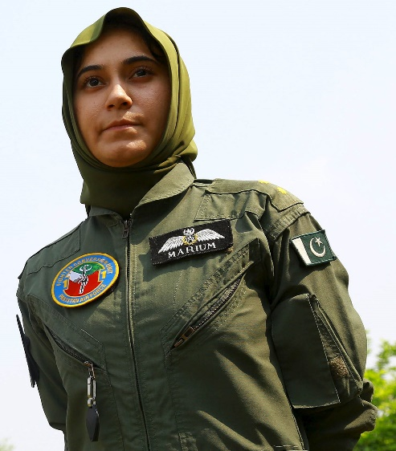

***Pessimistic Impacts***

1. *Exploitation of Women*

Media exploits women in many ways. Now a days in most talk shows and media shows women are brought up to do some illiterate challenges. Our talk shows morning shows are the living example of it. The same media that shouts for women’s rights is now showing them in a weird environment and women are exploited in such manner. They do not know that they are being used for a greater cause. Feminism was basically a call for proper women’s rights but has been exploited in such a way by the media and left-wing in such a way that it has developed hatred of men in women and the definition of a free and empowered women has changed. Media plays an important role in this as our talk shows, media shows and dramas are full of such filth.

1. *Wrong Use of Feminism*

Feminism has been exploited in such a way by the media itself too as it has created hatred for men in our society. Most women now exploit this system and media gives them coverage too.

Recent cases of Ali Zafar and Babar Azam Are Living Examples.

False accusations are given against men in order to tarnish their reputation and when that backfires media protects these women and no coverage is given when the situation is in the favor of men. The system is portrayed as biased and a black system by the media and these women are given special Coverage.

Media does not Support the actual causes now which are need of help rather false and biased causes are supported.

1. *Hypocrisy of the Media an Example*

The hypocrisy of the media can be judged by solely on the example that in our society having black skin is considered a taboo and bad and this issue has a lot been raised by the media the men don’t accept women with black skins. The same media then encourages people to buy beauty products such as fairness creams and other things so the media is winning at both sides which people do not understand. If the media was that much of a supporter the media would support rather than play those ads and encourage to buy beauty products.

Eg Recent Fair And Lovely Ad.

***Summarization***

In short now media has portrayed women in a lot of negative side than a positive side. Women are being exploited without being knowing and media keeps exploiting them for their own cause. Rather than focusing on Actual women issues it focuses on cheap slogans and false women empowerment. Its best to avoid such stuff in every possible way.