*CPEG 210L-3 Project*

*Scrolling Marquee with Name*

*Name:-*

*Ali Khalid Ali*

*ID’s:-*

*S00051555*

*Date of Submission:-*

*15/09/2020*

*Objective*

* To Create Rotating Marquee of Alphabets With Your Own Name

***A Rotating Marquee:-***

A display where text moved from one end of the display to the other end and reappears back on the first end, achieved via rotation of characters of a text in a loop.

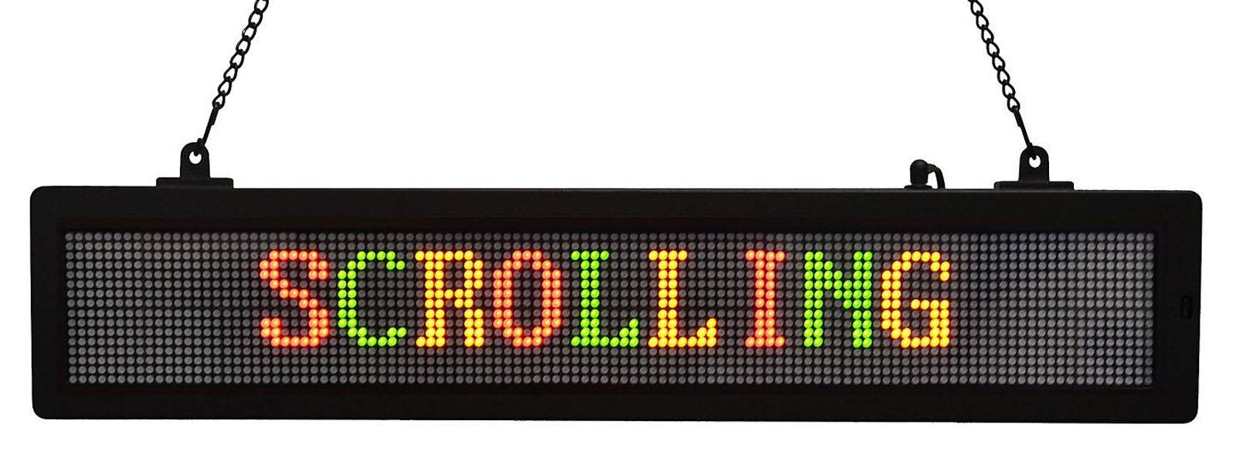

Credits:Exportcontrolforeningen.se

*Introduction:-*

1. We will construct rotating marquee with 7 segment display

2. We will use my name as text, since my name is Ali of three characters, you will use a display of 5 x 7 segments side by side to create the display and rotate the text on it.

3. To display alphabetic characters on 7 segment, a custom decoder will be required which will decode the binary sequence representation of alphabet into signaling for 7 segment display.

4. The text required to be rotated on display need its characters to be stored for certain time and shifted to next position on the display i.e the next 7 segment. A sequential circuit provided with a CLK signal will do the job. A suitable option is using shift register. Since 26 alphabets can be represented in binary sequence of 5 bits, hence a shift register of 5 bits can be used.

5. The shift registers holding the binary representation of alphabets should be connected to form a loop so text rotation can be observed on the display. However, we need to be able to add our alphabets into the circuit to be displayed.

If an addition of 3 characters is required, 3 shift registers will be added with the shift registers corresponding to the display LEDs to complete the loop. These three back-end shift registers will be used to load the binary sequence of alphabets into the marquee and once loaded, can be used to begin rotating the data in a loop so moving text is displayed on the 7 segments

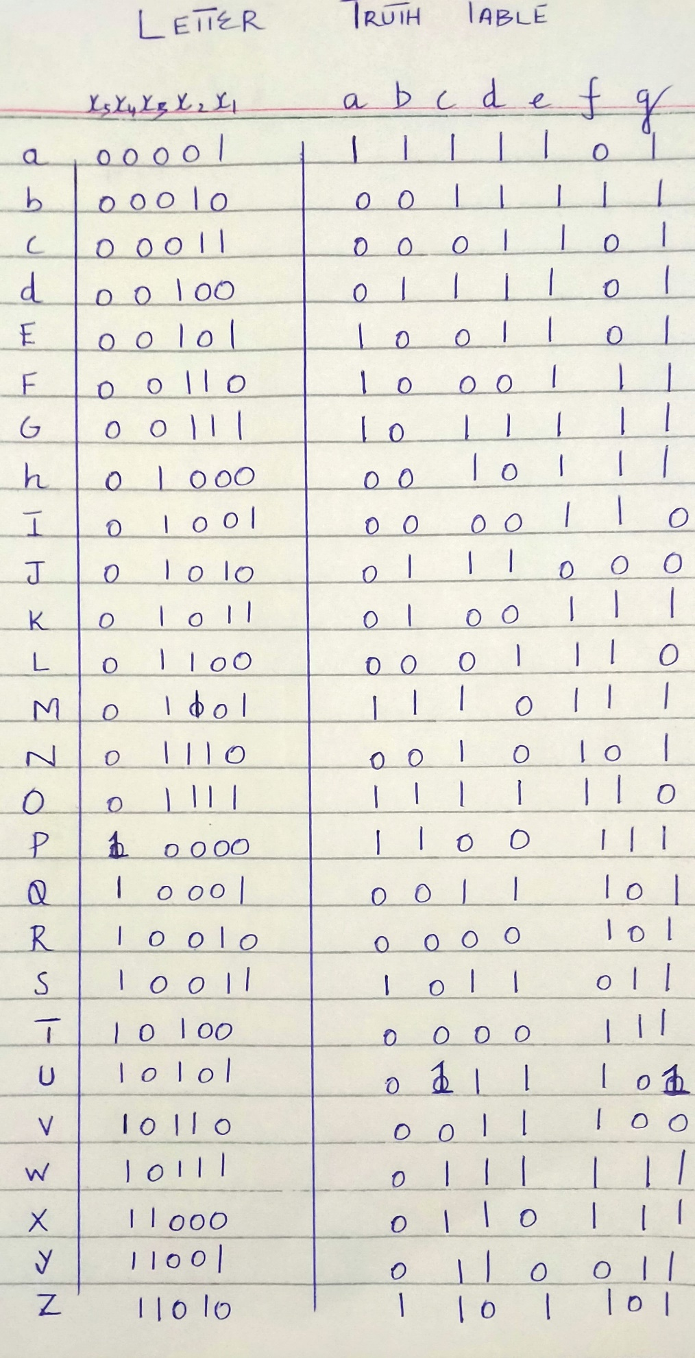

*Methodology*

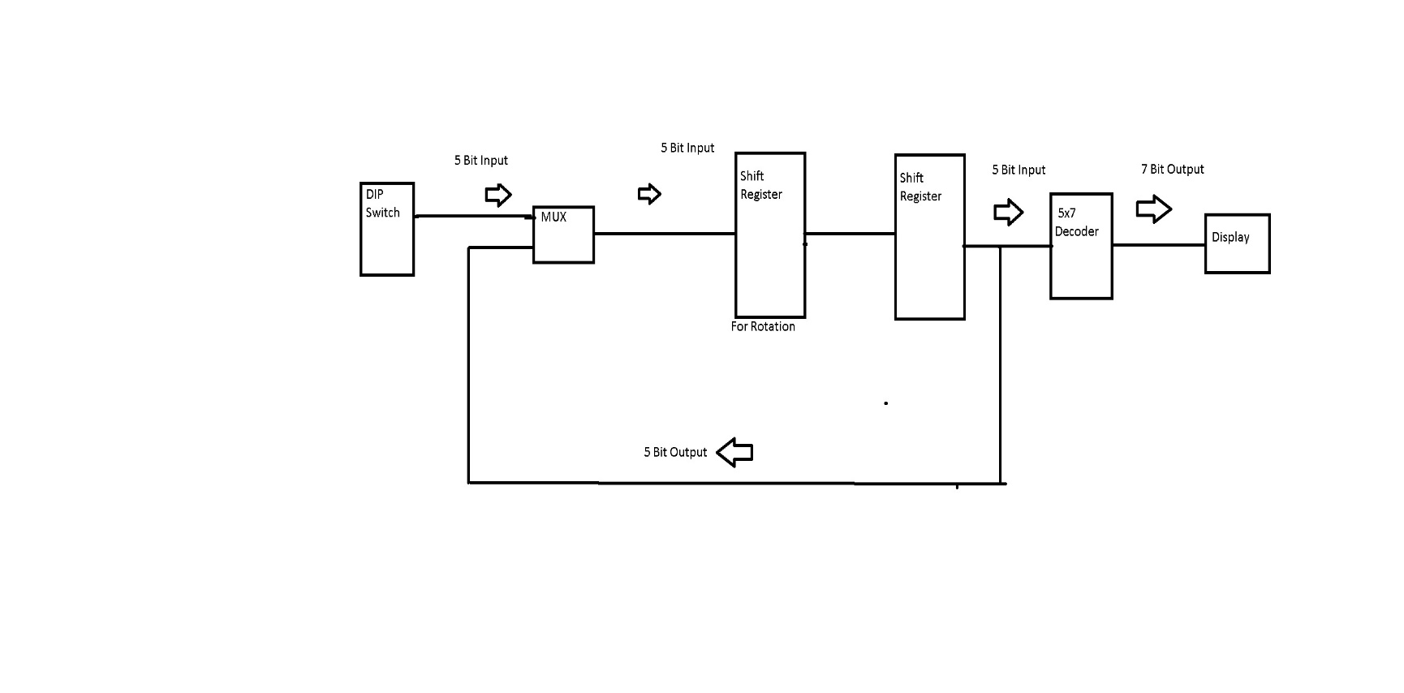The Block Diagram Of the Circuit is Given Below

* 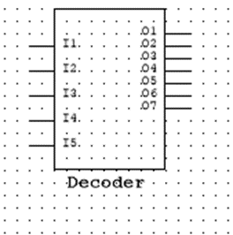Binary Decoder

1. We make a Custom Binary Decoder Having 5 inputs and 7 outputs .
2. K Maps Calculated are used to build the outputs of the decoder .
3. Each output of the decoder corresponds to the input of the 7 segment.
4. 5 Decoders are used each connected to a Segment Display.
5. The input Combination of Decoder Gives us the Desired output.

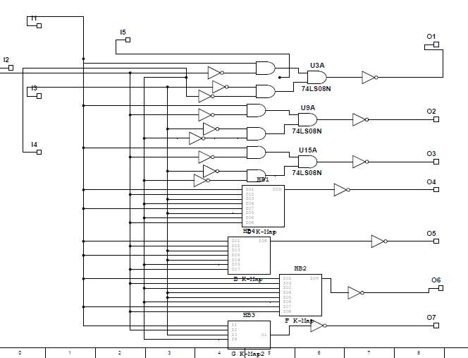

*Internal View of the Decoder*

*K-Maps*

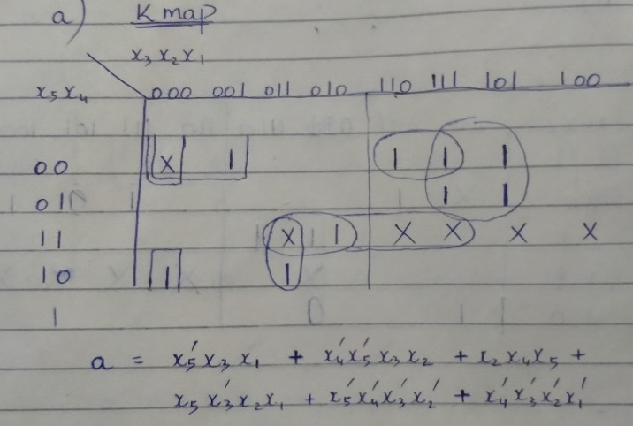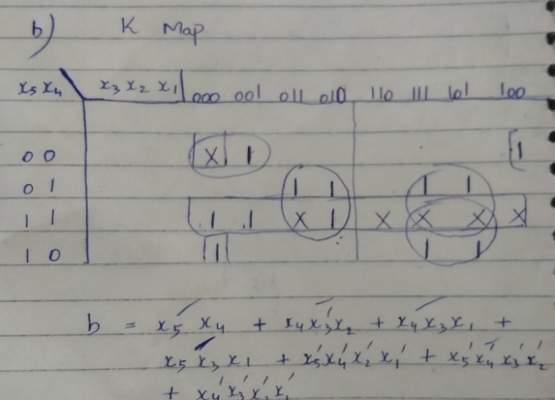 A K-Map B K-Map

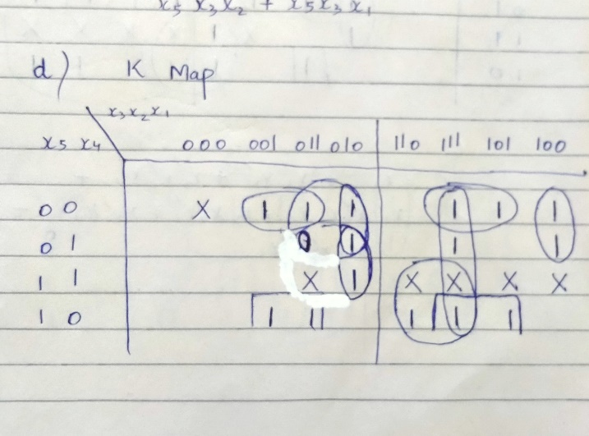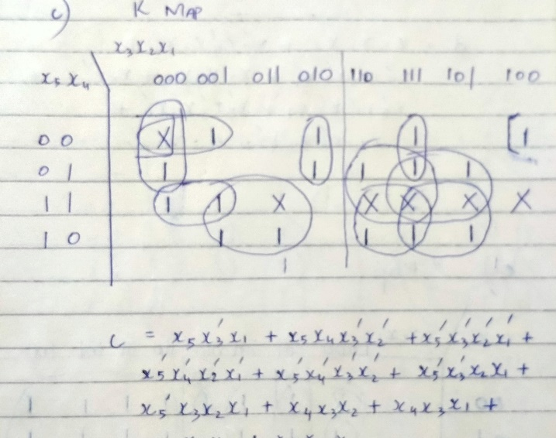 C K-Map D K-Map

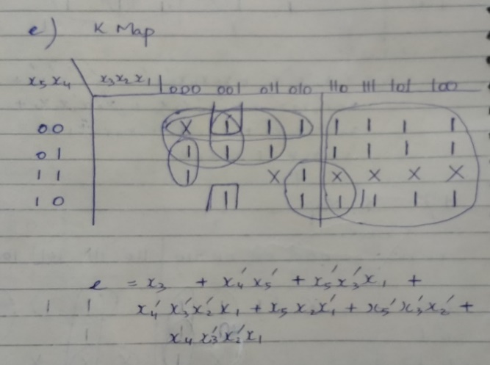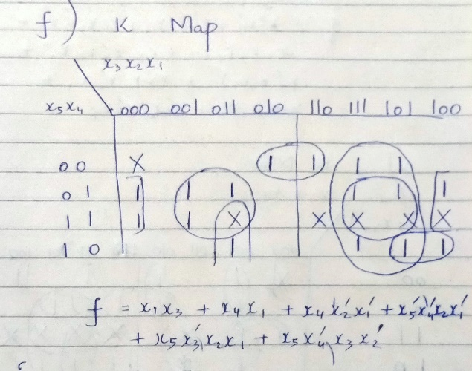E K-Map F K-Map

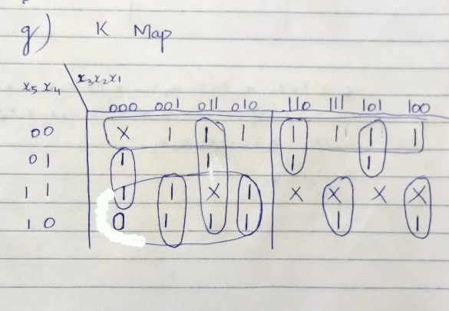G K-Map

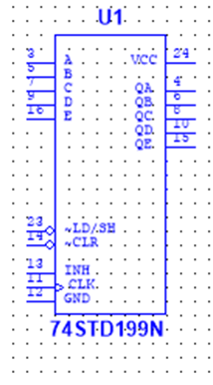

* Shift Registers

1. Shift Register 74STD199N are Used
2. 8 BIT Shift Registers are used with 3 Pins Disabled because we are taking 5 bit input only
3. All shift registers have common CLK of 1HZ.
4. OutPut of Shift registers which are used for rotation is Connected to MultiPlexer.
5. 8 Shift Registers are used 5 of which directly connected with Decoders and 3 connected with Multiplexers for rotation of Inputs.

* 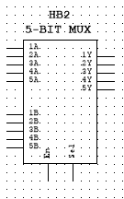Mutiplexer

1. 5 Bit Custom Multiplexer is used by joining two 4 bit 74LS157N Multiplexers and disabling the 3 input output pins of second multiplexer.
2. The Multiplexer is used to Give One Set of inputs and Is Connected to Shift Registers.
3. 3 Multiplexers are used .

*Internal View of Multiplexer*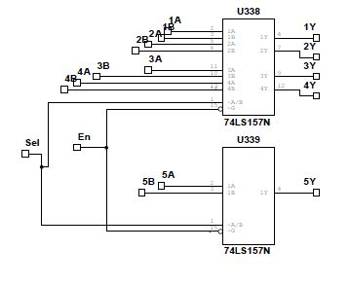

* 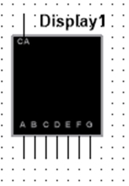7 Segment Display

1. 5 7 Segment Displays are used .
2. Each Segment is Connect to output of the Decoder.
3. The Segments used are Common Anode 7 segment Displays

* DIP Switch

1. 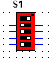 5 Input DIP Switch is used in order to give input
2. These switches are attached with the Multiplexer.



* Select and Master CLR DIP

1. 2 Input DIP Switch is used to Connect to Select inputs of All Multiplexers .
2. Second input is connected to Clear of All 3 Shift Registers used for rotation Which Clears All Inputs in the registers.

* AND Gate

1. 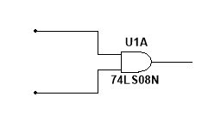An AND gate is connect with outputs of Select and Master Clear Dip Switch
2. The output of AND gate is connected to CLR of 5 Shift registers

* Functionality of Select and CLR

1. Select = 0 loads the input onto the3 loading shift registers.
2. After Loaded on CLK Select = 1 will Start the rotating Marquee.

*Results*

* When the Select Switch is Turned the First input is loaded onto the registers which forward the input onto the decoders and desired letter is displayed .
* Then after when select input is turned the next input is loaded by the multiplexers onto the shift registers and decoder which shifts the previous input forward and new input is appears on the Display .
* The Given Input Keeps on Moving Along the 7 Segments Until the Simulation is Stopped by the User.
* The clear Input Clears All of the Input in the Registers. This process continues until the Simulation is Stopped.
* The Outut is Then Displayed One By One On each Segment

The Proper Working Circuit is Given Below

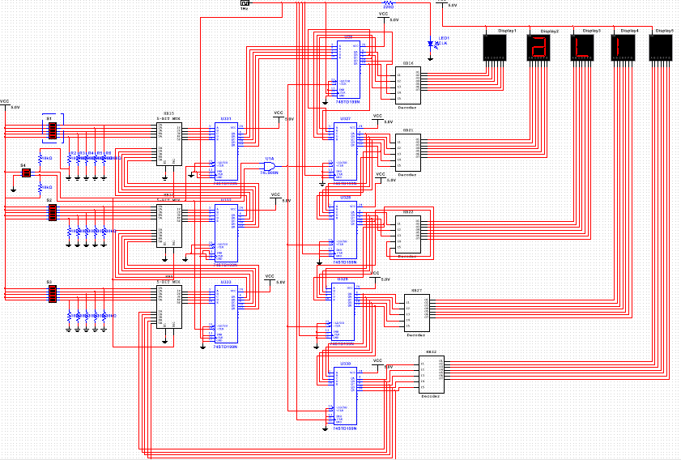*Conclusion*

Project is Successful and Working Properly.