**Database Development using MySQL**

**LAB REPORT # 4**



**Spring 2023**

**Data Base Management System Lab**

Submitted by: **Hamza Ali**

Registration No.: **20PWCSE1917**

Class Section: **B**

“On my honor, as student of University of Engineering and Technology, I have neither given nor received unauthorized assistance on this academic work.”

Student Signature: **HamzakhanSwati**

Submitted to:

**Ma’am Sumiyya**

March07, 2023

Department of Computer Systems Engineering

**University of Engineering and Technology, Peshawar**

**Database Development using MySQL**

***---------------------------Task 4.5---------------------------***

Consider the Relational Schema given in Figure 4.3 and its tables given in Figure 4.4. Write SQL commands to create all the tables. Take the appropriate attribute type and length from the data provided. (Note: Use the following hierarchy for table creation: 1) Type, Tournament and Team, 2) Member, and 3) Entry).

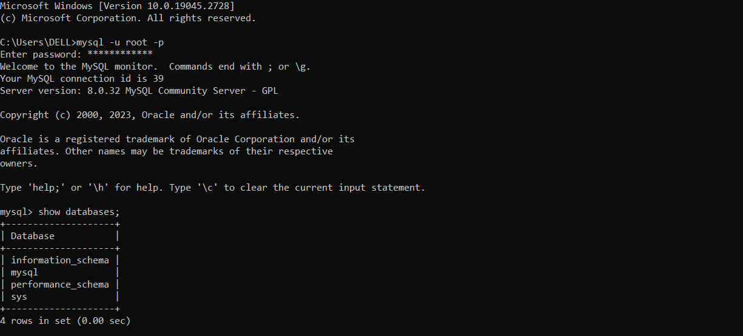

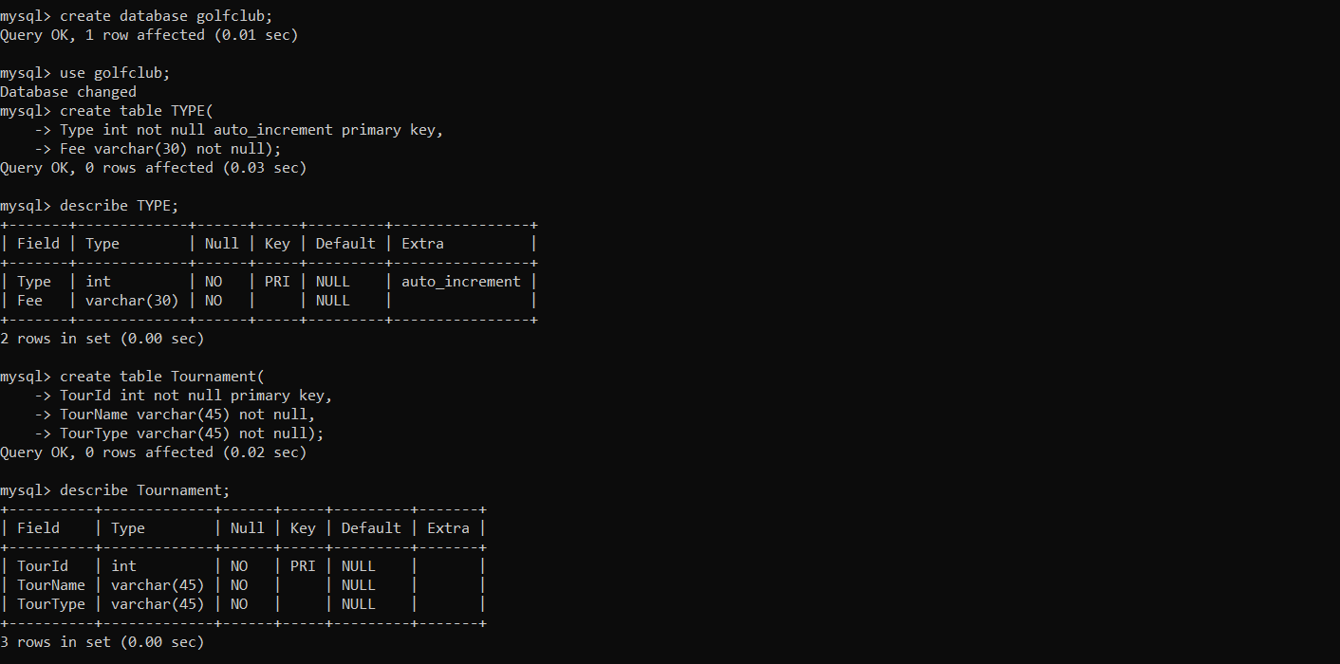



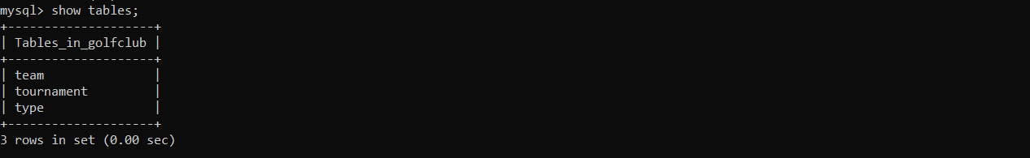

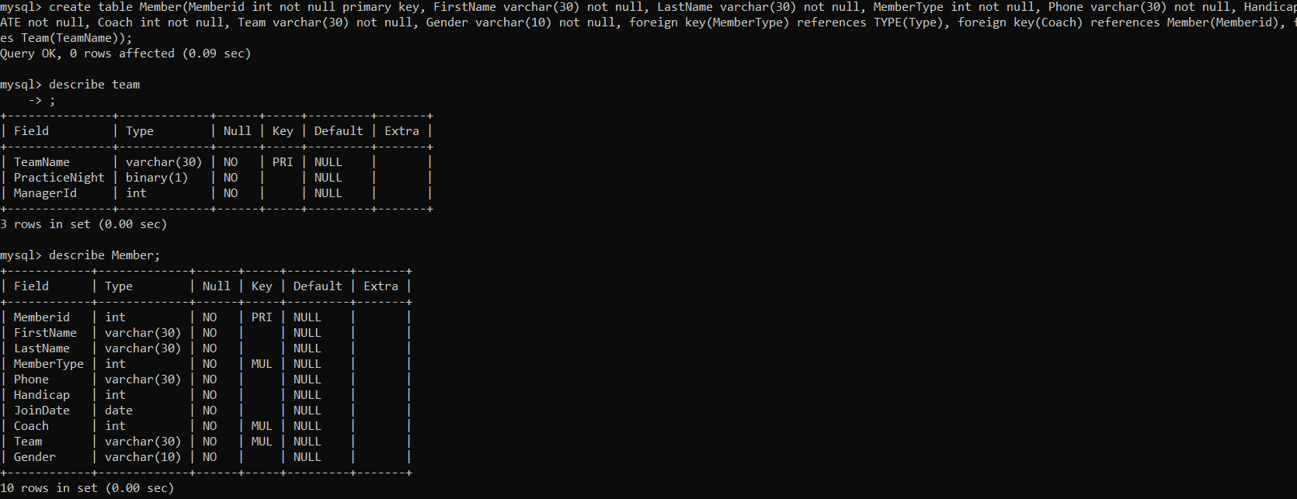

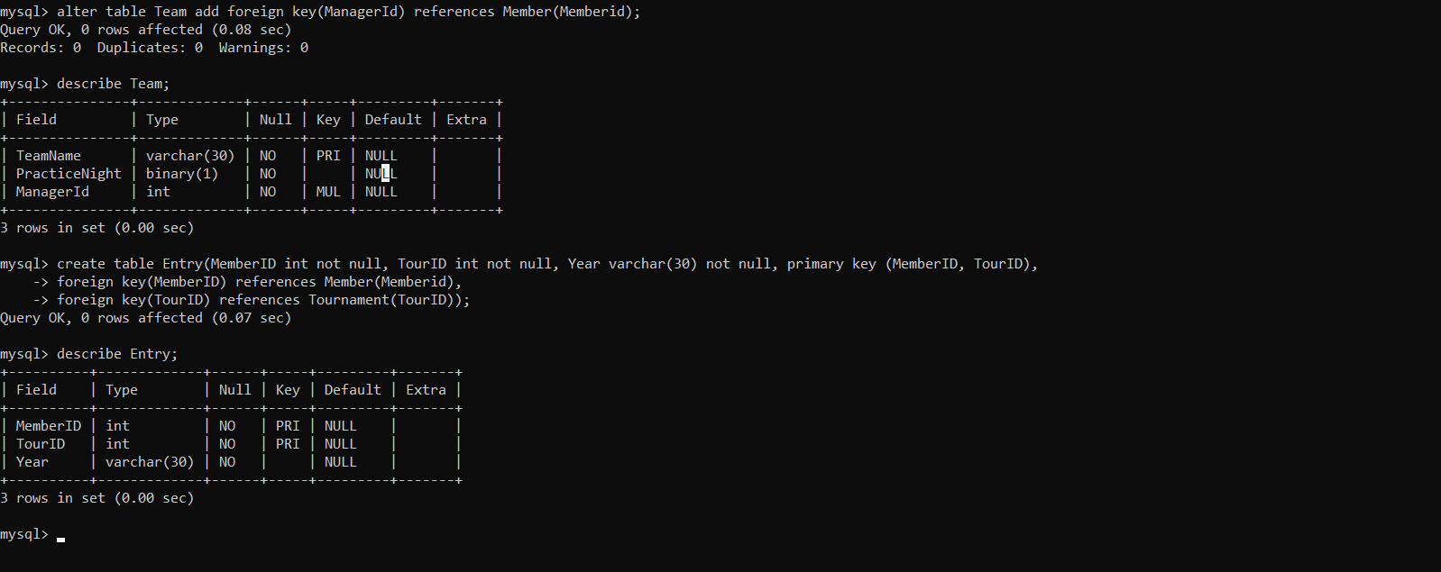

***---------------------------Task 4.6---------------------------***

Using insert command, populate all the records in member, type, entry, team, and tournament tables according to Figure 4.4a and Figure 4.4b.

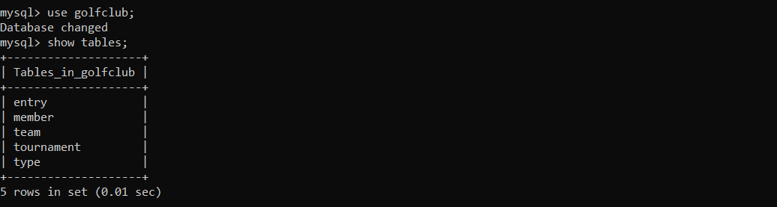

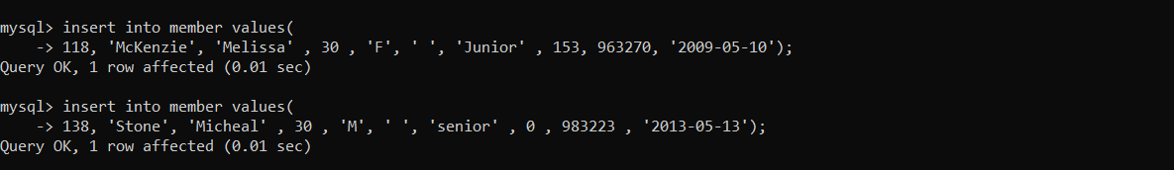



 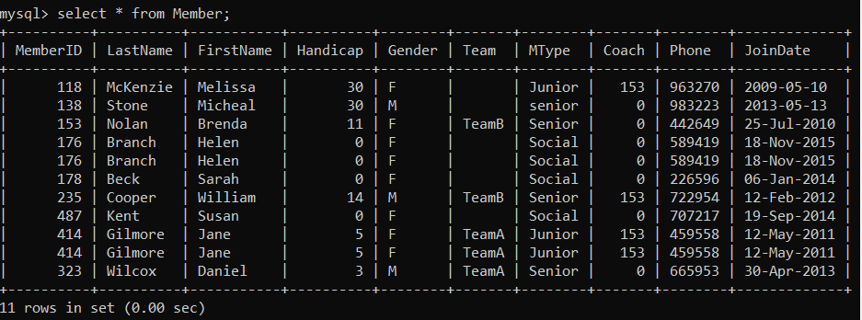



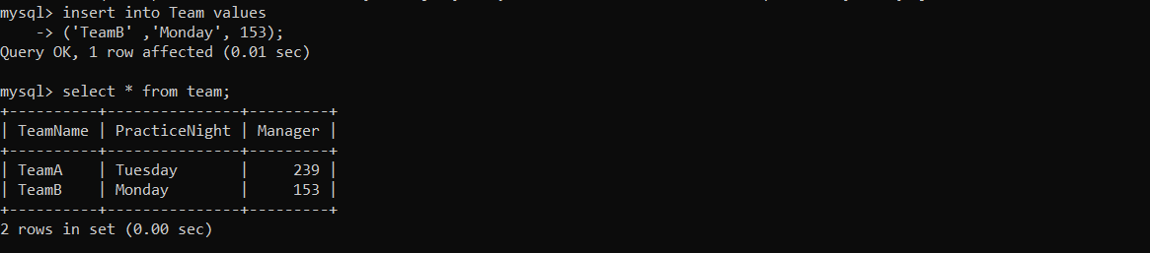

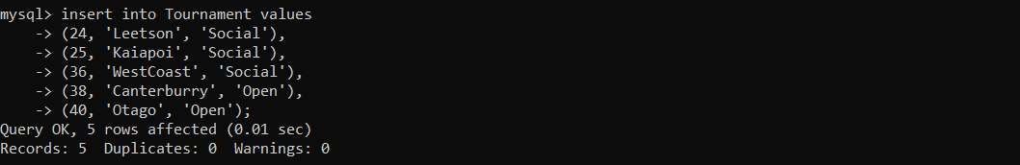

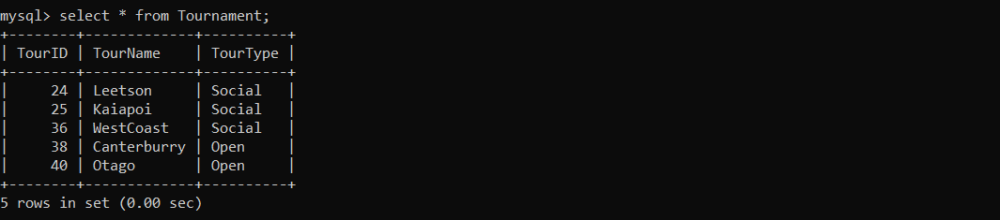

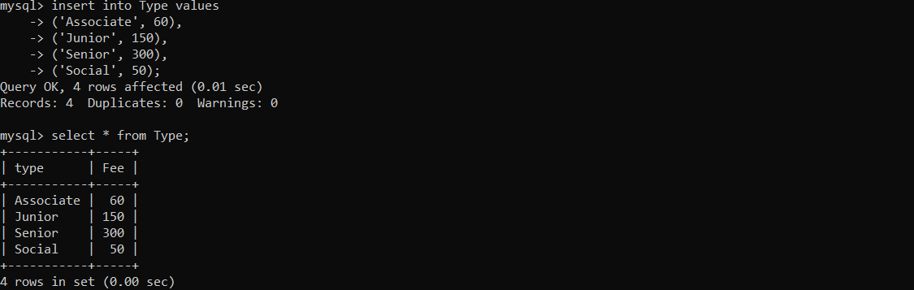

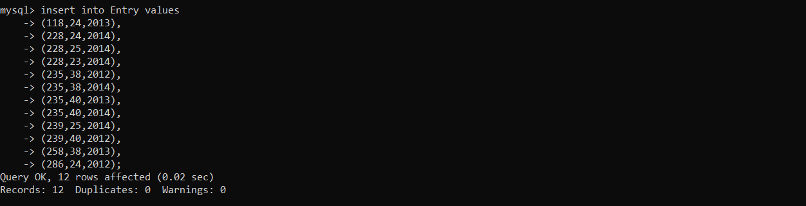

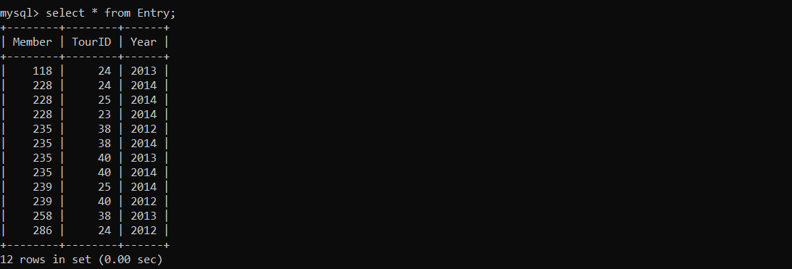

***---------------------------Task 4.7---------------------------***

Write the query for the following: a) List the first name, last name, and phone numbers of all the members.

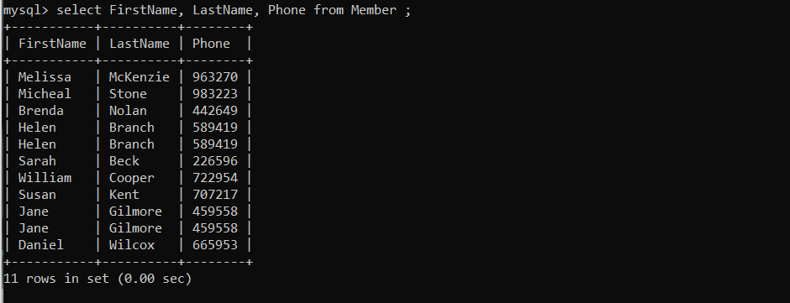

b) List complete information of all the male members.

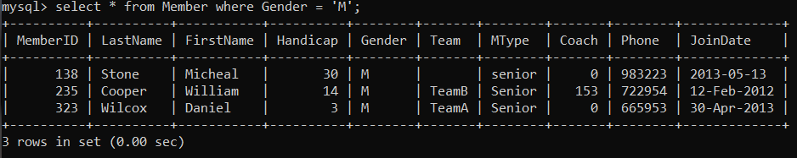

c) List complete information of all the members who joined after 01-01-2013

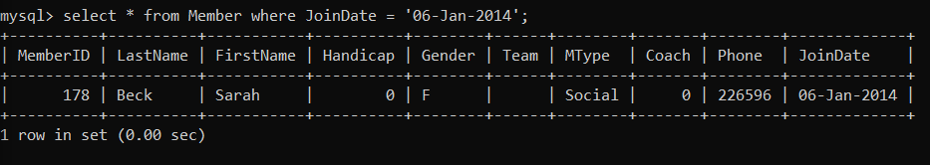

d) List name of all the members who belonged to Team A.

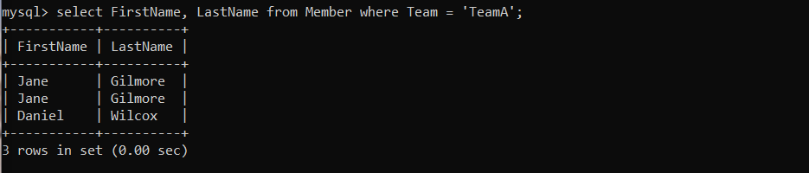

e) List complete information of all the senior members.

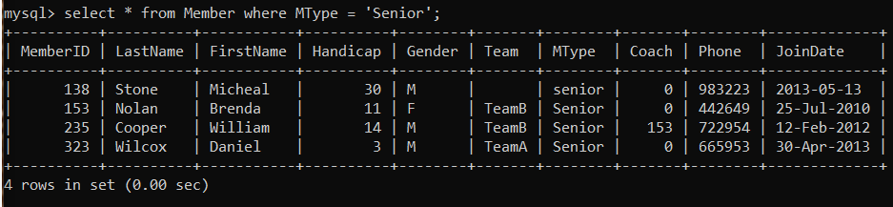

f) List complete information of all the members in order of LastName.

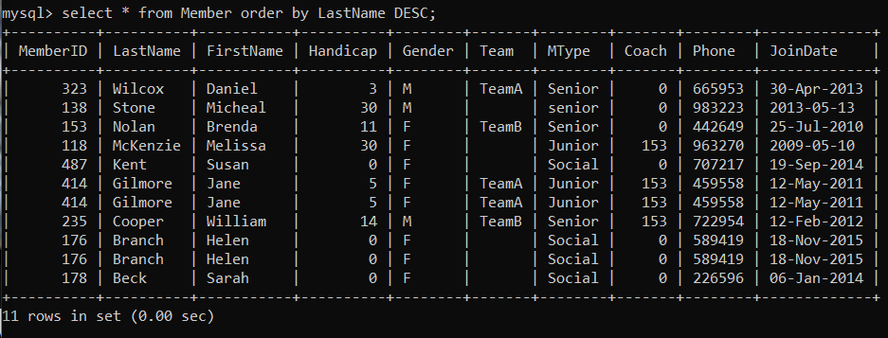

g) Retrieve the number of records in Member table.

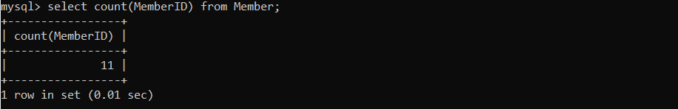

h) Provide the first name and last name of the two coaches.

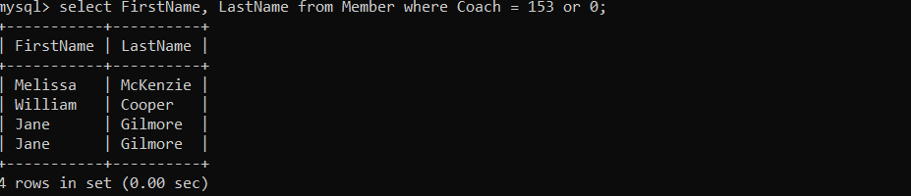

j) Delete the record from Entry table where Member=415 and TourID=40.



k) Update the Fee of Associate in Type table from 60 to 80.

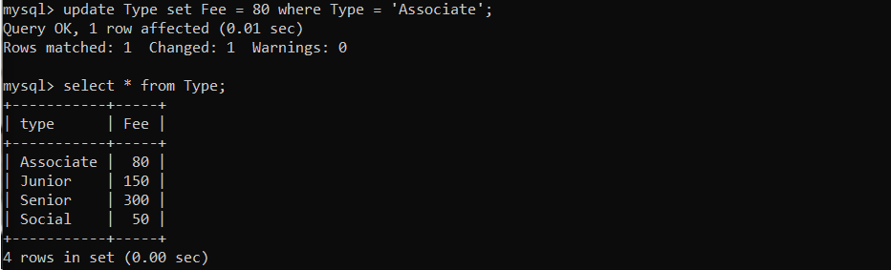

**---------------------------Task 4.8---------------------------**

MySQL supports various built-in functions belonging to various categories such as numeric functions, string functions, and date & time functions. Write MySQL commands for following numeric functions: ceiling, cos, degrees, log10, mod, radians, round, sqrt, and truncate. Next write MySQL commands for following string functions: concat, upper, lower, repeat, reverse, regexp, replace, length, ltrim, and rtrim. Finally write MySQL commands for following date & time functions: curdate, week, date_from, quarter, now, sysdate, and date_format.

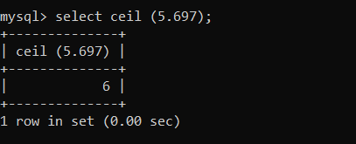

Output:

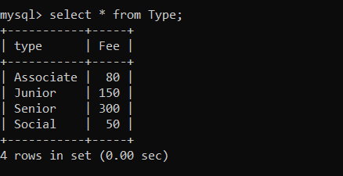

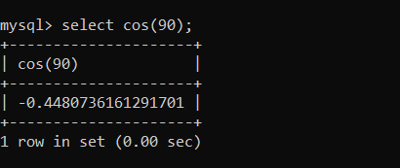

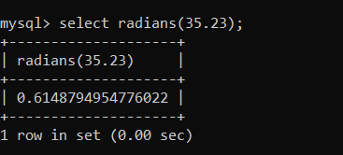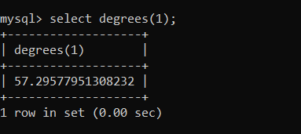

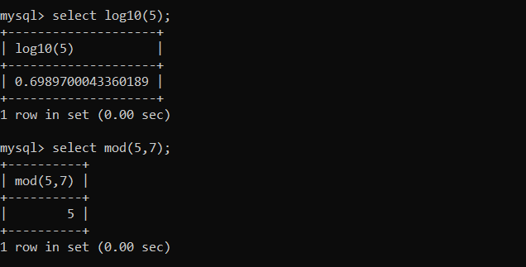

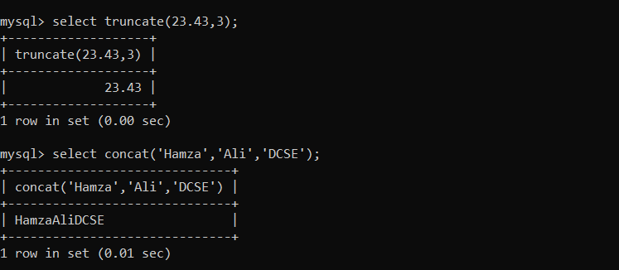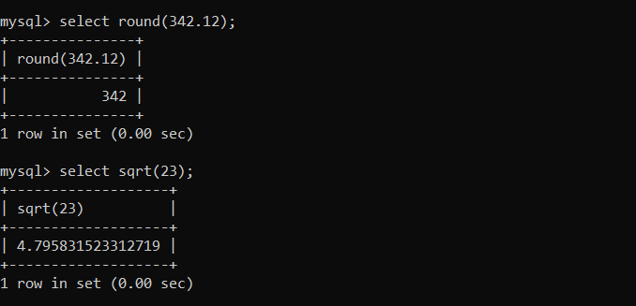

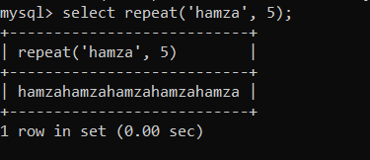 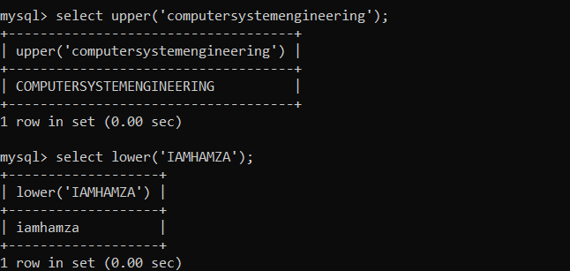

***---------------------------Task 4.9---------------------------***

MySQL uses various operators such as Comparison (, <=, >=, ==, and !=), Boolean (AND, OR, and NOT), and Special Operators (Between, Like, IN, Is Null, and Distinct). Give examples of these for Golf database created in this lab

***Use of = operator:***





***Use of Boolean AND:***



***Use of Boolean OR:***



***---------------------------Task 4.10--------------------------***

Alter is an important command of MySQL. It is used to alter variety of things associated with a database. It can alter the overall characteristics of database, metadata, view, function, procedure, event, and user. Alter table is used specifically for altering the table metadata. Write MySql statements involving alter table for following.

1. Add new column DOB to store member date of birth. Its type is date and can be null.

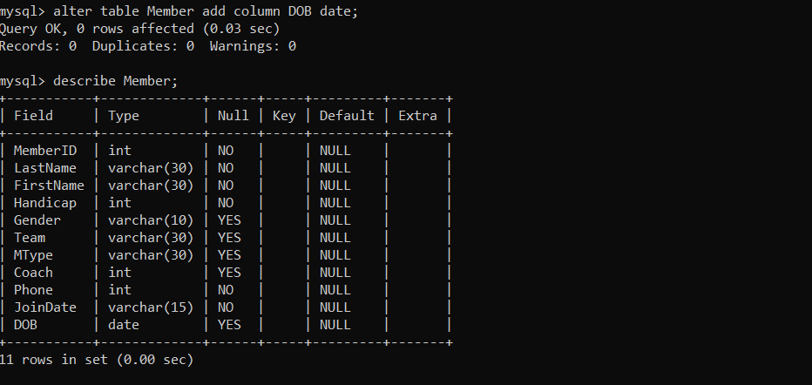

1. Now change the name of newly added column from DOB to M_DOB with date as data type and not null

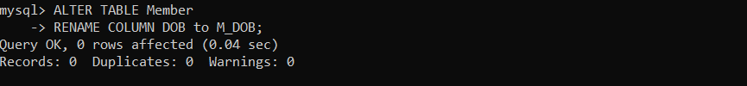

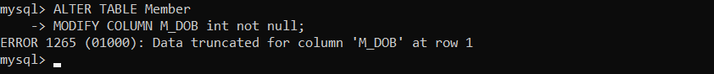

1. Now drop the M_DOB column from member table.

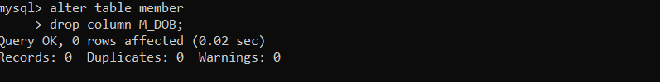

1. Next drop the primary key TourID from tournament table

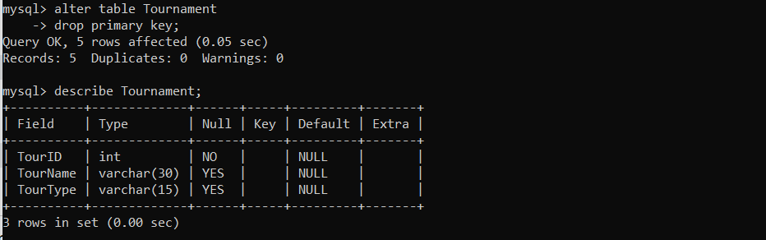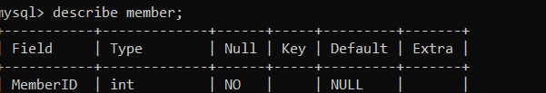

1. Now add new primary key TourID into tournament table

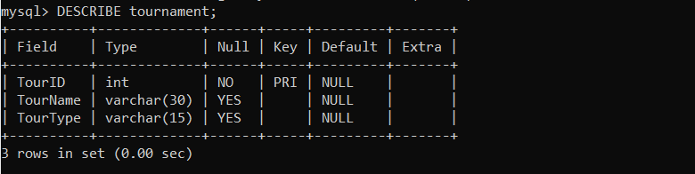

1. Next drop the foreign key Coach from member table.

