**Improved Web Design using CSS/Bootstrap**

**LAB REPORT # 3**



**Spring 2023**

**Data Base Management System Lab**

Submitted by: **Hamza Ali**

Registration No.: **20PWCSE1917**

Class Section: **B**

“On my honor, as student of University of Engineering and Technology, I have neither given nor received unauthorized assistance on this academic work.”

Student Signature: **HamzakhanSwati**

Submitted to:

**Ma’am Sumiyya**

March 14, 2023

Department of Computer Systems Engineering

**University of Engineering and Technology, Peshawar**

**Improved Web Design using CSS/Bootstrap**

***---------------------------Task 3.2---------------------------***

***Write the HTML code that generates the output web page shown in Figure 3.9 with following specification:***

***Code:***

<!DOCTYPE *html*>

<html>

  <head>

    <title>My Web Page</title>

    <style>

      h1 {

        font-family: Garamond, serif;

        font-size: 26pt;

        color: red;

        margin-top: 5%;}

      ul {

        list-style-type: square}

    </style>

  </head>

  <body>

    <h1>Silicon Chip Technologies</h1>

    <p>SCT provides Corporate Training for the following products: </p>

    <ul>

      <li>HTML</li>

      <li>JavaScript</li>

      <li>CGI</li>

      <li>Java</li>

      <li>Oracle Developer 2000</li>

      <li>Oracle DBA</li>

    </ul>

  </body>

</html>

***Output:***

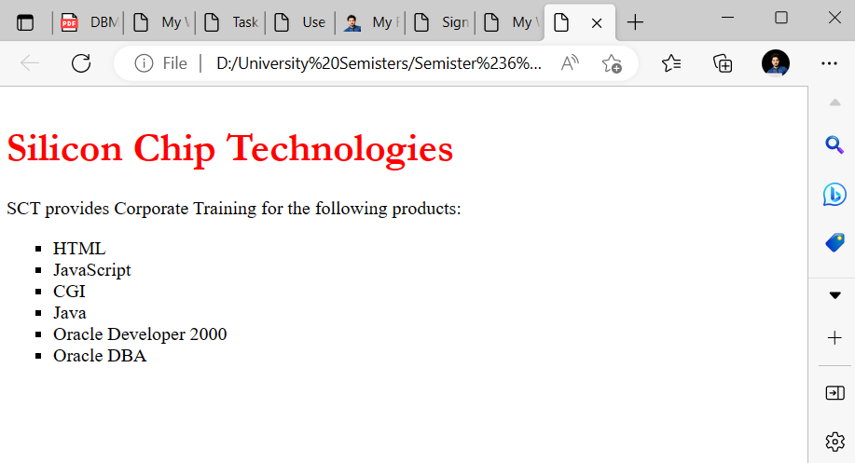

***---------------------------Task 3.3---------------------------***

***Write the HTML code along with CSS file that generates the output web page shown in Figure 3.9.***

***Code:(HTML File)***

<!DOCTYPE html>

<html lang="en">

<head>

    <meta charset="UTF-8">

    <meta http-equiv="X-UA-Compatible" content="IE=edge">

    <meta name="viewport" content="width=device-width, initial-scale=1.0">

    <title>Task3.3</title>

    <link rel="stylesheet" href="Task 3.3.css">

</head>

<body>

    <h1>Silicon Chip Technologies</h1>

    <p>SCT provides Corporate Training for the following products: </p>

    <ul>

        <li>HTML</li>

        <li>JavaScript</li>

        <li>CGI</li>

        <li>Java</li>

        <li>Oracle Developer 2000</li>

        <li>Oracle DBA</li>

      </ul>

</body>

</html>

**CSS File**

body{

    margin-top: 5%;

}

h1{

  font-family:  Garamond ;

  font-size: 26;

  color: red;

}

ul{

    list-style-type: disc;

}

**Output:**

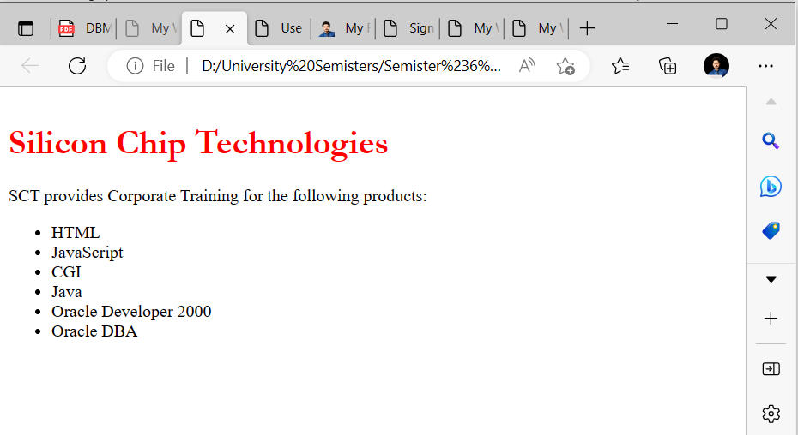

***---------------------------Task 3.4---------------------------***

***Rewrite Example 5 using ID Selector instead of class Selector and show its output.***

<!DOCTYPE html>

<head>

<title> Use of Margin Attributes </title>

<style type="text/css">

p {font-size:12pt;

font-weight:bold;

text-align:justify;

margin-left:10%;

margin-right:10%;}

 #question {color: brown; font-style: italic;}

 #answer {color:#23238e}

 </style>

 </head>

 <body>

 <p id="question">How to create style sheet to alter an HTML

 element?</p>

 <p id="answer">The Style assignment process can be accomplished with

 the &lt;STYLE&gt;...&lt;/STYLE&gt; tags. The syntax for making the

 assignment is simple. Between &lt;STYLE&gt; and &lt;/STYLE&gt;, HTML tags

 to which styles are to be assigned are to be listed ad each tag with a pair of

 curly brackets in which specific style attributes are to be specified. This

 &lt;STYLE&gt; tag should be within &lt;HEAD&gt;...&lt;/HEAD&gt;

 element.</p>

 <br>

 <p id="question">What are the attributes that can be specified? </p>

 <p id="answer">The attributes that can be specified are: Font attributes,

 Color and Background attributes, Text attributes, Border attributes, Margin

 attributes, and List attributes. </p>

 </body>

 </html>

***Output:***

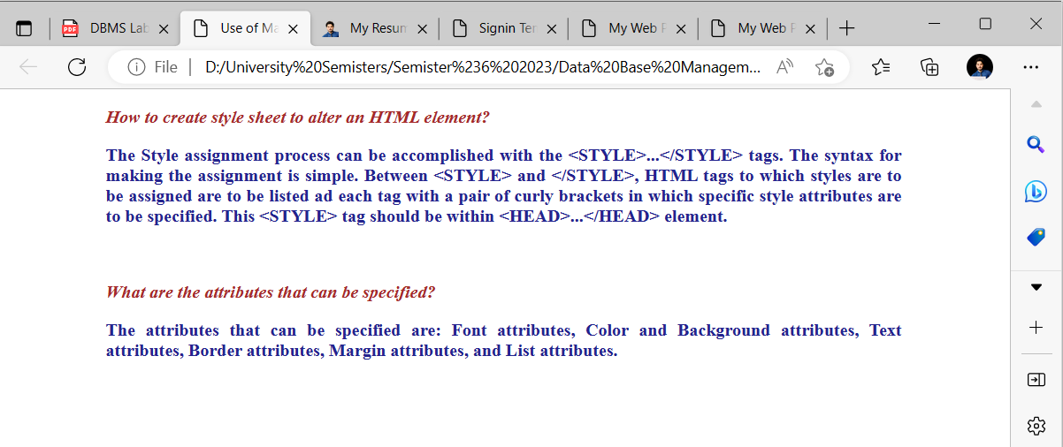

***---------------------------Task 3.5---------------------------***

Bootstrap 5.2.3 Examples: Go through the following examples in bootstrap-5.2.3-examples.zip file provided with Lab 01: sign-in, cover, checkout, with description. ***Output:***

***Sign In Page:***

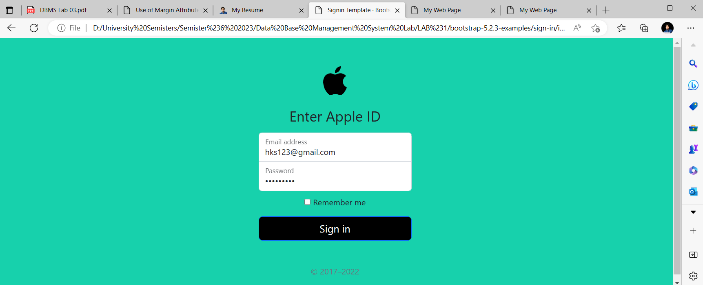

Cover Page:

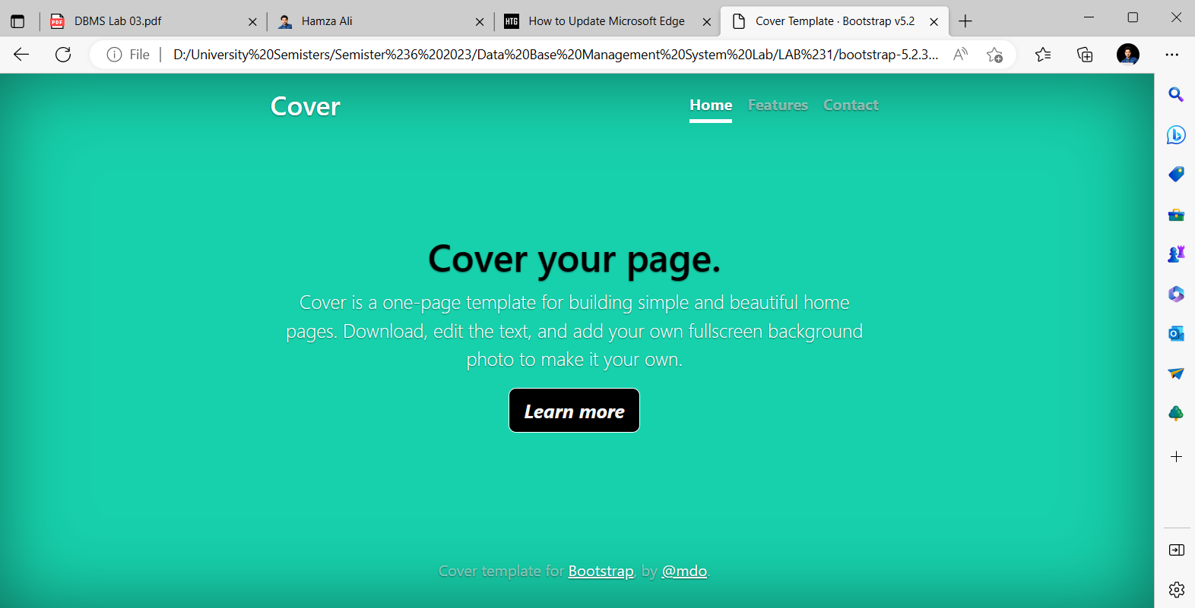

Checkout Page:

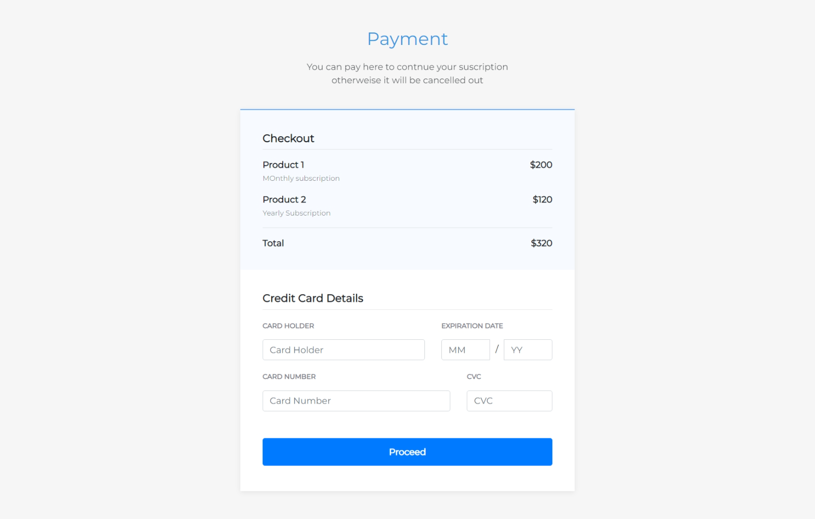

Blog Page:

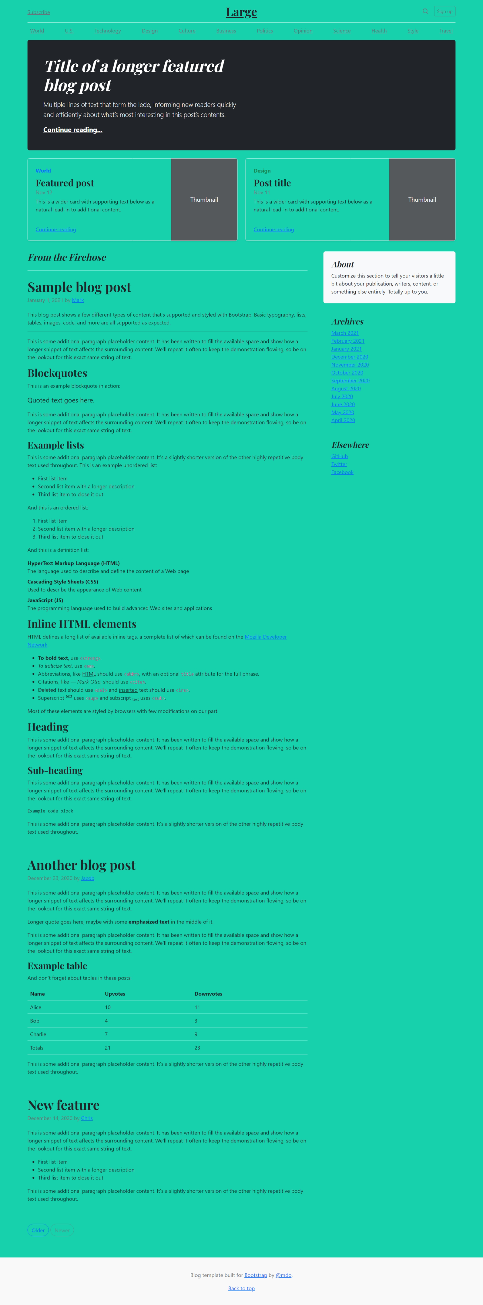

***---------------------------Task 3.6---------------------------***

***Modify your CV designed using plain HTML in last lab by adding CSS and Bootstrap in it. Upload both original one and modified one on the hosting site. Provide the link.***

***---------------------------Output----------------------------***

