**Programming in PHP**

**LAB REPORT # 5**



**Spring 2023**

**Data Base Management System Lab**

Submitted by: **Hamza Ali**

Registration No.: **20PWCSE1917**

Class Section: **B**

“On my honor, as student of University of Engineering and Technology, I have neither given nor received unauthorized assistance on this academic work.”

Student Signature: **HamzakhanSwati**

Submitted to:

**Ma’am Sumiyya**

April 04, 2023

Department of Computer Systems Engineering

**University of Engineering and Technology, Peshawar**

**Programming in PHP**

***---------------------------Task 5.1---------------------------***

In contrast to settype(), there is another method that causes a variable’s value to be treated as a specific type. It is known as type casting. Note that the variable itself remains unaffected during type casting. Consider the following variable: • $test_var = 8.23; Type cast this variable’s value to integer, string, and Boolean and show result using echo.

***Code:***

<?php

$test_var = 8.23;

*// Type cast to integer*

$test_int = (int) $test_var;

echo "Integer value: $test_int <br>";

*// Type cast to string*

$test_str = (string) $test_var;

echo "String value: $test_str <br>";

*// Type cast to boolean*

$test_bool = (bool) $test_var;

echo "Boolean value: $test_bool <br>";

?>

***Output:***



***---------------------------Task 5.2---------------------------***

Use and Specify the purpose of following functions:

1) intval( value )

2) floatval( value )

3) strval( value )

***Code:***

<?php

*//this is the example for the intval function shown in the lab manual*

$float_value = 3.14;

$int_value = intval($float_value);

echo "This is the float to Int conversin : $int_value <br>"; *// Output: 3*

$string_value = "42";

$int_value = intval($string_value);

echo "This is the string to int conversion: $int_value<br>"; *// Output: 42*

$string_value = "Hello world!";

$int_value = intval($string_value);

echo "This is the string to integer conversion: $int_value<br>"; *// Output: 0*

*//this is the example for the use of the floatval function*

$int_value = 42;

$float_value = floatval($int_value);

echo "This is the conversion of integer to float value: $float_value<br>"; *// Output: 42.0*

$string_value = "3.14";

$float_value = floatval($string_value);

echo "This is the conversion of the string to value: $float_value<br>"; *// Output: 3.14*

$string_value = "Hello world!";

$float_value = floatval($string_value);

echo "This is the conversion of the string to float value by floatval function: $float_value<br>"; *// Output: 0*

*//this is the example for the use of the strval function*

$int_value = 42;

$string_value = strval($int_value);

echo "This is the conversion of the integer to string conversion: $string_value<br>"; *// Output: "42"*

$float_value = 3.14;

$string_value = strval($float_value);

echo "This is the conversion of the float to string value: $string_value<br>"; *// Output: "3.14"*

?>

***Output:***

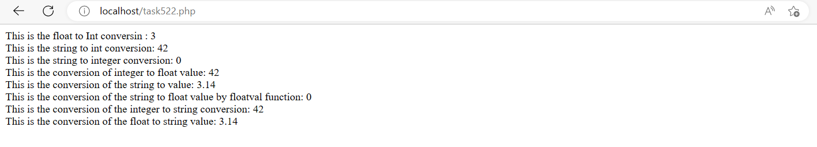***---------------------------Task 5.3---------------------------***

Write PHP script that shows the division table displayed as in Table 5.2 using different loops. For each number, display whether that number is an odd or even number, and also display a message if the number is a prime number. Display this information within an HTML table.

***Code:***

<!DOCTYPE html>

<html>

<head>

    <title>Table to check weather the numbers are even or odd</title>

</head>

<body>

<table border="1px solid">

    <thead>

        <tr>

            <th>&nbsp;</th>

            <?php

                for ($i = 1; $i <= 5; $i++) {

                    echo "<th>$i</th>";}

            ?>

        </tr>

    </thead>

    <tbody>

        <?php

            for ($i = 1; $i <= 5; $i++) {

                echo "<tr>";

                echo "<td>$i</td>";

                for ($j = 1; $j <= 5; $j++) {

                    $result = $i / $j;

                    if ($i % 2 == 0) {

                        $is_even_odd = "Even";

                    } else {

                        $is_even_odd = "Odd";}

                    $is_prime = true;

                    for ($k = 2; $k <= $i/2; $k++) {

                        if ($i % $k == 0) {

                            $is_prime = false;

                            break;}                    }

                    if ($is_prime && $j != 1) {

                        echo "<td><b>$result</b><br>($is_even_odd)<br>Prime</td>";

                    } else {

                        echo "<td>$result<br>($is_even_odd)</td>";}}

                echo "</tr>"; }

        ?>

    </tbody>

</table>

</body>

</html>

***Output:***

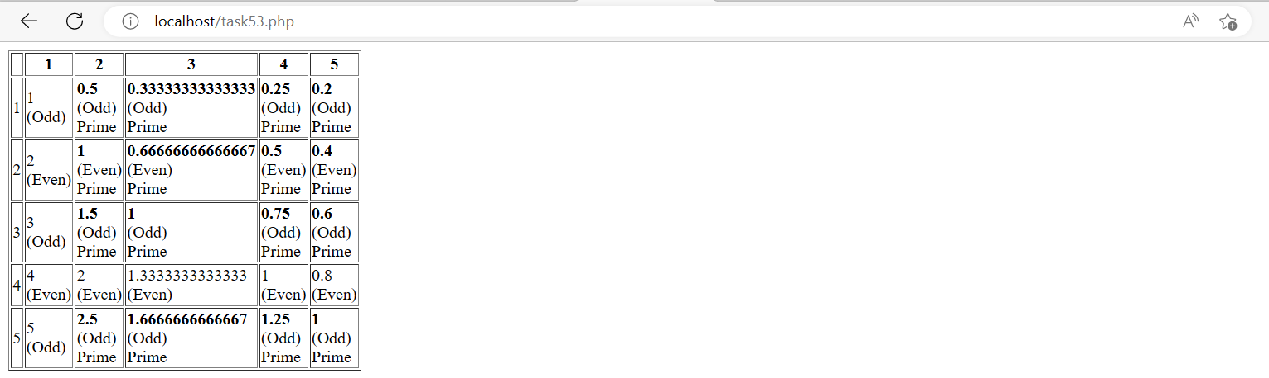

***---------------------------Task 5.4---------------------------***

Explore PHP Object Oriented using examples showing classes, objects, inheritance, and polymorphism.

***Code:***

***Polymorphism***

<!DOCTYPE html>

<html>

<body>

<h1>Polymorphism in PHP</h1>

<?php

interface Animal {

    public function makeSound();

}

class Lion implements Animal {

    public function makeSound() {

        echo "Roaring! <br>";

    }

}

class Bear implements Animal {

    public function makeSound() {

        echo "cheeew!";

    }

}

function animalSound(Animal $animal) {

    $animal->makeSound();

}

$Lion = new Lion();

$Bear = new Bear();

animalSound($Lion);

animalSound($Bear);

?>

</body>

</html>

***Output:***

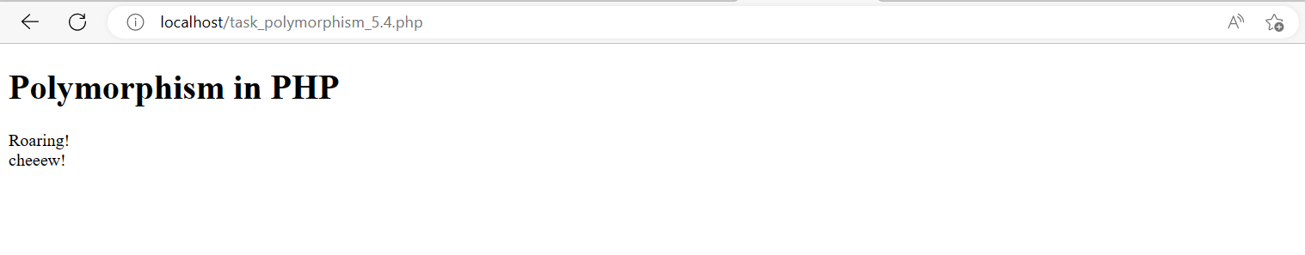

***Classes:***

<!DOCTYPE html>

<html>

<body>

<h1>Use of Classes</h1>

<?php

class Person {

public $name;

public $age;

public function construct($name, $age) {

*$this*->name = $name;

*$this*->age = $age;

}

public function greet() {

echo "I am Hamza$this->name and I am studying in UET Peshawar,$this->age Department of Computer Systems Engineering.";

}

}

$person1 = new Person("Hamza", "UET Peshawar");

$person1->greet();

?>

</body>

</html>

***Output:***



***Inheritance:***

<!DOCTYPE html>

<html> <body>

<h1>Inheritance</h1>

<?php

class Person {

public $name;

public $age;

public function __construct($name, $age) {

*$this*->name = $name;

*$this*->age = $age;

}

public function greet() {

echo "Hello, I am $this->name and I am studying in UET Peshawar,$this->age .";

}

}

$person1 = new Person("Hamza", "DCSE");

$person1->greet();

class Student extends Person {

public $student_id;

public function __construct($name, $age, $student_id) {

parent::__construct($name, $age);

*$this*->student_id = $student_id;

}

public function greet() {

echo "This is $this->name and I am doing  $this->student_id in $this->age using PHP.";

}

}

$student1 = new Student("DBMS lab#5", "task#5.4", "inheritance");

$student1->greet();

?>

</body>

</html>

***Output:***



***---------------------------Task 5.5---------------------------***

Build an image gallery website using PHP without database. Your website must show all the images in a given directory. Use bootstrap/CSS in your website. Please note that when a given image is clicked, it enlarges it and shows in higher resolution. Also, your website should be flexible enough to show the images when number of images are increased or decreased from a given directory.

***Code:***

<!DOCTYPE html>

<html>

<head>

    <title>Image Gallery</title>

    <meta charset="utf-8">

    <meta name="viewport" content="width=device-width, initial-scale=1">

    <link rel="stylesheet" href="https://maxcdn.bootstrapcdn.com/bootstrap/3.4.1/css/bootstrap.min.css">

    <script src="https://ajax.googleapis.com/ajax/libs/jquery/3.5.1/jquery.min.js"></script>

    <script src="https://maxcdn.bootstrapcdn.com/bootstrap/3.4.1/js/bootstrap.min.js"></script>

    <style>

        .img-thumbnail {

            width: 200px;

            height: 200px;

            object-fit: cover;

            cursor: pointer;

        }

        #myModal img {

            max-width: 100%;

            height: auto;

        }

    </style>

</head>

<body>

    <div class="container-fluid">

        <div class="row">

            <?php

                $dir = "images/";

                $images = glob($dir . "*.{jpg,jpeg,png,gif}", GLOB_BRACE);

                foreach ($images as $image) {

                    echo '<div class="col-md-2 col-sm-4 col-xs-6">';

                    echo '<a data-toggle="modal" data-target="#myModal">';

                    echo '<img src="' . $image . '" class="img-thumbnail">';

                    echo '</a>';

                    echo '</div>';}?>

        </div>

    </div>

    <div class="modal fade" id="myModal" tabindex="-1" role="dialog" aria-labelledby="myModalLabel">

        <div class="modal-dialog" role="document">

            <div class="modal-content">

                <div class="modal-body">

                    <img src="" class="img-responsive" id="modalImage">

    </div>

    <script>

        $(document).ready(function(){

            $('.img-thumbnail').click(function(){

                var imgSrc = $(*this*).attr('src');

                $('#modalImage').attr('src', imgSrc);}); });

    </script>

</body>

</html>

***Output:***

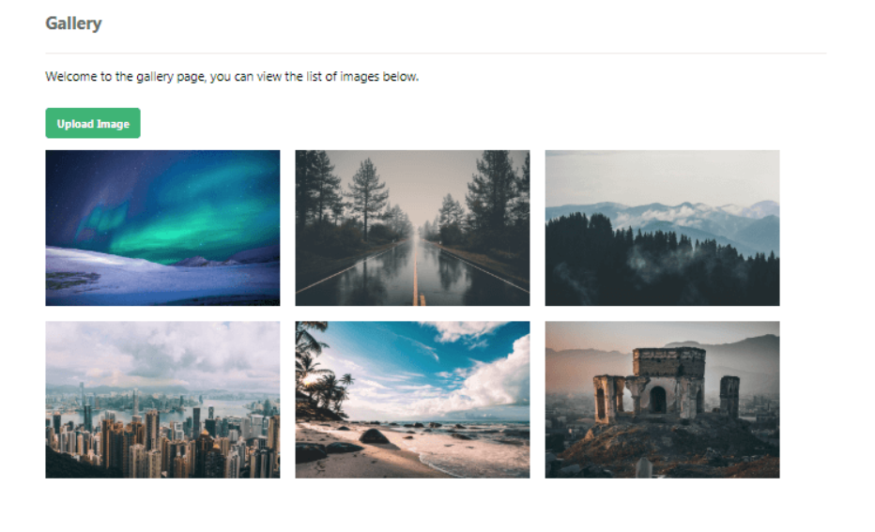

***---------------------------Task 5.7---------------------------***

Implement the following relationship in Laravel. Department: depID, depName, Emplyee: empID, empName, empJob, dID Note that the department has at least one or many employees working in it; while employee works exactly in one department. Also, feed atleast five records in the created tables.

***Output:***



