

**<<Gamestore >>**

**Software Requirement Specification**

– Hochiminh, September 2022 –

**Table of Contents**

I. Overview 3

1. Introduction 3

2. System Functions 4

3. Common Requirements 5

II. Functional Requirements 6

1. <<Feature Name 1>> 6

a. <<Function Name 1>> 6

b. <<Function Name 2>> 6

2. <<Feature Name 2>> 6

# I. Overview

## 1. Introduction

Buying and selling game keys is now very popular in the gaming community. The website that sellsgames is created to help the gaming community stay up to date with the latest paid games at attractive promotional prices. At the same time, the website will contain the latest articles on many different game genres

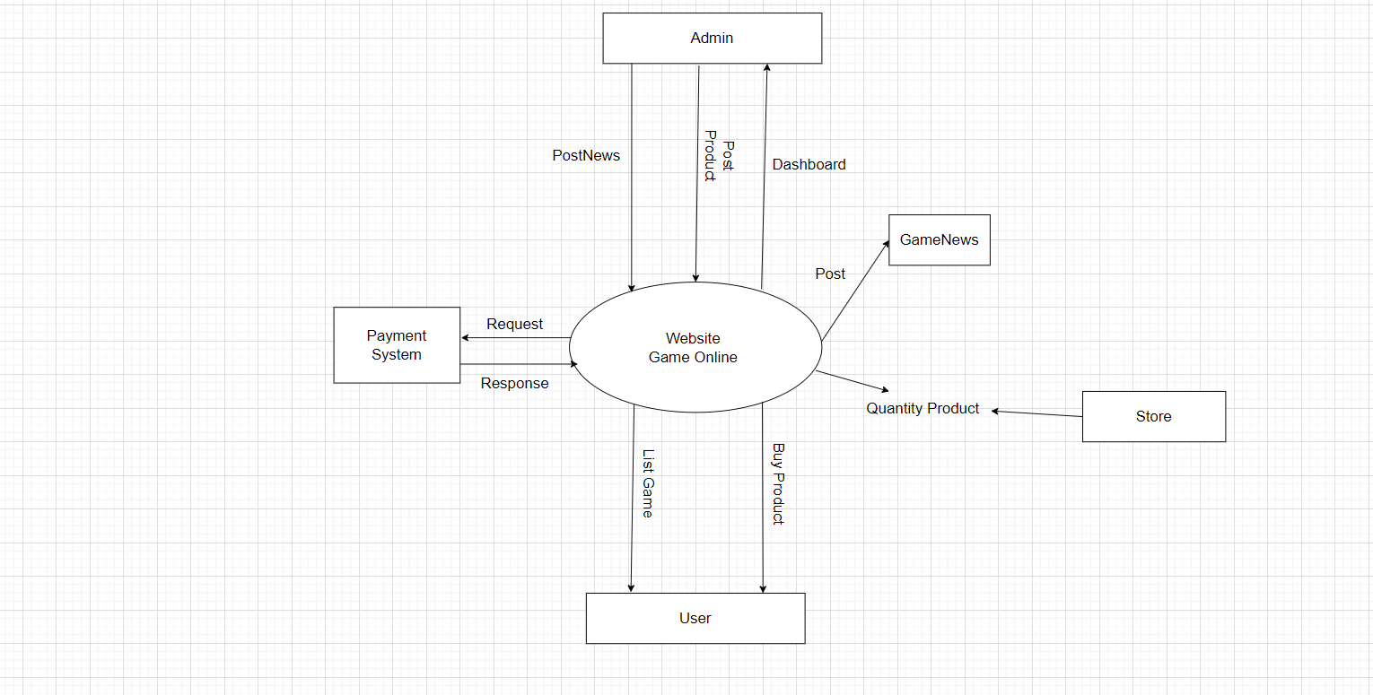>>

## 2. System Functions

#### a. Screen Flow

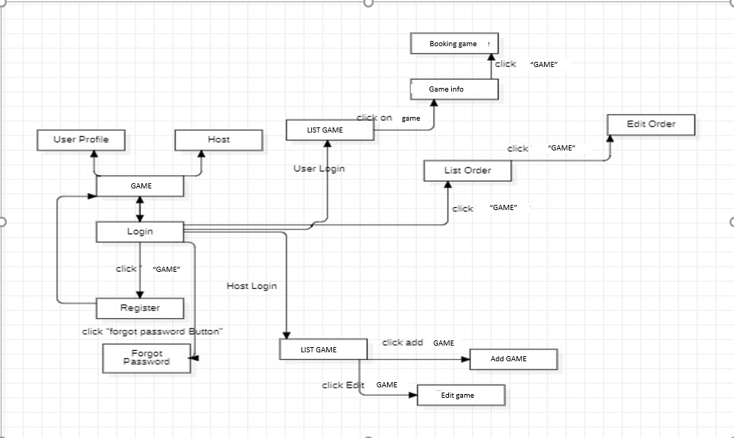

#### b. Screen Details

|  |  |  |  |
| --- | --- | --- | --- |
| **#** | **Feature** | **Screen** | **Description** |
| 1 | Display all lists of the app | User | Print all game and genre lists for users. |
| 2 | Login | Login | Sign in with your registered account. |
| 3 | Filter | User | Search by user-selected price, by rating and category. |
| 4 | Forgot password | Login | A new password will be generated and sent to the email registered by the user. |
| 5 | Checkout | User | Users check the order again, enter their full address and information. |
| 6 | Dashboard | Admin | Admin can see the number of paid orders, the number of visitors and the total revenue of the sales page. |
| 7 | Buy product | User | Users can add products and adjust the number of products they want to buy, the screen will print the total amount to pay. |
| 8 | Add new product | Admin | Admin will add, delete, edit prices and products. |
| 9 | Registration | User | Create an account with username, password and email. |
| 10 | Comment | User | Users can feel carefully about the game experience |

#### c. User Authorization

|  |  |  |
| --- | --- | --- |
| **Screen** | **User** | **Admin** |
| Homepage | x | x |
| Login | x | x |
| List Shop | X | X |
| Create new product |  | x |
| Dashboard |  | x |
| Views Game News | x |  |
| Post Game News |  | x |
| Checkout | x |  |
| Buy product | x |  |

In which:

* Role1: User
* Role2: Admin

#### d. Non-Screen Functions

|  |  |  |  |
| --- | --- | --- | --- |
| **#** | **Feature** | **System Function** | **Description** |
| 1 | Username | Registration | Non special characters. |
| 2 | Password | Registration | Need 6 characters. |
| 3 | Email | Registration | Correct format xxx@xxxx |
| 4 | Buy Product | Shopping Cart | Need Login |
| 5 | Filter | Shopping Cart | Search allow rating, genre, name |
| 6 | Remember | Login | Save cookies user |
| 7 | Search | Search | Users can search by Vietnamese and letters in the product name |
| 8 | Filter | Search | Adjust the price using the toolbar and search within |
| 9 | Password | Registration | Encode before insert database |

## 3. Common Requirements

*<<fill here with all the common requirements...>>*

# II. Functional Requirements

## 1. Gamepage

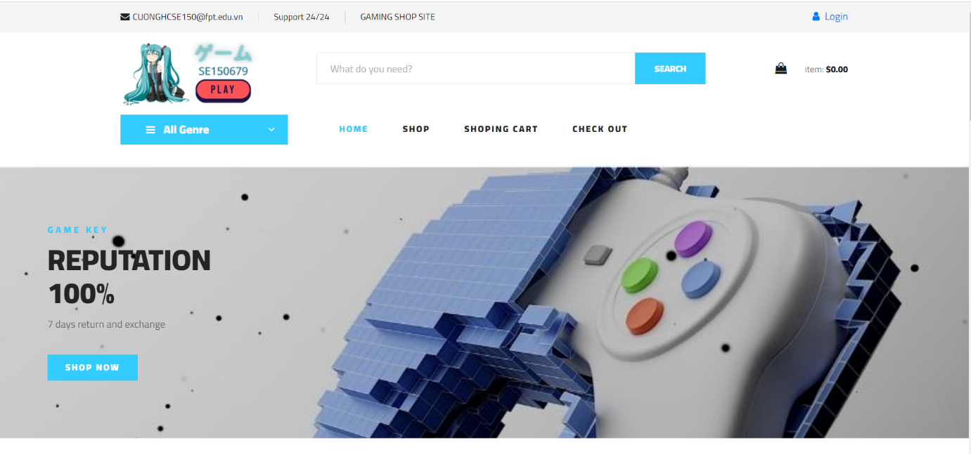

### 

### 2. Checkout

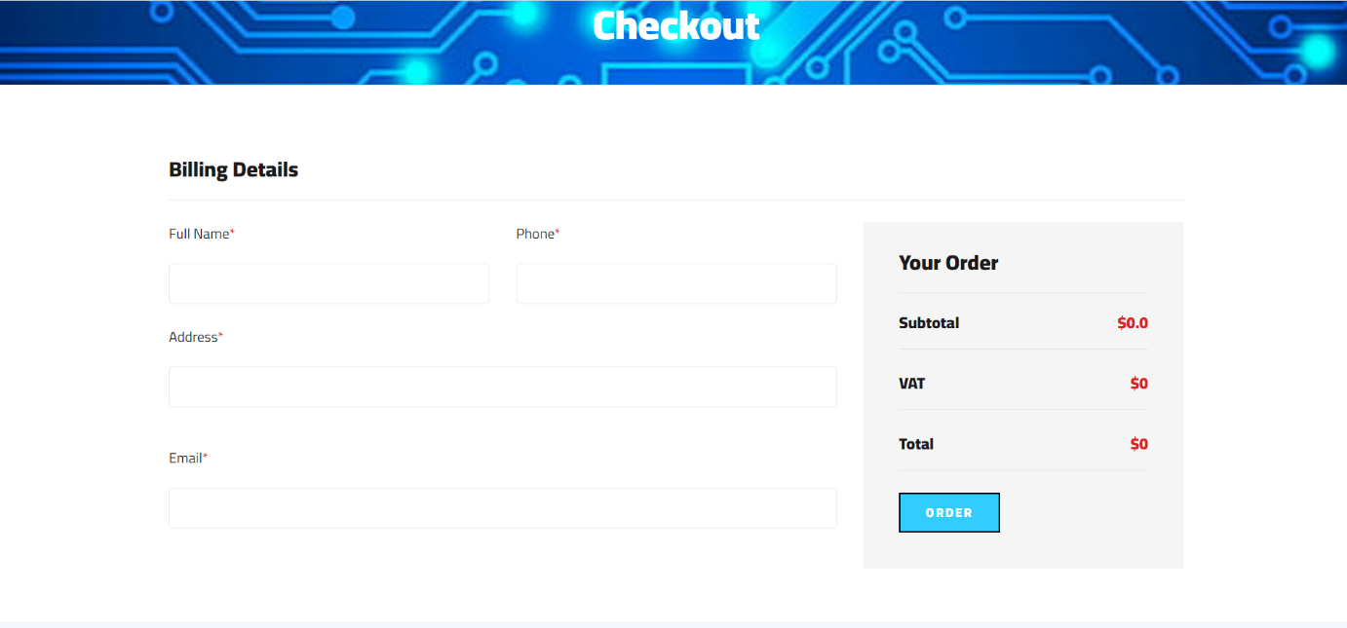

### 

3. View Shop

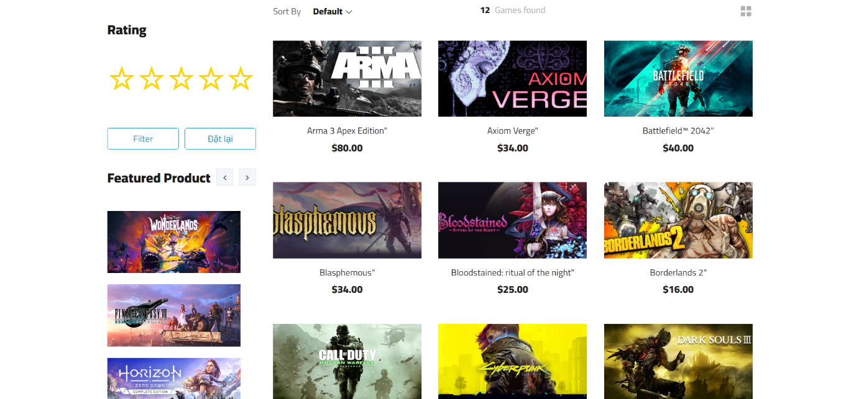

### 4. Filter in View Shop

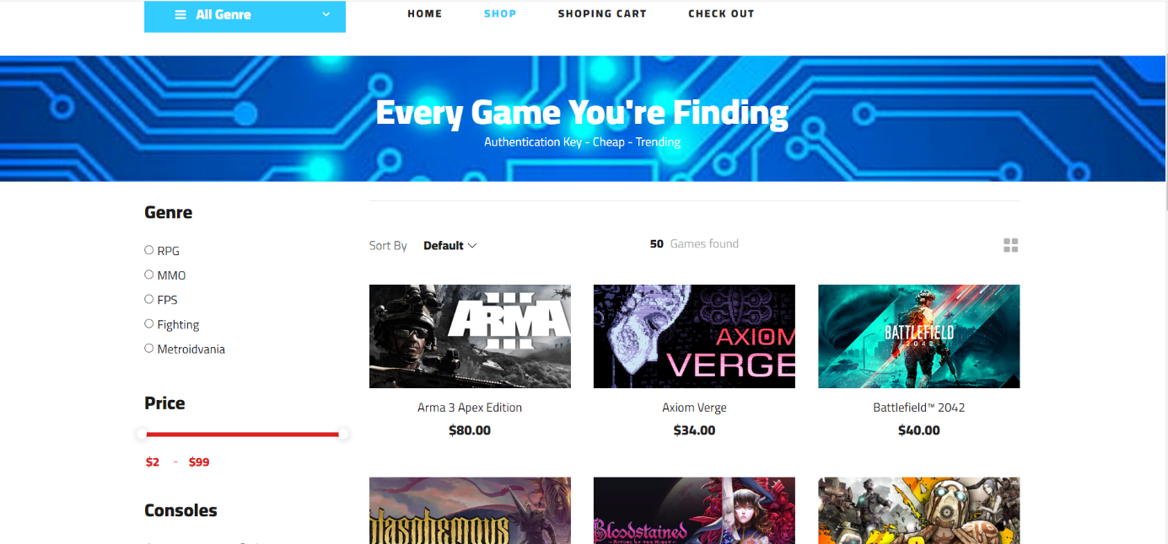

### 5. Shopping cart

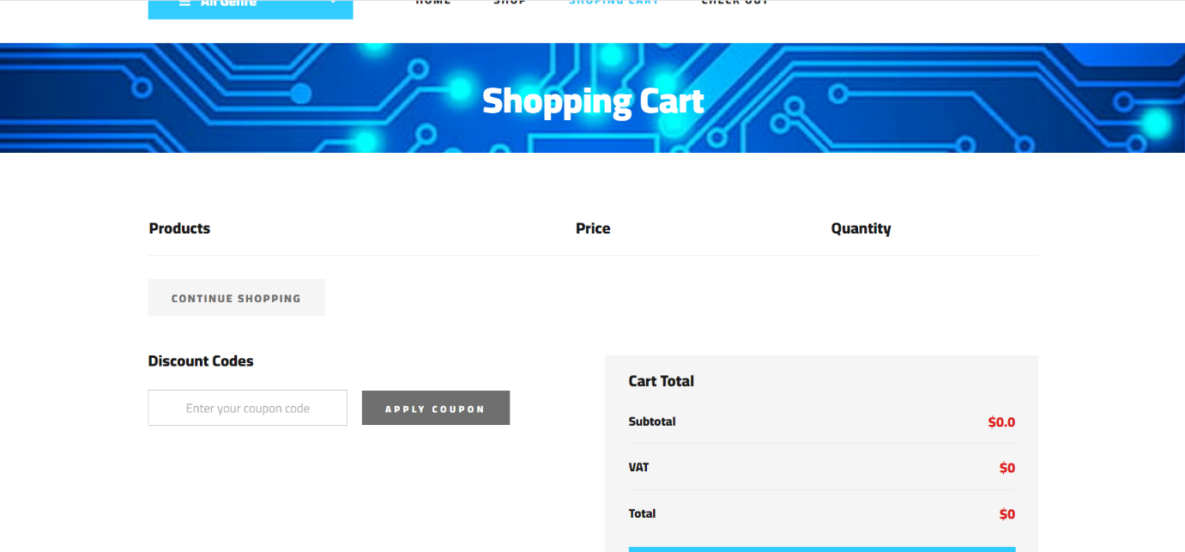



6.Forgot Password

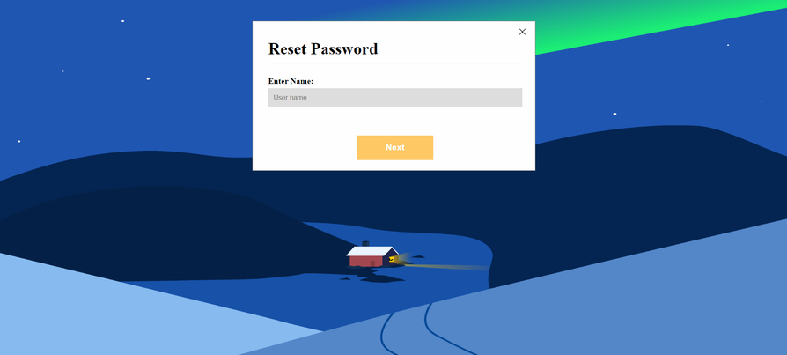

7.Login

