VN-LiteWaste: A Lightweight Attention-Enhanced CNN for Household Waste Classification
H.-Ngan NGUYEN-THI ^{1[0009-0003-3861-223X]}, Q.-Hai NGUYEN ^{1[0009-0002-9606-4588]}, V.-Diep NGUYEN ^{1[0009-0005-6334-4462]}, T.-Phuc NGUYEN ^{1[0009-0004-7753-979X]}, A.-Thuan LUU ^{1[0009-0002-3799-9842]}, X.-Trang PHAN-THI ^{1*}
¹ School of Digital Technology and Artificial Intelligence, Nam Can Tho University, 168 Nguyen Van Cu Street, An Binh Ward, Can Tho City, Vietnam.
{ngan223845@student.nctu.edu.vn, ptxtrang@nctu.edu.vn}
Abstract. Household waste misclassification remains a pressing environmental challenge in Vietnam, where the Environmental Protection Law 2020 mandates the segregation of household solid waste into three categories at source, with enforcement beginning January 1, 2025. While deep learning has demonstrated strong potential for automated waste classification, existing approaches either rely on heavyweight architectures unsuitable for resource-constrained deployment or adopt material-based taxonomies incompatible with Vietnamese legal requirements. This study proposes VN-LiteWaste, a lightweight CNN built upon Residual Separable Convolution blocks integrated with SimAM attention and Large Kernel Attention, trained from scratch on 15,515 images with labels explicitly remapped to three legal groups defined in Article 75. A dedicated training pipeline combining sub-class balanced oversampling, Focal Loss, and Mixup augmentation was employed to mitigate the severe class imbalance introduced by the legal remapping process. VN-LiteWaste achieved 95.24% test accuracy and a macro F1-score of 0.90 with only 1,827,907 parameters, outperforming VGG16 (94.41%), EfficientNetB0 (94.67%), and MobileNetV2 (92.86%) baselines trained on the identical dataset. Upon TFLite FP16 conversion, the model occupies 3.48 MB at 50.4 FPS on CPU, providing a strong computational foundation for future mobile and edge deployment.
Keywords: Waste Classification; Lightweight CNN; Attention Mechanism; Vietnamese Environmental Law; Edge Deployment
- Introduction
The rapid pace of urbanization has placed mounting pressure on waste management systems worldwide, with global municipal solid waste projected to grow from 2.3 billion tons in 2024 to 3.8 billion tons by 2050 (UNEP, 2024). Vietnam exemplifies this challenge: despite improved awareness, only about 30% of households sort waste correctly and consistently, primarily due to difficulty distinguishing categories rather than lack of awareness (VietnamNet, 2024). This issue has gained urgency since the Environmental Protection Law 2020 mandated three-category household waste separation at source from January 1, 2025, with Decree 45/2022/ND-CP imposing penalties of VND 500,000–1,000,000 for non-compliance (National Assembly of Vietnam, 2020; Government of Vietnam, 2022), shifting waste segregation from a voluntary practice into a legal obligation. AI-based decision-support tools offer a promising response, letting users obtain instant, legally aligned sorting guidance from a smartphone photo (Anh-Khoi et al., 2024). However, existing deep learning approaches show three key limitations for the Vietnamese context: (1) most adopt material-based taxonomies (plastic, glass, metal) incompatible with the three-category legal framework; (2) high-accuracy models often require tens of millions of parameters, limiting deployment on resource-constrained devices; and (3) remapping material labels into legal categories introduces severe class imbalance, a problem largely unaddressed in prior studies.
Motivated by these gaps, this study proposes VN-LiteWaste, a lightweight CNN trained from scratch for the Vietnamese three-category waste classification task. The main contributions are threefold:
- A legal-aware label remapping and imbalance mitigation framework is proposed for Vietnamese three-category waste classification.
- A lightweight attention-enhanced CNN is developed using Residual Separable Convolution, SimAM, and Large Kernel Attention, with fewer than two million parameters.
- TensorFlow Lite FP16 conversion is employed to evaluate deployment readiness for mobile and edge devices.
- Related Work
In recent years, deep learning research on waste image classification has shifted from heavyweight pretrained architectures toward lightweight designs suited for practical deployment. The literature can be organized into three main streams.
Early work demonstrated the feasibility of AI-assisted waste sorting through community-facing applications. Prasad et al. (2024) deployed a VGG16-based classifier on a web platform in Malaysia, achieving 77.62% accuracy across 12 waste categories on a dataset of 15,497 images. Although the system incorporated practical features such as disposal guidance and recycling center localization, VGG16's 138 million parameters result in slow inference and high memory consumption, rendering it unsuitable for mobile or embedded deployment. To improve computational efficiency, Gurcan and Soylu (2025) conducted a systematic comparison of 14 pretrained CNN models, identifying MobileNetV2 as a strong performer at 96.95% accuracy. However, this result was obtained on a purpose-built dataset under controlled conditions without evaluating deployment readiness on resource-constrained hardware.Recognizing the limitations of direct transfer learning, Yin (2025) proposed Lite-ResNet — a ResNet18 variant reducing the parameter count to 5.62 million — achieving 91.2% accuracy on the TrashNet benchmark (Thung & Yang, 2016). TrashNet, however, comprises only 2,527 images across 6 categories under uniform laboratory conditions, raising concerns about generalizability (Thung & Yang, 2016). Accuracy degraded notably on visually similar categories, recording 82.4% for plastics and 80.0% for miscellaneous waste. At the opposite end of the complexity spectrum, Verber et al. (2026) introduced CustomNet — a hybrid ensemble of ResNet-50, EfficientNet-B0, and MobileNetV3 fused through multi-head self-attention — achieving 97.79% accuracy across 10 categories. Despite successful deployment on NVIDIA Jetson Orin Nano, the model retains 40.3 million parameters, limiting practical scalability.
These findings reveal a persistent trade-off: models achieving high accuracy are computationally prohibitive, while lightweight models are validated only on small-scale laboratory datasets.
Research directly addressing the Vietnamese regulatory context remains limited. Do and Vuong (2026) proposed a YOLOv8-based system classifying household waste into three groups aligned with Vietnam's Environmental Protection Law 2020, achieving mAP@0.5 of 0.915 with a deployment size of 6.2 MB. This work is the closest precedent in terms of legal alignment; however, YOLOv8 is an object detection architecture rather than a pure image classifier, and the dataset used was limited in scale and diversity. Furthermore, no existing study has addressed the specific class imbalance arising when material-based labels are collapsed into legal groups — where 9 of 12 original classes merge into a single dominant category.
Motivated by these gaps, this study proposes VN-LiteWaste: the first lightweight CNN trained from scratch with labels explicitly aligned to Vietnamese legal requirements, supported by a purpose-designed imbalance mitigation pipeline. The system design, model architecture, and experimental results are detailed in Sections 3, 4, and 5 respectively.
- Dataset and Preprocessing
As illustrated in Fig. 1, the proposed system follows five sequential stages, each of which is described in detail in the following subsections.
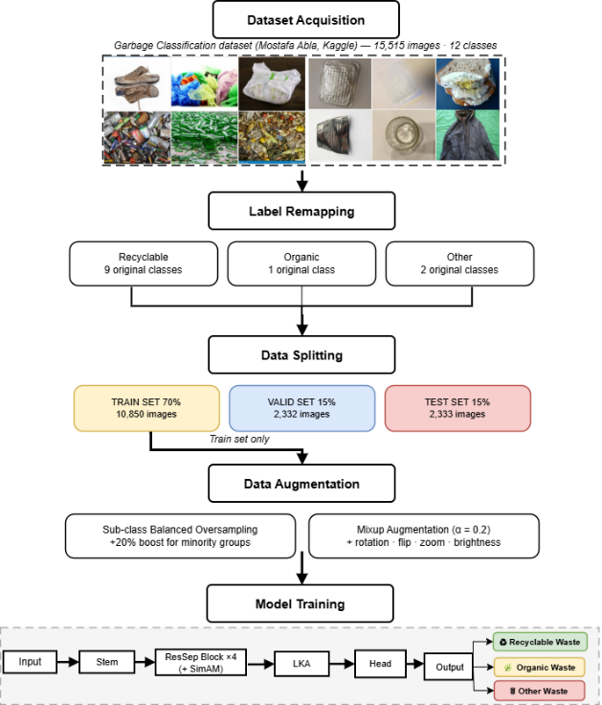
Fig 1. Overall Research Workflow of the Proposed VN-LiteWaste System.
The Garbage Classification dataset (Mohamed, 2021) served as the data source, comprising 15,515 images across 12 material-based categories — paper, cardboard, biological, metal, plastic, three glass variants, clothes, shoes, batteries, and trash. The images were collected via web scraping with keyword searches approximating real-world appearances: for example, the biological category includes rotten produce and food remains, while clothes and shoes are mostly in normal, non-discarded condition. This variety in background, lighting, and orientation provides greater ecological validity than controlled benchmarks such as TrashNet (Thung & Yang, 2016).
  - Label Remapping
Since the 12 original categories are organized by material composition rather than waste management practice, they are incompatible with Vietnamese waste regulations. Pursuant to Article 75, Clause 1 of the Environmental Protection Law 2020 (National Assembly of Vietnam, 2020), a static mapping table was constructed to remap all 12 classes into three legally defined groups, as summarized in Table 1.
Table 1. Label remapping scheme and image distribution across three legal groups.
Legal Group | Original Classes | Classes | Images | %
Recyclable | cardboard, paper, plastic, metal, brown-glass, green-glass, white-glass, clothes, shoes | 9 | ~13,112 | 84.5%
Other | battery, trash | 2 | ~1,398 | 9.0%
Organic | biological | 1 | ~985 | 6.5%
Total |  | 12 | 15,515 | 100%

The Recyclable group aggregates nine original classes and accounts for 84.5% of total images, while Organic represents only 6.5% — an imbalance ratio of 13.3× that is a direct structural consequence of legal grouping rather than natural data distribution. This asymmetry necessitates the dedicated mitigation strategies described in Section 5.1.
  - Data Splitting
The dataset was divided into training (70%), validation (15%), and test (15%) partitions using stratified splitting on the 12 original classes, ensuring proportional representation of all original categories in each partition, as shown in Figure 4. The test set was strictly isolated throughout training and evaluated only once upon completion to ensure unbiased performance estimation. The training, validation, and test sets comprised 10,850, 2,332, and 2,333 images respectively.
- Theoretical Background
This section presents the theoretical foundations of the three core components integrated into the proposed VN-LiteWaste architecture: Residual Separable Convolution, SimAM attention, and Large Kernel Attention.
  - Residual Separable Convolution
Standard convolution requires K² × C × N parameters for N output channels. Depthwise Separable Convolution (Zhang et al., 2018) reduces this cost by decomposing the operation into a depthwise convolution followed by a pointwise (1 × 1) convolution, resulting in K² × C + C × N parameters. The reduction ratio is:
$R=1/N+1/K²$ (1)
For K = 3 and N = 256, this corresponds to approximately 9× fewer parameters than standard convolution. To facilitate stable training, residual shortcut connections (He et al., 2016) are incorporated to improve gradient flow and mitigate the vanishing gradient problem.
  - SimAM: Simple Attention Module
SimAM derives attention weights from a neuroscience-inspired principle: neurons that stand out from their local context — exhibiting high energy contrast relative to their spatial neighborhood — are assigned higher importance (Yang et al., 2021). Formally, the energy function for neuron x is defined as:
$e\left(x\right)=\left(x-μ\right)²/\left(4\left(σ²+λ\right)\right)+0.5$ (2)
where μ and σ² denote the spatial mean and variance of the feature map computed over all spatial locations, and λ = 10⁻⁴ is a regularization constant preventing division by zero. The attention weight is subsequently obtained as:
$ã=sigmoid\left(-e\left(x\right)\right)$ (3)
and applied element-wise to the feature map. A distinguishing property of SimAM is that it introduces zero learnable parameters: attention is computed entirely from the statistical properties of the input feature map at inference time, preserving the model's parameter budget entirely for feature extraction. This is in contrast to channel attention mechanisms such as SE-Net, which require two fully connected layers per block.
  - Large Kernel Attention
Convolutional neural networks typically use small kernels (e.g., 3 × 3 or 5 × 5) to reduce computational cost, but this limits the receptive field. Large Kernel Attention (LKA) (Guo et al., 2023) overcomes this limitation by combining depthwise, dilated depthwise, and pointwise convolutions to efficiently capture both local and long-range spatial dependencies. This design provides an effective receptive field of approximately 19 × 19 while avoiding excessive parameter growth, enabling better recognition of global object structures and visually similar waste categories.
- Proposed Method
VN-LiteWaste addresses these gaps through three integrated components — a legally-aligned imbalance mitigation pipeline, a purpose-designed lightweight architecture, and a training configuration optimized for minority-class performance — described in turn below.
  - Data Balancing and Augmentation Strategy
Sub-class balanced oversampling equalized sample counts across original classes within each legal group. The Recyclable group received 3,500 training samples, while Organic and Other each received about 4,200 (a 20% boost), directly addressing the 13.3× imbalance from legal remapping. Online augmentation included random rotation (±30°), horizontal flip, shift (±15%), zoom (±25%), and brightness variation (0.60–1.40×). Mixup (Zhang et al., 2018, α = 0.2) was additionally applied at the batch level as a regularizer against overconfident predictions.
  - VN-LiteWaste Architecture
VN-LiteWaste was designed from scratch with two goals: parameter efficiency for edge deployment, and architectural specialization for the three-class Vietnamese waste task. The architecture accepts 260 × 260 × 3 RGB images and produces a three-class probability vector through six sequential stages (Figure 4).
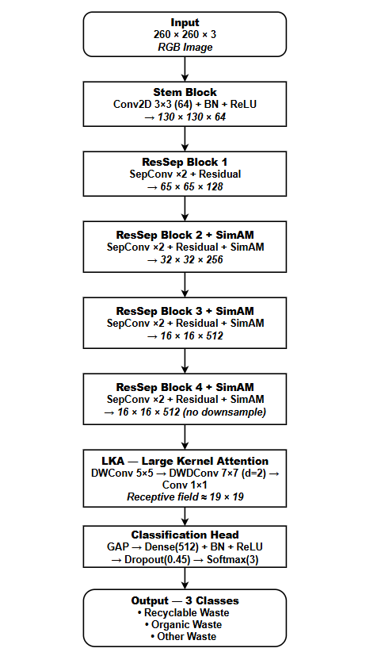
Fig 2. Detailed Architecture of the Proposed VN-LiteWaste Model.
The input resolution was determined by the network's downsampling schedule: after one stride-2 Stem convolution and three MaxPooling operations, the spatial dimension reduces to 16 × 16 — the minimum at which SimAM computes reliable spatial statistics. The network begins with a Stem block (Conv2D 3 × 3, 64 channels, stride 2) performing initial feature extraction at 130 × 130. Four ResSep blocks then progressively expand channel depth (128 → 256 → 512 → 512) while halving spatial dimensions at the first three stages; SimAM attention is integrated into blocks 2, 3, and 4, where deeper feature maps carry sufficient semantic content for meaningful spatial weighting, while block 4 preserves the 16 × 16 resolution for the subsequent LKA module. LKA expands the effective receptive field to approximately 19 × 19, enabling discrimination of visually similar materials such as transparent plastic and white glass where local texture alone is insufficient. The Classification Head comprising Global Average Pooling, Dense (512), Batch Normalization, ReLU, Dropout (0.45), and Softmax (3) produces the final output. The complete model contains 1,827,907 parameters, of which 1,816,131 are trainable.
The model was trained for a maximum of 120 epochs with batch size 24 using AdamW (Loshchilov & Hutter, 2019) (weight decay = 1e-4) with a Cosine Decay learning rate schedule incorporating a 5-epoch linear warmup, peaking at 3×10⁻⁴. Focal Loss (Lin et al., 2017) with γ = 2.0 and label smoothing ε = 0.05 served as the training objective, concentrating gradient updates on hard misclassified samples — particularly effective given the severe class imbalance. EarlyStopping with patience of 25 epochs monitored validation accuracy and restored the best checkpoint automatically, with training converging at epoch 115 out of the maximum 120.
The combined effect of the three components described in Sections 5.1–5.3 constitutes the core technical contribution of this study: a cohesive pipeline that simultaneously addresses legal taxonomy alignment, class imbalance from label remapping, and parameter efficiency — three challenges that, to the best of our knowledge, have not been jointly addressed in prior waste classification work.
- Experiments and Results
  - Experimental Setup
All experiments were conducted on Kaggle Notebooks using two NVIDIA Tesla T4 GPUs with TensorFlow 2.19.0 and Python 3.12. Computational efficiency was evaluated using TensorFlow Lite FP16 on a CPU-only Intel Xeon environment over 200 inference runs following 20 warmup runs. For comparison, VGG16, EfficientNetB0, and MobileNetV2 were fine-tuned on the same dataset and 70/15/15 split using standard two-stage transfer learning with categorical cross-entropy loss.
  - Evaluation Metrics
Model performance was evaluated on the held-out test set using four standard metrics, macro-averaged to assign equal importance to all classes despite the severe imbalance between Recyclable (83.1%) and Organic (6.3%):
$Accuracy=\left(TP₁+TP₂+TP₃\right)/N$ (4)
$Precision=\left(1/K\right)×ΣₖTPₖ/\left(TPₖ+FPₖ\right)$ (5)
$Recall=\left(1/K\right)×ΣₖTPₖ/\left(TPₖ+FNₖ\right)$ (6)
Macro-averaged F1-score is the harmonic mean of Precision and Recall:
$F1=2×\left(Precision×Recall\right)/\left(Precision+Recall\right)$ (7)
where K = 3, and TPₖ, FPₖ, FNₖ denote the true positives, false positives, and false negatives for class k, respectively.
For deployment evaluation, model size (MB), mean latency (ms), p95 latency (ms), and throughput (FPS) were additionally recorded. Latency measurements were averaged over 200 inference runs following 20 warmup runs.
  - Overall Performance
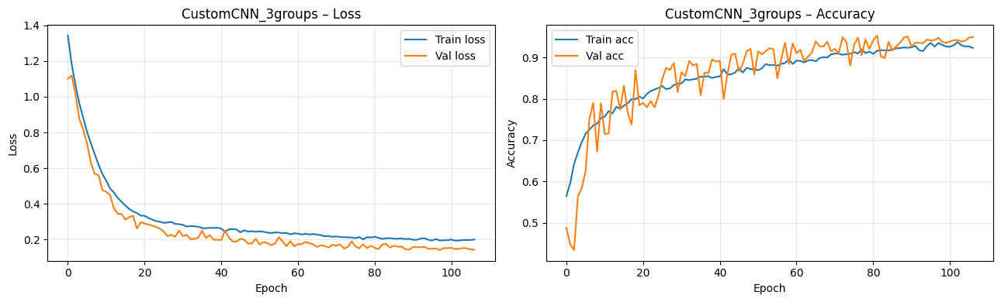
Fig 3. Training and Validation Loss and Accuracy Curves over 115 Epochs.
VN-LiteWaste achieved 95.24% test accuracy with macro precision of 0.88, recall of 0.92, and F1-score of 0.90, exceeding the predefined 90% accuracy target. The consistency between validation accuracy (95.07%) and test accuracy (95.24%) — a gap of only 0.17 percentage points — confirms that the model generalizes well without overfitting. Figure 3 presents the training and validation loss and accuracy curves over 115 epochs, demonstrating stable convergence with no significant divergence between training and validation trajectories.
  - Comparative Results
Table 2. Comparison with self-run baselines on the same dataset and 70/15/15 split. Standard two-stage transfer learning with cross-entropy loss.
Model | Params | Size (MB) | Accuracy | F1 (macro)
VGG16 | 138M | ~528 | 94.41% | 91.74%
EfficientNetB0 | 5.3M | ~20 | 94.67% | 92.28%
MobileNetV2 | 3.4M | ~14 | 92.86% | 89.45%
VN-LiteWaste (Proposed) | 1.83M | 3.48 | 95.24% | 90.00%
Table 2 compares VN-LiteWaste with three transfer-learning baselines evaluated under identical experimental settings. VN-LiteWaste achieved the highest accuracy (95.24%) while using the fewest parameters (1.83M) and the smallest deployment size (3.48 MB). While EfficientNetB0 attained a higher macro F1-score, it required substantially greater model complexity and storage. Overall, VN-LiteWaste provides an effective trade-off between classification performance and computational efficiency.
  - Per-Class Analysis and Confusion Matrix
Table 3. Per-class classification results on the test set.
Class | Precision | Recall | F1-score | Support
Other | 0.80 | 0.83 | 0.81 | 247
Recyclable | 0.98 | 0.96 | 0.97 | 1,938
Organic | 0.86 | 0.95 | 0.90 | 148
Macro average | 0.88 | 0.92 | 0.90 | 2,333
Accuracy |  |  | 0.95 | 2,333

Table 3 presents the per-class performance of VN-LiteWaste on the test set. The model achieved an overall accuracy of 95.24% across 2,333 test samples. The Recyclable class obtained the highest F1-score (0.97). Despite representing the smallest class with only 148 test samples, the Organic category achieved an F1-score of 0.90, suggesting that the proposed imbalance mitigation strategy was effective. The Other class recorded the lowest F1-score (0.81), which may be attributed to the broader visual variability of objects within this category.
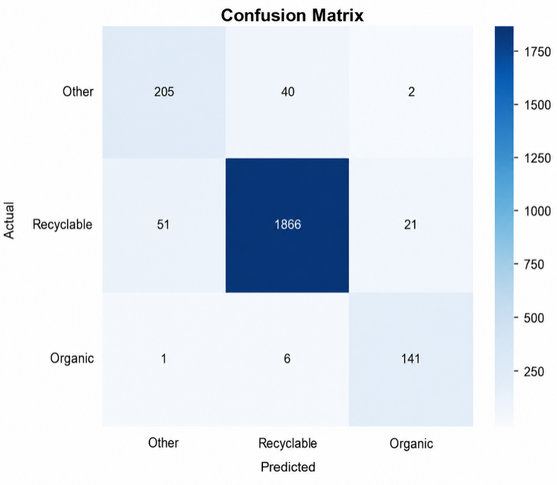
Fig 4. Confusion Matrix for Three-Class Vietnamese Waste Classification.
Figure 6 shows that most misclassifications occurred between the Recyclable and Other categories, with 51 Recyclable samples predicted as Other and 40 Other samples predicted as Recyclable. This pattern likely reflects the greater visual variability of objects within the Other category. In contrast, the Organic class exhibited limited confusion, with only 7 misclassified samples out of 148, indicating that organic waste possesses relatively distinctive visual characteristics.
  - Computational Efficiency Analysis
Table 4. Computational efficiency before and after TFLite FP16 conversion (CPU, 200 runs).
Metric | Keras (.keras) | TFLite FP16
Parameters | 1,827,907 | 1,827,907
GFLOPs | 1.5007 | ~0.75*
Model size | 21.10 MB | 3.48 MB (−83.5%)
Mean latency | 84.53 ms | 19.86 ms (4.3× faster)
p95 latency | 89.27 ms | 20.82 ms
Throughput | 11.8 FPS | 50.4 FPS
Test accuracy | 95.24% | 95.20%

Table 4 summarizes the computational efficiency of VN-LiteWaste before and after TFLite FP16 conversion. Model size decreased by 83.5% (21.10 MB to 3.48 MB) with negligible accuracy loss (95.24% vs. 95.20%), while throughput increased from 11.8 FPS to 50.4 FPS on CPU. These results support the deployment of VN-LiteWaste on resource-constrained devices.
- Discussion
These results indicate that a lightweight CNN trained from scratch on a legally-aligned dataset can achieve performance competitive with pretrained transfer-learning models while requiring substantially fewer parameters (Table 2). Although EfficientNetB0 attains a marginally higher macro F1-score (92.28% vs. 90.00%), it requires nearly 3× more parameters and a deployment size roughly 6× larger than VN-LiteWaste after TFLite conversion — a trade-off favoring VN-LiteWaste in storage- and latency-constrained scenarios. More broadly, these findings support the proposition that purpose-designed lightweight architectures can be competitive with general-purpose transfer learning when the target task has a well-defined, constrained output space.
The integration of SimAM and LKA is expected to have contributed to this discrimination ability. SimAM assigns per-neuron attention weights based on local energy contrast at zero additional parameter cost, while LKA extends the effective receptive field to approximately 19×19, improving the model's ability to perceive global object shape — particularly useful for distinguishing materials such as transparent plastic and white glass, where local texture alone is insufficient. The Organic class's F1-score of 0.90, achieved despite representing only 6.5% of the dataset, further suggests that the combined oversampling and Focal Loss pipeline effectively addresses the 13.3× imbalance introduced by legal remapping — a problem that has received limited attention in prior waste classification studies. Notably, Do and Vuong (2026) reported lower organic-category performance (mAP 0.873) using a YOLOv8-based approach on a different dataset and task formulation; although direct comparison is limited by these methodological differences, the result is consistent with end-to-end CNN training offering practical advantages for this task.
Two limitations constrain the generalizability of these results. First, the dataset was assembled under relatively controlled visual conditions, and performance on images captured spontaneously by Vietnamese households — with cluttered backgrounds, inconsistent lighting, and partial occlusion — remains unevaluated. Second, inference was benchmarked on cloud CPU hardware rather than physical edge devices, so it is not yet confirmed how the observed 50.4 FPS translates to mobile processors.
- Conclusion
Despite these limitations, this study demonstrates that a purpose-designed lightweight CNN trained from scratch on a legally-aligned dataset can achieve competitive classification performance without relying on heavyweight pretrained architectures. VN-LiteWaste achieved 95.24% test accuracy and a macro F1-score of 0.90 with only 1.83M parameters, surpassing VGG16 (94.41%), EfficientNetB0 (94.67%), and MobileNetV2 (92.86%) on the identical dataset without ImageNet pretraining. The Organic class attained an F1-score of 0.90 despite representing only 6.5% of the dataset, confirming the effectiveness of the proposed imbalance mitigation pipeline. Upon TFLite FP16 conversion, the model occupies 3.48 MB at 50.4 FPS on CPU — 43.9% smaller than the prior Vietnamese-context system (Do & Vuong, 2026).
To address the two limitations identified above, future work will pursue three directions: collecting real-world waste images from Vietnamese households to improve domain robustness; benchmarking inference on physical edge devices including entry-level smartphones; and exploring INT8 quantization and knowledge distillation to reduce model size below 2 MB for connectivity-limited rural areas. Integration with continuous learning frameworks (Ngo-Ho et al., 2023; Ngo et al., 2024) could further enable adaptation to new waste types without full retraining.

References
- Anh-Khoi, N. H., Thanh-Nam, T., Van-Linh, N., & Anh-Duy, N. (2024). Water quality inspection system for mariners using EKI’s continuous learning algorithms. In International Conference on Smart Objects and Technologies for Social Good (pp. 218–230). Springer Nature Switzerland.
- Do, M. H., & Vuong, T. L. A. (2026). A new deep learning model to support people in classifying household waste in Vietnam. TEM Journal, 15(1), 867–875. https://doi.org/10.18421/TEM151-79
- Government of Vietnam. (2022, July 7). Decree No. 45/2022/ND-CP on administrative penalties for violations of environmental protection regulations. https://congbao.chinhphu.vn/van-ban/nghi-dinh-so-45-2022-nd-cp-37540.html
- Guo, M.-H., Lu, C.-Z., Liu, Z.-N., Cheng, M.-M., & Hu, S.-M. (2023). Visual attention network. Computational Visual Media, 9(4), 733–752. https://arxiv.org/abs/2202.09741
- Gurcan, F., & Soylu, A. (2025). Automated waste classification for smart recycling: A multi-class CNN approach with transfer learning and pre-trained models. Environmental Technology & Innovation, 39, 104673. https://doi.org/10.1016/j.eti.2025.104673
- He, K., Zhang, X., Ren, S., & Sun, J. (2016). Deep residual learning for image recognition. In Proceedings of the IEEE Conference on Computer Vision and Pattern Recognition (pp. 770–778). https://arxiv.org/abs/1512.03385
- Ho, A. K. N. (2015). Méthodes de classifications dynamiques et incrémentales: Application à la numérisation cognitive d'images de documents (Doctoral dissertation, University of Tours).
- Lin, T.-Y., Goyal, P., Girshick, R., He, K., & Dollár, P. (2017). Focal loss for dense object detection. In Proceedings of the IEEE International Conference on Computer Vision (pp. 2980–2988). https://doi.org/10.1109/ICCV.2017.324
- Loshchilov, I., & Hutter, F. (2019). Decoupled weight decay regularization. In International Conference on Learning Representations (ICLR). https://openreview.net/forum?id=Bkg6RiCqY7
- Mohamed, M. (2021). Garbage classification (12 classes) [Dataset]. Kaggle. https://www.kaggle.com/datasets/mostafaabla/garbage-classification
- National Assembly of Vietnam. (2020, November 17). Law on Environmental Protection No. 72/2020/QH14. https://vanban.chinhphu.vn/?pageid=27160&docid=202613
- Ngo-Ho, A. K., Bui, H. B., & Pham, V. T. (2023). Continuous learning for automatic identification of Oc Eo antique glass jewelry. In 2023 15th International Conference on Knowledge and Systems Engineering (KSE) (pp. 1–4). IEEE.
- Prasad, R. K., Ghani, M. F. A., & Annamalai, S. (2024). An AI-based smart waste management system for community support. International Journal of Advanced Computer Science and Applications, 15(10). https://doi.org/10.14569/IJACSA.2024.0151009
- Thung, G., & Yang, M. (2016). Classification of trash for recyclability status [CS229 Project Report]. Stanford University. https://github.com/garythung/trashnet
- UNEP. (2024). Global waste management outlook 2024: Beyond an age of waste. United Nations Environment Programme. https://www.unep.org/resources/global-waste-management-outlook-2024
- Verber, D., Grneva, T., & Dugonik, J. (2026). Image-based waste classification using a hybrid deep learning architecture with transfer learning and edge AI deployment. Mathematics, 14(7), Article 1176. https://doi.org/10.3390/math14071176
- VietnamNet. (2024, June). Ministry identifies challenges in household solid waste management in Vietnam. https://vietnamnet.vn/en/ministry-identifies-challenges-in-household-solid-waste-management-in-vietnam-2315062.html
- Yang, L., Zhang, R.-Y., Li, L., & Xie, X. (2021). SimAM: A simple, parameter-free attention module for convolutional neural networks. In Proceedings of the 38th International Conference on Machine Learning (Vol. 139, pp. 11863–11874). https://proceedings.mlr.press/v139/yang21o.html
- Yin, P. (2025). Application of lightweight CNN in garbage image classification. Computing, Performance and Communication Systems, 9(1), 65–72. https://doi.org/10.23977/cpcs.2025.090109
- Zhang, H., Cisse, M., Dauphin, Y. N., & Lopez-Paz, D. (2018). mixup: Beyond empirical risk minimization. In International Conference on Learning Representations (ICLR). https://openreview.net/forum?id=r1Ddp1-Rb

