.content1 {

width: 80%;

height: 500px;

border: 1px solid;

display: grid;

grid-template-columns: 1fr 1fr;

grid-template-rows: 1fr 1fr;

justify-items: center;

align-items: center;

}

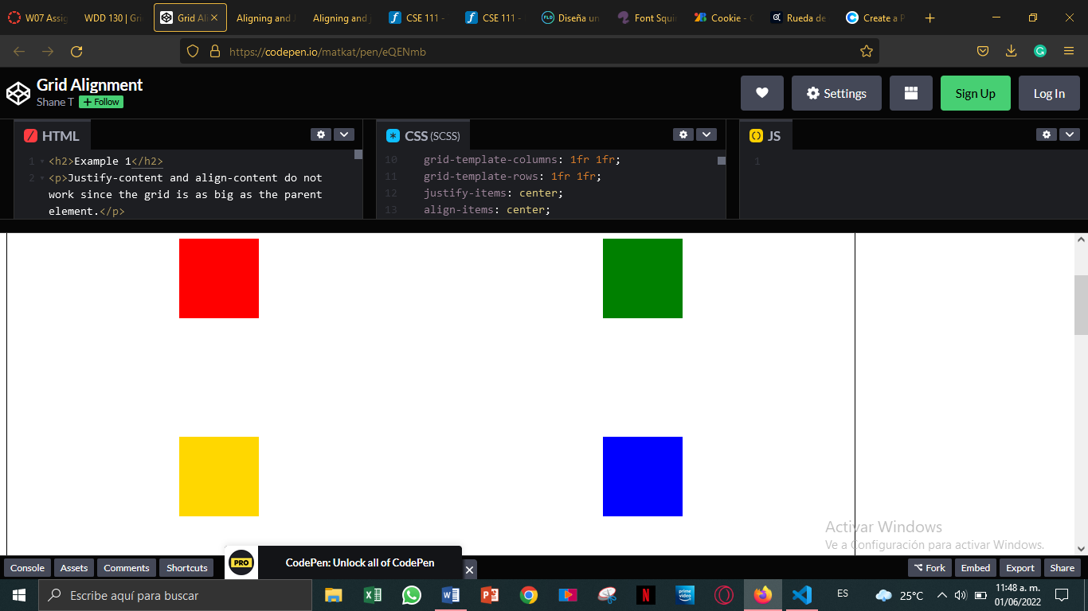

Exercise 2

.content2 {

width: 80%;

height: 500px;

border: 1px solid;

display: grid;

grid-template-columns: 150px 150px;

grid-template-rows: 150px 150px;

justify-content: center;

align-content: center;

}

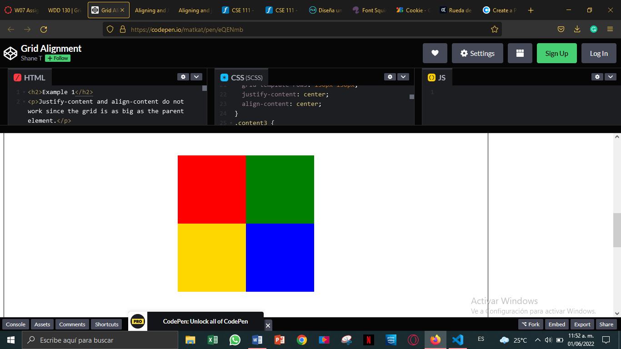

.content3 {

width: 80%;

height: 500px;

border: 1px solid;

display: grid;

grid-template-columns: 150px 150px;

grid-template-rows: 150px 150px;

justify-content: center;

align-content: center;

justify-items: center;

align-items: center;

}

