# Assignment 1: Recurrent Neural Network

## Overview

Neural networks imitate the function of the human brain in the fields of AI, machine learning, and deep learning, allowing computer programs to recognize patterns and solve common issues.

RNNs are a type of neural network that can be used to model sequence data. RNNs, which are formed from feedforward networks, are similar to human brains in their behaviour. Simply said, recurrent neural networks can anticipate sequential data in a way that other algorithms can’t.

## Requirements

* Understand the theories and applications,
* Implement the LSTM model using Pytorch based on the section “Hints” (try to understand the code and implement)
* Prepare 3-5 slides to present your work (LSTM vs GRU structure, code, applications)

## Hints

<https://d2l.ai/chapter_recurrent-modern/gru.html>

https://d2l.ai/chapter_recurrent-modern/lstm.html

## Reference

<https://www.analyticsvidhya.com/blog/2022/03/a-brief-overview-of-recurrent-neural-networks-rnn/>

<https://towardsdatascience.com/predictive-analytics-time-series-forecasting-with-gru-and-bilstm-in-tensorflow-87588c852915>

HOCHREITER, Sepp; SCHMIDHUBER, Jürgen. Long short-term memory. Neural computation, 1997, 9.8: 1735-1780.

CHUNG, Junyoung, et al. Empirical evaluation of gated recurrent neural networks on sequence modeling. arXiv preprint arXiv:1412.3555, 2014.

# Assignment 2: Pandas

## Overview

pandas is a fast, powerful, flexible and easy to use open-source data analysis and manipulation tool, built on top of the Python programming language.

## Requirements

* Given:

* Develop a mini excel-like software using pandas library to generate the following result

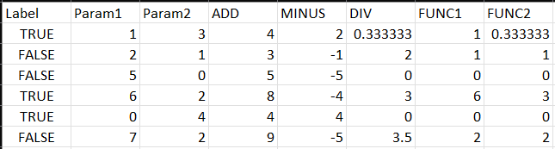

## Hints

## Reference

<https://pandas.pydata.org/>

<https://pandas.pydata.org/docs/reference/api/pandas.DataFrame.apply.html> (apply)