人和小鼠的co-functional network数据收集

**HumanNet-CF.tsv** 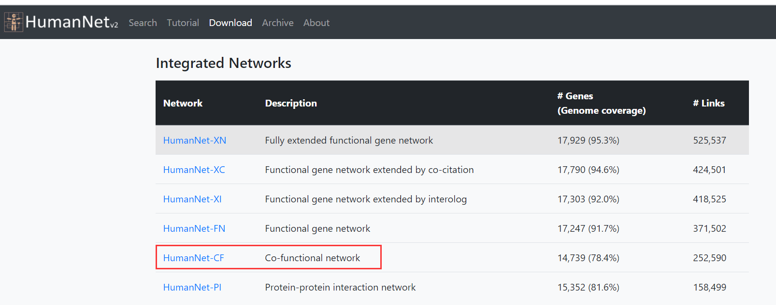

**MouseNetV2_GS_symbol.txt**

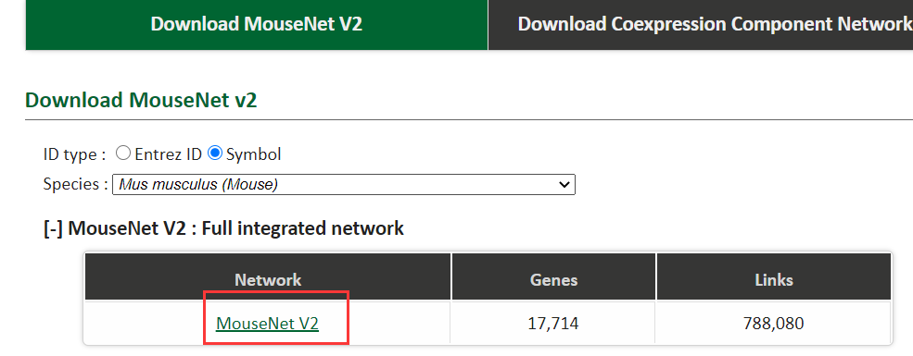

**MouseNetV2_symbol.txt**

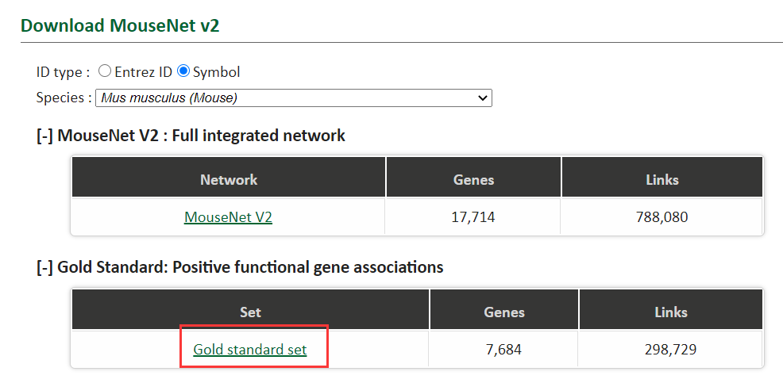

## HumanNet v2:

https://www.inetbio.org/humannet/download.php

文献：

Hwang S, Kim CY, Yang S, Kim E, Hart T, Marcotte EM, Lee I. HumanNet v2: human gene networks for disease research.

Nucleic Acids Res. 2019 Jan 8;47(D1):D573-D580. doi: 10.1093/nar/gky1126. PMID: 30418591; PMCID: PMC6323914.

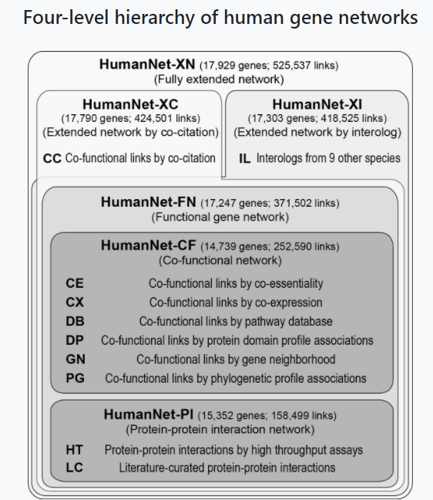

## MouseNetV2：

https://www.inetbio.org/mousenet/downloadnetwork.php

文献：