# Notes: ***Hanona🦆***

* String (object): String Pool, immutable
* StringBuffer (object): mutable

access modifiers:

* public: anywhere in the project
* private: over class
* protected: over the package & (subclasses 🡪 between packages using inheritance)
* default: in the package

* final: keyword 🡪 using with classes & methods
* finally: block 🡪 try... catch, always executed even if handle Exception
* finalize: method 🡪 garbage collection ( cleanup activity is implemented)

static:

🡪 method: can't be overridden

🡪 variable: can't be reinitialized

🡪class: inner class , staticNestedClass

Constructor :

* no return datatype, initialize the object state
* constructor name== class name
* can't be marked as final
* when can it be private? Singleton (one static instance can created from class) , factory static method, unity class-> only contain static methods

super, this?

* + this: Keyword 🡪 refer to the current instance of class
  + super: keyword 🡪
    - refer to the super class of the current instance
    - call super class constructor (Default) into subclass constructor (METHOD)

Stack, Heap?

* + Stack ( LIFO ): local & temporary variables and function call, fast
    - limited size, Managed automatically by the system
  + Heap: dynamic memory allocation using objects, DS like Arrays & LinkedList
    - manage by garbage collector 🡪 Slow, Large size

shallow copy, deep copy?

* + - * Shallow copy: copy references to nested objects
        + change changes in nested objects are reflected
        + in both the original and copied objects.
      * Deep copy: changes in nested objects do not affect each other
        + between the original and copied objects. 🡪create new object reference

throw, throws?

* + throw: throw Exception if something wrong has occurred
  + throws: the type of Exception like " FileNotFoundException "

composition, aggregation?

* + composition: relation between objects 🡪 one contain(Own) anthor (object part of anthor )
    - * containing object cannot exist without objects it contains
      * containing object is destroyed ->contained objects are also destroyed.
      * like (car & engine)
  + aggregation: relation between objects 🡪 one contain(Own) anthor
    - * the contained object can exist independently of the containing object
      * like(University & department)

System.out.println()?

* print in the Console 🡪
* Java.lang package 🡪 System 🡪 PrintStream 🡪 static variables like(out),methods like (println())

* java 8 🡪 stream ,lambda ,static&default (implemented)methods in interface, functional interfaces , optionals

concepts of oop?

Inhertance:-

* Allows subclasses to inherit behaviors and properties from another class (superclass).
* Enables code reuse and extension without rewriting existing code.

Abstraction:-

* abstract class : at least one abstract method
* -interface: all methods are abstract by default but befor Java-8 default & static methods with implementation
* Hides complex implementation details and shows only essential features of an object
* Methods without implementation

Polymorphism:-

* override 🡪 methods in subclass with a different implementation
* Overloading 🡪 methods with the same name but differnt parameters type or number
* Enables methods to be called on objects of different classes executing different behaviors based on the object type

Encapsulation:-

* hide data
* direct access to some of an object's components and protects its internal state.
* private to variables , public to classes (setters & getters)

Exception Handling?...

Checked exceptions (Compile-time exceptions)

* + is checked (notified) by the compiler at compilation-time,also called as compile time exceptions.
  + cannot simply be ignored, the programmer should take care of (handle) these exceptions.

Exception & error?

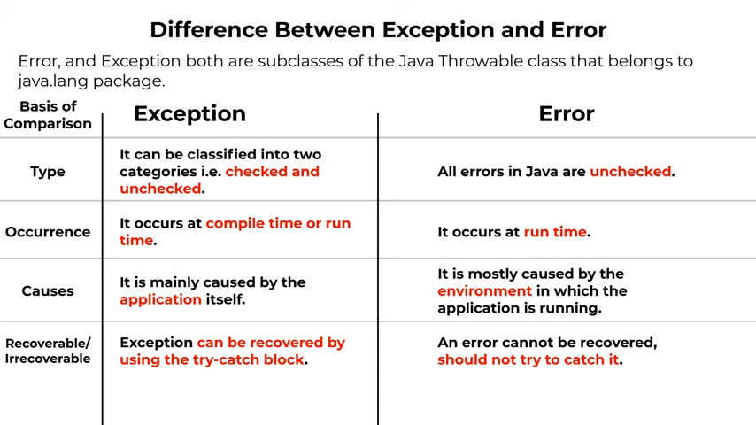

**collection/s** :

* Collection: 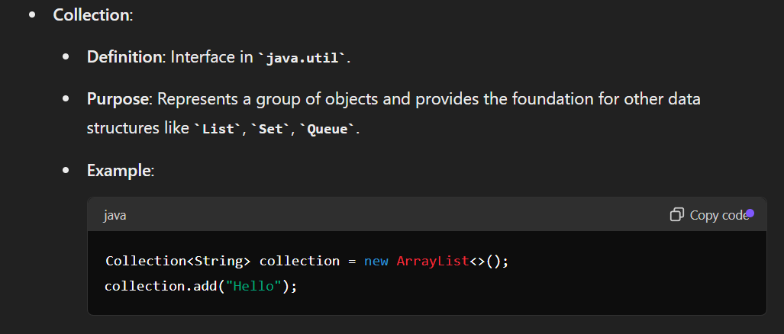
* Collections: 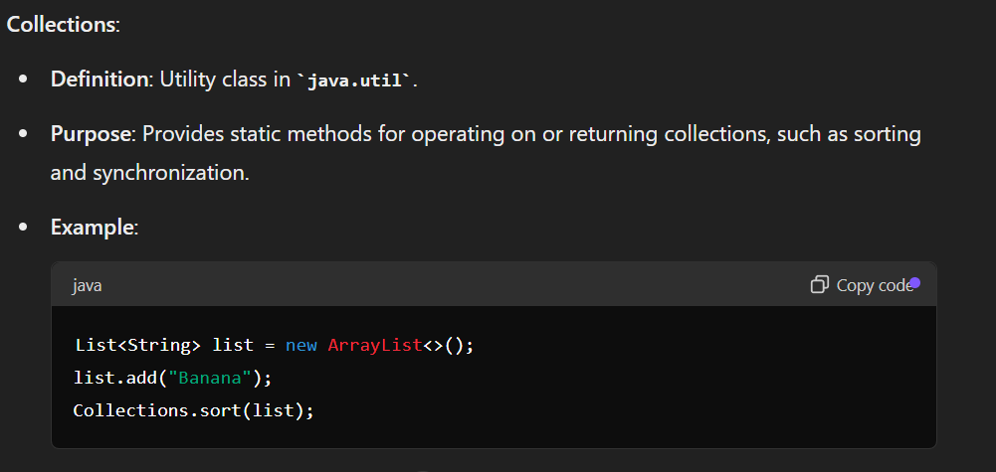

List ,Map, Set

| **Feature** | **List** | **Set** | **Map** |
| --- | --- | --- | --- |
|  |  |  |  |
| **Interface** | java.util.List | java.util.Set | java.util.Map |
|  |  |  |  |
| **Allows Duplicates** | Yes | No | Keys: No, Values: Yes |
|  |  |  |  |
| **Maintains Order** | Yes | No (unless LinkedHashSet) | Yes (unless HashMap) |
|  |  |  |  |
| **Random Access** | Yes | No | Yes (for keys) |
|  |  |  |  |
| **Access Time** | O(1) for ArrayList,  O(n) for LinkedList | O(1) for HashSet, O(log n) for TreeSet | O(1) for HashMap,  O(log n) for TreeMap |
| **Null Handling** | Allows multiple null elements | Allows a single null element (for HashSet and LinkedHashSet) | Keys: Allows one null key  (for HashMap),  Values: Multiple null values |
|  |  |  |  |
| **Typical Use Cases** | Ordered lists,  frequent read access by index | Unique elements,  fast lookup and deletion | Key-value pairs,  fast lookup by key |
| **Memory Usage** | Depends on implementation, generally lower than Set | Higher memory usage due to storage of elements without duplicates | Higher memory usage due to  storage of key-value pairs |
|  |  |  |  |
| **Performance** | Fast random access, slower insertions/deletions for ArrayList; consistent time for LinkedList | Fast access, insertion, and deletion for HashSet; sorted access for TreeSet | Fast access, insertion,  and deletion for HashMap;  sorted access for TreeMap |

Design pattern:

* creational:
  + - singleton :
* Ensure a class has only one instance and provide a global point of access to it
* private constructor
  + - * + static method (getInstance)-> if there is instance return it or create an instance
        + can’t use “New” keyword
        + can use Enum -> Serialization &multithreading

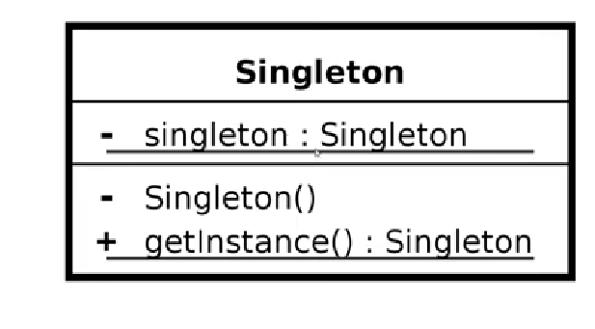

* + - factory method :

كـأني بعمل وسيط ينفذ اللي انا عايزو عشان احافظ ان كله هيتم بنفس الطريقة او الجودة ف الكلاسيز المختلفة ولما احتاج اعدل هعدل ف مكان واحد بس وهو ال )factory (

* Structural Patterns:
  + - adaptor (تكيف):

Adapt to changes, can use Inheritance or

composition

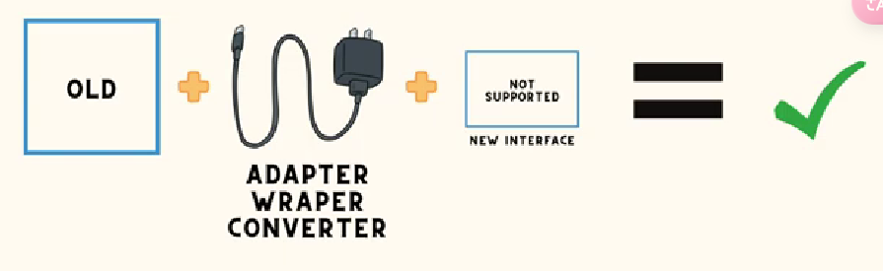

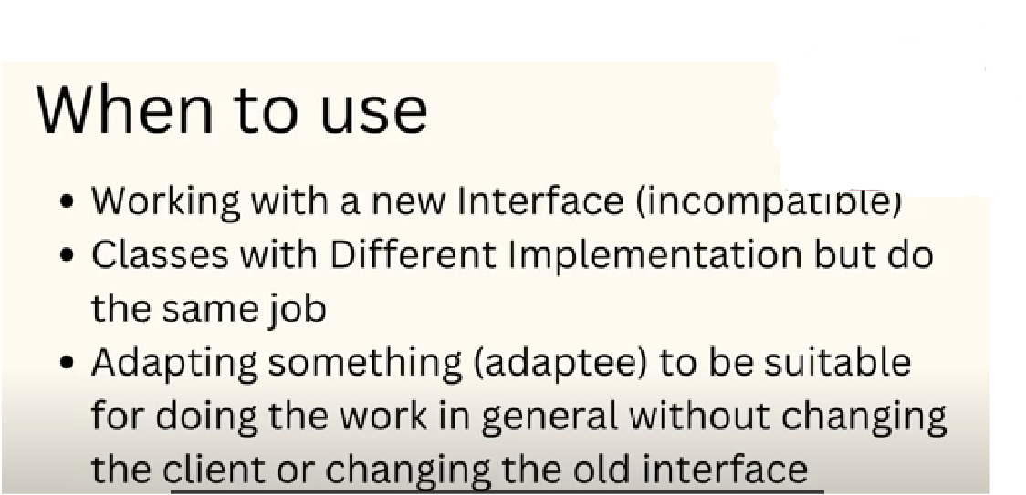

# Proxy (wrapper):

* like a chain
* Extra behavior at run time instead of using static inheritance
* For Final Classes
* Reuse (objects/ methods/classes/… )

# Facade (Wrapper):

# Client 🡪 Facade 🡪 Complex Class (what client wants).

# The client doesn’t know anything about how the facade works.

* + Good Isolation (Changes don’t affect the client).
  + Giving simple interface for complex systems.
  + Can use more than one façade for a single system.

# 

* behavioral: communication/interaction between classes

# Command Pattern :

* decoupling/reducing the responsibility of the class that have to much functionality.

🡪 Invoker (execute some responsibilities of the class ).

عندي كلاس فيه مسؤليات (فانكشنز كتير) ومش هيقدر ينفذها كلها ف بيشوف حد يخفف من عليه شوية ويساعده ف تنفيذ بعض العمليات دي

بيبدأ يساعد الكلاس دا ويقوم بمسؤلياته Invoker

من غير ما يعرف او يفهم اي بالظبط نوع المسؤلية او ال “command” اللي هينفذه

* Encapsulating requests on object
* Undo operation.

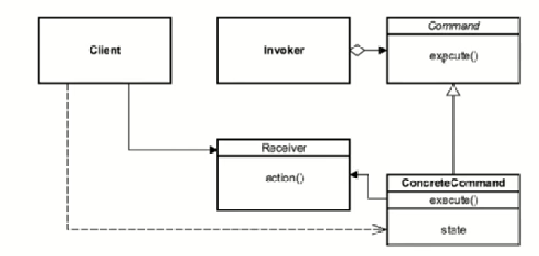

* Observer :

* Strategy :

Streams:

https://docs.oracle.com/javase/8/docs/api/java/util/stream/Stream.html

* wrapper for data provided to them
* not used to store -> not a data structure
* never modify underlying data given to it -> the original data don’t change.
* Stream Operations: Intermediate & Terminal operations
  + Intermediate: return a stream as a result (chained one after the

other) 🡪 map, filter, sorted.

* + Terminal: make the end of chained stream calls, and return any result 🡪 collect, forEach, reduce.

Functional Interfaces: **By java8 (java.util.function)**

Interface 🡪

* Contain only Single Abstract Method (SAM)
* Basis for lambda Expression

Built-in Functional Interface :

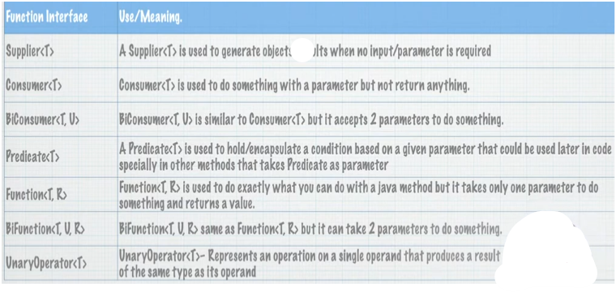

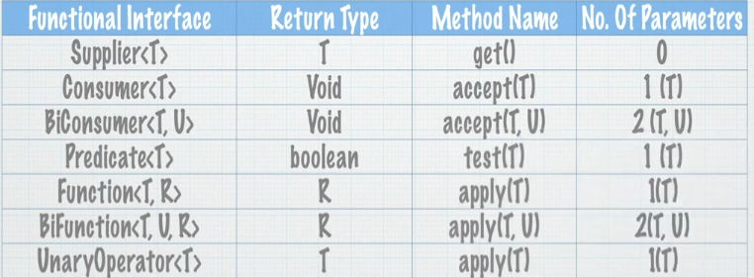

Method Reference

* Instance :: member method

Call method and pass parameters to it

JRE will infer to parameters types

* Class :: static method

Call static method , JRE will infer Parameter types

* Class :: member method

Call member method from first parameter

And pass the second as method argument

Ex: x.concat(y)

* Class :: new 🡪 constructor reference

Invoke class constructor -> Class obj=newClass();

Optional <T>

* Avoid NullPointerException @ return of method
* Increase Code Readability
* Design better APIs / Methods
* Usually used with Wrapper classes Like:[Float ,Integer ,Long…] that can be null

Ex: boolean can be True or False, Boolean can be True False or null.

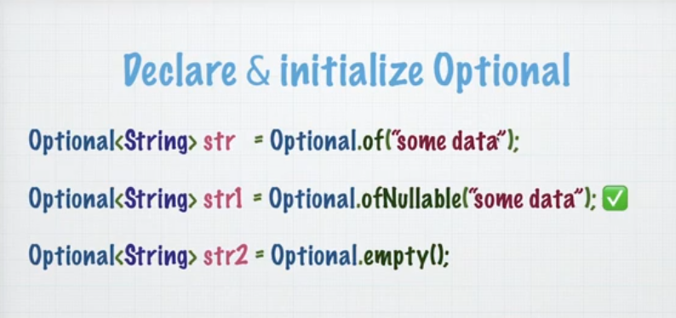

Optional.of() : doesn’t accept null values

Optional.ofNullable() : accept null values

Optional member methods : 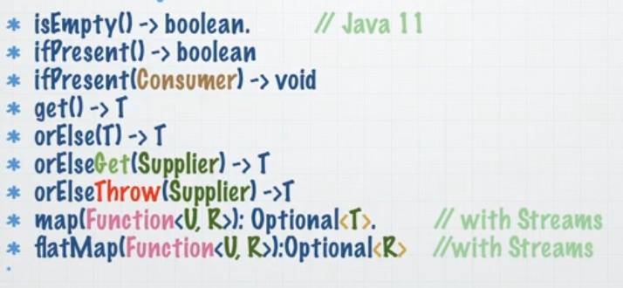

Where to use Optional ?

* + In method returns : force user to check for null .
  + With Streams / Functional Programming .

Where not to use Optional?

