Hussein MOHAMMADI  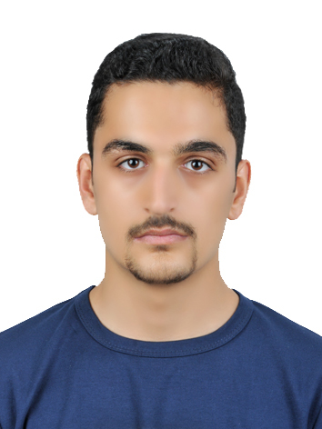  CONTACT  Address:  8, Narges building, Golbaran complex, Farvardin shomali Street, Pardis city, Tehran province, Iran  Phone:  +98 921 564 6501  Email:  h.mohammadi2079@gmail.com  LANGUAGES  English  Persian |  | OBJECTIVE  Provide engineering & negotiation support in TSV enterprises as oil and gas expert translator.  WORK EXPERIENCE  08/2019 - current  Experienced Translator, Targomic Company, Tehran Iran  Responsibilities and translating fields:  - Oil, Gas and petrochemical as Golden translator  - Documents and Contracts as Golden translator  - Geology as silver translator  - Politics as silver translator  - Social Science as Golden translator  03/2020 – current  Translator, Transnet enterprise, Tehran Iran  :  - Oil, Gas and petrochemical  - Geology  - Total scores for translations: 90  EDUCATION  2018 - current  Bachelor Degree of Petroleum engineering, Petroleum University of Technology – Ahwaz, Iran  Address: Abadan main road, Ayatollah Behbahani highway, Ahwaz, Iran – postal code: 63431 Phone: +989613555105-6  Website: ahwaz.put.ir Email: ahwaz@put.ac.ir  ADDITIONAL SKILLS  Database operation: PVTI  Programming: Python, Django, Matlab  Programming: HTML, CSS,  Second ranking in the whole University  Ability to design a website and support its backend  REFERENCES  Targomic.com  Transnet.ir

