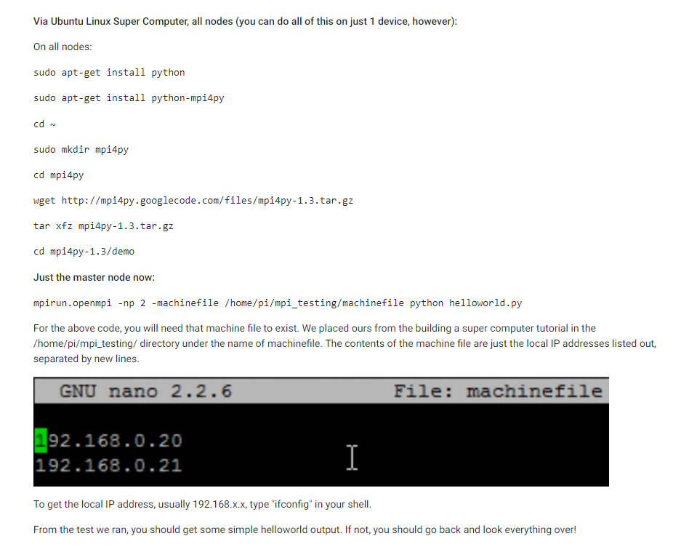

“Slave1 slots=2” in machinefile : actually it’s exactly look like hostfile

