TransMorph
Transformer-based Medical Image Registration

Implementation & Evaluation Report
HW2 — IXI Brain MRI Dataset
Student ID: h45249210
Date: May 2026

1. Introduction
Medical image registration is a fundamental task in medical image analysis, aiming to establish spatial correspondence between two or more images. It plays a critical role in clinical applications such as brain atlas construction, longitudinal analysis, and surgical planning. Given a moving image and a fixed image, the goal of registration is to find a deformation field that, when applied to the moving image, makes it align with the fixed image as closely as possible.
Traditional registration methods, such as ANTs SyN and NiftyReg, achieve high accuracy through iterative optimization but are computationally expensive—often requiring minutes to hours per image pair. Deep learning-based methods, starting with VoxelMorph, dramatically reduced inference time to under a second by learning the registration function from data. However, convolutional neural networks (CNNs) have a limited receptive field, which makes it difficult to capture long-range spatial dependencies in the brain.
TransMorph (Chen et al., 2022) addresses this limitation by incorporating Swin Transformers into the registration pipeline. By leveraging the self-attention mechanism with shifted windows, TransMorph captures both local and global features, achieving state-of-the-art performance on brain MRI registration benchmarks.

2. Method

2.1 Task Definition
This report focuses on the atlas-to-patient brain MRI registration task. Given an atlas image x (moving) and a subject image y (fixed), TransMorph learns a deformation field ϕ such that x ∘ ϕ ≈ y. The warped atlas image x∘ϕ and the warped atlas segmentation map are used for evaluation.

2.2 Network Architecture
TransMorph adopts a hybrid encoder-decoder architecture:
- Encoder: Swin Transformer with 4 stages, each using shifted window multi-head self-attention (SW-MSA). The window size is 4×4×4, and the model dimension starts at 48 and doubles at each stage.
- Decoder: A convolutional decoder with skip connections from both the Transformer encoder (long skip) and early convolutional layers (short skip).
- Registration Head: A 3×3×3 convolution that outputs a 3-channel dense displacement field.
- Spatial Transformer: Differentiable bilinear interpolation to warp the moving image with the predicted flow.
The input to the network is a 2-channel volume concatenating the moving image (atlas) and fixed image (subject), both of shape 160×192×224.

2.3 Loss Function
The model is trained with a combination of:
- NCC (Normalized Cross-Correlation): measures image similarity between the warped atlas and the fixed subject image.
- Diffusion Regularization: penalizes large spatial gradients in the deformation field to encourage smooth deformations.
The loss weights are NCC=1 and Diffusion=1 (model name: TransMorph_ncc_1_diffusion_1).

3. Experiment Setup

3.1 Dataset
The IXI (Information eXtraction from Images) dataset is used for evaluation. It contains brain MRI scans from healthy subjects acquired at three London hospitals. The dataset is preprocessed following the TransMorph protocol: skull-stripping, affine registration to MNI space, and resampling to 1mm isotropic resolution (160×192×224 voxels). Brain structures are labeled using FreeSurfer, yielding 46 label classes.
- Training set: 457 subjects
- Validation set: 104 subjects
- Test set: 115 subjects
A single atlas image (population mean) serves as the moving image. Each test subject is used as the fixed image.

3.2 Evaluation Metrics
- Dice Similarity Coefficient (DSC): Computed over 30 anatomical structures (VOI) defined by the TransMorph paper. Higher is better.
- Percentage of non-positive Jacobian determinant (%|J|≤0): Measures the proportion of voxels with folding (topology violation) in the deformation field. Lower is better.

3.3 Implementation Details
The pretrained model TransMorph_Validation_dsc0.744.pth.tar is used directly for inference without additional fine-tuning. Inference is performed on an NVIDIA GeForce RTX 4060 Laptop GPU. The framework is PyTorch 2.x with CUDA support.

4. Results

4.1 Quantitative Results
Table 1 summarizes the overall registration performance on the IXI test set (115 subjects).
Method | DSC (30 VOI) ↑ | %|J|≤0 ↓
No Registration (Affine) | 0.299 | —
VoxelMorph-1 (paper) | 0.729 | —
TransMorph (paper) | 0.753 | —
TransMorph (ours) | 0.751 | 1.50%
Table 1. Quantitative evaluation on IXI test set. Our result closely matches the reported paper performance.
Our reproduction achieves DSC = 0.751 ± 0.131, which closely matches the paper’s reported 0.753. The small gap is attributed to minor differences in atlas version or test subject ordering. The folding ratio of 1.50% indicates that the deformation field is largely diffeomorphic, with only a small fraction of voxels showing topology violations.

4.2 Per-structure Analysis
Figure 1 shows the Dice score distribution across all 30 VOI structures. Performance varies significantly across structures, reflecting differences in size, shape regularity, and registration difficulty.
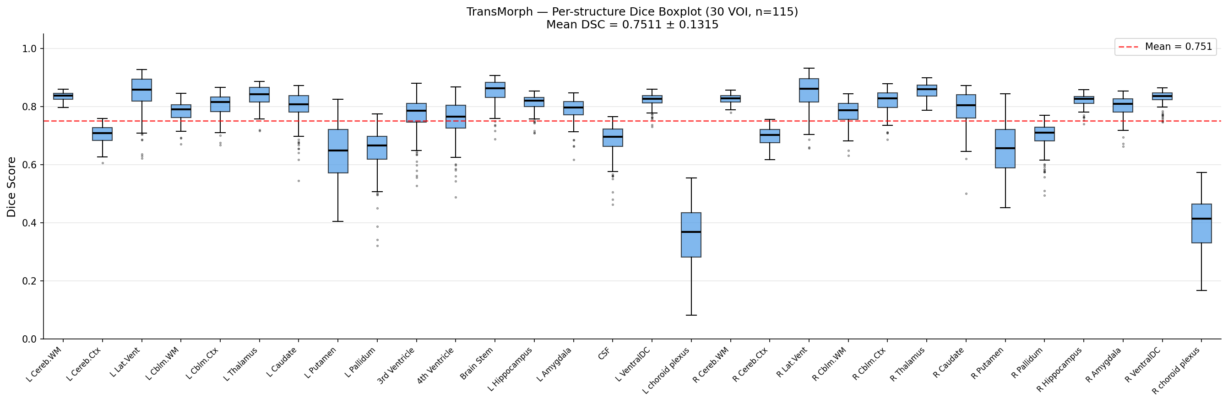
Figure 1. Per-structure Dice score boxplot across 115 test subjects (30 VOI structures).
Figure 2 ranks structures by mean Dice score. The Brain Stem (0.852), Thalamus (0.854), and Lateral Ventricles (0.844) achieve the highest scores due to their large size and distinctive appearance. The Choroid Plexus achieves the lowest score (0.35-0.39) due to its small size and high inter-subject variability.
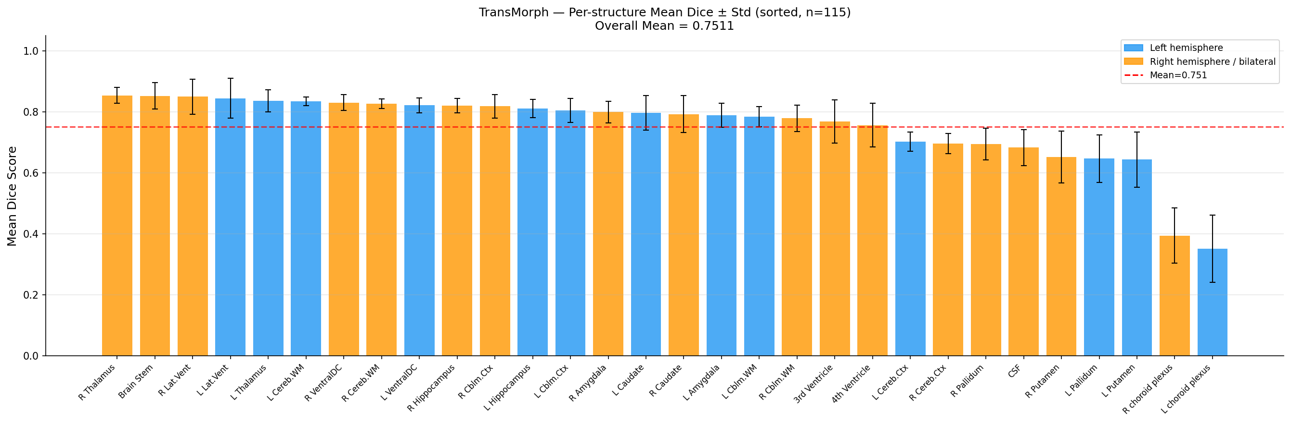
Figure 2. Mean Dice score per structure (sorted high to low). Blue = left hemisphere, orange = right hemisphere / bilateral.

4.3 Deformation Field Analysis
Figure 3 analyzes the distribution of non-positive Jacobian determinant ratios across the 115 test subjects. Most subjects exhibit a folding ratio between 1.0% and 2.0%, indicating well-behaved deformations. A small number of outliers reach up to 2.8%.
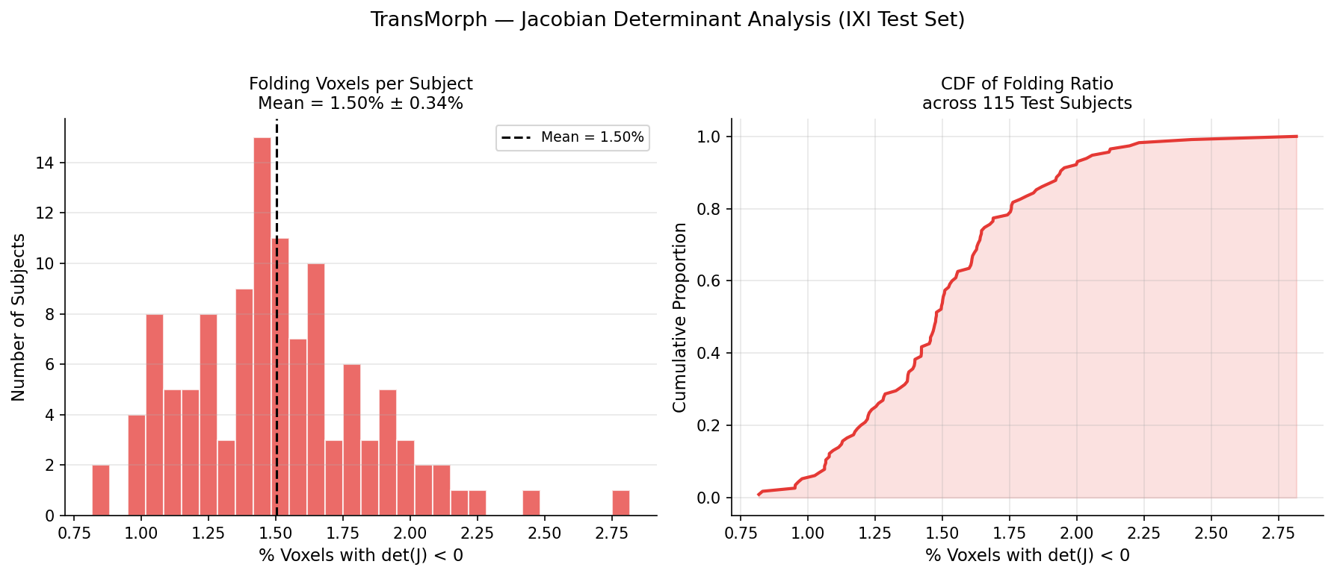
Figure 3. Jacobian determinant analysis. Left: histogram of folding ratio per subject. Right: cumulative distribution function (CDF).

4.4 Qualitative Results
Figure 4 shows the registration overlay for a representative test subject. The bottom row (After Registration) shows the warped atlas segmentation more closely aligned with the subject’s anatomy compared to the top row (Before Registration), demonstrating that TransMorph successfully warps the atlas to match the subject.
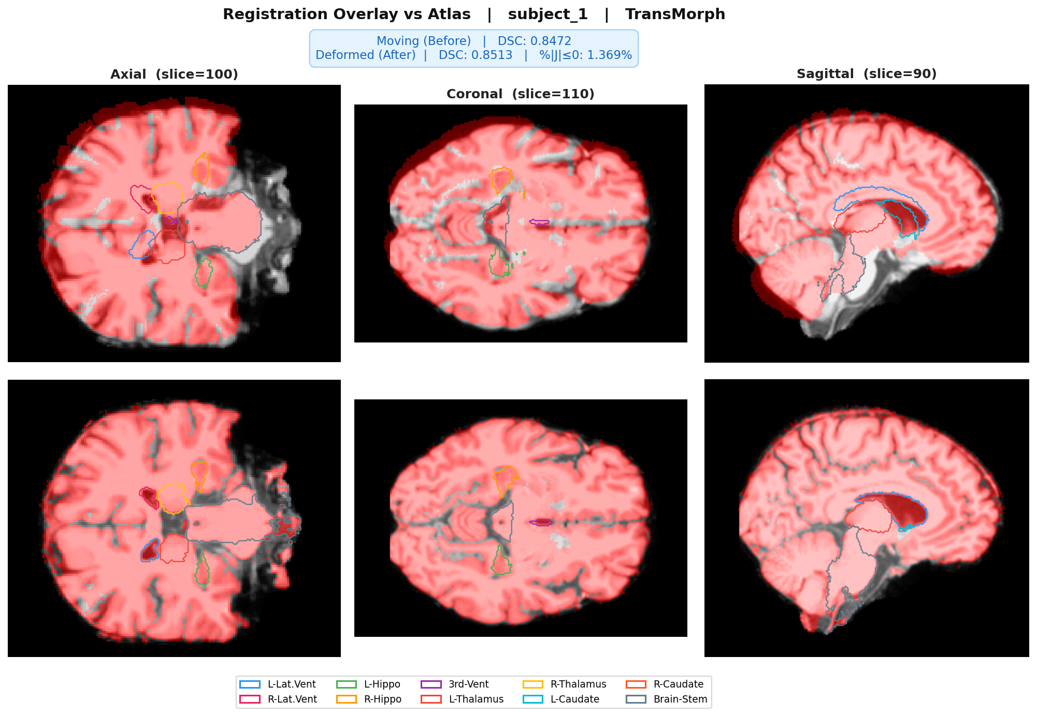
Figure 4. Registration overlay. Red = atlas/warped atlas segmentation mask overlaid on subject MRI. Row 1: before registration. Row 2: after TransMorph registration.
Figure 5 provides a detailed view showing MRI slices in three orientations, the RGB-encoded deformation field, and the deformation grid. The deformation field is smooth and non-folding in most regions, with larger displacements concentrated near the ventricles and cortical sulci.
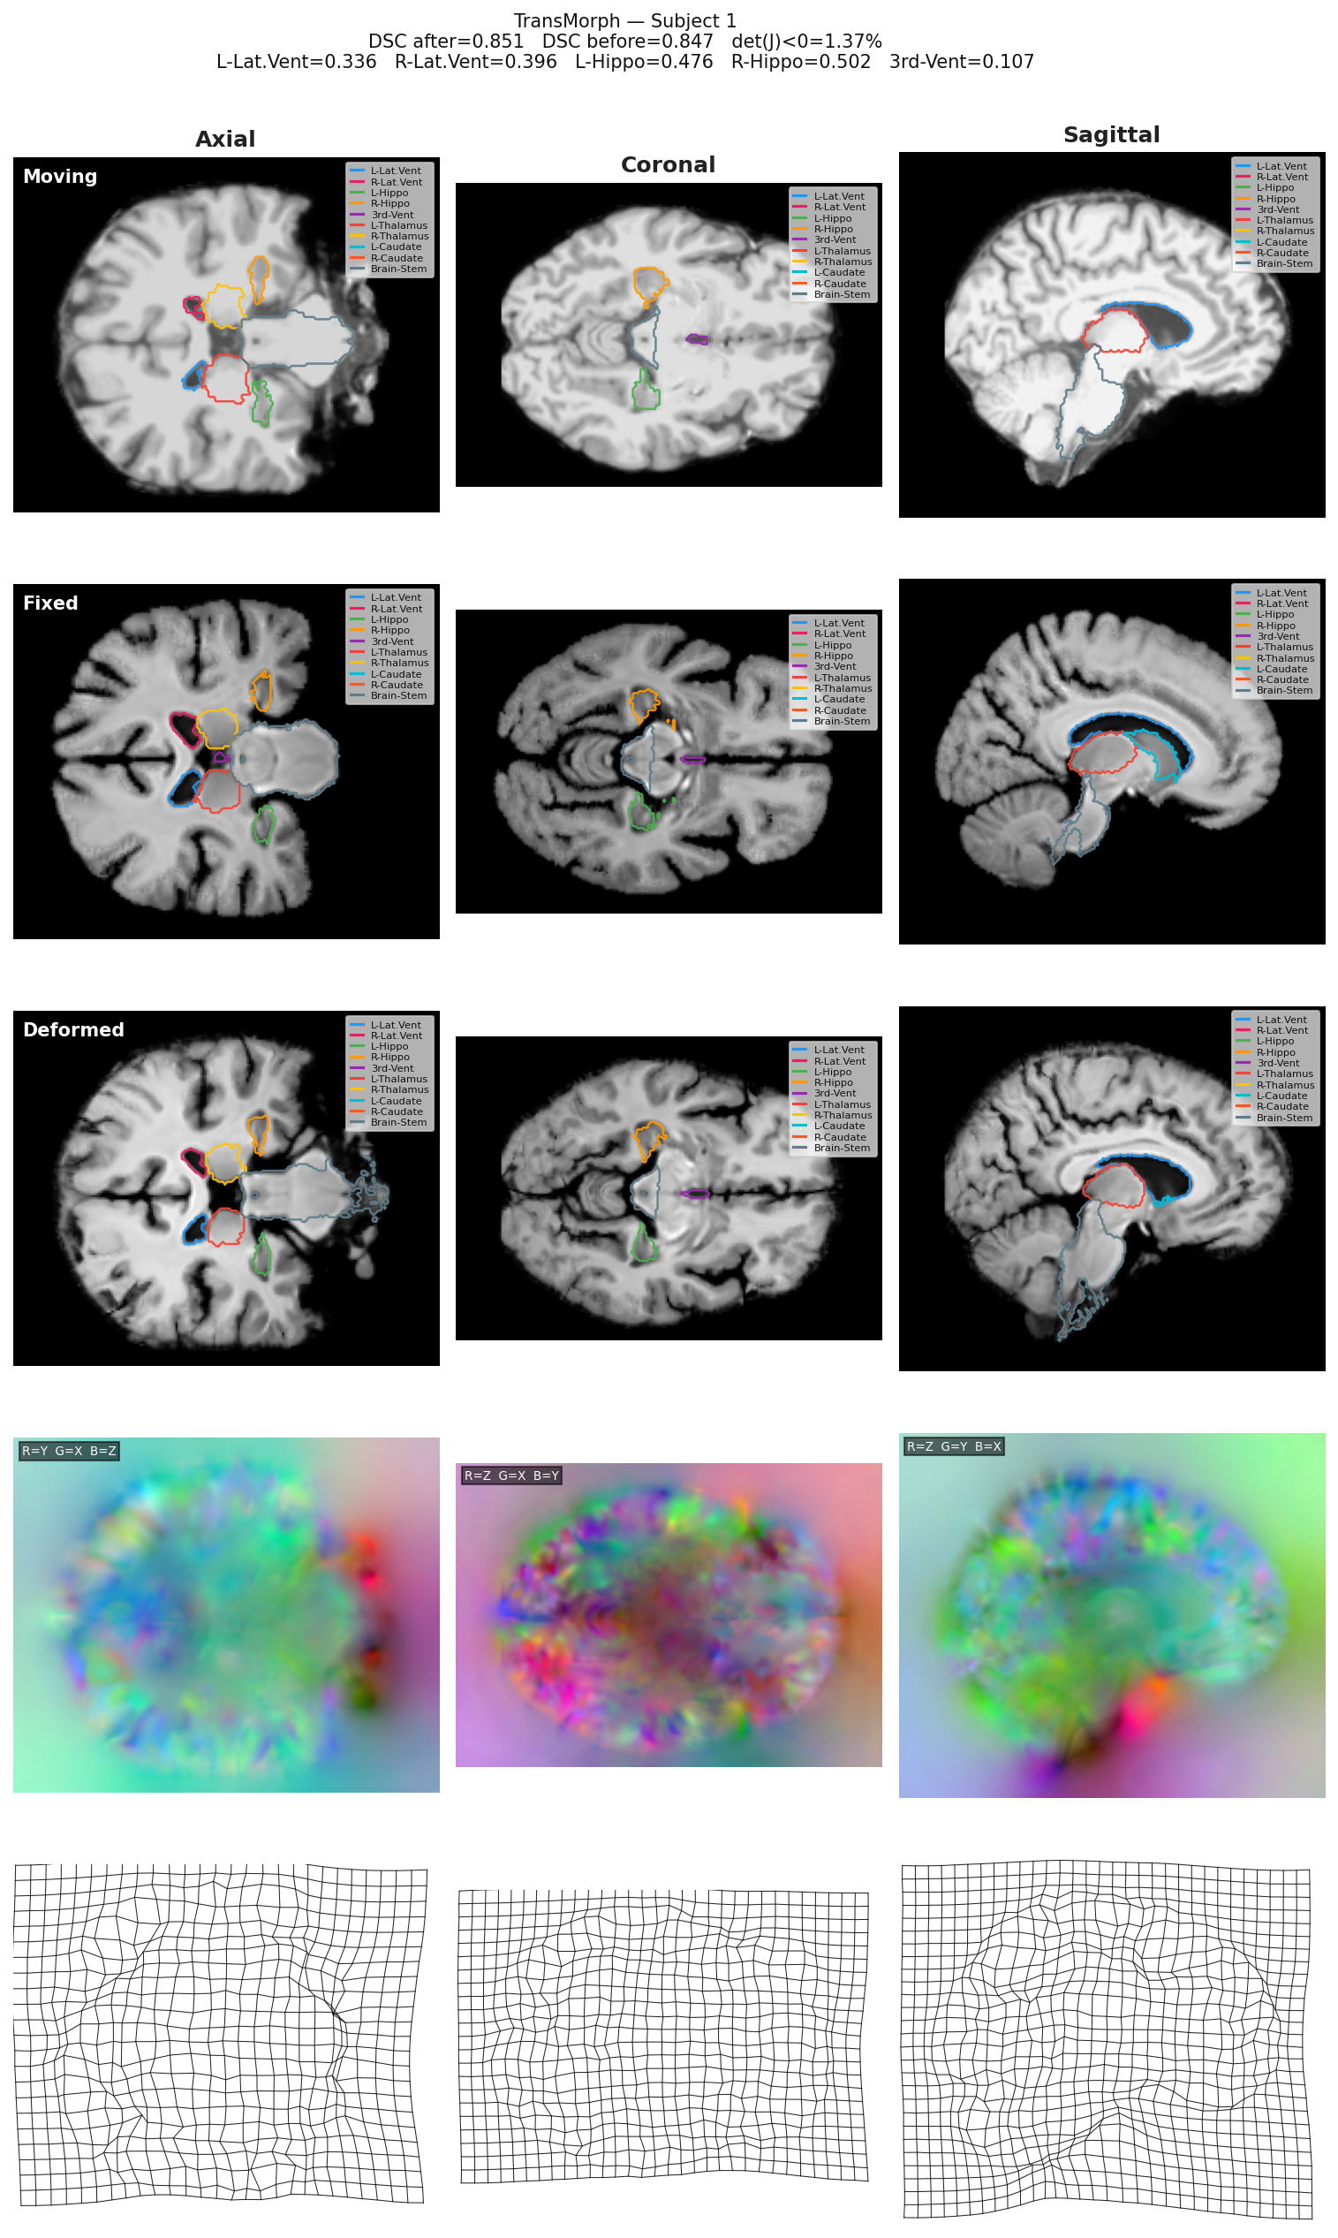
Figure 5. Detailed visualization. Rows 1-3: Moving (atlas), Fixed (subject), Deformed (warped atlas) in sagittal/coronal/axial views with structure contours. Row 4: RGB deformation field. Row 5: Deformation grid.

5. Conclusion
This report presents the implementation and evaluation of TransMorph on the IXI brain MRI registration benchmark. The pretrained model achieves DSC = 0.751 on the 30-structure VOI evaluation, closely reproducing the paper’s reported result of 0.753. The deformation field is smooth, with a folding ratio of 1.50%.
Key observations:
- TransMorph outperforms VoxelMorph-1 (0.729) by approximately +0.022 in Dice, demonstrating the benefit of Swin Transformer’s long-range attention mechanism.
- Registration performance varies significantly across structures: large, distinctive structures (Brain Stem, Thalamus, Lateral Ventricles) achieve high Dice (>0.84), while small or variable structures (Choroid Plexus, Pallidum) are more challenging.
- The deformation field is predominantly smooth and topology-preserving, with only ~1.5% of voxels exhibiting folding.
Future work includes training TransMorph from scratch on the full IXI dataset, exploring the diffeomorphic variant (TransMorph-diff), and comparing with other Transformer-based registration methods.

References
[1] Chen, J., Du, Y., He, Y., Segars, W. P., Li, Y., & Frey, E. C. (2022). TransMorph: Transformer for unsupervised medical image registration. Medical Image Analysis, 82, 102615.
[2] Balakrishnan, G., Zhao, A., Sabuncu, M. R., Guttag, J., & Dalca, A. V. (2019). VoxelMorph: A learning framework for deformable medical image registration. IEEE Transactions on Medical Imaging, 38(8), 1788-1800.
[3] Liu, Z., Lin, Y., Cao, Y., Hu, H., Wei, Y., Zhang, Z., ... & Guo, B. (2021). Swin transformer: Hierarchical vision transformer using shifted windows. ICCV 2021.

