Q1

As Y(radius of circle) is uniformly distribute between [0, d/2], so is X(distance between line and the middle of the circle), so I just randomly generate n pairs(number of samples the case wanted) of number between [0, d/2] and ++ whenever X>Y(which means the distance is bigger than the radius), meaning that the circle didn’t cross any line. After that, I sum up and divide the sum with the total sample number, getting the probability of the case with n sample. In the end, I just simply connect each point and get the figure down below.

The probability should get closer and closer to 0.5 as n gets bigger and bigger.

|  |
| --- |
| d=2;  count =0;  Z = zeros(1,7);  sample=[10 20 50 100 200 500 1000];    for N=1:7  count=0;  x=rand(1,sample(N))*d/2;  y=rand(1,sample(N))*d/2;  for A=1:sample(N)  if y(A)>x(A)  count=count+1;  end  end  Z(N)=count/sample(N);  end    plot(sample, Z, 'b', sample, Z, 'go');  axis([1, 1000,0,1]);  xlabel('n');  ylabel('an'); |

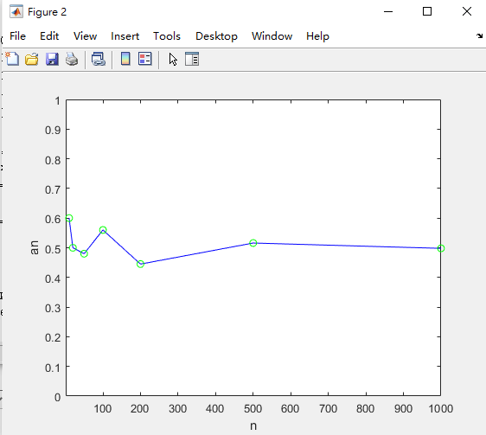

Q2

As Y in problem 2 is exponential random variable, the probability decrease exponentially as Y gets bigger. To get the value of Y by probability, I randomly pick points in square (0~100, 0~100), whenever I find a point between exp(-x) and x-axis, and compare it with a randomly picked number in [0, 1](as X is uniformly distributed 0~d/2 = 1), if X is bigger, I ++ count for the after P(Z=0), if not, I calculate how many lines the circle crossed by seeing if the circle is able to cross the two lines that keep the center in between. After that, I further calculate of the radius is big enough to cross the line across the line on the side, or even further line, and sum up the total number of crossed lines. After each case, I divide count with n to get P(Z=0), and divide sum with n to get E[Z].

The probability get closer to 0.366, and E[X] get closer to 1 as n gets bigger.

|  |
| --- |
| sample=[10 20 50 100 200 500 1000]  A=zeros(1,7);  M=zeros(1,7);  for n=1:7  T=zeros(1,sample(n));  k=1;  count=0;  sum=0;  while T(sample(n))==0  x=rand(1,1)*100;  y=rand(1,1)*100;  if y(1)<exp(-x(1))  T(k)=y(1);  k=k+1;  z=rand(1,1)*1;  if z(1)>x(1)  count=count+1;  else  if x(1)-2+z(1)>=0  sum = sum+1+(x(1)-z(1))/2+1+(x(1)-2+z(1))/2;  else  sum = sum+1;  end  end  end  end  A(n)=count/sample(n);  M(n)=sum/sample(n);  end    figure(1);  plot(sample, A, 'b', sample, A, 'go');  axis([1, 1000,0,1]);  xlabel('n');  ylabel('bn');    figure(2);  plot(sample, M, 'b', sample, M, 'go');  axis([1, 1000,0,2]);  xlabel('n');  ylabel('cn');  title('E[x]'); |

