

**Assignment 2: Static Website**

Individual Assignment

*Course code and name:* COSC2430

*Professors: Tom Huynh*

*Nguyen Hoang Thien Phuc*

Ho Dac Quang Minh S3893444

**a. Introduction**

In this assignment, introduce the Copyrights bookstore's website, which will help people from around the country buy the book that they are looking for and listen to some of the audiobooks available online. Not only that but also I aim to sell exclusive books from around the world at a reasonable price so that everyone can be able to read and learn about other cultures. And, we have books for football/soccer lovers to be able to read about their favourite teams, managers/coaches, and footballers.

**b. Project Description**

One of the greatest methods for students to gain genuine coding experience in Australian colleges is to participate in a project-based hackathon held by tech firms to tackle problems that are important to them. The term is derived from the words "hack" and "marathon," which should give you a fair understanding of what this word means. Thus, a hackathon is a coding event in which participants strive to design, innovate, enhance, and build a software solution to a societal problem. As a result, the purpose of Assignment 1 is to give you a taste and experience of a 3-week tech hackathon. Assume you've been charged with developing a commercial book shop for a startup/company, which means you'll get to put your concept into action.

**c. Implementation Details**

**a)**

In this project, besides applying html knowledge and css knowledge, I have to apply the colour palette to this project so that it will make the website easy to read and eye-catching so that the customers will come back. UI/UX is a must for this project to make it easy to read and understand what is happening in the website and how I want to display my products on my website.

**b)**

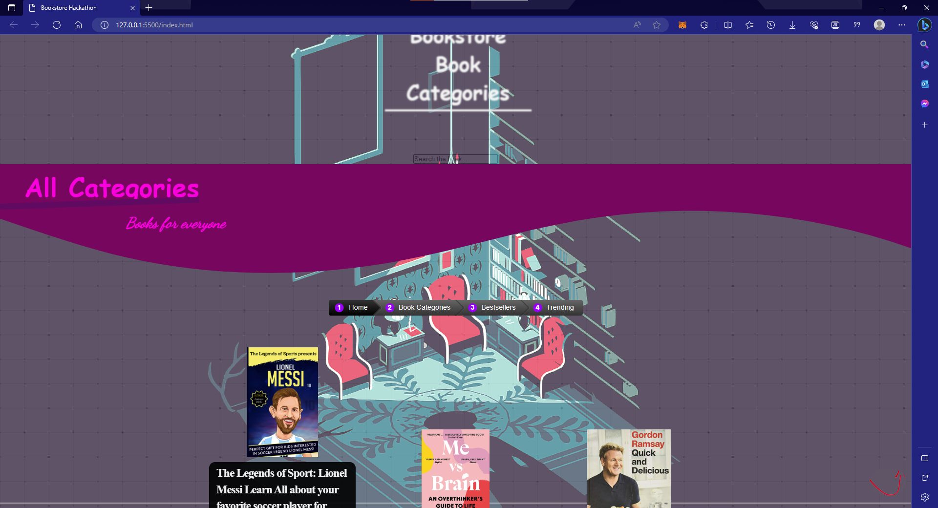

The features that I have done are the exact same form of what the description wanted the website looks like and I implement it in my website. The reason I chose the colour pink is because pink represents a feeling of love and kindness, and also from my perspective it fits with the dark background that I choose for the website. Not only that but the background is a sketchfab 3d model which can be adjust by the empty spaces on the left and right of the website

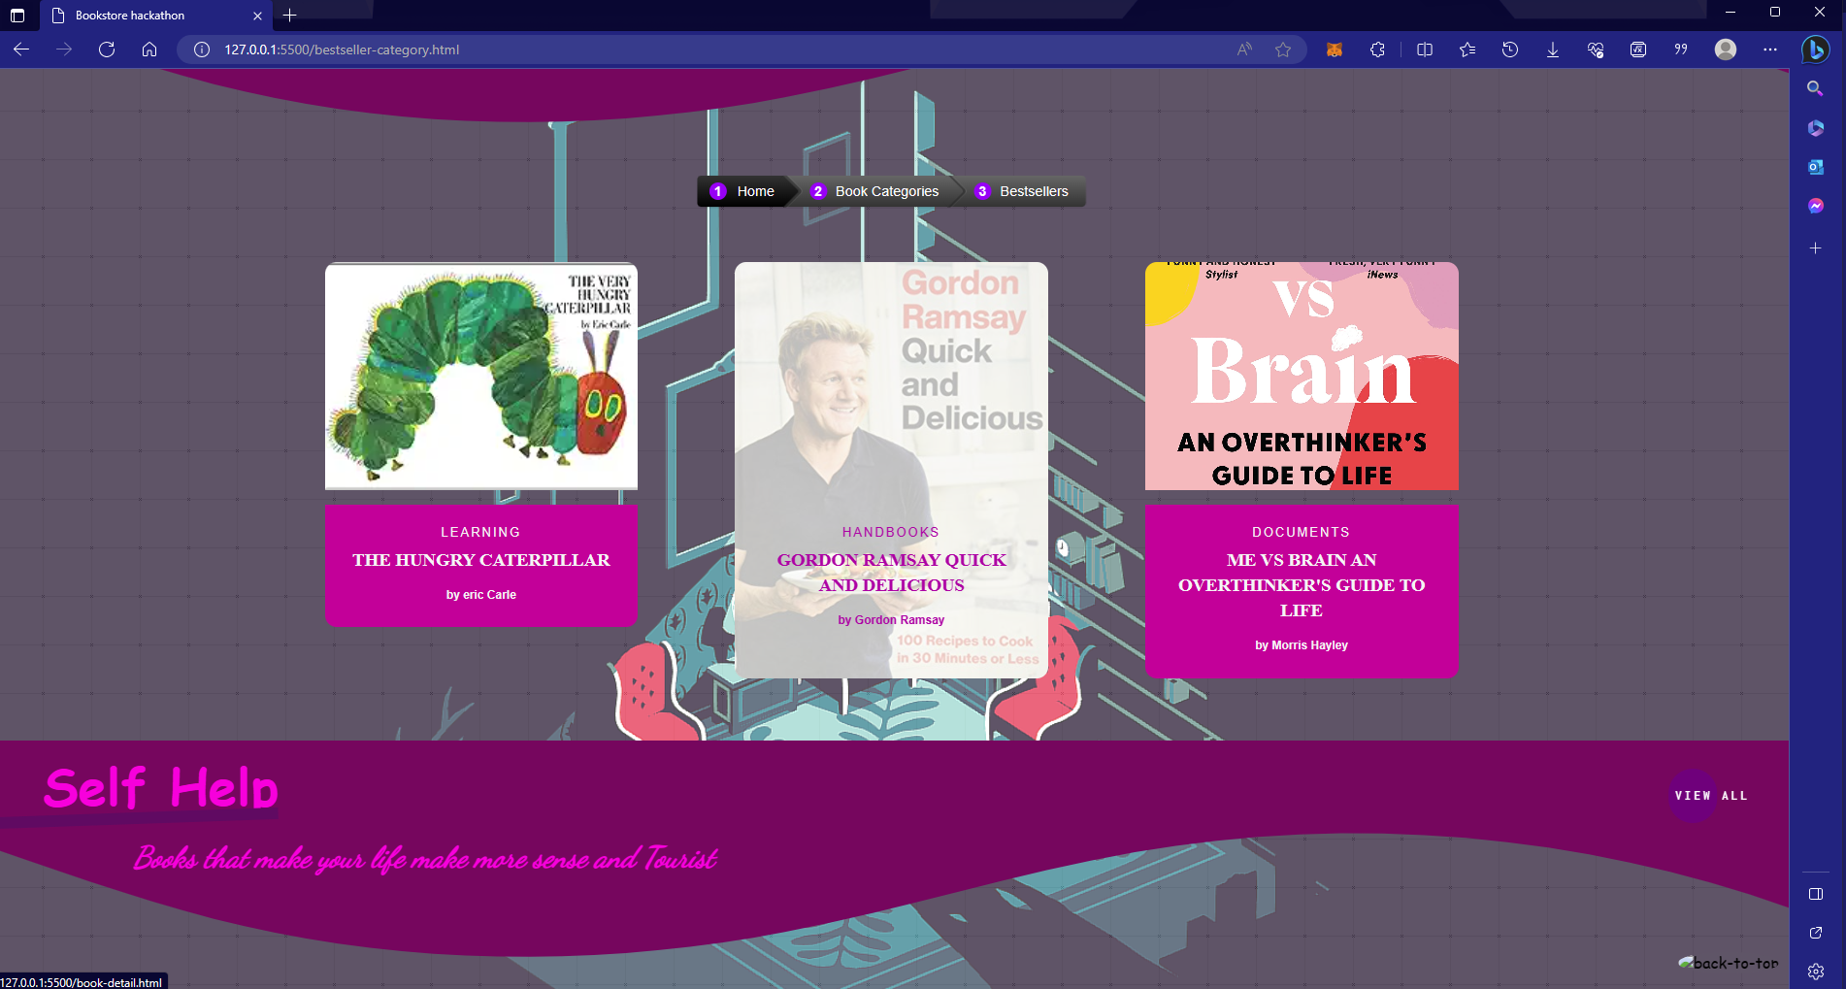

I applied the image hover to the book section because it will look much cooler and it will easier to draw attention to the customers.

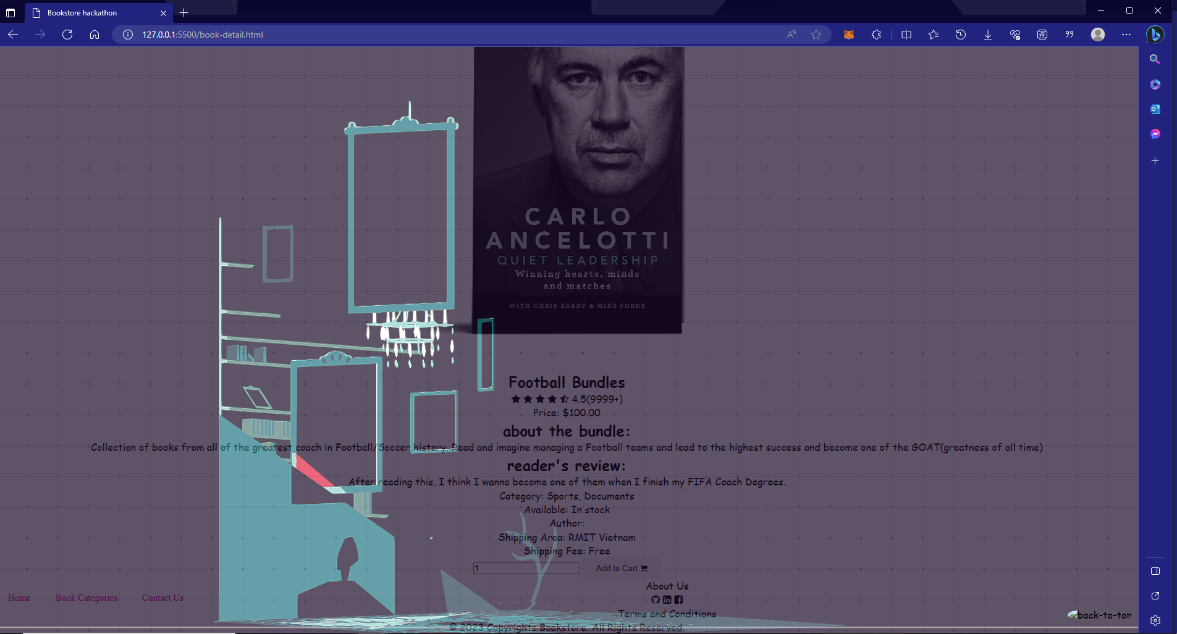

A book details for the customers to know that if the books or the bundle are worthy are not based on the reviews and the feedback that the other customers comments.

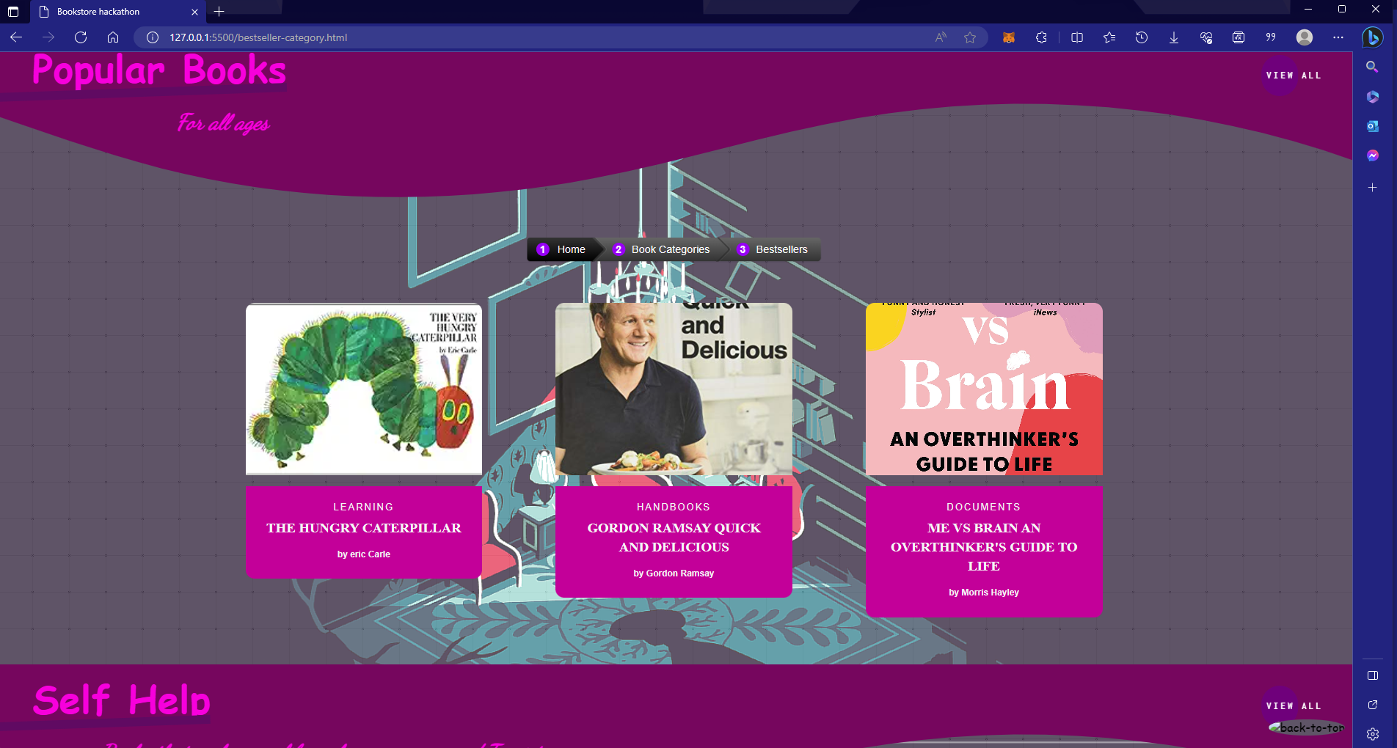

And the section to show that what is our most selling product and which products that most of the customers search on our website

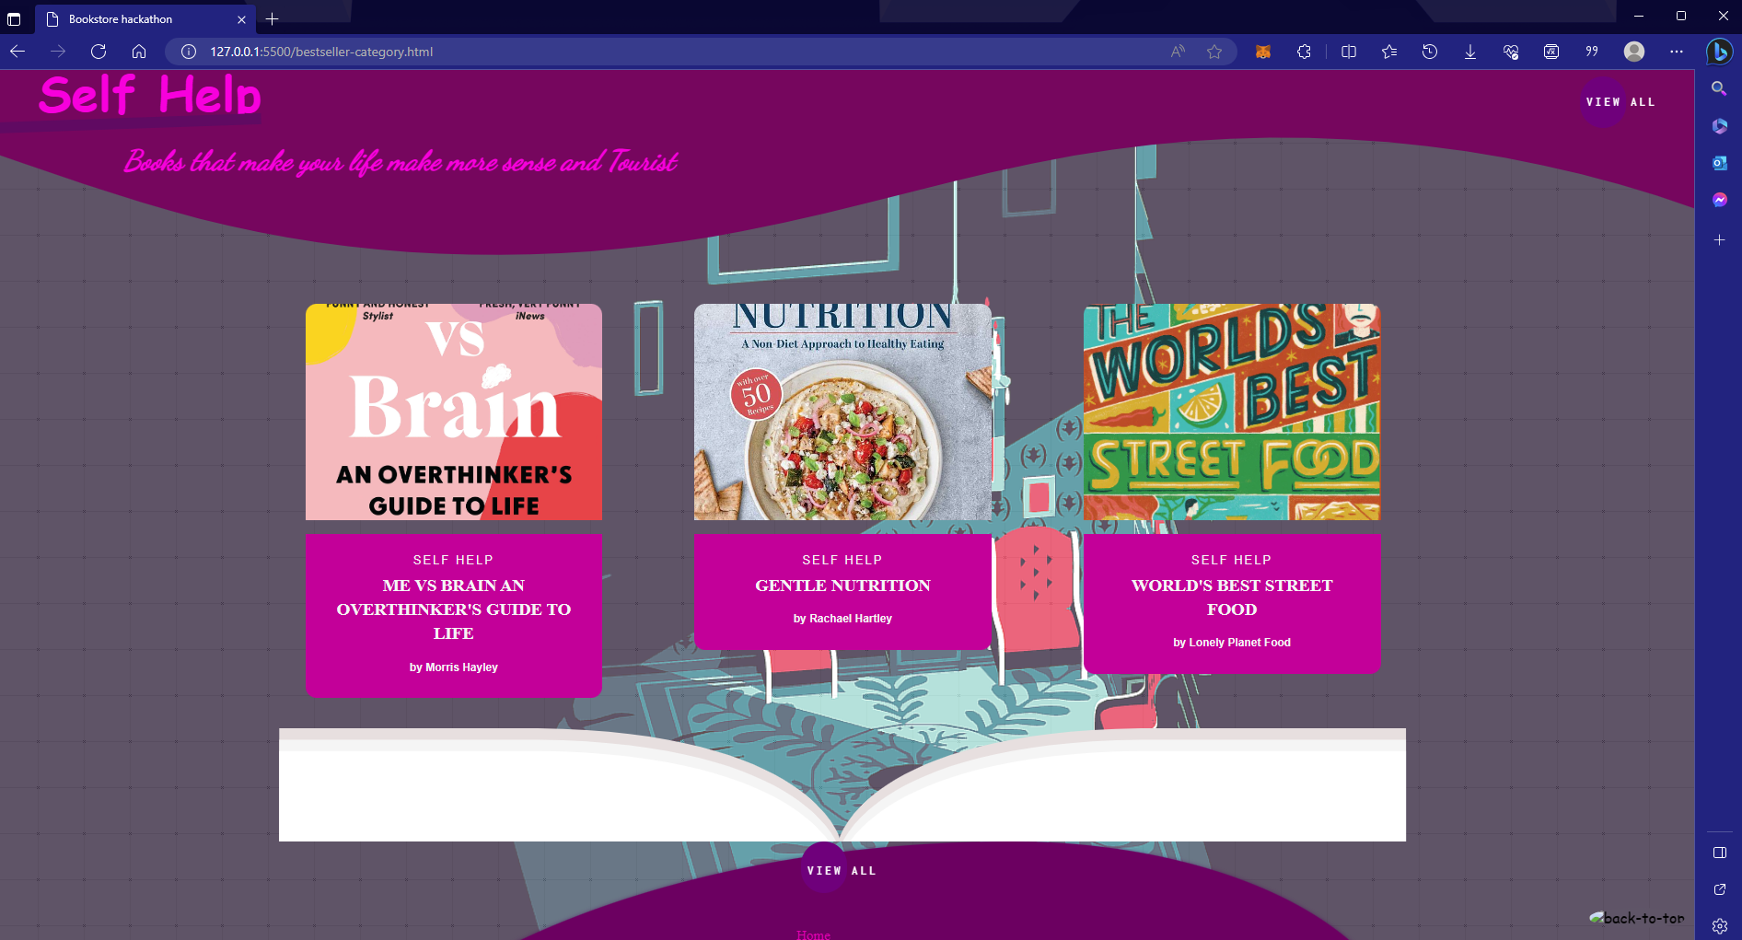

Website link: [Bookstore Hackathon (hodacquangminh.github.io)](https://hodacquangminh.github.io/Book_hackathon_s3893444/)

The bugs:

* Audiobook won't play
* Book details only show one products

**d. Conclusion**

In conclusion, from my perspective, I did not do my website like what I expected on my storyboard and what I plan to add in due to my time management was a little off. But thanks to this project, I was able to overcome my understanding in HTML and CSS because I used to not understand what it is about but due to this project, I was able to discover more about the wonderful things about web programming. In the future, I will manage my timetable more efficiently so that my can overcome the difficulties during the project not only in this program but also in other program so that I can finish on time

**e. Reference**

[HTML Cheat Sheet 📃 - The best interactive cheat sheet](https://htmlcheatsheet.com/)

[CSS Code - 𝗜𝗡𝗧𝗘𝗥𝗔𝗖𝗧𝗜𝗩𝗘 𝗢𝗡𝗟𝗜𝗡𝗘 𝗧𝗢𝗢𝗟𝗦 𝗔𝗡𝗗 𝗥𝗘𝗦𝗢𝗨𝗥𝗖𝗘𝗦 (html-css-js.com)](https://html-css-js.com/css/)

[Newsfeed - Sketchfab](https://sketchfab.com/feed)

Amazon.com ( for books cover and images)

[Color Palettes for Designers and Artists - Color Hunt](https://colorhunt.co/).