Project Report

COS10026 Computing Technology Inquiry Project

Assignment 1

Name: Ho Duc Manh Nguyen

ID: 104169549

***Introduction***

  This is a project report about the Simple Static Website in the Assignment1. A website to sell luxurious, elegant, professional watches is made with excitement and enthusiasm to work every day. This website will help you better understand the world of watches and have a different view of luxury items. The next part of the report will have sections including Website Content, Website Style,  Key Features,

My Contribution and Conclusion.

***Website Content***

At the Index page(Home page), you will have an overview of our store as the brand name is Chrono and we sell luxury watches. Also this page shows some basics about our store such as hot selling products, some promotional activities, connection between watches and people's life.

At the Watches page(Product page), you will have an objective, more detailed view of the products as well as how they are made. Here, you can see more clearly that Chrono's goal is to help shape the value of life. In addition, you will see the ingredients of the product, which are all made from premium materials. We also briefly introduce the brand history and some product specifications on this page. Besides, you will see the products are professionally displayed and arranged as well as the function of each product.

At the Enquiry page, you can fill your information to sign up and become our VIP member.

At the About us page, you can see some information about our team including members' names and some information about us.

At the Enhancements page, you can see some enhancements of our website.

This is how we arrange the files in the folder:

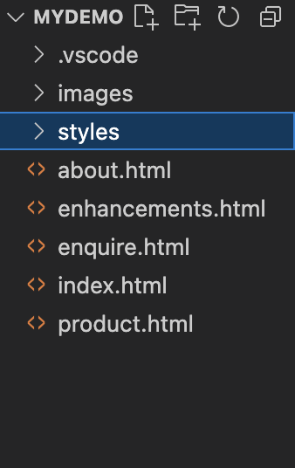

Five files html and one file css to reuse. We split the html file into small parts for easy management and control. In all pages, we have navigation bar to easily navigate to another page of the website.

***Website Style***

On how to use the css file, we divide it into five separate sections clearly, to easily distinguish and correct errors if any. We use the comment command to divide it into five sections for clarity. Since there is only one css file for all five html files, we keep it clear and concise. In addition, there are things in the css file that we have not learned in school, which are completely self-taught and researched. For exmaple,



like on the navigation bar, when hovering, it will show a horizontal bar running below and opacity to create more interesting effects for users.

***Key Features***

We have some amazing features, such as

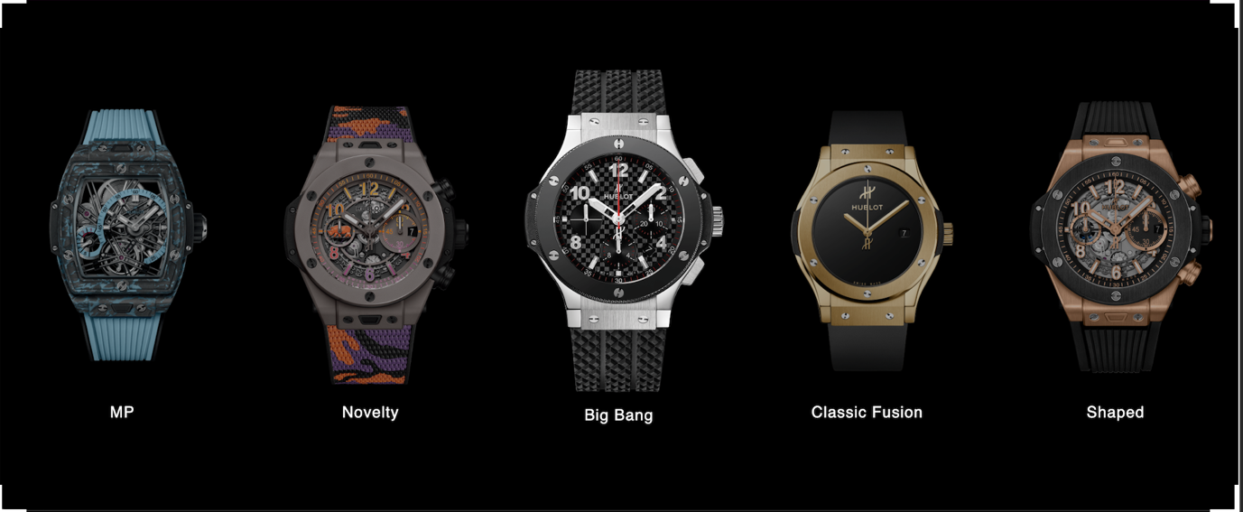

when hovering over the clock image, you will see the clock appear to be large, creating a very new feeling.

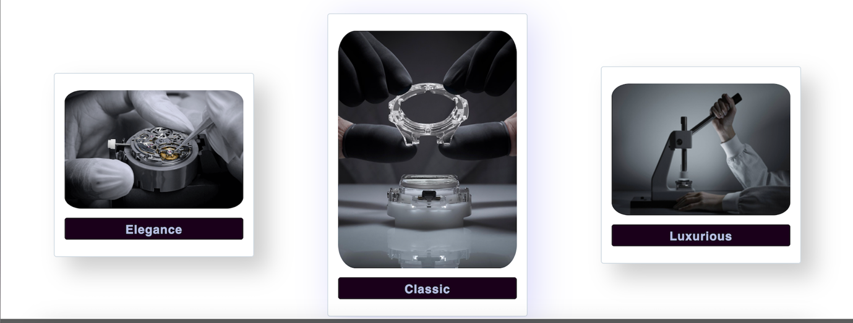

Or the box-shadows will appear full of fanciful colors to help increase the user experience.

In the enhancements section, we have responsive, navigation’s underline when hover and color changing button, help the website to be displayed better and increase the fun when customers use it.

***My Contribution***

To my ability, I have completed the product.html and css page of this page. In addition, I also support my teammates to complete the task. We have divided the tasks and my task is to complete the product page, both html and css. I have also received great support from my associates.

Conclusion

In this report, I made it clear about Website Content, Website Style, Key Features and My Contribution. I also state my opinion of each page, its functions, and the progress of the product. In addition, I also highlight the enhancements available on our website.