# 



**<JAVA – Canteen MS>**

**Documentation**

|  |  |
| --- | --- |
| **Authors** | **C2108L-Team 3** |
| **Ho Gia Huy**  **Duong Van Hoang**  **Pham Hai Hung** |
| **Date** | **14-9-2022** |
| **Instructor** | **Tran Van Diep** |

Hanoi, 27 – 5 – 2022**Index**

1. Problem Definition 3

1.1. Problem Abstraction 3

1.2. The Current System 3

1.3. The Proposed System 4

1.3.1. Boundaries of the System 5

1.3.2. Hardware and Software Requirements 5

2. Customer Requirements Specification 6

2.1. Users of the System 6

2.2. System functions 7

3. System Designs 8

3.1. Entity Relationship Diagram 8

3.2. Database Design 9

3.3. Applicatiom diagram 12

3.3.1. Main page 12

3.3.2. The report page 14

3.3.3. The information about us page 16

3.3.4. The register and login page 17

3.3.5. Admin page 19

3.4. System fucntions design 21

3.4.1. Register function 21

3.4.2. Login function 22

3.4.3. Sending report function 23

3.4.4. Show table function 24

3.4.5. Delete database function 25

4. Task sheet 26

5. Validation Checklists 28

# Problem Definition

## Problem Abstraction

People in ancient times managed everything by copying and recording it in books. Although copying, recording and preserving books so that they do not get lost or torn is a problem that in ancient times was difficult to deal with.

We here review an application that will provide brief details about the products and the categories of each product. The app is supposed to provide a user-friendly and navigational environment. Menus with each item are clear and color combinations are expected.

## The Current System

Management 4.0 allows users to manage work methodically, modernly, intuitively, easily control and update information quickly.

Easily track work progress remotely, feedback and record through the management software. Data and documents are updated directly to the common system, decentralized and shared for different individuals. Statistics on the work and results of each member of the company easily, helping to reward the right people for the right job. Record all information data, easy access, avoid getting lost and difficult searching.

## The Proposed System

This application has a number of features such as registration, login, view detailed information of each product, order management along with employee management to help canteen managers easily manage several databases. data such as adding, editing, deleting employees; product and sales statistics. The app has a clear category menu so users can easily find what they want.

## Boundaries of the System

The goal in this app is to help this canteen activity. The application serves 3 types of objects: Managers, Service staff with activities such as:

+ Manage products sold in the canteen

+ Create and manage sales invoices

+ Employee management

+ Statistics on products and sales.

## Hardware and Software Requirements

In this application we use Java, JavaFX, CSS to create the user interface. Java has made the application stable and user-friendly.

It can run with minimum configuration so that you don’t need a strong computer to access it.

# Customer Requirements Specification

## Users of the System

Users can only use functions such as registering, logging in, viewing customer, buying and selling product, and show customer and their income, order, revenue to the system.

1. Employers.

* Log in and log out.
* Manage employee.
* Manage customer.
* Choose customer to sell product.
* Choose product and quantity to sell.
* Show cart and ask customer to confirm.
* Confirm order.
* Show order in the past.
* Show revenue of all orders and calculate total revenue.

1. Employees.

* Log in and log out.
* Manage customer.
* Choose customer to sell product.
* Choose product and quantity to sell.
* Show cart and ask customer to confirm
* Confirm order.

1. Customers

* Buy product from customer.
* See product at menu and ask employees to choose product and quantity.
* Confirm order and buy product.

## System functions

The first function we want to mention is the subscription function. Regarding the registration function, users will need to fill in some information to have an account. Information about this user will be sent to the database and admin can easily manage this user.

The next function that we want to mention is the login function. When the user fills in the email or phone number and password, if it matches and the account is in the database, the user will login successfully.

The third function is to display employees, customers who want to order and products sold in the canteen, allowing users to view employee information as well as salary and working time about each person of the canteen manager and the canteen's products being sold. Store staff can view their salary, order products when customers order, see what products need to be done to serve customers, show all order in the past and revenue of order to calculate total revenue.

And the last function is to add, edit, delete employees, customers, products, and edit income. When the manager presses the add, edit or delete button to add, edit or remove the employee, customer, product, and only edit income. The application sends information to the database and this information in the database is deleted. And then we can't see this information even in the database.

# System Designs

## Entity Relationship Diagram

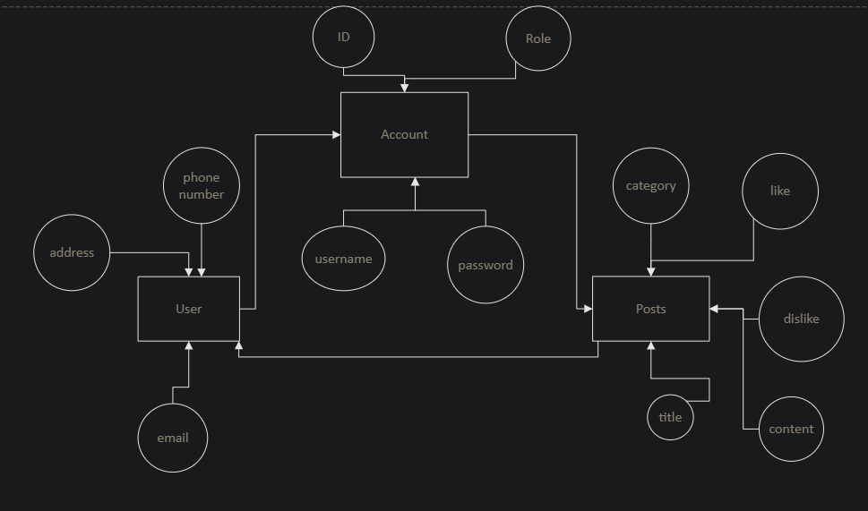

Picture 3.1: Entity Relationship diagram

User affect by some element like address, phone number, email address. And user will affect to account. Account is affected by id, role, username, password. And account can affort to a post. A post has some element like category, number of like, number of dislike, title and content. And many posts can affort to users.

## Database Design

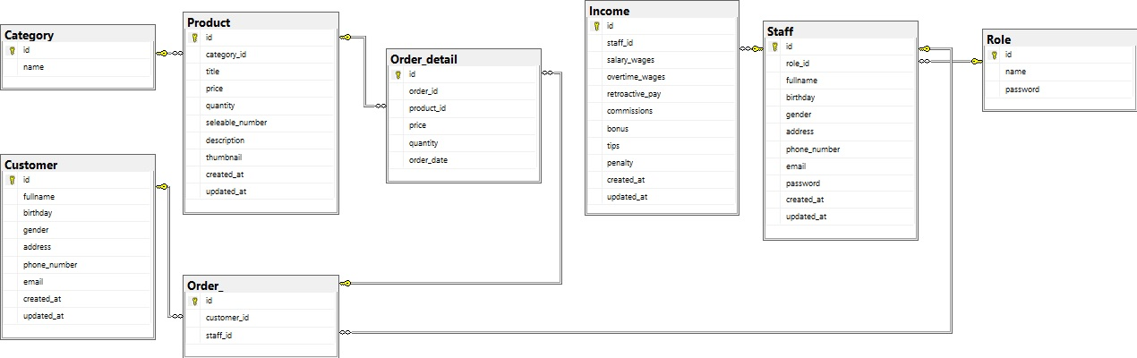

Picture 3.2: The database design

In this project we have eight tables of database:

* The first table in here is table Staff. In this table we will have information about the staff. In here we have id of staff, id of role, username, staff’s email address, staff’s password, staff’s phone number, and we can know when this account created with staff’s created time and when this account updated with staff’s updated time. The primary key in this table is the user’s id. The foreign key is role_id. In this table we used type of data as table 3.1:

Table 3.1: Type of data in table Staff

|  |  |  |  |
| --- | --- | --- | --- |
| Column | Datatype | Constraint | Description |
| Id | INT |  | Auto_increment |
| Role_id | INT |  |  |
| Fullname | Varchar(50) |  |  |
| Birthday | Date |  |  |
| Gender | varchar(16) |  |  |
| Address | Varchar(50) |  |  |
| Phone_number | INT |  |  |
| Email | INT |  |  |
| Password | Varchar(100) |  |  |
| Created_at | Datetime |  |  |
| Updated_at | Datetime |  |  |

* The second table in here is table role. In that table we will have only two information. We have role’s id and the role name. The role table will lead us permission as a user or an admin. The primary key in this table is role’s id. In this table we used type of data as table 3.2:

Table 3.2: Type of data in table Role

|  |  |  |  |
| --- | --- | --- | --- |
| Column | Datatype | Constraint | Description |
| Id | INT |  | Auto_increment |
| Name | Varchar(30) |  |  |
| Password | Varchar(100) |  |  |

* The third table is report table. The report table will receive information user send and show it to the admin. In the report table we have 6 information. We have report’s id, name of who sent the report, email address of him/her, his/her phone number, user’s id who sent this report, report’s title, report’s content. In this table we used type of data as table 3.3:

Table 3.3: Type of data in table Income

|  |  |  |  |
| --- | --- | --- | --- |
| Column | Datatype | Constraint | Description |
| Id | INT |  | Auto_increment |
| Staff_id | INT |  |  |
| Salary_wages | FLOAT |  |  |
| Overtime_wages | FLOAT |  |  |
| Retroactive_pay | FLOAT |  |  |
| Commissions | FLOAT |  |  |
| Bonus | FLOAT |  |  |
| Tips | FLOAT |  |  |
| Penalty | FLOAT |  |  |
| Created_at | Datetime |  |  |
| Updated_at | Datetime |  |  |

* The fourth table is category table. The category table has id’s category, category’s name and category’s content. In this table we used type of data as table 3.4:

Table 3.4: Type of data in table Category

|  |  |  |  |
| --- | --- | --- | --- |
| Column | Datatype | Constraint | Description |
| Id | INT |  | Auto_increment |
| Name | Varchar(15) |  |  |
| Created_at | Datetime |  |  |
| Updated_at | Datetime |  |  |

* The fifth table is posts table. The posts table has post’s id, post’s title, post’s content, author’s id, category’s id, number like of post, number dislike of post, time when this post created at, time when this post updated. In this table we used type of data as table 3.5:

Table 3.5: Type of data in table Customer

|  |  |  |  |
| --- | --- | --- | --- |
| Column | Datatype | Constraint | Description |
| Id | INT |  | Auto_increment |
| Fullname | Varchar(15) |  |  |
| Birthday | Date |  |  |
| Gender | Varchar(16) |  |  |
| Address | Varchar(50) |  |  |
| Phone_number | INT |  |  |
| Email | Varchar(30) |  |  |
| Created_at | Datetime |  |  |
| Updated_at | Datetime |  |  |

Table 3.6: Type of data in table Product

|  |  |  |  |
| --- | --- | --- | --- |
| Column | Datatype | Constraint | Description |
| Id | INT |  | Auto_increment |
| Category_id | INT |  |  |
| Title | FLOAT |  |  |
| Quantity | INT |  |  |
| Seleable_number | INT |  |  |
| Description | Varchar(100) |  |  |
| Thumbnail | Varchar(500) |  |  |
| Created_at | Datetime |  |  |
| Updated_at | Datetime |  |  |

Table 3.7: Type of data in table Sale_off

|  |  |  |  |
| --- | --- | --- | --- |
| Column | Datatype | Constraint | Description |
| Product_id | INT |  |  |
| Quantity | INT |  |  |
| Price | FLOAT |  |  |
| Date_start | Datetime |  |  |
| Date_end | Datetime |  |  |

Table 3.8: Type of data in table Comment

|  |  |  |  |
| --- | --- | --- | --- |
| Column | Datatype | Constraint | Description |
| Id | INT |  | Auto_increment |
| Customer_id | INT |  |  |
| Product_id | INT |  |  |
| Rate | INT |  |  |
| Evaluate | Varchar(100) |  |  |
| Created_at | Datetime |  |  |
| Updated_at | Datetime |  |  |

Table 3.9: Type of data in table Order_

|  |  |  |  |
| --- | --- | --- | --- |
| Column | Datatype | Constraint | Description |
| Id | INT |  | Auto_increment |
| Customer_id | INT |  |  |
| Staff_id | INT |  |  |
| Created_at | Datetime |  |  |
| Updated_at | Datetime |  |  |

Table 3.10: Type of data in tableOrder_detail

|  |  |  |  |
| --- | --- | --- | --- |
| Column | Datatype | Constraint | Description |
| Id | INT |  | Auto_increment |
| Order_id | INT |  |  |
| Product_id | INT |  |  |
| Quantity | INT |  |  |
| Price | FLOAT |  |  |
| Order_date | Datetime |  |  |
| Created_at | Datetime |  |  |
| Updated_at | Datetime |  |  |

## Application diagram

## Main page

In the home page and information pages we separated page into three parts. The first part is the header, the second part is the main content, and the third part is the footer.

About the header part, we have two lines. The first line we have logo, finding box link to the register and login page. The second line is a menu which links to other pages.

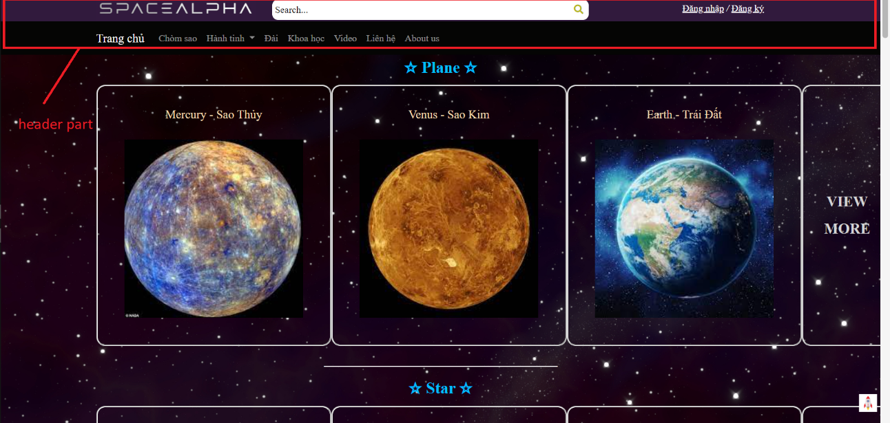

Picture 3.3: Header part

* The first link in the second line which name is “Trang chủ” will lead us to home page.
* The second link which name is “Chòm sao” will lead us to a page name chomsao.html.
* The third link we have a dropdown menu. In the dropdown menu we have eight pages which have information about planet in the sun system.
* The fourth link is an information page about some famous observatory.
* The fifth link is an information page about space science.
* The sixth link will lead you to a video page, but unfortunately it is still in development.
* The seventh link will lead you to a report page. In this page you can send a report to us. And with that we can know what you want, and we can develop the page become better.
* The final link will lead you to the page which will show you more information about us who have developed this page.

About the main content, we used a space background to make the page more beautiful and we hope you can feel more excited when you read information about the space. And when you scroll down the page you can see a small button in the bottom left corner of the page. This is scroll up button. You can scroll up faster to the header by clicking this button.

Picture 3.4: Main part

Picture 3.5: scroll up button

About the footer we have three parts:

Picture 3.6: footer part

* The first part is a directional links. Which that you don’t need to scroll up to the header to go to other pages. You just need to click to the page which you want to go in the footer, and it will link you to this page.
* The second part we have logo of the page, a small finding box.
* The third is some information about us, in here we have address, phonenumber and the email address.

## The report page

About the report page we have a form for you. The form has three main information we want you to fill in.

* The first is your full name
* The second is your email address. If you didn’t fill correct email format you cannot send the report to us
* The third is your report you want send to us.

The report will send to us when you click the send button. But if you forgot fill any information the page would alert it so you can know where you forgot fill in and you will need to fill it to send the report to us. We will see your report in the admin page when it successfully. If you don’t want to send report you can come back home page by clicking home button, it lie on the right center of the page.

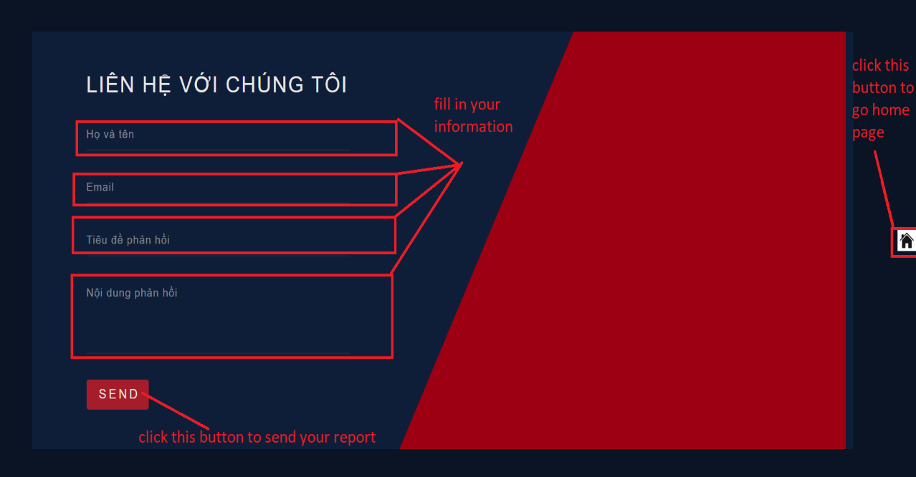

Picture 3.7: report page

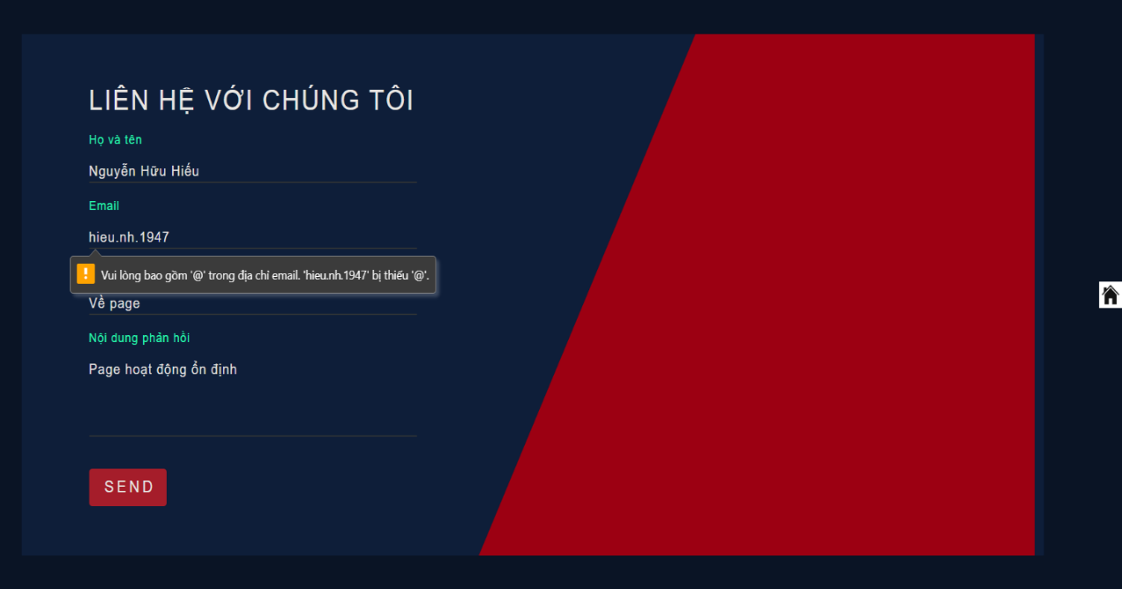

Picture 3.8: When you fill in wrong email format

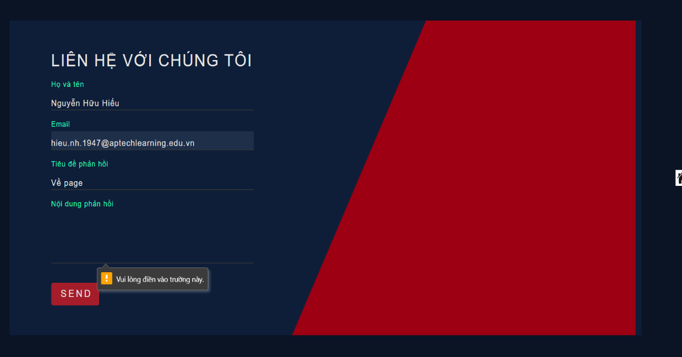

Picture 3.9: When you forgot fill in one information

## The information about us page

In the information about us page we have four cards. Each card has information about one of four member who make this project. You can find some information like facebook, Instagram, twitter, YouTube. And each card has profile picture of us.

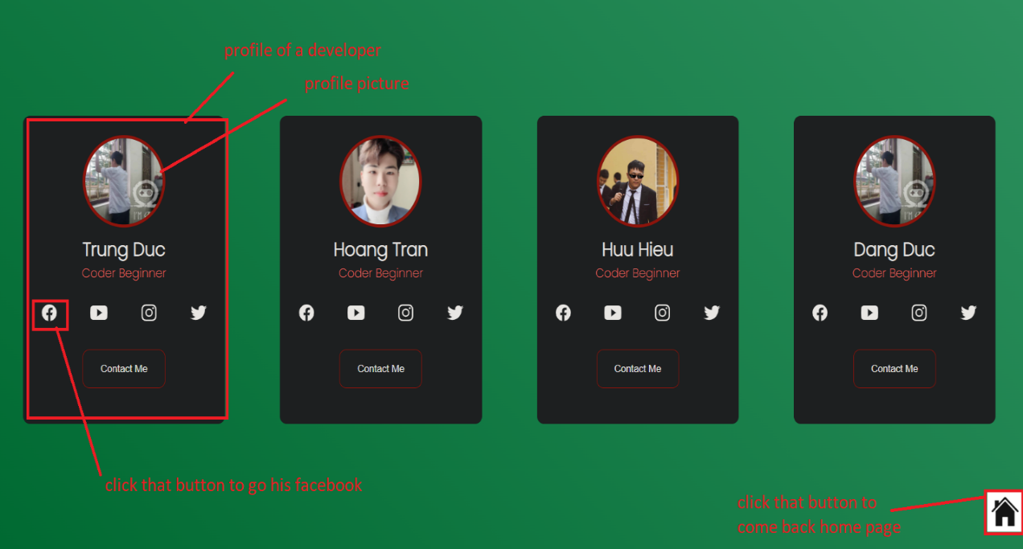

Picture 3.10: About us page

## The register and login page

About register page you need to fill in some information to register an account. You need to fill in username, password, verify your password, email address, your address and finally is your phone number. If your username has been used, we will alert you and you need to use another username to register. Moreover, you need to fill verify password as same as password. If you verify password is different from the password, we will alert you and you can check your password. Make sure that you remember your password because now we haven’t developed forgot password feature. And if your register successfully the information will be sent to the database, and you will link to login page. And if you had an account you could click to “Đăng nhập tại đây” and it will let you to login page. If you don’t want to register, you can click to “Quay lại trang chủ” and it will help you comeback to home page

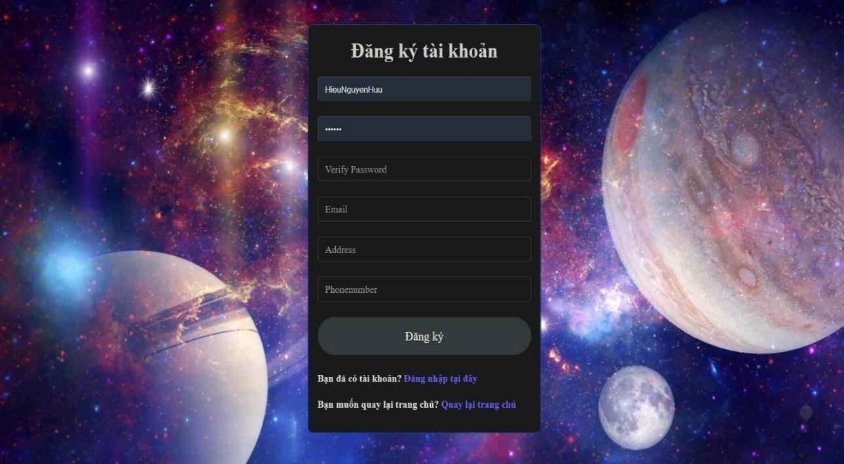

Picture 3.11: Register page

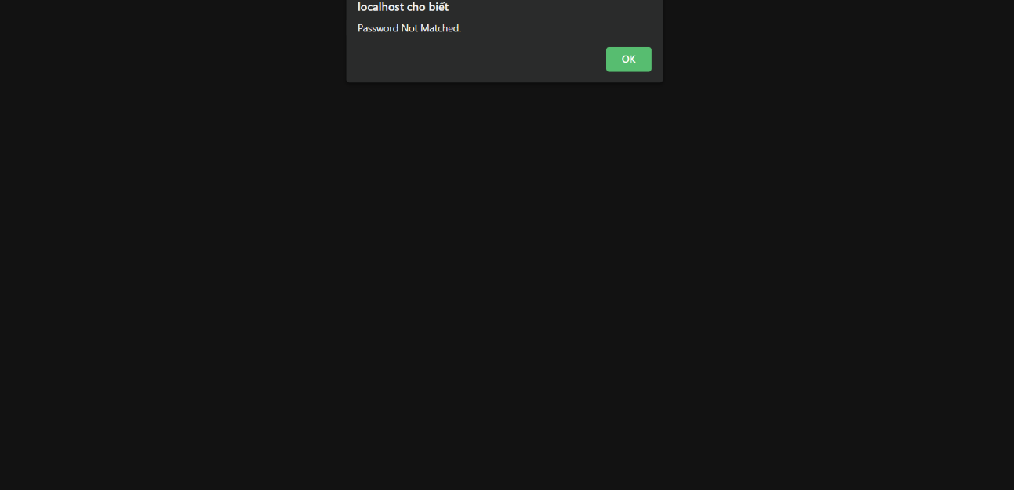

Picture 3.12: When your password different from your verify password

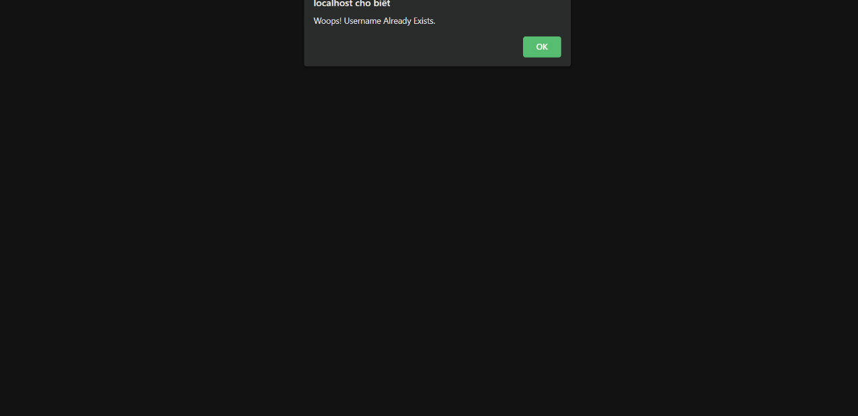

Picture 3.13: When your username has been already used

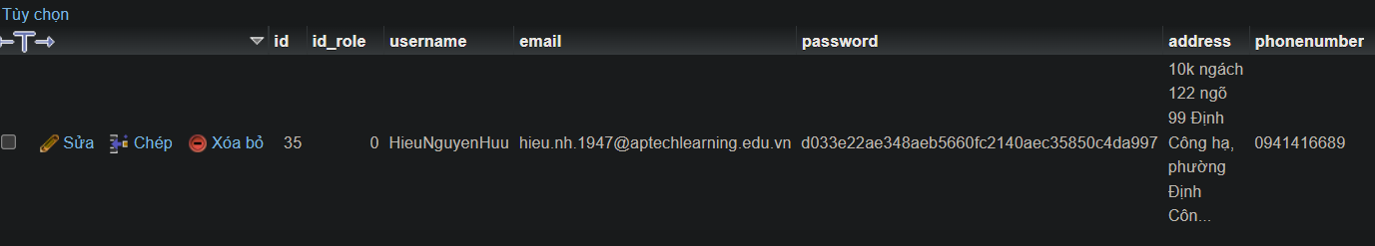

Picture 3.14: The database received your register successfully

In the login page you only need to fill in username and password. If it is correct, you will be sent home page. If your username and password don’t match the database, we will alert you so you can check your account. If you don’t have an account, you can click to “Đăng ký tài khoản mới” and it will lead you to register page. If you don’t want to login, you can click to “Quay lại trang chủ” and it will help you comeback to home page.

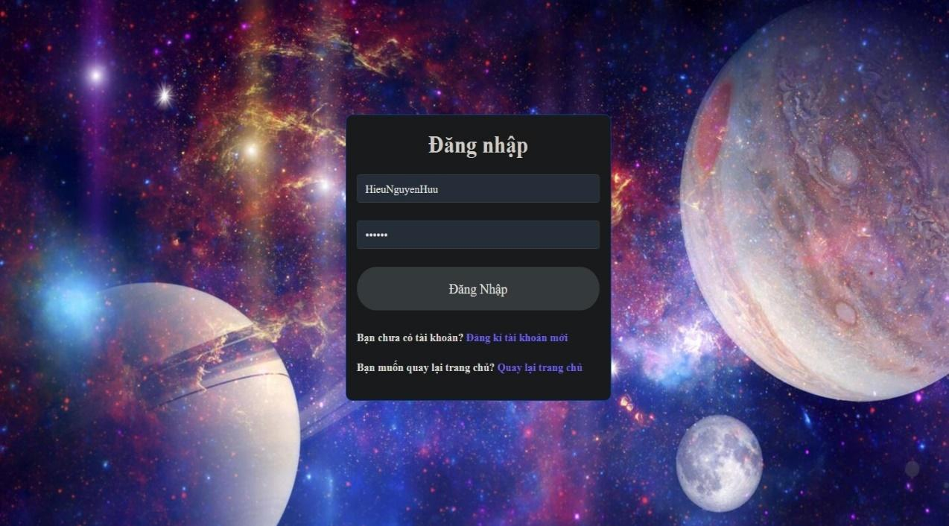

Picture 3.15: Login page

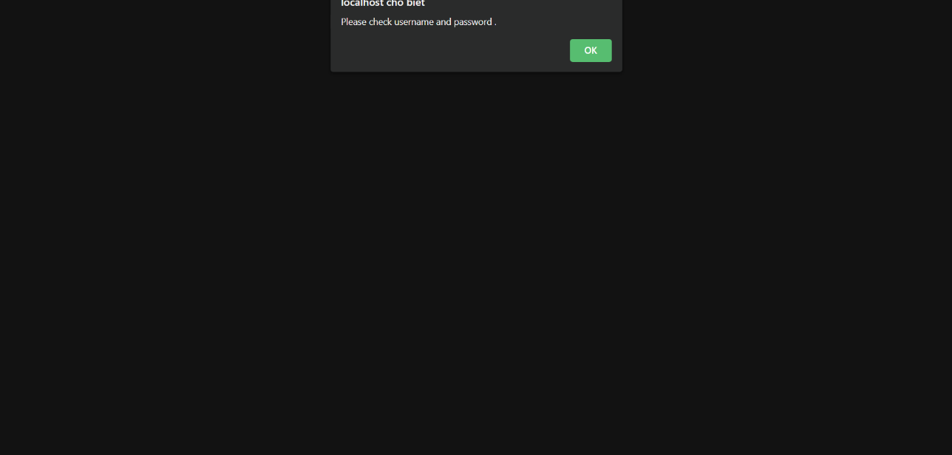

Picture 3.16: When you fill in wrong username or password

## Admin page

In the admin page we have two pages, each page is used to manage one database. Now admin can easily manage account and user’s report. In admin page, admin can delete an account or a report if he/she want by clicking the delete button in the end of the line which have account or a report they want to delete

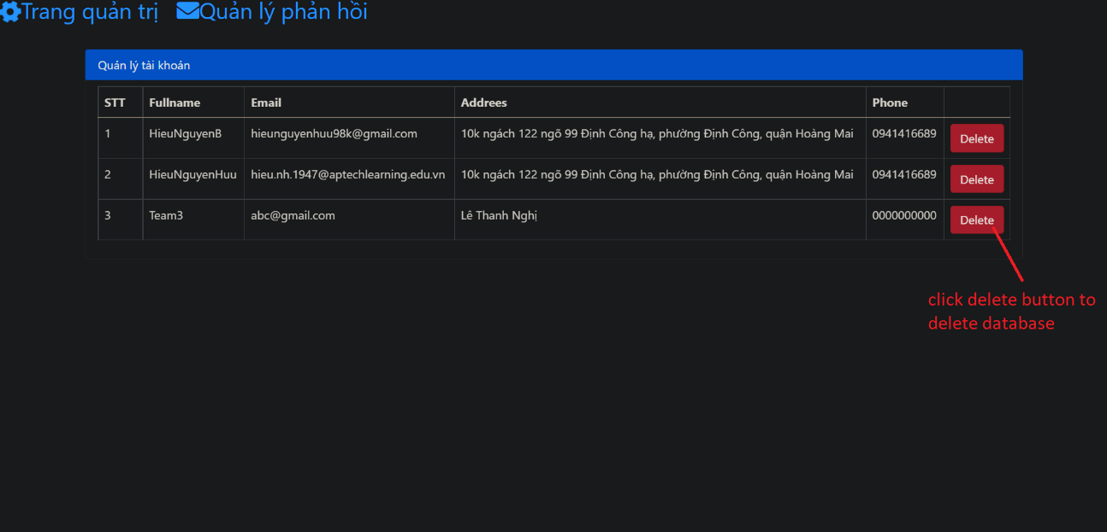

Picture 3.17: Admin’s manage accounts page

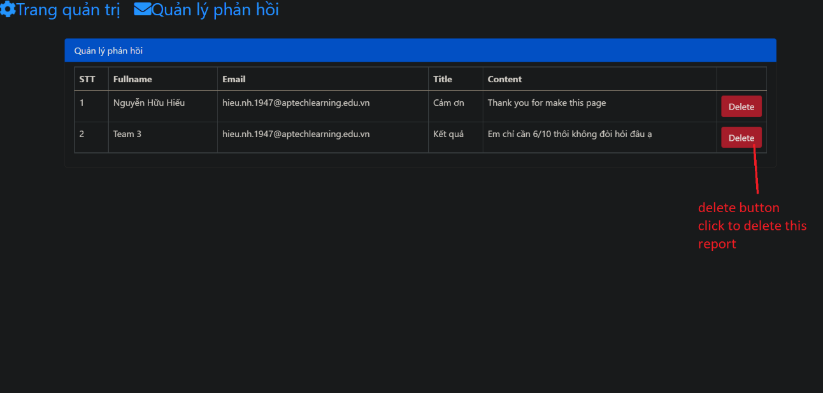

Picture 3.18: Admin’s manage reports page

## System fucntions design

## Register function

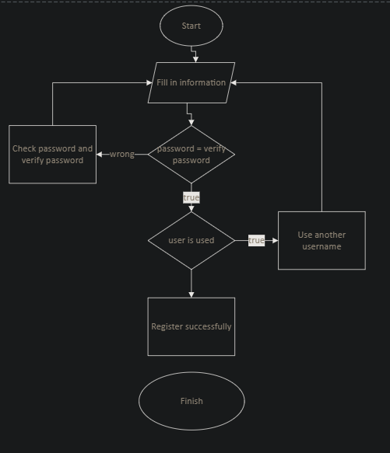

Picture 3.19: Function registration page

When you fill in information and send a register account form if password is not as same as verify password we must check password and verifypassword. If the password is as same as verify password the database will check that had username been used. If the username was used we must find another username. If no one used this username we can use this username.

## Login function

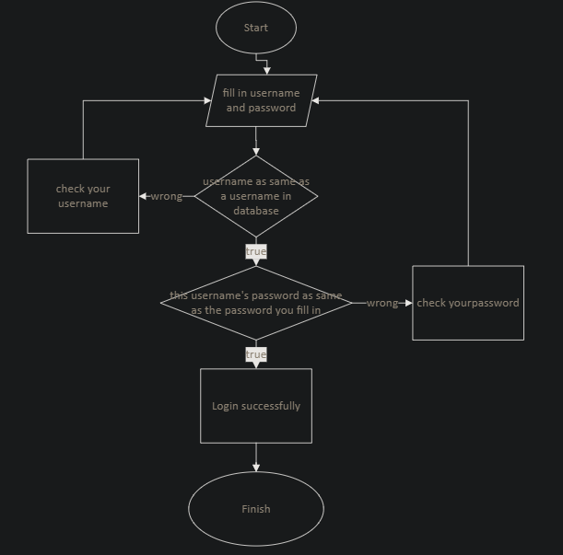

Picture 3.20: Function of login

After you fill in your username and password, we will select username and password from the database which has username is as same as username you filled. If there is no username in database is as same as username you fill you will need to check your username. If there is a username as same as your username, it will check if the password of its as same as your password. If it correctly your login complete but if it wrong you will need to check your password again.

## Sending report function

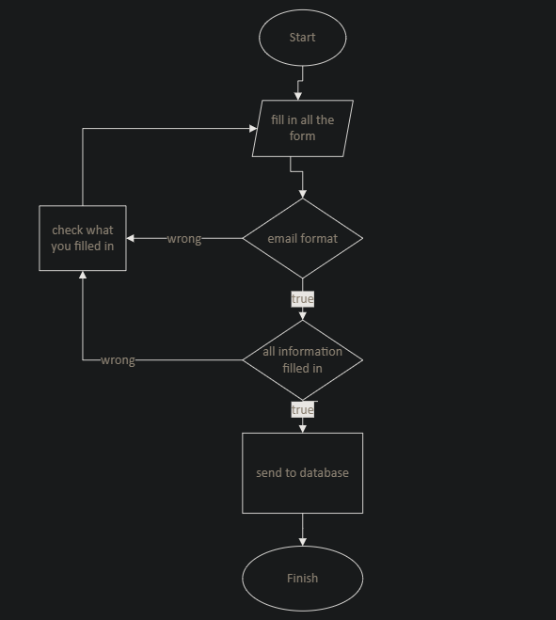

Picture 3.21: Function of sending a report

When you start function, you must fill in all the form in this page. First of all the system will check your email format. If it is true you will go to check all information. And it all information is checked that you have fill in all information, it will sent information to the database successfully. If there is any wrong in checking email format step or in checking all information you fill in you need to check what you filled in and after that you must fix what you fill in to and check it again.

## Show table function

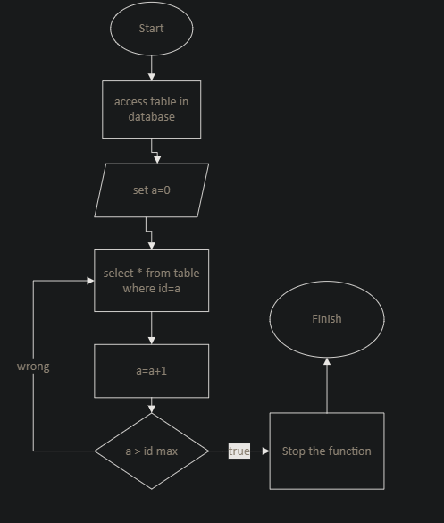

Picture 3.22: Function show table of database

When you start the function, you set a variable a = 0, after that you select all information from that table you want where id=a. After that you set a=a+1. If a isn’t greater than id max you turn back to step select all information from that table you want where id=a. If a greater than id max you stop the function and finish it

## Delete database function

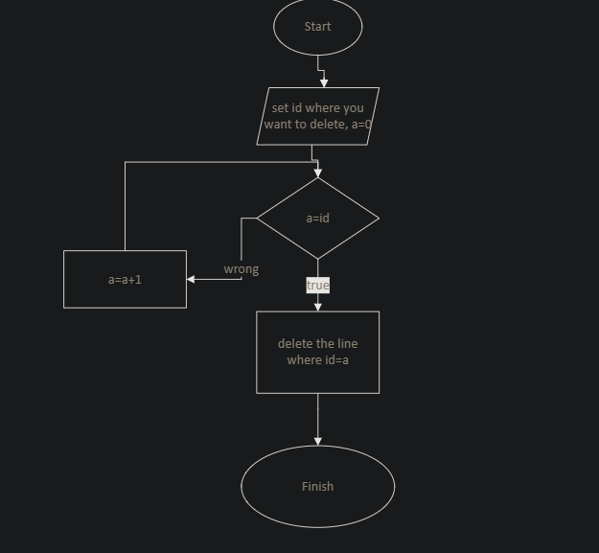

Picture 3.22: Function delete a database

When you start the function, you set what id you want to delete and set a variable a=0. If a=id you want to delete you will delete this line and finish function. But if a<id you will let a=a+1 and repeat check a with id.

# Task sheet

Table 4.1: Task sheet

|  |  |  |  |  |
| --- | --- | --- | --- | --- |
| **Task** | **Start time** | **Finish time** | **Implemented by** | **Evaluation**  **(%)** |
| **Feasibility study phase** |  |  |  |  |
| Write document | 04/04/2022 | 04/04/2022 | Duong Van Hoang | 20 |
| Contribute ideas | 04/04/2022 | 04/04/2022 | Nguyen Huu Hieu | 30 |
| Contribute ideas | 04/04/2022 | 04/04/2022 | Pham Dang Duc | 10 |
| Contribute ideas | 04/04/2022 | 04/04/2022 | Nguyen Trung Duc | 10 |
| Approve and update | 04/04/2022 | 05/04/2022 | Duong Van Hoang  Nguyen Huu Hieu | 30 |
| **Requirement Analysis phase** |  |  |  |  |
| Analysis Database | 04/04/2022 | 07/04/2022 | Nguyen Huu Hieu | 30 |
| Analysis Functions | 04/04/2022 | 07/04/2022 | Duong Van Hoang | 30 |
| Contribute ideas | 07/04/2022 | 07/04/2022 | Pham Dang Duc | 10 |
| Approve and update | 08/04/2022 | 08/04/2022 | Nguyen Huu Hieu | 30 |
|  |  |  |  |  |
|  |  |  |  |  |
| **Design phase** |  |  |  |  |
| Buid Database | 08/04/2022 | 09/04/2022 | Nguyen Huu Hieu | 15 |
| Contribute ideas | 09/04/2022 | 09/04/2022 | Duong Van Hoang | 5 |
| Approve and update | 09/04/2022 | 09/04/2022 | Nguyen Huu Hieu | 10 |
| Deign pages | 18/04/2022 | 18/04/2022 | Duong Van Hoang | 15 |
| Contribute ideas | 18/04/2022 | 18/04/2022 | Nguyen Huu Hieu | 5 |
| Contribute ideas | 18/04/2022 | 18/04/2022 | Nguyen Trung Duc | 5 |
| Contribute ideas | 18/04/2022 | 18/04/2022 | Pham Dang Duc | 5 |
| Approve and update | 18/04/2022 | 18/04/2022 | Duong Van Hoang | 10 |
| Insert data | 29/04/2022 | 29/04/2022 | Nguyen Huu Hieu | 10 |
| Contribute ideas | 02/05/2022 | 02/05/2022 | Nguyen Trung Duc | 5 |
| Approve and update | 04/05/2022 | 04/05/2022 | Nguyen Huu Hieu | 10 |
|  |  |  |  |  |
|  |  |  |  |  |
| **Development phase** |  |  |  |  |
| Buid pages | 18/04/2022 | 18/04/2022 | Duong Van Hoang | 10 |
| Contribute ideas | 18/04/2022 | 23/04/2022 | Pham Dang Duc | 5 |
| Contribute ideas | 18/04/2022 | 20/04/2022 | Nguyen Trung Duc | 5 |
| Approve and update | 20/04/2022 | 04/05/2022 | Duong Van Hoang | 10 |
| Fill data from database | 29/04/2022 | 29/04/2022 | Nguyen Huu Hieu | 10 |
| Contribute ideas | 02/05/2022 | 02/05/2022 | Nguyen Trung Duc | 5 |
| Approve and update | 04/05/2022 | 04/05/2022 | Nguyen Huu Hieu | 5 |
| Admin pages | 04/05/2022 | 04/05/2022 | Duong Van Hoang | 10 |
| Contribute ideas | 05/05/2022 | 05/05/2022 | Nguyen Huu Hieu | 5 |
| Approve and update | 05/05/2022 | 07/05/2022 | Duong Van Hoang | 10 |
| Responsive pages | 25/04/2022 | 25/04/2022 | Duong Van Hoang | 10 |
| Contribute ideas | 26/04/2022 | 27/04/2022 | Nguyen Huu Hieu | 5 |
| Approve and update | 27/04/2022 | 29/04/2022 | Duong Van Hoang | 10 |
|  |  |  |  |  |
|  |  |  |  |  |
| **Testing phase** |  |  |  |  |
| Testing project | 24/05/2022 | 26/05/2022 | Nguyen Huu Hieu | 25 |
| Testing project | 24/05/2022 | 26/05/2022 | Pham Dang Duc | 25 |
| Testing project | 24/05/2022 | 26/05/2022 | Nguyen Trung Duc | 25 |
| Testing project | 24/05/2022 | 26/05/2022 | Duong Van Hoang | 25 |
| **Deployment phase** |  |  |  |  |
| Record demo video | 27/05/2022 | 27/05/2022 | Nguyen Huu Hieu | 25 |
| Slide introduce project | 27/05/2022 | 27/05/2022 | Duong Van Hoang | 25 |
| Approve | 27/05/2022 | 27/05/2022 | Duong Van Hoang | 25 |
| Deploy files | 27/05/2022 | 27/05/2022 | Duong Van Hoang  Nguyen Huu Hieu | 25 |

# Validation Checklists

Table 5.1: Validation checklists

|  |  |  |  |  |  |  |  |
| --- | --- | --- | --- | --- | --- | --- | --- |
| ID | Items | Sub-item | Step to Excute | Expected output | Microsoft Edge | Chrome | Cốc Cốc |
| Front end | |  |  |  |  |  |  |
| 1 | Home page | Display | 1. Open home page | Every layout as same as designed | pass | pass | pass |
| 2 | Home page | Link to other page | 1.Open home page. 2. Click any link to go to other page | Every layout as same as designed, all the link work good | pass | pass | pass |
| 3 | Home page | Scroll-up | 1. Open home page 2. Scroll down the page 3.Click the scroll up button | Every layout still good, Scroll up button not hidden. This button can help scroll up to the head of the page easier | pass | pass | pass |
| 4 | Admin page | All database can show to admin see | 1. Open admin page 2. Check the admin table | Every information can show in the table in the admin page, there is no error about display | pass | pass | pass |
| 5 | Admin page | Delete an account or a report | 1. Open admin page 2. Check the admin table 3. Click delete to delete a line | Ony this line was deleted, no other lines were deleted | pass | pass | pass |
| 5 | Register page | Create an account | 1. Open register page 2. Fill in information | Everyform can fill in normal, if you fill wrong format you cannot register | pass | pass | pass |
| 6 | Login page | Login an account | 1. Open login page 2. Fill in information | Everyform can fill in normal | pass | pass | pass |
| 7 | Report page | Send a report | 1. Open report page 2. Fill in information | Everyform can fill in normal, if you fill wrong format or not fill all information you cannot register | pass | pass | pass |
| Back end | | | | | | | | |
| 1 | Register page | Create an account | 1. Open register page 2. Fill in information | Database can receive all this information | pass | pass | pass |
| 2 | Login page | Login an account | 1. Open login page 2. Fill in information | Login page can access database. If you fill correct username and password you can login | pass | pass | pass |
| 3 | Report page | Send a report | 1. Open report page 2. Fill in information | You can send all the report to the database | pass | pass | pass |
| 4 | Admin page | Delete an account or a report | 1. Open admin page 2. Check the admin table 3. Click delete to delete a line | Ony this line in database was deleted, no other lines were deleted | pass | pass | pass |
| 5 | Admin page | All database can show to admin see | 1. Open admin page 2. Check the admin table | Every information in admin page is as same as database. When database change it will change too | pass | pass | pass |