|  |  |  |  |  |  |  |  |
| --- | --- | --- | --- | --- | --- | --- | --- |
| Name | Nguyen Anh Huy | No. | T062 | Div/Dept | DSD/ACD/ACT2 | Job  Date：2022/11/04  Title | Intern |
| Please tick  the period | First Month | □W1 □W2 □W3 □W4 | | | | | |
| Second Month | □W1 □W2 □W3 □W4 | | | | | |
| Third month | 🗹W1 | | | | | |

1. The weekly report aims to help accelerate member’s workspace integration and should be reviewed by mentor on the last working day of the week.
2. The new weekly report should be reviewed and signed by mentor and direct supervisor.

|  |
| --- |
| Work Experience Record |
| 1. Please describe the tasks and achievements you learned/executed :  All of the tasks I learned during this first week are based on the training plan of 2022, below are a brief description of the tasks and what I learned:   1. Final Term report |
| 2. What are the problems encountered this week? Any actions taken? Any help needed?   * Issue: * How to solve: |
| 3. What are the tasks for next week? Any preparation needed in advance?   * Make a final term power point report |
|  |

|  |  |  |
| --- | --- | --- |
| Name  (Date) | Mentor | Direct Supervisor |
| Huy Nguyen (2022/11/04) | (Signature/Date) | (Signature/Date) |

【Note】

1. Please include your afterthought on this week’s training lectures.
2. At the end of each report, Manager is to indicate review completion in the blank space.
3. Why we need to force clock ?

Force clock is a method to validate that function tested can work correctly or not.

1. What is time unit used in Verdi ?

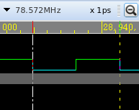

1. Count the number of pass and fail pattern after running fsim.

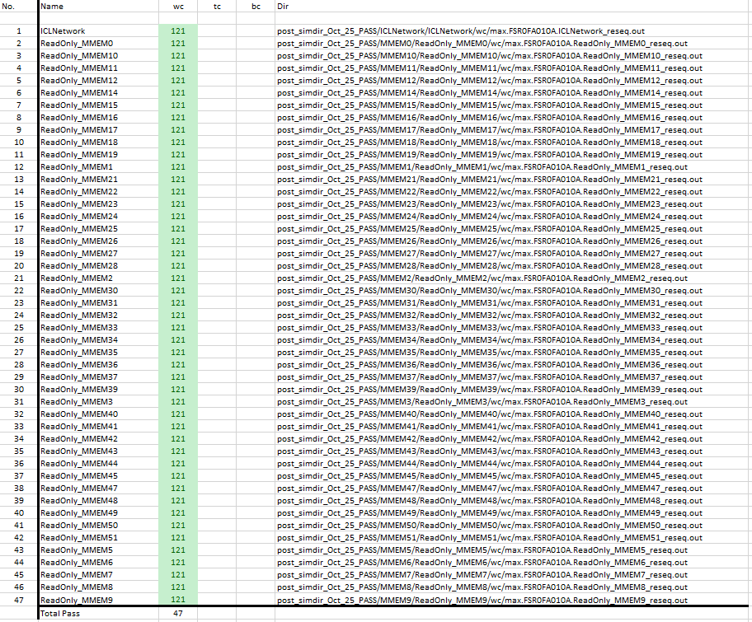

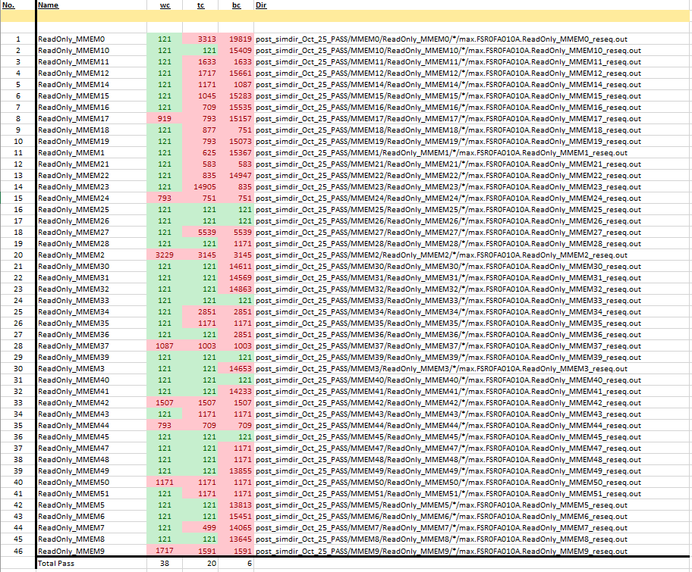

1. Different between DCO and PLL g

|  |  |
| --- | --- |
| DCO | PLL |
| DCO has generated frequency more unstable than PLL. | PLL has generated frequency more stable than DCO. |

# post simulation