|  |  |  |  |  |  |  |  |
| --- | --- | --- | --- | --- | --- | --- | --- |
| Name | Vance Hang | No. | T161 | Div/Dept | DSD/ACD/ACT | Job  Date：2024/05/27  Title | Intern |
| Please tick  the period | First Month | □W1 □ W2 □W3 □W4 | | | | | |
| Second Month | □W1 □ W2 □ W3 □W4 | | | | | |
| Third Month | □W1 🗹W2 □W3 □W4 | | | | | |

1. The weekly report aims to help accelerate member’s workspace integration and should be reviewed by mentor on the last working day of the week.
2. The new weekly report should be reviewed and signed by mentor and direct supervisor.

|  |  |  |
| --- | --- | --- |
| Work Experience Record | | |
| 1. Please describe the tasks and achievements you learned/executed :  All of the tasks I learned during this first week are based on the training plan of 2024, below are a brief description of the tasks and what I learned:   1. Gen SDF 2. Run STA 3. Run Post-layout sim | | |
| 2. What are the problems encountered this week? Any actions taken? Any help needed?   1. How to config setup.ftc file to run Post-layout sim | | |
| 3. What are the tasks for next week? Any preparation needed in advance? | | |
| Name  (Date) | Mentor | Direct Supervisor | |
| Vance Hang (2024/05/27) | Alden Duong (Signature/Date) | Xen Ha  (Signature/Date) | |

# Gen SDF

## Get netlist and spef data from PI

*/home/ftv_training/AC_training/Intern_Mar_2024/DataPI/06122023*

At beginning, we collect the post-layout netlist and spef data from PI. Then we run fsta to generate sdf.

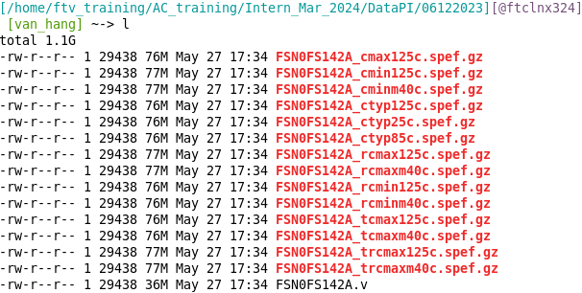

Inside the the *FSN0FS142A_cmax125c.spef.gz*

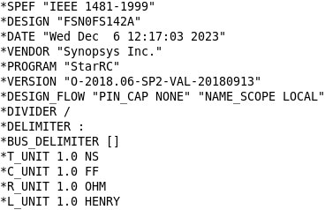 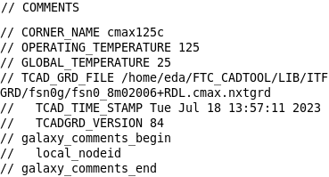

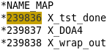 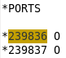   

## Generate SDF

*/home/ftv_training/AC_training/Intern_Mar_2024/Intern/Vance_Hang/FSN0FS142A/FE/Fsta/Post_STA/TDI_2705*

