**Vietnam General Confederation of Labor**

**TON DUC THANG UNIVERSITY**

**FACULTY OF INFORMATION TECHNOLOGY**



**FINAL REPORT**

**INTRODUCTION TO**

**MACHINE LEARNING**

**Question 1**

*Instructor*: **Ph.D LE ANH CUONG**

*Student*: **Ho Huu An – 521H0489**

*Class* **: 21H50301**

*Year* **: 25**

**HO CHI MINH CITY, 2023**

**Vietnam General Confederation of Labor**

**TON DUC THANG UNIVERSITY**

**FACULTY OF INFORMATION TECHNOLOGY**

**FINAL REPORT**

**INTRODUCTION TO**

**MACHINE LEARNING**

**Question 1**

*Instructor*: **Ph.D LE ANH CUONG**

*Student*: **Ho Huu An – 521H0489**

*Class* **: 21H50301**

*Year* **: 25**

**HO CHI MINH CITY, 2023**

ACKNOWLEDGEMENT

I would like to express my deep appreciation to Ph.D. Le Anh Cuong from Ton Duc Thang University for his invaluable assistance and guidance. His expertise in the field of machine learning has played a crucial role in shaping the direction of this project.

Ph.D. Le Anh Cuong's unwavering commitment to excellence and his openness to share his knowledge have greatly contributed to the success of this endeavor. His mentorship has not only improved my comprehension of utilizing machine learning algorithms and models but has also motivated me to explore new avenues in logic and machine learning deployment.

I sincerely thank Ph.D. Le Anh Cuong for his continuous encouragement and support, which have been pivotal in the completion of this project. His dedication to creating a conducive learning environment has been a source of inspiration, and I am grateful for the opportunity to work under his guidance.

*Ho Chi Minh city, 20th December, 2023*

*Author*

*(Sign and write full name)*

**

*Ho Huu An*

**THIS PROJECT WAS COMPLETED AT**

**TON DUC THANG UNIVERSIY**

I fully declare that this is my own project and is guided by Mr. Mai Van Manh; The research contents and results in this topic are honest and have not been published in any form before. The data in the tables for analysis, comments and evaluation are collected by the author himself from different sources, clearly stated in the reference section.

Besides that, the project also uses a number of comments, assessments as well as data from other authors, other agencies and organizations, with citations and source annotations.

**Should any frauds were found, I will take full responsibility for the content of my report.** Ton Duc Thang University is not related to copyright and copyright violations caused by me during the implementation process (if any).

*Ho Chi Minh city, 20th December, 2023*

*Author*

*(Sign and write full name)*

**

*Ho Huu An*

CONFIRMATION AND ASSESSMENT SECTION

**Instructor confirmation section**

_______________________________________________________________________________________________________________________________________________________________________________________________________________________________________________________________________________________________________________________________________________________________________________________________________________

*Ho Chi Minh December, 2023*

*(Sign and write full name)*

**Evaluation section for grading instructor**

_______________________________________________________________________________________________________________________________________________________________________________________________________________________________________________________________________________________________________________________________________________________________________________________________________________

*Ho Chi Minh December 2023*

*(Sign and write full name)*

SUMMARY

In machine learning model training, optimizers are algorithms used to adjust the model's parameters iteratively. They play a crucial role in minimizing the loss function. Commonly used optimizers include Stochastic Gradient Descent (SGD), Adam, RMSprop, and Adagrad. SGD is simple and efficient but can be noisy, while Adam combines adaptive learning rates and momentum for fast convergence. RMSprop and Adagrad also adapt the learning rates but in different ways. The choice of optimizer depends on the specific problem and the characteristics of the dataset.

Continual learning refers to the ability of a machine learning system to learn and adapt continuously over time, without forgetting previously learned knowledge. It addresses the challenge of retaining knowledge from previous tasks while accommodating new tasks or data. Techniques such as regularization, replay, and parameter isolation have been proposed to mitigate catastrophic forgetting and enable continual learning.

Test production, on the other hand, is a crucial step in building a machine learning solution for a specific problem. It involves designing and implementing a testing process to evaluate the performance and effectiveness of the trained model. This includes selecting appropriate evaluation metrics, preparing test datasets, and conducting rigorous testing to ensure the model's reliability and generalizability.

INDEX

ACKNOWLEDGEMENT i

CONFIRMATION AND ASSESSMENT SECTION iii

SUMMARY iv

LIST OF TABLES, DRAWINGS, GRAPHICS 3

CHAPTER 1 – OPTIMIZER 4

1.1 Gradient Descent 4

Advantages: 7

Disadvantages: 7

1.2 Stochastic Gradient Descent 7

Advantages: 9

Disadvantages: 9

1.3 Gradient Descent with Momentum 10

Advantages 11

Disadvantages 11

1.4 Nesterov accelerated gradient (NAG) 11

1.5 Adagrad 12

1.6 RMSprop 12

1.7 Adam 12

CHAPTER 2 – CONTINUAL LEARNING AND TEST PRODUCTION 13

2.1 Continual learning 13

Stateless retraining & Stateful training 14

How often to Update your models 15

2.2 Test production 15

Testing in Production Strategies 16

Shadow Deployment 16

LIST OF TABLES, DRAWINGS, GRAPHICS

**List of figures**

Figure 1: Derivative 4

CHAPTER 1 – OPTIMIZER

An optimizer is an algorithm used in machine learning that adjusts the parameters of a model to minimize the difference between predicted and actual outcomes, improving the model's accuracy.

* 1. Gradient Descent 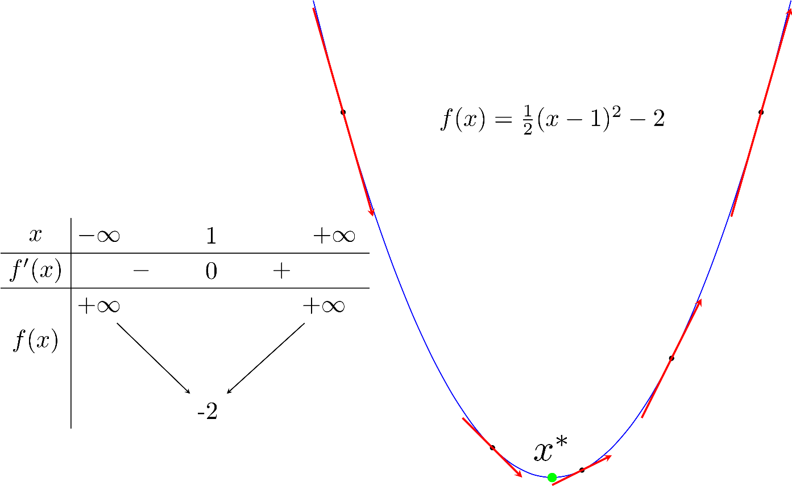

Figure : Derivative

Suppose xt is the point we find after the tth iteration. We need to find an algorithm to bring xt as close to x∗ as possible.

1. If the derivative of the function is at xt: f′(xt)>0 then xt is to the right compared to x∗ (and vice versa). To get the next point xt+1 closer to x∗, we need to move xt to the left, that is, to the negative side (and vice versa). In other words, we need to move the opposite sign of the derivative:
$$x_{t+1}=x_{t}+ ∆$$

2. The farther xt is from x∗ to the right, the larger f(xt) is than 0 (and vice versa). So, the amount of movement Δ, most intuitively, is proportional to −f′(xt).

The two comments above give a simple update:

xt+1=xt − ηf′(xt)

In which η (read as eta) is a number called learning rate. The minus sign shows that we have to go against the derivative

**Rule to remember**: always go in the opposite direction of the derivative.

Gradient descent depends on many factors: for example, choosing different initial x points will affect the convergence process; or the learning rate is too large or too small, it also has an impact: if the learning rate is too small, the convergence speed is very slow, affecting the training process, and if the learning rate is too large, it will quickly reach the target after a few minutes. However, the algorithm does not converge and loops around the destination because the jump is too large.

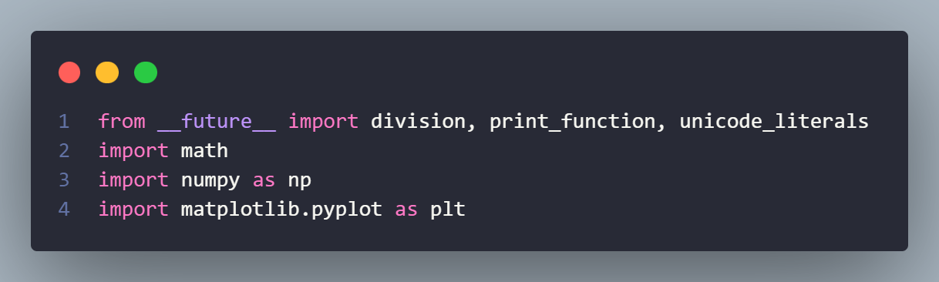Example:

Figure : Import Library for Gradient Descent Example Code

Consider the function f(x)=x2+5sin(x) with the derivative f′(x)=2x+5cos(x). Suppose starting from a certain point x0, at the tth loop, we will update as follows:

Xt+1=xt – η (2xt+5cos(xt))

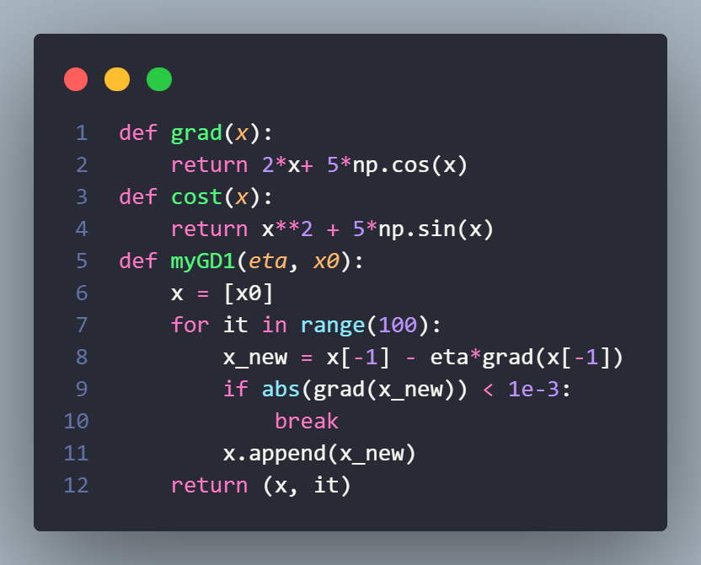‘grad’ to calculate the derivative

Figure : Functions for Gradient Descent Example Code

‘cost’ to calculate the value of the function. This function is not used in the algorithm but is often used to check whether the calculation of the derivative is correct or to see if the value of the function decreases with each iteration.

‘myGD1’ is the main part that implements the Gradient Desent algorithm mentioned above. The input to this function is the learning rate and the starting point. The algorithm stops when the derivative has a sufficiently small magnitude.

Figure : Test for Gradient Descent Example Code

Different starting points:

After having the necessary functions, I try to find solutions with different initialization points: x0=−5 and x0=5.

So with different initial points, our algorithm finds nearly the same solution, although with different convergence rates.

Output:

Solution x1 = -1.110667, cost = -3.246394, obtained after 11 iterations

Solution x2 = -1.110341, cost = -3.246394, obtained after 29 iterations

The choice of learning rate is very important in practical problems. Choosing this value depends heavily on each problem and requires some experiments to choose the best value. In addition, depending on some problems, GD can work more effectively by choosing an appropriate learning rate or choosing a different learning rate in each iteration.

Advantages:

Simple gradient descent algorithm that is simple to grasp. By adjusting the weights after each loop, the technique solves the challenge of optimizing the neural network model.

Disadvantages:

The Gradient Descent method has various disadvantages due to its simplicity, such as relying on the initial initial solution and learning rate.

As an illustration, a function with two global minimums will give two distinct final solutions depending on the two original beginning points.

A big learning rate will cause the algorithm to fail to converge and linger about the target due to the large leap; a modest learning rate will effect the training pace.

* 1. Stochastic Gradient Descent

Gradient Descent is a variant of Stochastic. Instead of updating the weight once after each epoch, we will update the weight N times in each epoch using N data points. On the one hand, SGD will drop the pace by one epoch. Looking in the opposite way, SGD will converge quite fast after only a few epochs. The SGD formula is similar to the 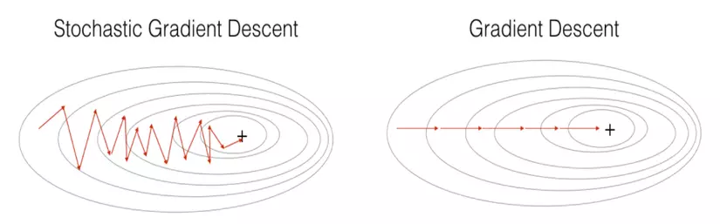GD formula, however it is applied to each data point.

Figure : Compare Stochastic Gradient Descent vs Gradient Descent

Looking at the image above, we can observe that SGD has a more zigzag course than GD. It's simple to grasp since one data point cannot represent all of the facts. Because GD has limits for big datasets (several million data points), computing the derivative on the full data set over each loop becomes tedious. Furthermore, education is not suited to online learning. When data is regularly changed (for example, by adding registered users), we must recalculate the derivative on the full data set, resulting in a long computation time and the method no longer being online. As a result, SGD was created to address this issue, because each time new data is supplied, only one data point needs to be modified, making it ideal for online learning.

For example, with 10,000 data points, we may acquire a satisfactory solution within only 3 epochs, but with GD, we must spend up to 90 epochs to reach the same result.

Return back example in Gradient Descent:

Figure : Example about Stochastic Gradient Descent

Advantages:

The algorithm has the ability to handle big databases that Gradient Descent does not. This optimization technique is still widely employed today.

Disadvantages:

The algorithm has not yet solved the two major disadvantages of gradient descent (learning rate, initial data points). Therefore, we have to combine SGD with some other algorithms such as Momentum, AdaGrad, etc.

* 1. Gradient Descent with Momentum

The GD algorithm is often compared to the effect of gravity on a marble placed on a surface shaped like a valley like figure 1a) below. Regardless of whether we place the marble at A or B, the marble will eventually roll down and end up at position C.

Figure : Compare Gradient Descent with physical phenomena

Nevertheless, if the surface contains two valley bottoms, as illustrated in Figure b), the eventual location of the ball will be C or D, depending on whether it is put at A or B. Point D is an unexpected local minimum point.

If we consider more physically, still in Figure b), if the starting velocity of the ball at point B is big enough, the ball can continue to go up the slope to the left of D when it rolls to point D. If the starting velocity is increased, the ball can move uphill to point E and subsequently downhill to point C, as shown in Figure c). This is just what we desire.

Based on this phenomenon, an algorithm was created to overcome the problem of GD's solution falling into an undesirable local minimum point. That algorithm is called Momentum

**Express momentum mathematically**

In Gradient Descent, we need to calculate the amount of change at time t to update the new position of the solution (ie the marble). If we think of this quantity as the physical velocity vt, the new position of the marble will be θt+1=θt−vt. The minus sign represents having to move against the derivative. Our job now is to calculate the quantity vt so that it both carries information about the slope (ie the derivative) and also carries information about the momentum, which is the previous velocity vt−1 (we consider the initial velocity v0=0). In the simplest way, we can add (weight) these two quantities:

vt = γ vt−1 + η∇θJ(θ)

In which γ is usually chosen as a value of about 0.9, vt is the velocity at the previous time, ∇θJ(θ) is the slope of the previous point. Then the new position of the marble is determined as follows: θ = θ − vt

This simple algorithm proves to be very effective in practical problems (in high-dimensional space, the calculation method is completely similar).

Advantages

Gradient Descent, the best solution, addresses the problem by stopping at the local minimum rather than the global minimum.

Disadvantages

Although momentum helps the marble move upward towards the target, it still takes a long time to oscillate back and forth before halting fully, which is explained by the marble's momentum.

* 1. Nesterov accelerated gradient (NAG)

Momentum helps the marble overcome the locaminimum slope, however, there is a limitation we can see in the example above: When approaching the destination, momemtum still takes a lot of time before stopping. The reason is also because there is momentum. There is another method that further helps overcome this, a method called Nesterov accelerated gradient (NAG), which helps the algorithm converge faster.

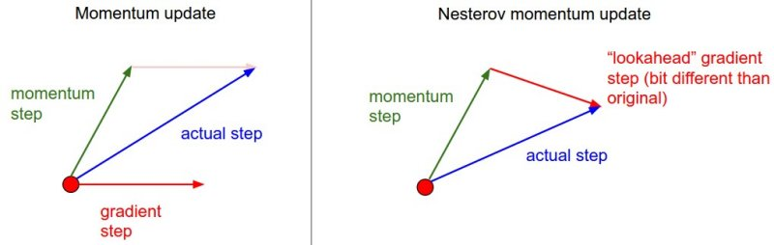The basic idea is to predict future direction, which means looking one step ahead! Specifically, if we use the momentum term γ vt−1 to update, we can approximate the marble's next position as θ −γ vt−1 (. So, instead of using the gradient of the current point, NAG go one step ahead, use the gradient of the next point. Follow the image below:

Figure : Nesterov's idea is accelerated gradient

* With normal momentum: the amount of change is the sum of two vectors: momentum vector and gradient at the present time.
* With Nesterove momentum: the amount of change is the sum of two vectors: the momentum vector and the gradient at the time that is approximated as the next point

NAG's updated formula is given as follows:

vt= γ vt−1 + η ∇ θ J(θ – γ vt−1) θ = θ − vt

* 1. Adagrad

* 1. RMSprop
  2. Adam

CHAPTER 2 – CONTINUAL LEARNING AND TEST PRODUCTION

1. Continual learning

The concept of continuous learning is to update your model as new data becomes available, allowing your model to stay up with the current data distributions.

Once your model is updated, it cannot be blindly released to production. It needs to be tested to ensure that it is safe and that it is better than the current model in production. This is where the next section "Testing Production" comes in.

**Continual learning is frequently misunderstood:**

* Continual learning does not refer to a special class of ML algorithms that allow for incremental update of the model when every single new datapoint becomes available. Examples of this special class of algorithms are sequential bayesian updating and KNN classifiers. This class of algorithms is small and is sometimes referred to "online learning algorithms".
* Continual learning does not mean starting a retraining job every time a new data sample becomes available. In fact this is dangerous, because it makes neural networks susceptible to catastrophic forgetting.

The primary purpose for this is to assist your model in keeping up with changes in data distribution:

* Use cases in which unexpected and rapid changes can happen.
* Use cases in which it is not possible to get training data for a particular event. An example of this are e-commerce models in Black Friday or some other sale event that has never been tried before. It is very hard to gather historical data to predict user behaviour in Black Friday, so your model must adapt throughout the day.
* Use cases that are sensitive to the cold start problem. This problems happens when model has to make predictions for a new (or logged out) user that has no historical data (or data is outdated).

Stateless retraining & Stateful training

Figure : Stateless retraining VS Stateful training

Stateless retraining

Retrain model from scratch each time, using randomly initialised weights and fresher data.

* There might be some overlap with data that had be used for training previous model version.
* Most companies start doing continual learning using stateless retraining.

Stateful training

Initialise model with the weights from the previous training round and continue the training using new unseen data.

* Allows your model to update with significantly less data.
* Allows your model to converge faster and use less compute power.

How often to Update your models

The first need to understand and determine what is the gain we get when we update model with fresh data. The more the gain, the more frequently it should be retrained.

Measuring the value of data freshness: One way to quantify the value of fresher data is to train the same model architecture with data from 3 different periods of time and then testing each model against current labelled data

If you discover that letting the model stale for 3 months causes a 10% difference in the current test data accuracy, and 10% is unacceptable, then you need to retrain in less than 3 months.

Figure : Train model on data from different time windows in the past and test on data from today

1. Test production

To sufficiently test your models before making them widely available you need both pre-deployment offline evaluations AND testing in production. Offline evaluations alone are not sufficient.

Each team should ideally spell out a clear pipeline for how models are reviewed, including which tests to run, who performs them, and the criteria that apply to advance a model to the next level. It is preferable if these assessment processes are automated and started whenever a new model update is released. The stage promotions should be assessed in the same way that CI/CD is in software engineering.

Testing in Production Strategies

Shadow Deployment

Intuition: Deploy the challenger model in parallel with the existing champion model. Send every incoming request to both models but only serve the inference of the champion model. Log the predictions for the both models to then compare them.

Advantages:

* This is the safest way to deploy your models. Even if your new model is buggy, predictions will not be served.
* It is conceptually simple.
* Your experiment will gather enough data to achieve statistical significance faster than all other strategies as all models receive full traffic.

Disadvantages:

* This technique can't be used when measuring model performance depends on observing how the user interacts with the predictions.
* This technique is expensive to run because it doubles the number of predictions and therefore the number of compute required.

A/B Testing

Intuition: deploy the challenger model alongside the champion model (model A) and route a percentage of traffic* to the challenger (model B). Predictions from the challenger are shown to the users. Use monitoring and prediction analysis on both models to determine if the performance of the challenger is statistically better than the champion.

Advantages:

* Since predictions are served to users, this technique allows us to fully capture how users are reacting to different models.
* A/B testing is simple to understand and there are a lot of libraries and documentation around it.
* It is cheap to run because there is only one prediction per request.
* We won't need to consider the edge cases that arise from parallelising inference requests for online prediction modes.

Disadvantages:

* It is less safe than shadow deployments. We want some stronger offline evaluation guarantee that your model will not miserably fail since you will be putting real traffic through it.
* We have an inherent choice to make between assuming more risk (routing more traffic to the B model) VS gaining enough samples to make an analysis faster.