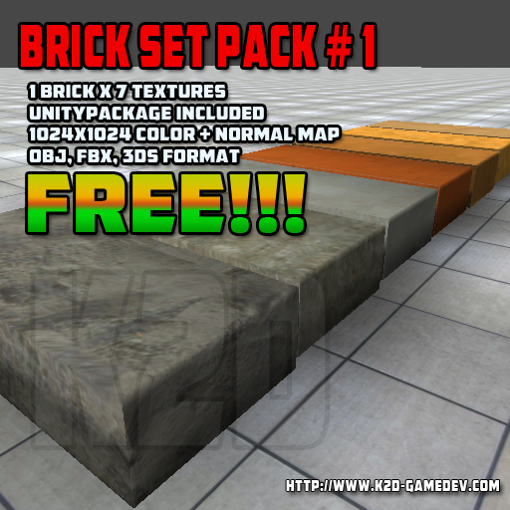
Thank you for downloading our FREE Brick Pack Set.
Come and visit our marketplace for more Freebies.
Enjoy..

Website : http://k2d-gamedev.com
Contact No. : +639093323347 / +639481414615

PRODUCT DETAILS:
Model Name : Brick Pack Set
Price : FREE
  - Model Format : 3ds, fbx , obj
  - Textured : Yes
  - Normal Map : Yes
  - Texture Size : (1024×1024) x 7 Textures
  - Texture Format :JPG
  - Unitypackage : Included

Use License Agreement
The products contained herein owned by K2D Game Development Team. K2D Game Development Team grants to you a perpetual, worldwide, non-exclusive, non-assignable, non-transferable license to use the products. This license is valid only with respect to the products and only if you have paid the applicable fee or the author allows you to do so. This use license agreement applies to both free and paid version of our products. We have the rights to terminate or revoke your license if you have violated these terms and condition at any time. You can or permitted to use the product:
  - For personal or commercial use.
  - For advertising or promotional use.
  - For website or in any electronic devices.
  - In broadcast, multimedia, video games or animation.
  - In books, or magazines.
  - You products may be modified for individual style and appearance.

You are not permitted or allowed to:
Market, distribute, give, transfer, sell or sub-license the products in any form with the exception of a compiled application such as a video game.
K2D Game Development Team doesn’t provide any physical product. All products from our website are digital and downloadable only.

