# Title Page:

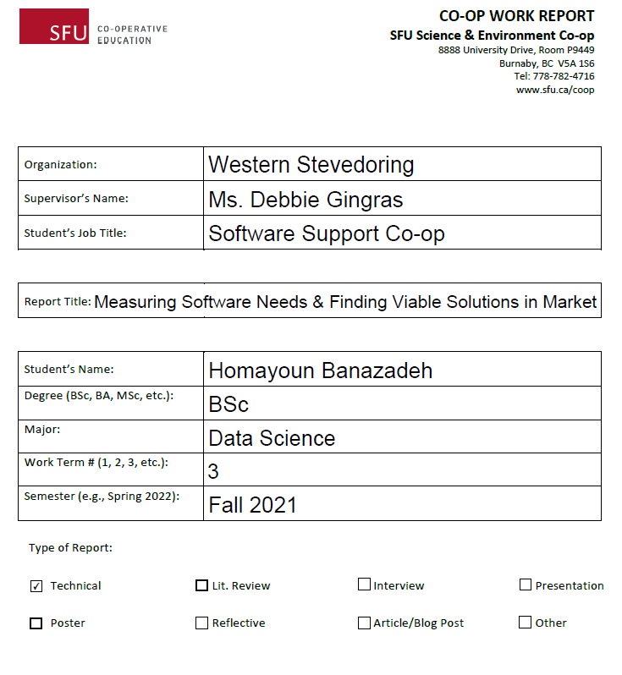

# Summary:

My co-op semester consisted of two main roles: Software Support and Business Intelligence Support. As a Software Support persona, main task was to gather requirements from different teams within the organization and research the market to find a group of affordable solutions that met most of the requirements and move forward by holding vendor demos where the vendors would present to a group of staff and the staff would rate them based on a pre-defined scoring criterion. It was also part of the job to create a scoring criterion that every stakeholder would agree with and present it to them before vendor demos. Once the demos were completed, my task was to compile the data into a final recommendation document and present it to stakeholders. When conducting product research, there were multiple organizations that would be a fit and the task required attention to details to see how the vision the stakeholders had matched with the product.

As a Business Intelligence persona, I was helping to enhance another co-op student’s project to create Power BI reports from various sources. One of the main tasks was to create a specific report that required Excel data. The data was not at all in a shape suitable for report generation so that required creating a data manipulation script in Python that would run automatically on everyday basis and take the Excel data and transform it to a usable format and save it on database. The task of creating the data manipulation script sharpened my data skills and understanding of Pandas package in Python (pandas: powerful Python data analysis toolkit, n.d.), while the task of teaching my code to other IT team members helped to bring consolidation to my code understanding and improved my communication skills.

Mentioned in my goal setting document, my main goal for my co-op term was to improve my communication skills and build trust with my co-workers, and I think the fact that my co-op term was in person helped a lot to get to know my colleagues individually and the discipline to have to go to work early morning everyday brought a head start to my days and made brought me the reality of workplace to get the job done throughout the rest of the day. Specifically, daily meetings with my mentor and director of IT team helped me to stay on track and their guidance helped me to know that I was doing alright, and I believe that is the most important aspect of any type of job.

# Table of Contents:

Title Page: 1

Summary: 2

Table of Contents: 3

Introduction: 4

Discussion: 6

Conclusions: 7

Recommendations: 8

References/Bibliography: 10

# Introduction:

Every team in each company has different software needs, and IT team should be ready to help and maintain a smooth communication between that team and software selling companies. If IT team is way too involved and completes the research without connecting to stakeholders, the product they find might be suitable for them, will most likely not be suitable for stakeholders. On the other hand, if IT team is too much reliant on stakeholders’ decisions, they might end up selecting a solution that looks good but might come with huge technical issues that are only going to be discovered once the software is already implemented, and at that point it might be too late to change their decision.

As of Software Support part of my job, I was tasked with finding a solution for Health & Safety team to support electronification of Audits and online training management system. Upon looking at viable solutions using the Quadrant Health & Safety 2019 (Quadrant, 2019) report, it became clear that from a couple dozen companies there, almost all of them had more than enough features to meet our requirements. Therefore, the main challenge was not finding a solution that had sufficient features, rather it was about their pricing models. One of the observations was that none of these companies ever openly showcased their pricing on their website. However, the fastest way to learn about it was leaving them a message and then letting them call us. Occasionally, I would encounter some companies that were highly reluctant to discuss their prices even after hours of demo, and they were seeking to talk with upper management, but I was informed that they would need to go through me to get to talk with upper management during vendor demos. The main challenge was that as I dived into more and more companies, I found lots of companies to have Transactional pricing model (Marn, 2003), which is a model that depending on its’ complexity. The price might depend on number of users, modules, admins, times for maintenance, or a combination of all of these. It might not sound realistic, but sometimes analyzing some of these models would take many days and a full report by itself.

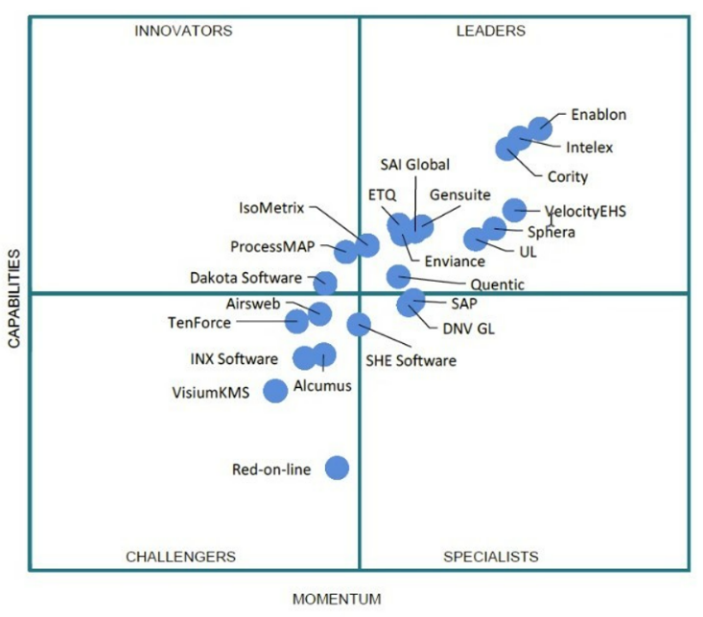

# Discussion:

As for one of the candidates, I was tasked with creating Potential Cost Case Analysis (Thakur, n.d.) and a calculator in excel to calculate the price over time. It was a complex task because even though we had an approximate for the number of current users, we did not know exactly how this number was going to change in the future. That was because it was possible for other teams other than Health & Safety to become interested in using it, or a sister company who we are mergers with might have shown interest in using the software for their own benefits. The problem aroused when I created that calculator, analyzed possible scenarios and realized with transactional model, the pricing for our truckers’ online courses would be astonishing. I communicated the results first with my managers and on the same day, I also mentioned to vendor representative that this is going to cause a problem. As a result, they came up with a hybrid model that would use fixed per year costs for truckers and transactional pricing for other modules.

After analysis I realized, this pricing is going to within our budgeting range, however, at that point my mangers had become sceptical towards this company and the complication of their pricing model. I learnt a lot from this experience because I realized my managers act based upon their intuition and a few principles that hold true in general. One of the principles was that if something is too complicated to understand, then we normally get skeptical towards its’ accuracy. That principle held true for that specific pricing model. Even though I dived in and did so much analysis, then contacted them so to get a better offer for their pricing, I did not realize how “non-straight forward” their pricing was. I would often feel overwhelmed, a bit disappointed and would start diving deeper and deeper to gain a better understanding, and finally when I understood how it all works for our status, I learnt from my managers that we are not sure how the future is going to look like, and we are still going to consider them, however, we better not continue to favour them because of their pricing.

# Conclusions:

Just like any other company, my managers were extremely busy with handling too many tasks at the same time. Sometimes I would imagine they are overwhelmed with how much they must do in each day, and the last thing I wanted was to be a burden for them or overtalk during our meetings. What I learnt from them was that they would like to see numbers and come to decisions quickly. They would change their decisions if required later, however, they were talented in seeing the big picture of how something works and make a data driven decision based on current information and previous experiences. That is what they saw in that company and interestingly I was personally feeling we should pursue with that company because I had done so much research, found out every possibility of combining their pricing and had built a connection with their representative, however, later when I was reflecting on my own work, I realized what my managers think makes so much sense. In fact, that company had such complicated pricing model and no other company I ever analysed had that, hence, brought up the question what might have been their intention for creating such hard-to-understand pricing model.

# Recommendations:

My main recommendation is to listen to what others have to say actively (Lyon, 2020), but always having ones’ own agenda about how the process should look like.

Active Listening in a nutshell is about:

1. Commit, make the conscious decision of making the conversation a priority. Relax, breath, slow down, and take your time.
2. Practice - keep making the attempt whenever engaging in conversations.
   1. Non-Verbal Communication, show non-verbally you're listening no distractions. Pay attention to what Non-Verbal cues they're giving you while talking.
   2. Verbal communication, ask a good question, after stop and listen to their response. Using Small utterances - shows and keeps you engaged. Saying a word or two - "yeah" or "I hear you". Doesn't have to be full words, "mm", "ahh".
3. Responding to what someone said - A. You ask a Question, B. They Respond (don't interrupt), C. Informed responds. Show them they've been heard. This can be by asking another question and/or reflecting back what you heard.
4. Keep the focus on them & Let them Talk - make the decision it is about them talking, resist the temptation to jump in. Keep your comments or questions concise. Stick to whatever topic they're interested in. Keep half of the conversation about them.

Having one’s own agenda is about:

It does not mean being an unagreeable individual and failing to obligate with what superiors have suggested, but it means taking notes from what they have mentioned, process the information in one’s own mind, understand what their motivations and concerns are, and creating a mind map, in other words a process that contains all they have mentioned but is built to work for one’s own thinking model. If a person is only listening and doing what is told to him, it will be hard for him to take the initiative, work outside of the box, and in some cases multiple people might mention different ideas to him and he will be unable to decide which one to move forward with. Doing the work means that the person has created that mind map (What is a Mind Map?, n.d.) and he is communicating the progress and new events on everyday basis to his managers to get their feedback and apply them, hence goes the next point.

Here is the process to create a mind map (What is a Mind Map?, n.d.):

1. The main idea, subject or focus is crystallized in a central image.
2. The main themes radiate from the central image as 'branches'.
3. The branches comprise a key image or key word drawn or printed on its associated line.
4. Topics of lesser importance are represented as 'twigs' of the relevant branch.
5. The branches form a connected nodal structure.

Next recommendation is finding a balance between asking for help and being independent (Stieg, 2021). Someone who always asks for help is perceived to not think thoroughly on his own, while someone who never asks for help is perceived to have a high ego and often will go in a direction that might be suitable for him, but it is not at all what his superiors ever envisioned. It all starts with a gut feeling that we need some help, or we are stuck somewhere, however, we are not able to put it in words how it is that we are stuck. Usually, it is between a couple of options to choose from, and the choice is impossible because we do not have enough context, or sometimes we are totally new to a field, and we need a few examples to know how other people have completed a certain task. There might be a temptation to not ask for help because it shows that we are not sensible and our concern is not important, however, if we write down what it is that is bothering us, often we are able to frame it in our own mind and then get mentorship from others.

Last recommendation is to have a check list (The ultimate guide to creating a checklist, n.d.) of what needs to be done in each day. It stems from the mind map mentioned earlier. My co-op colleague thought this to me. We would take our time in each day to breakdown the job and create a few small tasks for ourselves and that would help a lot when communicating with our managers later that day. Also, marking those tasks would create a positive feeling that would guide us to move forward the next day.

# References/Bibliography:

Lyon, A. (2020). *YouTube*. Retrieved from Active Listening Skills: https://www.youtube.com/watch?v=7wUCyjiyXdg&t=2s

Marn, M. V. (2003). *THe Power of Pricing*. Retrieved from Mckinsey Quarterly: https://www.mckinsey.com/business-functions/marketing-and-sales/our-insights/the-power-of-pricing

*pandas: powerful Python data analysis toolkit*. (n.d.). Retrieved from pypi.org: https://pypi.org/project/pandas/

Quadrant, G. (2019). *Green quadrant EHS software 2019*. Retrieved from wolterskluwer: https://www.wolterskluwer.com/en/expert-insights/green-quadrant-ehs-software-2019

Stieg, C. (2021). *Everyone needs help during the coronavirus pandemic—here’s the psychological reason why asking for it is so hard*. Retrieved from cnbc: https://www.cnbc.com/2020/04/22/why-asking-for-help-is-so-hard-and-how-to-get-better-at-it.html

Thakur, M. (n.d.). *What If Analysis in Excel*. Retrieved from Educba: https://www.educba.com/what-if-analysis-in-excel/

*The ultimate guide to creating a checklist*. (n.d.). Retrieved from canva: https://www.canva.com/learn/ultimate-guide-creating-checklist/

*What is a Mind Map?* (n.d.). Retrieved from MindMapping.com: https://www.mindmapping.com/mind-map