Mã giả:

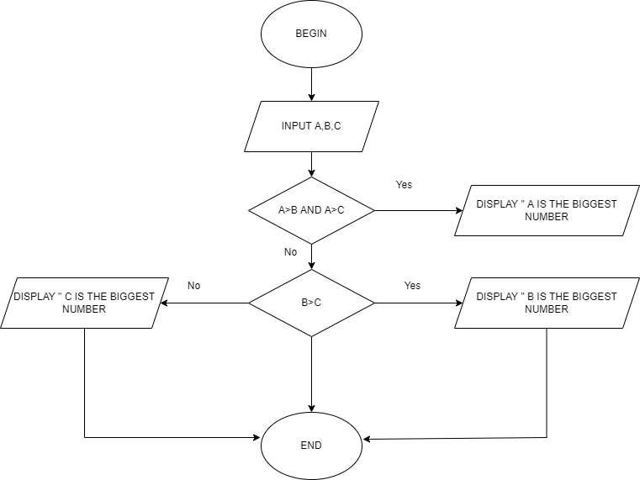

BEGIN

INPUT A,B,C

IF A > B AND A> C

DISPLAY “ A IS THE BIGGEST NUMBER”

END IF

IF B > C

DISPLAY “ B IS THE BIGGEST NUMBER”

ELSE

DISPLAY “ C IS THE BIGGEST NUMBER”

END IF

END