**Pseudo-code**  **Flowchart**

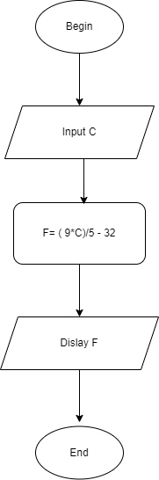Begin  
    Input C  
    F = (9*C)/5 + 32  
    Display F  
End