1. Class Diagram in Analys

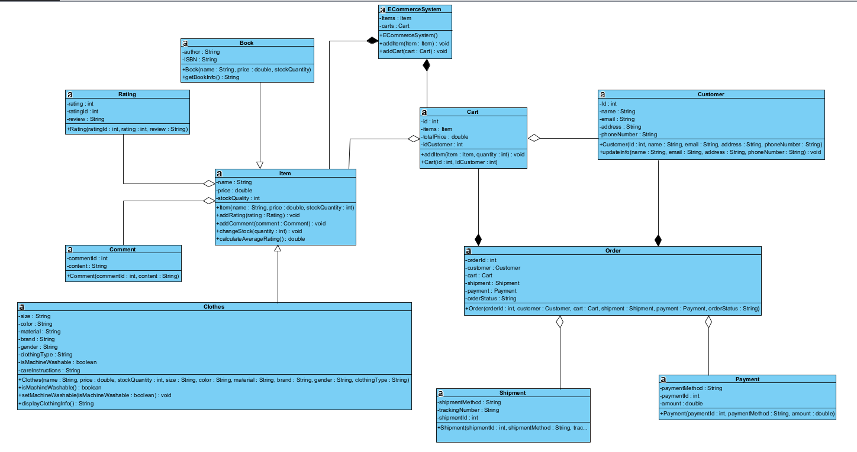

1. DAO, MVC Layers

Class Diagram in Design

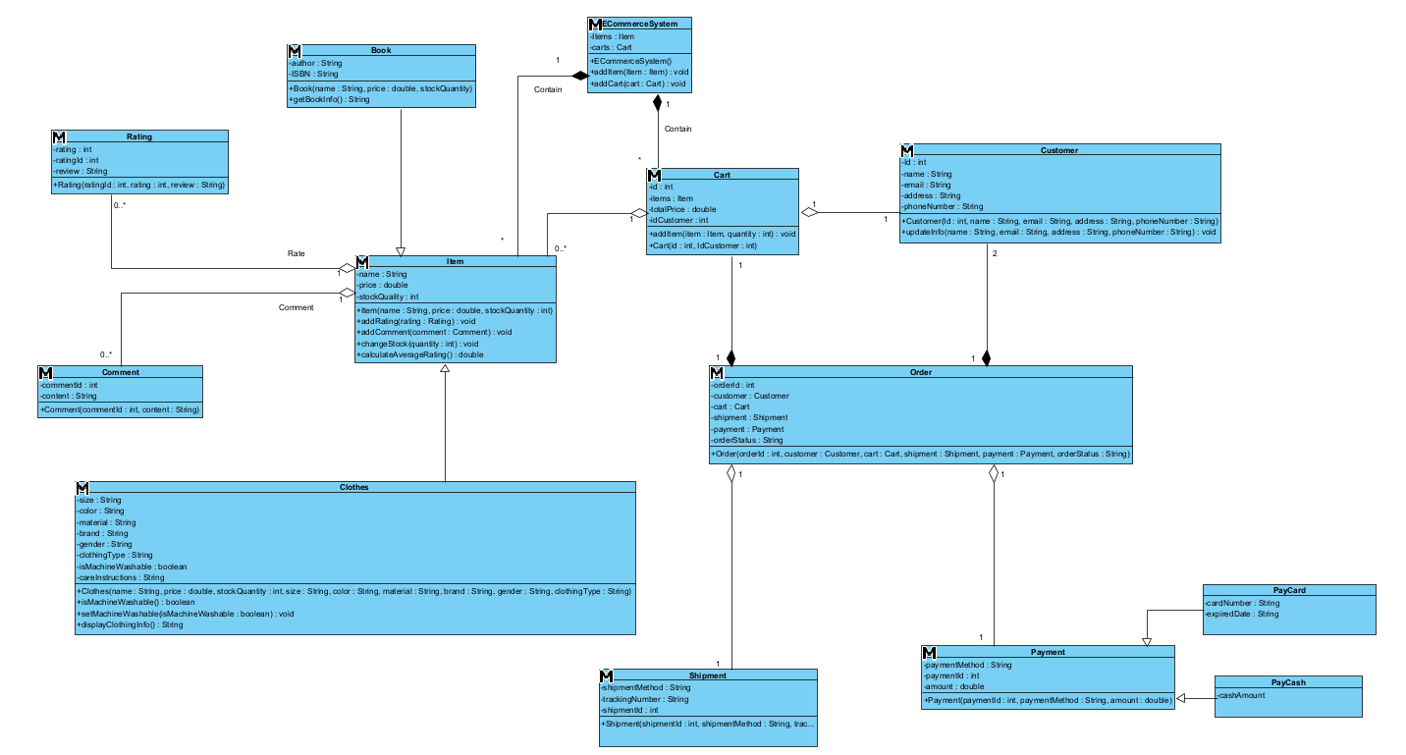

DAO, MVC LAYER

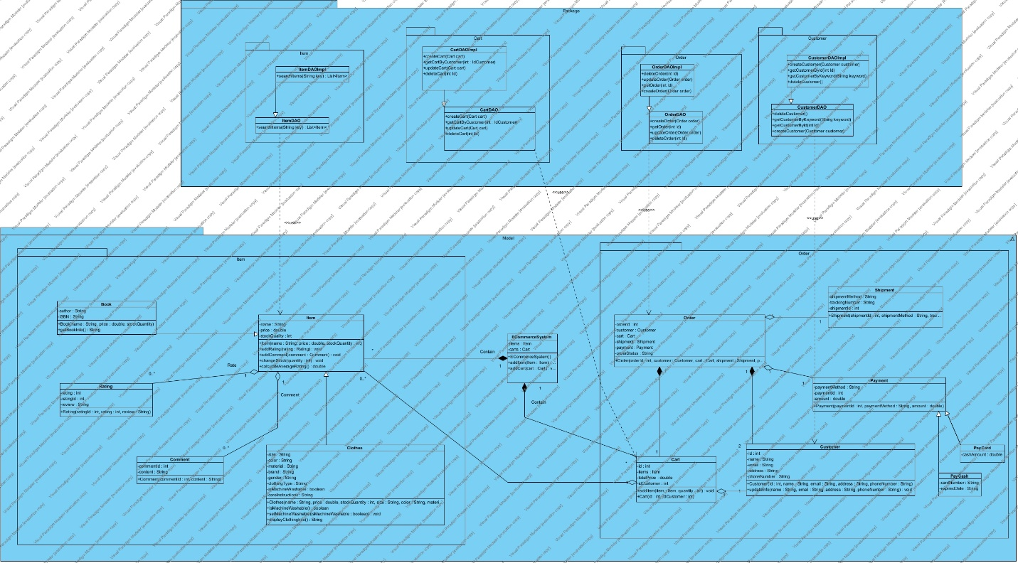

1. Add function search to select item and add to Cart. Select payPal to process payment; select drone to simulate shipping

