**Professor: Kadeem Best**

WEB322 Assignment03-5

Thi Phuong Hoa Nguyen

MAIN CONTENTS

**Assignment 3**

Application Architecture

User Registration Module

Authentication Module

**Assignment 4**

Inventory Clerk Module

Search Module

**Assignment 5**

Product Description Page

Shopping Cart Module

Link: <https://web322testing35.herokuapp.com/>

<https://github.com/HoaNguyen1202/Web322Assignment2Submit>

Note: Email for testing **Inventory Clerk Module**

Email: [Clerk@gmail.com](mailto:Clerk@gmail.com)

Password: 123456

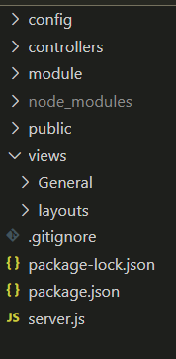**Assignment 3**

## **Application Architecture**

1. My application **MUST** be structured **FULLY** according to the MVC Design pattern
2. **All** sensitive credential information **must** be stored in **environment variables**

## **User Registration Module**

Validation for registration form :

* 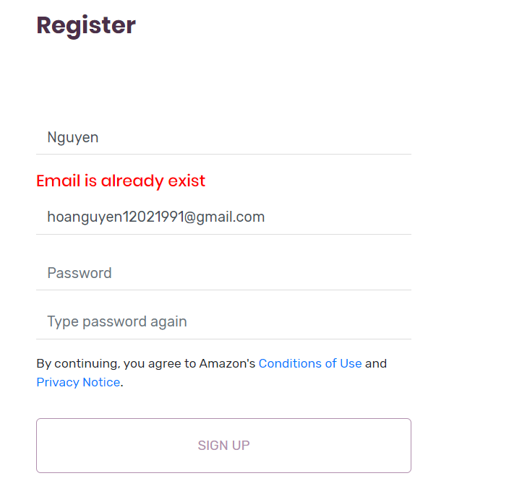User must entere name, email, password at least 6 to 12 characters and have letters and numbers only
* Password again must be match
* The email field in the registration form **is** **unique**
* 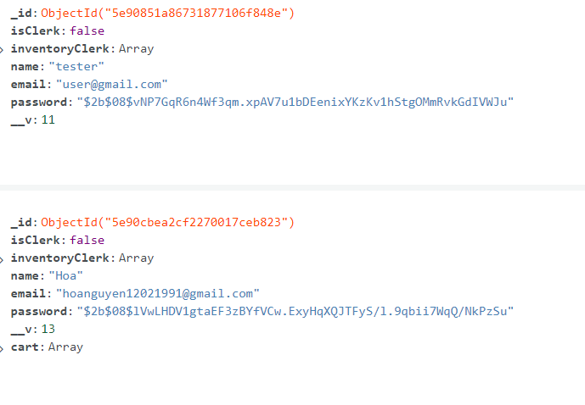Passwords **must not** be stored in plain

text in the database, thus my application

must store passwords in an encrypted format

## **Authentication Module**

* My application allow an Inventory Clerk and regular users, i.e, customers who want to purchase products, to **log-in via the login form created.**
* Upon an unsuccessful authentication, the application **must** display an message

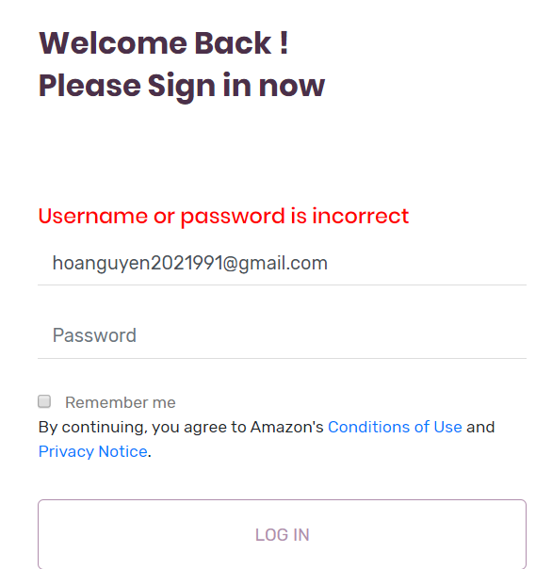

* Upon a successful authentication **a session must be created to maintain the user state until they have logged out of the application.**

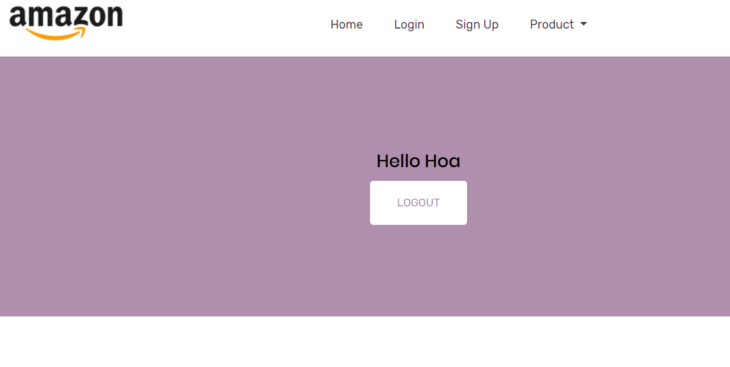

* A regular user will be directed to a user dashboard <https://web322testing35.herokuapp.com/login/cart>
* An inventory clerk will be directed to an inventory clerk dashboard.

<https://web322testing35.herokuapp.com/login/clerk>

Note : in my application, an inventory clerk will be a clerk if I set “isClerk” in my database is “true” to become a clerk in my database.

To test functionality of an inventory, I will give email and password for you do this

Email: [Clerk@gmail.com](mailto:Clerk@gmail.com)

Password: 123456

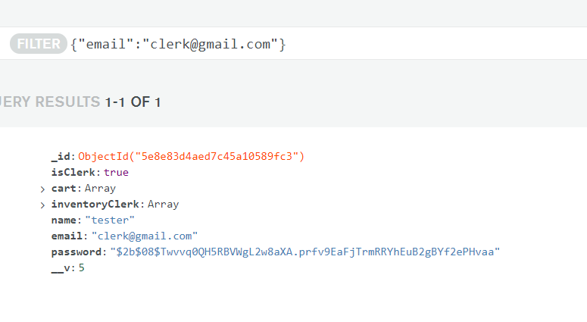

* The logout link must destroy the session created when the user initially authenticated.

Assignment 4

## **Inventory Clerk Module**

1. The Inventory Clerk must be able to add products to the database. Regular users cannot add product unless my permission.

To test how it works, you use email and password below

Email: [Clerk@gmail.com](mailto:Clerk@gmail.com)

Password: 123456

Here, a clerk will click “Add Product”

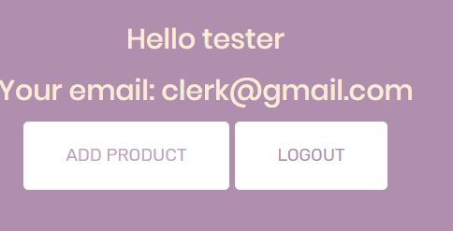

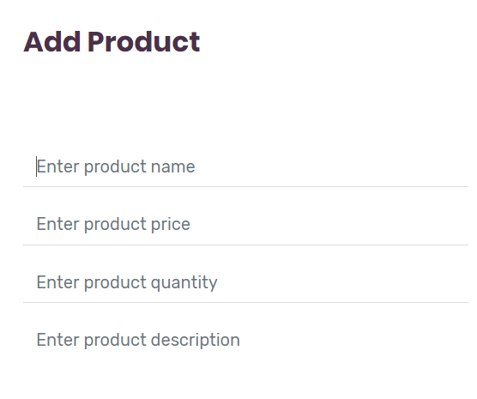

-

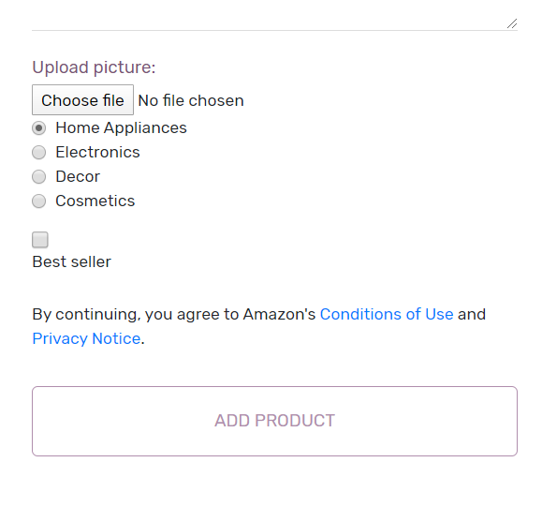

* A clerk can only upload an image, i.e jpgs,gifs,pngs, for the product photo and litmit size for upload is 5*1024*1024.
* After uploading the product will be showed on its category, and only products that were set as “**Best Sellers**” should be populated in the “**Best Seller”** section of the home page
* View a list of all created products.

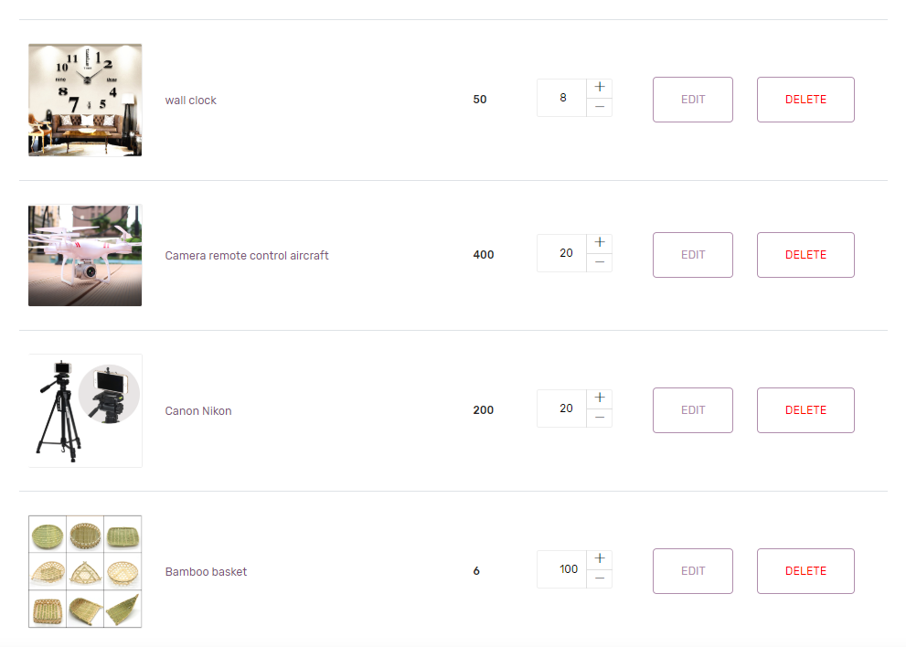

* Edit and change product details for a selected product

## **Search Module**

* This can be easily implemented by having a drop down list of your product categories and a search button.

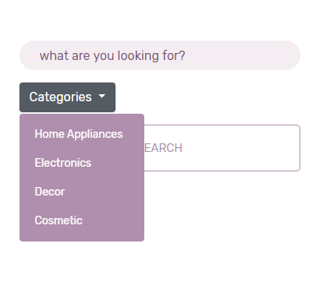

* User can search for any two characters contiguous in product name
* product_name: { $regex: `.*${*req*.body.product_name}.*`, $options: 'i' }

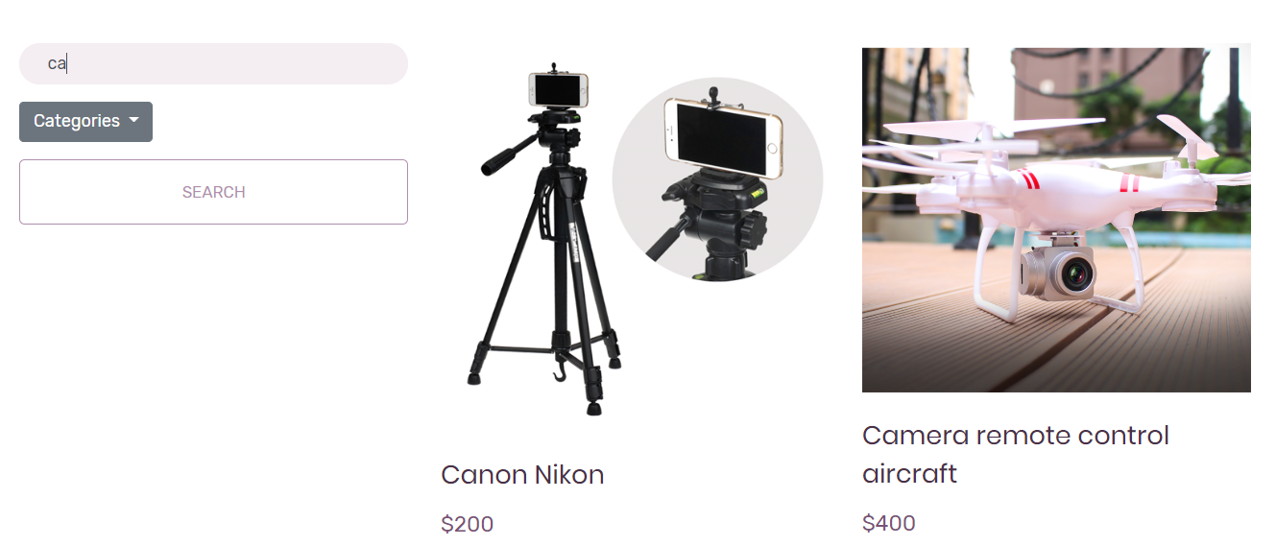

Assignment 5

## **Product Description Page**

* Only logged in users should be able to “purchase” products by adding selected products to their shopping cart.
* From the product listing page, when a user clicks on a particular product, they should be navigated to the **Product Description page** of the clicked product and from that page they can add the product to their shopping cart.

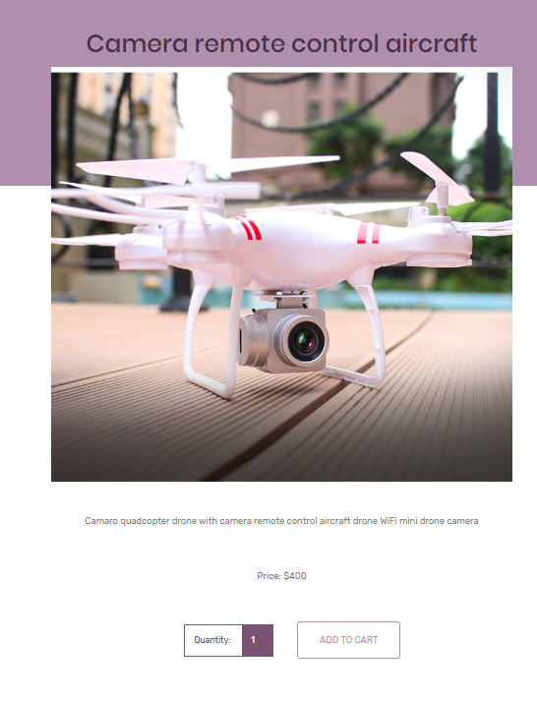

* If I enter quantity more than quantity in my database, it will notify 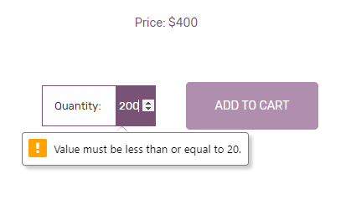
* This page must display all the products that were added to the shopping cart and how much of each product was added for the given user. Also, the page should have a “Proceed to checkout” button.

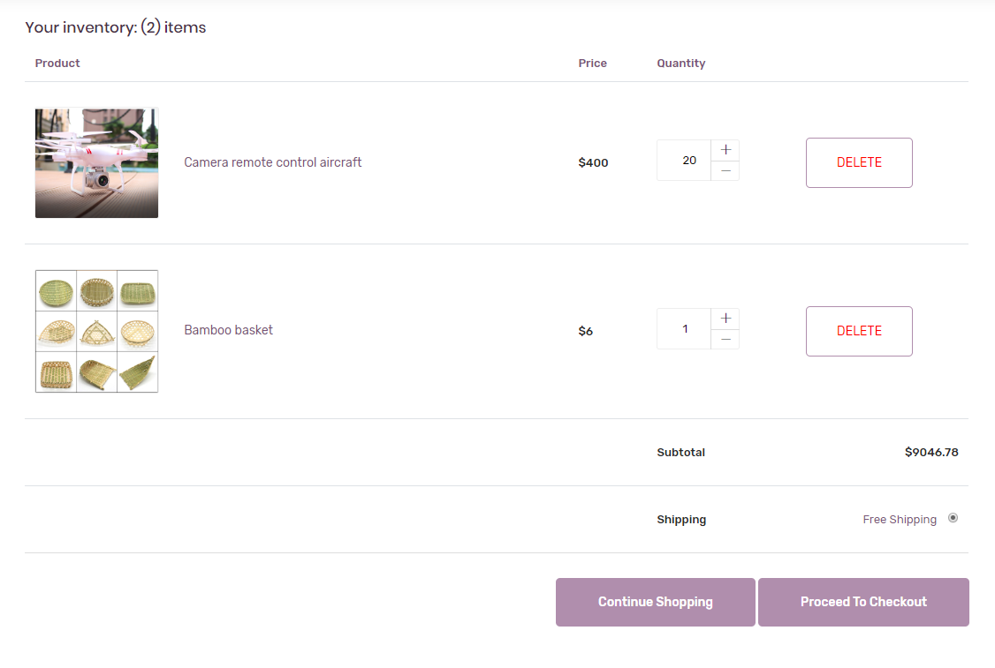

When the “**Proceed to checkout”** button is pressed, my web application should “clean” users shopping cart, send an email to the logged in user’s email, indicating all the products purchased and the quantity amount for each product purchased as well as the user’s order total.

