Nguyễn Văn Hoàng20106371

20106371

Lab2

Jquery

Get user

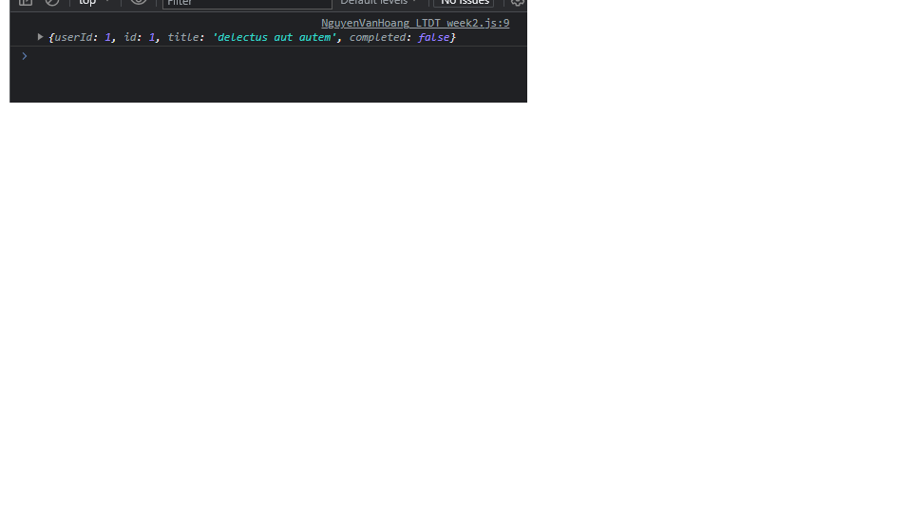

XmlHttpRequest

Get all user

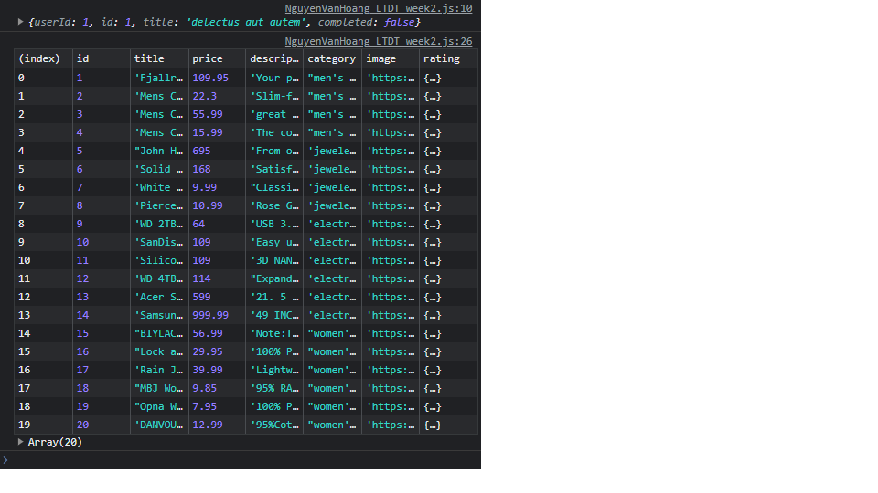

Get a user

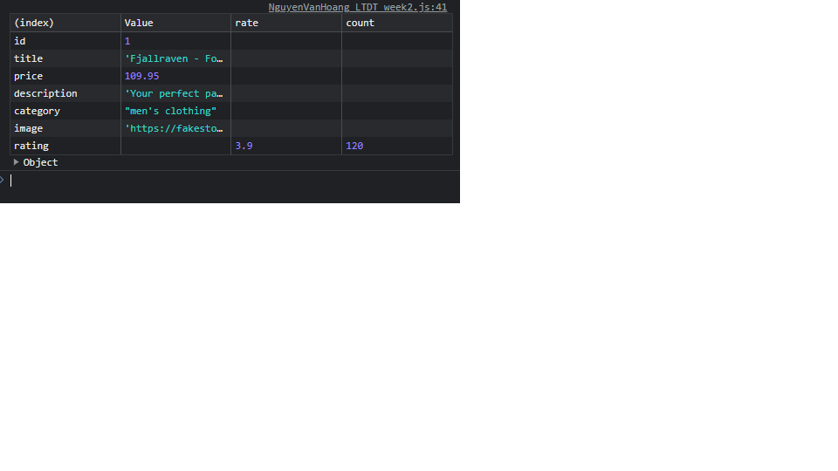

XMLHttpRequest  
RESTful POST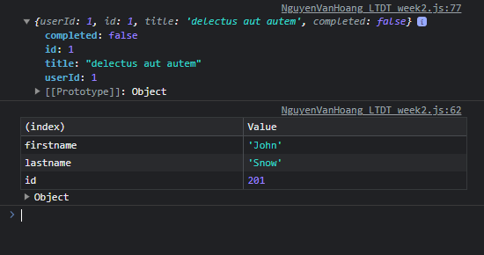

XMLHttpRequest  
RESTful PUT

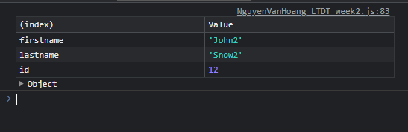

XMLHttpRequest  
RESTful DELETE

s

