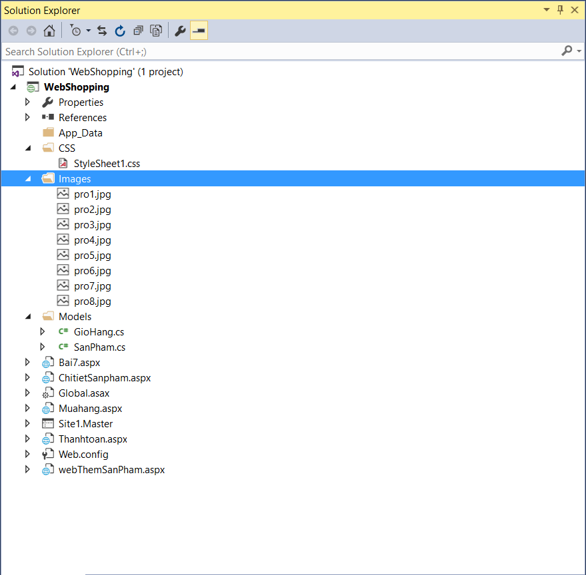

**StyleSheet1.css**

body {

font-family:Tahoma, Arial;

font-size:12pt;

}

#container{

width:800px;

margin:auto;

border:1px solid black;

overflow:auto;

}

header{

width:800px;

float:left;

border-bottom:1px solid black;

height:100px;

background-color:lavender;

text-align:center;

padding-top:50px;

}

nav{

width:800px;

float:left;

border-bottom:1px solid black;

height:40px;

background-color:violet;

text-align:center;

}

section{

width:800px;

float:left;

border-bottom:1px solid black;

}

footer{

width:800px;

float:left;

height:30px;

background-color:lavender;

text-align:center;

}

**GioHang.cs**

using System;

using System.Collections.Generic;

using System.Linq;

using System.Web;

namespace WebShopping.Models

{

public class GioHang

{

public string MaSP { get; set; }

public string TenSP { get; set; }

public int SoLuong { get; set; }

public decimal DonGia { get; set; }

public override bool Equals(object obj)

{

//return base.Equals(obj);

if (obj != null)

{

if (obj is GioHang)

{

GioHang s = (GioHang)obj;

if (s.MaSP == this.MaSP)

return true;

}

}

return false;

}

}

}

**SanPham.cs**

using System;

using System.Collections.Generic;

using System.Linq;

using System.Web;

namespace WebShopping.Models

{

public class SanPham

{

public string MaSP { get; set; }

public string TenSP { get; set; }

public string HinhSP { get; set; }

public decimal DonGia { get; set; }

public int SoLuong { get; set; }

public override bool Equals(object obj)

{

//return base.Equals(obj);

if (obj != null)

{

if (obj is SanPham)

{

SanPham s = (SanPham)obj;

if (s.MaSP == this.MaSP)

return true;

}

}

return false;

}

}

}

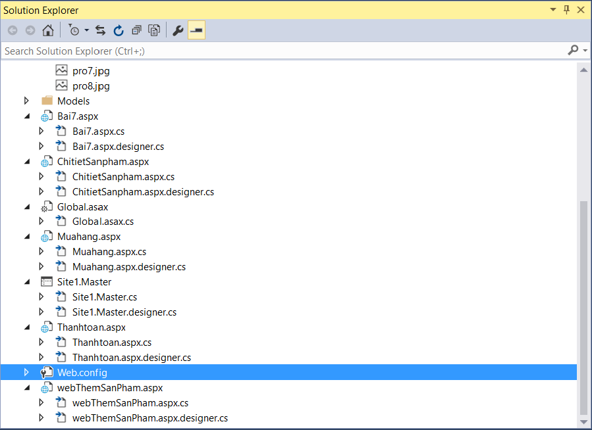

**Bai7.aspx**

<%@ Page Title="" Language="C#" MasterPageFile="~/Site1.Master" AutoEventWireup="true" CodeBehind="Bai7.aspx.cs" Inherits="WebShopping.Bai7" %>

<asp:Content ID="Content1" ContentPlaceHolderID="head" runat="server">

<style>

.a{

width:200px;

height:200px;

border:1px solid black;

padding:5px;

margin:10px;

float:left;

text-align:center;

}

.hinh{

width:100px;

height:100px;

}

</style>

</asp:Content>

<asp:Content ID="Content2" ContentPlaceHolderID="ContentPlaceHolder1" runat="server">

<div id="dssp" runat="server"></div>

</asp:Content>

**Bai7.aspx.cs**

using System;

using System.Collections.Generic;

using System.Linq;

using System.Web;

using System.Web.UI;

using System.Web.UI.WebControls;

using WebShopping.Models;

namespace WebShopping

{

public partial class Bai7 : System.Web.UI.Page

{

List<SanPham> lstSP;

List<GioHang> lstGH;

protected void Page_Load(object sender, EventArgs e)

{

if (!Page.IsPostBack)

{

if (Session["dssp"] == null)

{

lstSP = new List<SanPham>();

SanPham sp = new SanPham();

sp.MaSP = "pro01";

sp.TenSP = "Hoa Hồng Đỏ";

sp.DonGia = 70000;

sp.HinhSP = "Images/pro1.jpg";

sp.SoLuong = 10;

lstSP.Add(sp);

sp = new SanPham();

sp.MaSP = "pro02";

sp.TenSP = "Hoa Hồng Xanh dương";

sp.DonGia = 70000;

sp.HinhSP = "Images/pro2.jpg";

sp.SoLuong = 10;

lstSP.Add(sp);

sp = new SanPham();

sp.MaSP = "pro03";

sp.TenSP = "Hoa Lys + Hồng";

sp.DonGia = 70000;

sp.HinhSP = "Images/pro3.jpg";

sp.SoLuong = 10;

lstSP.Add(sp);

sp = new SanPham();

sp.MaSP = "pro04";

sp.TenSP = "Hoa Hồng tím";

sp.DonGia = 70000;

sp.HinhSP = "Images/pro4.jpg";

sp.SoLuong = 10;

lstSP.Add(sp);

sp = new SanPham();

sp.MaSP = "pro05";

sp.TenSP = "Hoa Hồng xanhh lá";

sp.DonGia = 70000;

sp.HinhSP = "Images/pro5.jpg";

sp.SoLuong = 10;

lstSP.Add(sp);

sp = new SanPham();

sp.MaSP = "pro06";

sp.TenSP = "Hoa Lys + Hồng vàng";

sp.DonGia = 70000;

sp.HinhSP = "Images/pro6.jpg";

sp.SoLuong = 10;

lstSP.Add(sp);

sp = new SanPham();

sp.MaSP = "pro07";

sp.TenSP = "Hoa Hồng";

sp.DonGia = 70000;

sp.HinhSP = "Images/pro7.jpg";

sp.SoLuong = 10;

lstSP.Add(sp);

sp = new SanPham();

sp.MaSP = "pro08";

sp.TenSP = "Hoa Hồng vàng";

sp.DonGia = 70000;

sp.HinhSP = "Images/pro8.jpg";

sp.SoLuong = 10;

lstSP.Add(sp);

//lưu vào session

Session["dssp"] = lstSP;

}

else

{

lstSP = (List<SanPham>)Session["dssp"];

}

//doc bien gio hang

if (Session["giohang"] == null)

{

lstGH = new List<GioHang>();

}

else

{

lstGH = (List<GioHang>)Session["giohang"];

}

if (Request.QueryString["id"] != null)

{

//doc lai id san pham khi chon them vao gio hang

string masp = Request.QueryString["id"].ToString();

GioHang gh = new GioHang();

SanPham sp = lstSP.Where(x => x.MaSP == masp).FirstOrDefault();

gh.MaSP = sp.MaSP;

gh.TenSP = sp.TenSP;

gh.DonGia = sp.DonGia;

//kiem tra gio hang co sp chua

if (!lstGH.Contains(gh))

{

//chua co thì them vào

gh.SoLuong = 1;

lstGH.Add(gh);

}

else

{

//có rồi thì thêm 1

//GioHang cn = lstGH.Where(x => x.MaSP == masp).FirstOrDefault();

//cn.SoLuong += 1;

lstGH.SingleOrDefault(x => x.MaSP == masp).SoLuong++;

}

//luu bien session gio hang

Session["giohang"] = lstGH;

}

string s = "";

foreach (var item in lstSP)

{

s += "<div class='a'>";

s += item.TenSP;

s += "<br/><img src='" + item.HinhSP + "' class='hinh'>";

s += "<br/>Giá: " + item.DonGia;

s += "<br/>Số lượng: " + item.SoLuong;

s += "<br/> <a href='ChitietSanpham.aspx?id=" + item.MaSP + "'>Chi tiết sản phẩm</a>";

s += "<br/> <a href='Bai7.aspx?id=" + item.MaSP + "'>Thêm vào giỏ hàng</a>";

s += "</div>";

}

dssp.InnerHtml = s;

}

}

}

}

**ChitietSanpham.aspx**

<%@ Page Title="" Language="C#" MasterPageFile="~/Site1.Master" AutoEventWireup="true" CodeBehind="ChitietSanpham.aspx.cs" Inherits="WebShopping.ChitietSanpham" %>

<asp:Content ID="Content1" ContentPlaceHolderID="head" runat="server">

<style>

.hinh{

width:200px;

height:200px;

}

#chitiet{

margin-left:40px;

padding:20px;

}

</style>

</asp:Content>

<asp:Content ID="Content2" ContentPlaceHolderID="ContentPlaceHolder1" runat="server">

<div id="chitiet" runat="server"></div>

</asp:Content>

**ChitietSanpham.aspx.cs**

using System;

using System.Collections.Generic;

using System.Linq;

using System.Web;

using System.Web.UI;

using System.Web.UI.WebControls;

using WebShopping.Models;

namespace WebShopping

{

public partial class ChitietSanpham : System.Web.UI.Page

{

List<SanPham> lstSP;

protected void Page_Load(object sender, EventArgs e)

{

if (!Page.IsPostBack)

{

if (Request.QueryString["id"] != null && Session["dssp"] != null)

{

lstSP = (List<SanPham>)Session["dssp"];

string maSP = Request.QueryString["id"].ToString();

SanPham sp = lstSP.Where(x => x.MaSP == maSP).FirstOrDefault<SanPham>();

if (sp != null)

{

string s = "Tên sản phẩm:" + sp.TenSP;

s += "<br/> <img src='" + sp.HinhSP + "' class='hinh'>";

s += "<br/>Giá: " + sp.DonGia;

s += "<br/>Số lượng: " + sp.SoLuong;

s += "<br/> <a href='Bai7.aspx'>Quay về</a>";

chitiet.InnerHtml = s;

}

}

}

}

}

}

**Muahang.aspx**

<%@ Page Title="" Language="C#" MasterPageFile="~/Site1.Master" AutoEventWireup="true" CodeBehind="Muahang.aspx.cs" Inherits="WebShopping.Muahang" %>

<asp:Content ID="Content1" ContentPlaceHolderID="head" runat="server">

</asp:Content>

<asp:Content ID="Content2" ContentPlaceHolderID="ContentPlaceHolder1" runat="server">

<div id="giohang" runat="server">

</div>

<asp:Button ID="btnThanhToan" Text="Thanh toán" runat="server" OnClick="btnThanhToan_Click" />

<asp:Button ID="btnMuaTiep" Text="Mua tiếp" runat="server" OnClick="btnMuaTiep_Click" />

</asp:Content>

**Muahang.aspx.cs**

using System;

using System.Collections.Generic;

using System.Linq;

using System.Web;

using System.Web.UI;

using System.Web.UI.WebControls;

using WebShopping.Models;

namespace WebShopping

{

public partial class Muahang : System.Web.UI.Page

{

List<GioHang> lstGH;

protected void Page_Load(object sender, EventArgs e)

{

if (!Page.IsPostBack)

{

if (Session["giohang"] != null)

{

//đọc lại giỏ hàng từ biến session

lstGH = (List<GioHang>)Session["giohang"];

//thực hiện xóa sản phẩm trong giỏ hàng:

if (Request.QueryString["id"] != null)

{

string masp = Request.QueryString["id"].ToString();

GioHang gh = lstGH.Where(x => x.MaSP == masp).FirstOrDefault();

if (gh != null)

lstGH.Remove(gh);//xoa

Session["giohang"] = lstGH;//cap nhat gio hang

}

//load vao table

string s = "<table border='1' width='100%' style='border-collapse:collapse'>";

s += "<caption>CÁC SẢN PHẨM BẠN ĐÃ CHỌN MUA</caption>";

s += "<tr><th>Mã sản phẩm</th><th> Tên sản phẩm</th><th> Đơn giá</th><th> Số lượng</th><th> Thành tiền</th><th>&nbsp;</th></tr>";

decimal tongthanhtien = 0;

foreach (var item in lstGH)

{

s += "<tr><td>" + item.MaSP + "</td><td>" + item.TenSP + "</td><td>" + item.DonGia + "</td><td>" +

item.SoLuong + "</td><td>" + item.DonGia * item.SoLuong +

"</td><td><a href='Muahang.aspx?id=" + item.MaSP + "'>Xóa</a></td></tr>";

tongthanhtien += item.DonGia * item.SoLuong;

}

s += "<tr><td colspan='4' style='text-align:center'>Tổng thành tiền</td><td colspan='2' >" + tongthanhtien + "</td></tr>";

s += "</table>";

giohang.InnerHtml = s;

}

}

}

protected void btnThanhToan_Click(object sender, EventArgs e)

{

//lưu vào database nếu có

Response.Redirect("Thanhtoan.aspx");

}

protected void btnMuaTiep_Click(object sender, EventArgs e)

{

Response.Redirect("Bai7.aspx");

}

}

}

**Site1.Master**

<%@ Master Language="C#" AutoEventWireup="true" CodeBehind="Site1.master.cs" Inherits="WebShopping.Site1" %>

<!DOCTYPE html>

<html xmlns="http://www.w3.org/1999/xhtml">

<head runat="server">

<title></title>

<asp:ContentPlaceHolder ID="head" runat="server">

</asp:ContentPlaceHolder>

<link rel="stylesheet" href="CSS/StyleSheet1.css" />

</head>

<body>

<form id="form1" runat="server">

<div id="container">

<header>

<h2>CÁC BÀI TẬP ASP.NET TUẦN 08</h2>

<asp:LinkButton ID="lnkGioHang" Text="" runat="server" OnClick="lnkGioHang_Click"></asp:LinkButton>

</header>

<nav><a href="Bai7.aspx">Trang chủ</a>|<a href="webThemSanPham.aspx">Thêm sản phẩm</a>|<a href="bai1.aspx">Bai1</a> | <a href="bai2.aspx">Bai2</a>| <a href="bai3.aspx">Bai3</a>|<a href="bai4.aspx">Bai4</a></nav>

<section>

<asp:ContentPlaceHolder ID="ContentPlaceHolder1" runat="server">

Đây là khung nội dung sẽ thay đổi tùy theo các trang trong website

</asp:ContentPlaceHolder>

</section>

<footer>SVTH: Nguyễn Văn A - MSSV: 141043589 Lớp DHKTPM10A </footer>

</div>

</form>

</body>

</html>

**Site1.Master.cs**

using System;

using System.Collections.Generic;

using System.Linq;

using System.Web;

using System.Web.UI;

using System.Web.UI.WebControls;

using WebShopping.Models;

namespace WebShopping

{

public partial class Site1 : System.Web.UI.MasterPage

{

List<GioHang> lstGH;

protected void Page_Load(object sender, EventArgs e)

{

if (Session["giohang"] != null)

{

lnkGioHang.Visible = true;

lstGH = (List<GioHang>)Session["giohang"];

lnkGioHang.Text = "Giỏ hàng (" + lstGH.Count + ")";

}

else

lnkGioHang.Visible = false;

}

protected void lnkGioHang_Click(object sender, EventArgs e)

{

Response.Redirect("Muahang.aspx");

}

}

}

**Thanhtoan.aspx**

<%@ Page Title="" Language="C#" MasterPageFile="~/Site1.Master" AutoEventWireup="true" CodeBehind="Thanhtoan.aspx.cs" Inherits="WebShopping.Thanhtoan" %>

<asp:Content ID="Content1" ContentPlaceHolderID="head" runat="server">

</asp:Content>

<asp:Content ID="Content2" ContentPlaceHolderID="ContentPlaceHolder1" runat="server">

<table border="1" width="100%" style="border-collapse:collapse">

<caption>MỜI BẠN NHẬP THÔNG TIN THANH TOÁN</caption>

<tr><td>Nhập tên người nhận: </td><td><asp:TextBox ID="txtNN" runat="server"></asp:TextBox></td></tr>

<tr><td>Địa chỉ người nhận: </td><td><asp:TextBox ID="txtDC" runat="server" Width="300px"></asp:TextBox></td></tr>

<tr><td>Email người nhận:</td><td><asp:TextBox ID="txtDC0" runat="server" Width="300px"></asp:TextBox></td></tr>

<tr><td>Tổng tiền trên hóa đơn: </td><td><asp:TextBox ID="txtTongTien" runat="server" ReadOnly="true"></asp:TextBox></td></tr>

<tr><td>Chọn hình thức thanh toán </td><td><asp:RadioButton ID="radTT" runat="server" Text="Trực tiếp" GroupName="grTT" />

<asp:RadioButton ID="radATM" runat="server" Text="Thẻ ATM" GroupName="grTT" />

<asp:RadioButton ID="radNL" runat="server" Text="Ngân lượng" GroupName="grTT" />

</td></tr>

<tr align="center"><td colspan="2"><asp:Button ID="btnLuu" Text="Lưu" runat="server" OnClick="btnLuu_Click"/>

<asp:Button ID="btnHuy" Text="Hủy" runat="server" OnClick="btnHuy_Click" />

</td></tr>

</table>

</asp:Content>

**Thanhtoan.aspx.cs**

using System;

using System.Collections.Generic;

using System.Linq;

using System.Web;

using System.Web.UI;

using System.Web.UI.WebControls;

using WebShopping.Models;

namespace WebShopping

{

public partial class Thanhtoan : System.Web.UI.Page

{

List<GioHang> lstGH;

decimal tongtien;

protected void Page_Load(object sender, EventArgs e)

{

if (!Page.IsPostBack)

{

if (Session["giohang"] != null)

{

lstGH = new List<GioHang>();

lstGH = (List<GioHang>)Session["giohang"];

tongtien = 0;

foreach (var item in lstGH)

{

tongtien += item.DonGia * item.SoLuong;

}

txtTongTien.Text = tongtien.ToString();

}

}

}

protected void btnLuu_Click(object sender, EventArgs e)

{

if (Page.IsValid)

{

//luu database neu co

//huy phien làm việc

Session.Abandon();

Response.Redirect("Bai7.aspx");

}

}

protected void btnHuy_Click(object sender, EventArgs e)

{

//huy không mua hàng

//khong luu database

Session.Abandon();

Response.Redirect("Bai7.aspx");

}

}

}

**webThemSanPham.aspx**

<%@ Page Title="" Language="C#" MasterPageFile="~/Site1.Master" AutoEventWireup="true" CodeBehind="webThemSanPham.aspx.cs" Inherits="WebShopping.webThemSanPham" %>

<asp:Content ID="Content1" ContentPlaceHolderID="head" runat="server">

</asp:Content>

<asp:Content ID="Content2" ContentPlaceHolderID="ContentPlaceHolder1" runat="server">

<table>

<tr>

<td>Nhap ma SP:</td>

<td>

<asp:TextBox ID="txtMa" runat="server"></asp:TextBox>

<asp:RequiredFieldValidator ID="rqMa" runat="server" ErrorMessage="*" ControlToValidate="txtMa">

</asp:RequiredFieldValidator>

<asp:RegularExpressionValidator ID="reMa" runat="server" ErrorMessage="Phai theo mau 'pro00'"

ControlToValidate="txtMa" ValidationExpression="^pro\d{2}$"></asp:RegularExpressionValidator>

</td>

</tr>

<tr>

<td>Nhap Ten SP:</td>

<td>

<asp:TextBox ID="txtTen" runat="server">

</asp:TextBox>

<asp:RequiredFieldValidator ID="rqTen" runat="server" ErrorMessage="*" ControlToValidate="txtTen"></asp:RequiredFieldValidator>

</td>

</tr>

<tr>

<td>Don gia:</td>

<td>

<asp:TextBox ID="txtDG" runat="server"></asp:TextBox>

<asp:RangeValidator ID="ranDG" runat="server" ErrorMessage="Phai la so >0" ControlToValidate="txtDG"

Type="Currency" MinimumValue="1" MaximumValue="100000000"></asp:RangeValidator>

</td>

</tr>

<tr>

<td>So luong:</td>

<td>

<asp:TextBox ID="txtSL" runat="server"></asp:TextBox>

<asp:RangeValidator ID="ranSL" runat="server" ErrorMessage="Phai la so >0" ControlToValidate="txtSL"

Type="Integer" MinimumValue="1" MaximumValue="1000"></asp:RangeValidator>

</td>

</tr>

<tr>

<td>Hinh anh:</td>

<td>

<asp:FileUpload ID="fileHinh" runat="server"></asp:FileUpload>

<asp:RegularExpressionValidator ID="reHinh" runat="server" ErrorMessage="Phai cho dung hinh"

ControlToValidate="fileHinh" ValidationExpression="\w+.(?i)(ico|gif|png|jpg)$"></asp:RegularExpressionValidator>

</td>

</tr>

<tr><td colspan="2"><asp:Button ID="btnSave" Text="Cap nhat" runat="server" OnClick="btnSave_Click" /></td></tr>

</table>

<asp:GridView ID="grSP" runat="server"></asp:GridView>

</asp:Content>

**webThemSanPham.aspx.cs**

using System;

using System.Collections.Generic;

using System.Linq;

using System.Web;

using System.Web.UI;

using System.Web.UI.WebControls;

using WebShopping.Models;

namespace WebShopping

{

public partial class webThemSanPham : System.Web.UI.Page

{

List<SanPham> lstSP;

protected void Page_Load(object sender, EventArgs e)

{

//load GridView

if (!Page.IsPostBack)

{

if (Session["dssp"] != null)

{

lstSP = (List<SanPham>)Session["dssp"];

LoadGriView(lstSP);

}

}

}

protected void btnSave_Click(object sender, EventArgs e)

{

if (Page.IsValid)//kiem tra cac phan tu nhap tren form co hop le chua

{

try

{

//luu vao bien session

//khoi tao san pham

SanPham sp = new SanPham();

sp.MaSP = txtMa.Text;

sp.TenSP = txtTen.Text;

sp.DonGia = decimal.Parse(txtDG.Text);

sp.SoLuong = int.Parse(txtSL.Text);

sp.HinhSP = "Images/" + fileHinh.PostedFile.FileName;

//them vao danh sach san pham

if (Session["dssp"] != null)

{

lstSP = (List<SanPham>)Session["dssp"];

}

else

lstSP = new List<SanPham>();

lstSP.Add(sp);

//luu hinh ve server

fileHinh.PostedFile.SaveAs(Server.MapPath("") +"/"+ sp.HinhSP);

Session["dssp"] = lstSP;

LoadGriView(lstSP);

}

catch (Exception ex)

{

Response.Write(ex.Message);

}

}

}

private void LoadGriView(List<SanPham> lst)

{

grSP.DataSource = lst;

grSP.DataBind();

}

}

}