Image Processing Application – Spring 2021

Lecturer: Professor Lee Guee Sang

Student: Le Hoai Duy – 218493

**Homework3**

Select at least 3 gray scale images:

1. Apply histogram equalization. Compare histograms before and after the histogram equalization. Explain what changes are made and how the contrast is enhanced:

**Code:**

from __future__ import print_function

from matplotlib import pyplot as plt

import cv2 as cv

for i in range(3):

    # read an image and apply histogram equalization

    img = cv.imread("./image"+ str(i) +".png",0)

    dst = cv.equalizeHist(img)

    # plot and save result

    fig, axes = plt.subplots(ncols=2, nrows=2,figsize=(20, 20))

    ax0, ax1, ax2, ax3 = axes.flat

    ax0.imshow(img,cmap='gray')

    ax0.set_title('Original', fontsize=24)

    ax0.axis('off')

    ax1.imshow(dst,cmap='gray')

    ax1.set_title('Histogram Equalization', fontsize=24)

    ax1.axis('off')

    ax2.hist(img.ravel(),256,[0,256])

    ax3.hist(dst.ravel(),256,[0,256])

    fig.savefig("D:/result_HW3_" + str(i) + ".png",bbox_inches='tight')

**Result:**

Figure 1. Original image and processed image after applying Histogram Equalization

Figure 2. Original image and processed image after applying Histogram Equalization

Figure 3. Original image and processed image after applying Histogram Equalization

**Analysis of the results**: Before applying histogram equalization, the value of the pixels is widely distributed in the average value area of the gray scale. There are very few pixels in the bright and/or dark areas. The histogram closely resembles the normal distribution. After applying histogram equalization, the histogram is converted to closely resemble a uniform distribution. The use of histogram equalization does have the general tendency of spreading the histogram of the input image so that the levels of the histogram-equalized image will span a fuller range of the gray scale. Contrast of all 3 images are significantly improved.

1. Choose different set of images where the histogram equalization does not improve the contrast or image quality. Apply histogram matching and compare 3 images with histograms, the original image, after histogram equalization, after histogram matching.

**Code:**

from skimage import data

from skimage import exposure

from skimage import io

import matplotlib.pyplot as plt

from skimage.exposure import match_histograms

# read input image

img1 = cv.imread("./mars1.jpg",0)

fig, axes = plt.subplots(ncols=3, nrows=2,figsize=(20, 20))

axes.flat[0].imshow(img1,cmap='gray')

axes.flat[0].set_title('Original', fontsize=24)

axes.flat[0].axis('off')

# apply histogram equalization

dst = cv.equalizeHist(img1)

axes.flat[1].imshow(dst,cmap='gray')

axes.flat[1].set_title('Histpgram Equalization', fontsize=24)

axes.flat[1].axis('off')

# apply histogram matching

image = io.imread("./mars1.jpg", True)

reference = io.imread("./moonr33.jpg", True)

matched = match_histograms(image, reference, multichannel=False)

axes.flat[2].imshow(matched,cmap=plt.cm.gray)

axes.flat[2].set_title('Histogram Matching', fontsize=24)

axes.flat[2].axis('off')

for i, img in enumerate((image, dst, matched)):

    img_hist, bins = exposure.histogram(img)

    axes.flat[i+3].plot(img_hist)

axes.flat[3].set_title('Original', fontsize=24)

axes.flat[4].set_title('Histogram Equalization', fontsize=24)

axes.flat[5].set_title('Histogram Matching', fontsize=24)

fig.tight_layout()

fig.savefig("D:/result_HW3_4.png",bbox_inches='tight')

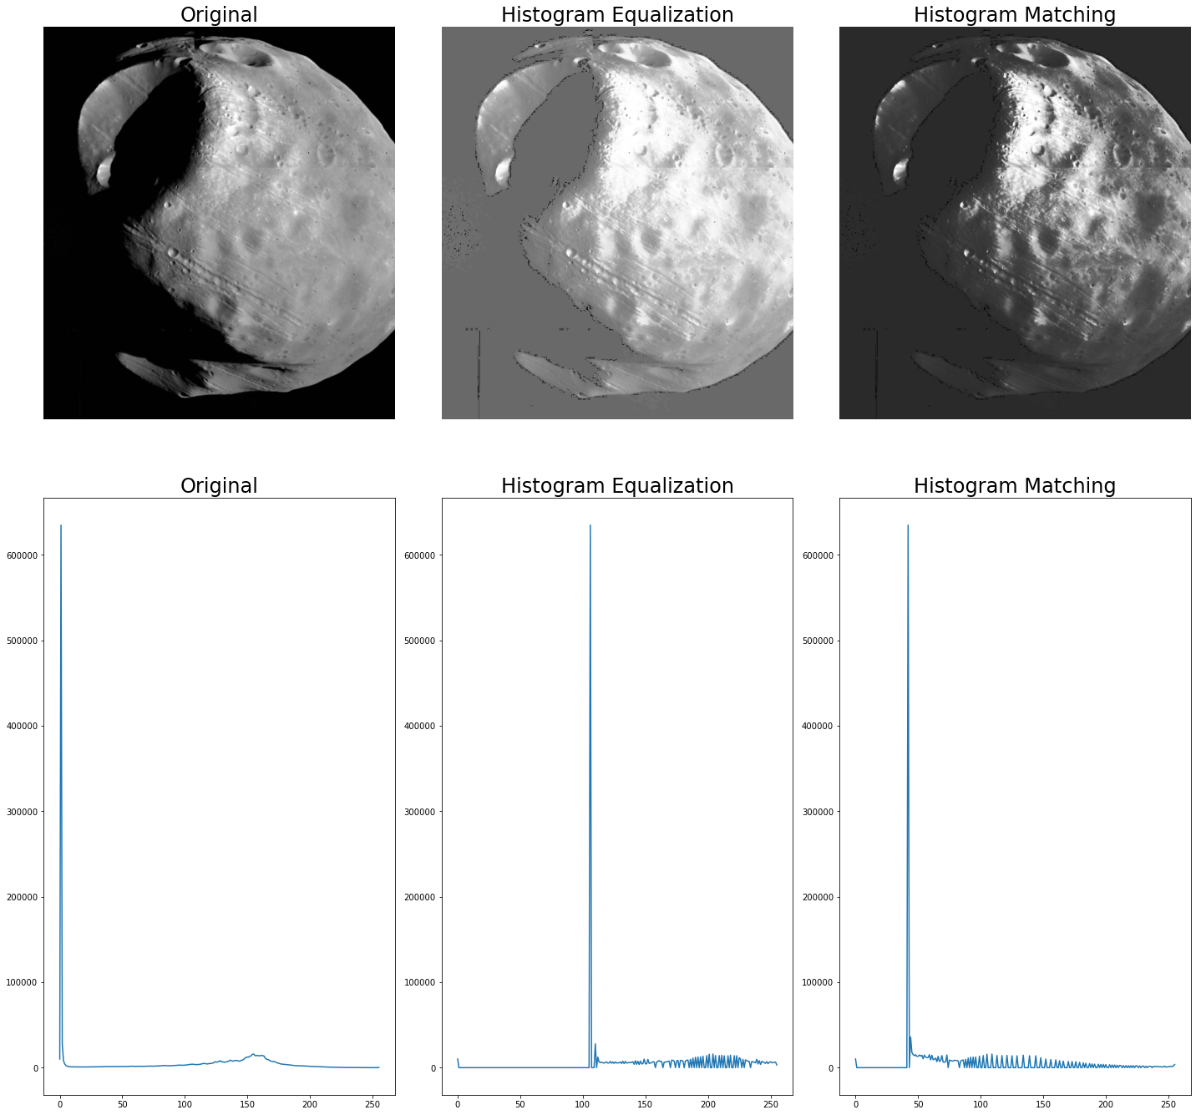**Result**

Figure 4. Original and processed image after applying Histogram Equalization and Histogram Matching

Figure 5. Original and processed image after applying Histogram Equalization and Histogram Matching

Figure 6. Original and processed image after applying Histogram Equalization and Histogram Matching

**Analysis of the results**: Images that have low contrast results when applying the Histogram Equalization technique have common feature is that they are dark images, the pixels are distributed mainly in the small value area of the gray scale. After applying Histogram Equalization, the pixel distributions of those images are shifted to an area of large pixel value, so the output image is bright and has low contrast.

In contrast, when applying the Histogram Matching technique and choosing a suitable transfer function, the pixel distributions of those images shift only a very small amount into the area of the bright pixel value. As a result, the output images of Histogram Matching have a higher contrast than the output images of Histogram Equalization technique.